BOROUGH OF KETTERING

Committee | Full Planning Committee - 21/06/2011 | Item No: 5.2
Report Originator | Fjola Stevens  Development Officer | Application No:  KET/2011/0187
Wards Affected | Desborough Loatland
Location | 72 Station Road, Desborough
Proposal | Full Application: Change of use from dwelling to ground floor restaurant and first floor studio flat. Two storey rear extension and single storey front extension
Applicant | Miss R Boksh

1. PURPOSE OF REPORT

  - To describe the above proposals
  - To identify and report on the issues arising from it
  - To state a recommendation on the application

2. RECOMMENDATION

THE DEVELOPMENT CONTROL MANAGER RECOMMENDS that this application be delegated back to the Development Control Manager to be REFUSED on or after 23rd June 2011 for the following reason(s):-

1. The proposed extension to the front of the building by reason of its design and appearance, which would span the width of the building and would incorporate commercial roller shutters, would be an alien form of development totally out of keeping with the traditional architectural features and character of the host building and adjacent buildings on the corner of Station Road and Gladstone Street. Furthermore due to its prominent siting at the gateway to the town centre the proposal would constitute an incongruous and inappropriate form of development that would harm the visual amenity of the streetscene which is in need of enhancement, degrade the quality of the locality further, and would prejudice the comprehensive redevelopment of the northern gateway to Desborough Town Centre. In addition, the proposed extension as a result of its unsympathetic and inappropriate design and its prominant siting within the Conservation Area would also fail to preserve or enhance the character and appearance of the Desborough Conservation Area. The proposal is therefore contrary to PPS1, PPS4 and PPS5, Policies 1, 2 and 11 of the East Midlands Regional Plan, Policy 13(h) and (o) of the North Northamptonshire Core Spatial Strategy, Policies 33 and D2 of the Local Plan for Kettering Borough and Policy 16 of the emerging Rothwell and Desborough Urban Extension Area Action Plan.

Notes (if any) :-
- NONE

Justification for Granting Planning Permission
Not applicable

Officers Report

3.0 | Information

Relevant Planning History
KET/2010/0726 – Change of use from dwelling to restaurant with flat above, two storey rear extension and single storey front extension WITHDRAWN 09/12/10

KET/2008/0841 – Alterations to shop front and inclusion of roller shutters APPROVED 11/12/08

Site Description
Officer's site inspection was carried out on 23rd May 2011.

The application site lies on the northern side of Station Road, one of the main roads within Desborough Town Centre, and is prominently located close to its junction with Gladstone Street. The site therefore forms part of the northern gateway into the town and the Desborough Conservation Area.

The application property; a mid-terrace 2 storey building is currently vacant, however previously it was a dwellinghouse. The site sits to the east of an existing Indian restaurant and take-away which has residential accommodation above. The premises adjoining the site to the west are also vacant at ground floor level, however in the past it was a shop with accommodation above.

Proposed Development
This application seeks planning permission to change the use of the ground floor to a restaurant seating area, to be used in conjunction with the adjoining restaurant, with the first floor being changed to a 1 bed studio flat.

A replacement 2 storey rear extension with mono-pitched roof is proposed to provide rear accesses to the restaurant and flat at ground floor level with a kitchen for the flat at first floor level. In addition, a ground floor extension is proposed on the front elevation to replace the existing bay window. The new frontage would incorporate blue external roller shutters.

The proposed rear extension would measure approx. 5.7m (h) x 3.4m (w) x 3.8m (d). The proposed front extension would measure approx. 3.1m (h) x 3.4m (w) x 0.8m (d).

Any Constraints Affecting The Site
Conservation Area

4.0 | Consultation and Customer Impact

Town Council
Comments received 27/05/11:
Support – Desborough Town Council supports the application to extend this restaurant in Station Road. The restaurant is well established, well used and a local employer.

Comments received 19/05/11:
A letter was received from the Town Council supporting the proposal which they had discussed with the applicant prior to submission. Letter supported the proposal and the need for shutters for security reasons due to a number of incidents occurring within the town.

Environmental Health
No objection.
Comments that adequate sound insulation should be provided between the proposed kitchen and any habitable room on adjoining properties to prevent transmission of sound. Also suggests that consideration should be given to the impact of smoke on neighbours from the outdoor smoking area and this should be taken into account when placing seating or other items in the smoking area.

Neighbours
1 3rd party support
- Support the plan to expand the business and the need for external shutters due to incidents within the town.

5.0 | Planning Policy

National Policies
PPS1 Delivering sustainable development
PPS4 Planning for sustainable economic growth
PPS5 Planning for the historic environment

Development Plan Policies

East Midlands Regional Plan (EMRP)
P. 1 Regional core objectives
P. 2 Promoting better design
P. 3 Distribution of development
P. 11 Development in the southern sub-area
P. 27 Regional priorities for the historic environment

North Northamptonshire Core Spatial Strategy (CSS)

P. 1 Strengthening the network of settlements
P. 9 Distribution and location of development
P. 13 General sustainable development principles
P. 14 Energy efficiency and sustainable construction

Local Plan for Kettering Borough (LP)
P. 33 Shopfronts, signs and shopfronts
D.2 Desborough: Environmental Improvement

SPGs
Sustainable Design SPD

Emerging Policy
Rothwell and Desborough Urban Extension Area Action Plan Proposed Submission 2009 (AAP)
P. 16 Public realm and public art

6.0 | Financial/Resource Implications
 | None
7.0 | Planning Considerations
The key issues for consideration in this application are:-

- Principle of development
- Design & Visual Impact
- Impact upon character and appearance of Conservation Area
- Impact upon neighbours

1. Principle of development

PPS1, Policies 1, 3 and 11 of the EMRP and Policies 1 and 9 of the CSS all direct new development to existing built up areas. PPS4 deals with economic development, and states that Local Planning Authorities (LPA’s) should adopt a positive and constructive approach towards planning applications for economic development and that planning applications that secure sustainable economic growth should be treated favourably. In addition, PPS4 requires all new development to be assessed in terms of it environmental impact, sustainability in terms of accessibility by a choice of means of transport, design and impact upon character and quality of the area, impact upon economic and physical regeneration, and impact on local employment. This section of the report deals with the principle of the proposed changes of use, and the issues regarding the design and appearance of the proposed extensions are addressed in the section blow.

The application site lies in a sustainable location within the town centre where new development is encouraged by the national, regional and local planning policies set out above. Therefore in principle new development in this location is generally acceptable, subject to the usual material planning considerations. The proposed development would increase the level of seating available for an existing restaurant/take-away and would encourage more diners to ‘eat-in’ and may even encourage customers to stay in the town for longer periods of time and spend money in other establishments during their visit. In addition, the proposal would provide 2 additional full-time jobs and 1 additional part time job thereby increasing the employment opportunities within the town albeit on a small scale. Therefore, although the proposal is small scale it would have a positive impact upon the vitality and viability of the town centre by increasing spending in the town and increasing the job opportunities. It is therefore considered that due to the location of the site within an existing town centre and due to the economic benefits that the proposal would bring to Desborough the principle of the proposed change of use to enlarge the restaurant use accords with planning policy.

A small residential unit in the form of a studio flat is also forms part of the proposal, and due to the location of this unit in a sustainable location within an existing town centre this part of the proposal also accords with planning policy and is therefore acceptable in principle.

2. Design & Visual Impact
PPS1 states that good design is indivisible from good planning and that design which is inappropriate within its context, or which fails to take the opportunities available for improving the character and quality of an area and the way it functions should not be accepted. PPS4 also requires all new economic development to be assessed in terms of whether the proposal secures high quality design which takes the opportunities available to improve the character and quality of an area. In addition, Policies 1 and 2 of the EMRP and Policy 13(h) of the CSS require new development to respect and enhance its surroundings whilst Policy 33 of the LP states that new shopfronts must be sympathetic to the architectural style of the building and should contribute to the enhancement of its surroundings in terms of scale, proportions, materials, style and appearance.

There are also local policies in place and emerging which stress the importance of improving the appearance and quality of Desborough. Policy D2 of the LP and the Rothwell and Desborough AAP also set out the importance of improving the public realm in Desborough town centre, with particular attention paid to the gateways into the centre. Policy D2 of the LP states that provision will be made for the implementation of environmental improvement schemes and that in environmental enhancements and improvements will be sought. Policy 16 of the AAP states that urban extension will seek to improve the quality of the public realm on the main route-ways into and out of Desborough town centre. The AAP also points out that the quality of the urban environment contributes to the character and identity of an area and therefore affects the way in which people perceive and enjoy places. As such, the APP states that significant adverse impact on the environment should be avoided and alternative options which might reduce or eliminate them should be pursued.

The proposed 2 storey rear extension would be sited between 2 existing outshots at the rear of the adjoining properties and constitutes a form of development which is common on terraced properties of this age and style. In addition, due to the location of the proposed extension it would be well screened by the surrounding buildings. As such, due to the siting and scale of the proposed 2 storey rear extension it would not detract from the existing building and would not harm the visual amenity of the surrounding area. This part of the proposal therefore accords with PPS1, Policy 2 of the EMRP and Policy 13(h) of the CSS.

The proposed single storey front extension would span the width of the building completely replacing an existing pitched roof bay window and a partially blocked up doorway on the front of the building. The extension would have a flat roof and a central white upvc window on the front elevation with blue external roller shutters. The proposed extension would not respect in any way the traditional architectural features and character of the existing building and it would instead result in the loss of attractive original features common to this age of property. Furthermore, the solid roller shutters would provide a dead frontage to the front of the building when the restaurant is closed and as such would lead to a loss of natural surveillance in this part of the street. It is therefore considered that whilst the shutters would protect the proposed windows they would do nothing to deter crime because people within the street would not feel overlooked.

The application site lies in a highly prominent location at a gateway to the main shopping area of the town, which in accordance with policy D2 of the LP and the AAP should be enhanced to improve the urban environment in this location. The area is in need of environmental improvement and this could be achieved through sensitive alterations to the existing and adjoining building; such as renovating the existing bay window and reinstating the traditional features on the adjoining building to provide a comprehensive redevelopment of the northern gateway to the town centre. Unfortunately due to the flat roof design of the proposed front extension, its width which spans the whole of the front elevation and the inclusion of commercial roller shutters, the proposal would be totally out of keeping with the traditional appearance of the host building and therefore the proposal fails to do this.

PPS1, PPS4, Policy 2 of the EMRP and Policy 13(h) are all very clear that inappropriate development which does not respect or enhance its surroundings should not be accepted The proposed extension due to its prominent siting would not only have an adverse impact upon the appearance of the host building it constitute an incongruous form of development within the streetscene and would prejudice the comprehensive redevelopment of this part of the town centre. The proposal as a result would degrade the character and quality of the area further, rather than improving and enhancing it. Therefore the proposed development does not accord with PPS1, PPS4, Policies 1 and 2 of the EMRP, Policy 13(h) of the CSS, Policies 33 and D.2 of the LP or Policy 16 of the emerging AAP.

Although the LPA is supportive of the applicant’s plan to change the use of the building to restaurant and ground floor level with a flat above, the small economic benefits of bringing the application building back into use do not outweigh the serious harm that would be caused to the character and appearance of the streetscene and surrounding area as result of the proposed alterations to the front of the building. Therefore due to the serious deficiencies of the scheme in terms of the proposed alterations to the front of the building, the application is recommended for refusal.

3. Impact upon character and appearance of the Conservation Area
S. 72 of the Planning (Listed Buildings and Conservation Areas) Act 1990 (The Act) requires LPA’s to give special attention to preserving or enhancing the character and appearance of the Conservation Area. In addition, PPS5 states that there should be a presumption in favour of the conservation of heritage assets, and that the significance of a heritage asset can be harmed or lost through alteration or destruction of a heritage asset or development within its setting. Furthermore, policy 27 of the EMRP and policy 13(o) of the CSS require development to preserve and conserve built environmental assets.

As set out above the proposed extension to the rear of the property is acceptable in terms of its design and appearance given its location to the rear of the building screened by the surrounding development. It is therefore considered that the proposed extension would preserve the character and appearance of the conservation area. The proposed extension to the front of the building however , which would involve the removal of an original existing bay window feature on the front of the building and its replacement with a flat roof extension, incorporating a white UPVC window and external roller shutters with boxing, would constitute a modern and unsympathetic alteration to the existing building. This extension as a result of its siting, design and appearance would not only detract from the appearance of the existing building it would cause significant harm to the character and appearance of the Conservation Area.

The proposal therefore would not conserve or preserve the character and appearance of the Conservation Area in accordance with The Act, and would not accord with PPS5, Policy 27 of the EMRP or Policy 13(o) of the CSS and as such the impact upon the conservation area forms part of the recommended reason for refusal. The proposed extension to the front of the building would not provide an increase in floor area which would significantly affect the viability of the scheme or would result in such great economic benefit to the wider area that would outweigh the strict rules set out in legislation and planning policy surrounding the conservation and preservation of Conservation Area.

4. Impact upon neighbours
Policy 13(l) of the CSS states that new development should not have an unacceptable impact upon neighbours in terms of noise, vibration, smell, light or other pollution, loss of light or overlooking.

The application site is location on Desborough High Street and many of the units in the proximity of the application site are occupied by commercial units at ground floor level with residential accommodation above. The restaurant would extend an existing restaurant use to provide seating only with the kitchen and serving areas remaining in their current location. It is therefore considered that the proposed restaurant extension would not have a significant impact upon neighbours in terms of noise, vibration or smell.

The first floor of the building would require the installation of a new kitchen to serve the studio flat, however this too is not uncommon in the locality with many units having flats on the upper floors of the buildings. The Environmental Health Officer has recommended that the sound insulation between the newly constructed bedsit kitchen and any habitable room on the adjoining properties should be constructed so as to prevent transmission of sound that would result in a reduction in residential amenity. Therefore, subject to sound insulation being provided the proposal would not have an unacceptable impact upon neighbours.

The proposed single storey front extension would not have a significant impact upon neighbouring properties due to its scale. The 2 storey rear extension would replace an existing outshot to the rear of the building, albeit larger to fill the width of the plot and approx. 1m deeper. It is considered that due to the scale of the proposal and its position between 2 existing outshots on the adjoining properties the proposed extension would not result in loss of light or have an overbearing impact. In addition, only 1 window is proposed on the rear elevation of the extension and this would replace an existing window. It is therefore considered that the proposal would not result in an unacceptable level of overlooking.

For the reasons set out above it is considered that the proposal would not have an unacceptable impact upon neighbours and therefore the proposal accords with policy 13(l) of the CSS.

Conclusion

In accordance with S.38(6) of the Planning and Compulsory Purchase Act 2004 planning applications must be determined in accordance with the development plan unless other material considerations indicate otherwise.

Although the Local Planning Authority welcomes the enlargement of the existing restaurant with residential accommodation above within the centre of Desborough, which would bring an empty building back into use and would bring economic benefits to the town, these benefits do not outweigh the harm caused to the character and appearance of the Conservation Area as a result of the inappropriate design of the alterations to the front of the building. Despite encouragement from the LPA, the applicant has failed to consider the possibilities available to retain the existing features on the front of the building with sensitive signage and internal security shutters (if other less intrusive security measures are shown to be inadequate).

Therefore it is recommended that due to the impact of the proposed extension to the front of the building which by reason of its; design and appearance would be an alien form of development totally out of keeping with the domestic character and appearance of the host building; and its prominent siting the proposal would constitute an incongruous and inappropriate form of development that would detract from the visual amenity of the streetscene, degrade the quality of the locality and would fail to preserve or enhance the character and appearance of the Conservation Area. The proposal is therefore contrary to PPS1, PPS4 and PPS5, Policies 1, 2 and 11 of the East Midlands Regional Plan, Policy 13(h) and (o) of the North Northamptonshire Core Spatial Strategy, Policies 33 and D2 of the Local Plan for Kettering Borough and Policy 16 of the emerging Rothwell and Desborough Urban Extension Area Action Plan.

Background Papers |  | Previous Reports/Minutes
Title of Document: |  | Ref:
Date: |  | Date:
Contact Officer: | Fjola Stevens, Development Officer on 01536 534316

SITE LOCATION PLAN

72 Station Road, Desborough
Application No.: KET/2011/0187

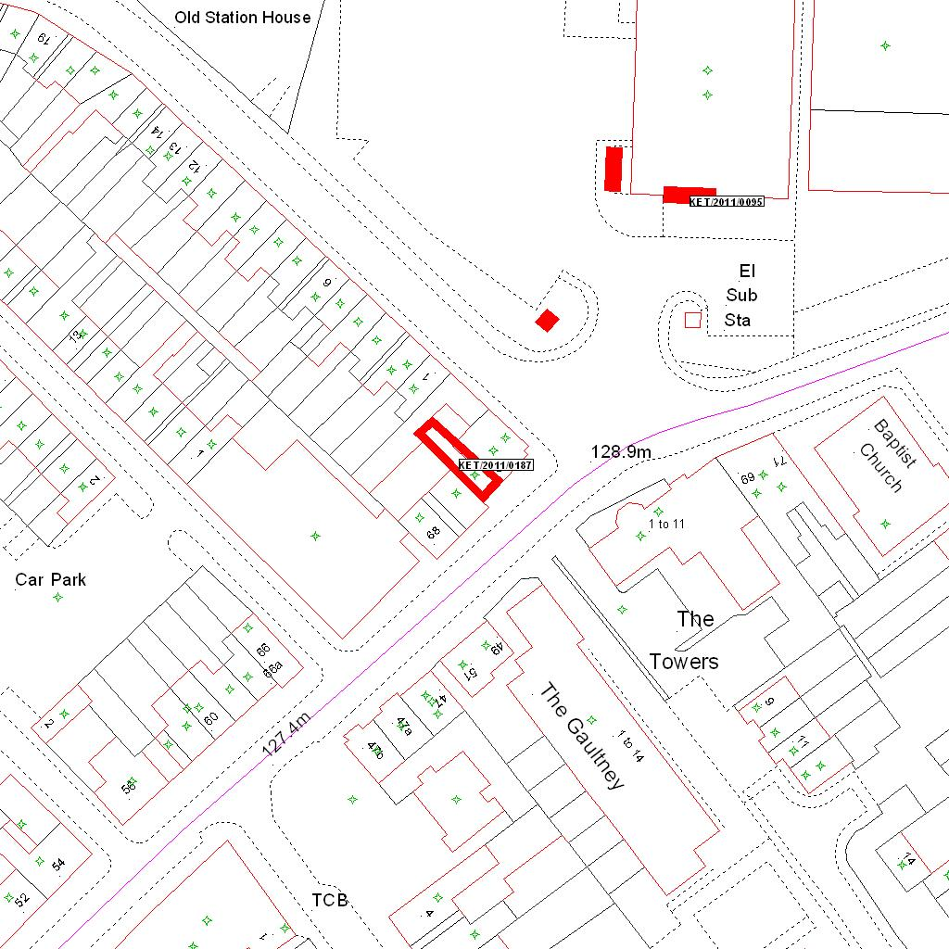

Reproduced from the Ordnance Survey mapping with the permission of the Controller of Her Majesty’s Stationery Office © Crown copyright. Unauthorised reproduction infringes Crown copyright and may lead to prosecution or civil proceedings.  LA078344 |  | N
Date: 29/03/2011 Do not scale from this map. For illustrative purposes only.

