1. PURPOSE OF REPORT

To present the 2011/12 service plans for endorsement by the Executive.

2. INFORMATION

What are service plans?

  - The Council operates a coherent group of services which work together to deliver the Council’s key priorities, aims and ambitions (set out in the Council’s summary corporate plan). Each cluster of services produce a plan (service plan) that outlines what its key focus and activity will be over the coming months. Service plans are supported in many areas by more detailed plans, for example, the Housing Business Plan. This relationship is shown diagrammatically below:

Service Plans – How they fit in:-
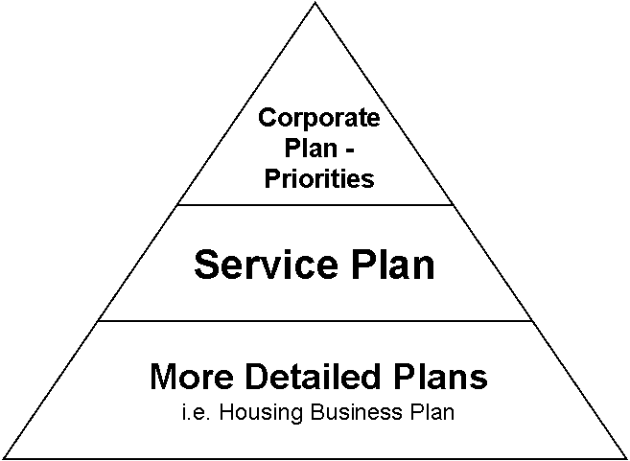

“Service Plans translate the Council’s economic and service priorities into operational delivery”

  - Service plans play an important role in the delivery of the Council’s services and priorities. They help translate the “desk top” budget exercise into reality and also help outline how service areas will deliver future savings. It is important to note that service plans are primarily a tool for heads of service to use to translate the Council’s economic and service priorities into operational delivery. However, it is considered good practice to share these plans with members in order to keep them informed and up to date.

  - We live in rapidly changing times and it is important that the service plans remain flexible and responsive to change. They will therefore remain fluid and may be updated throughout the year to ensure that the Council remains light on its feet. It is suggested that in future, rather than report service plans on an automatic and annual basis, that they are reported when their content changes significantly, which could be more or less than once a year, depending on the service area and issues in hand.

  - The service plans have been developed alongside the budget process. Given the financial climate within which the Council operates, it will be essential that the Council remains focused on the delivery of its agreed plans and avoids unnecessary distractions.

  - Progress of service plans will be monitored in terms of outcomes via the Key Performance Information Booklet. This is reported to each meeting of the Monitoring and Audit Committee and a copy is circulated to all members for information.

  - Because of their nature, the service plans are fairly large and detailed documents. In the interest of the environment, they have been made available electronically via a web link: www.kettering.gov.uk/service-plans. Identical copies have also been placed in the member’s library and are available on the member’s intranet.

3. CONSULTATION AND CUSTOMER IMPACT

The delivery of the service plans will have a significant impact on citizens in the Borough. The action plans include an assessment of both customer impact and risk. This also forms part of the Council’s approach to risk management.

4. POLICY IMPLICATIONS

The service plans help the Council stay focused on the delivery of its policy commitments as set out in its corporate priorities. Any new policy decisions that arise as a result of the actions set out within any of the service plans will be made in line with the constitutional framework.

5. USE OF RESOURCES

The service plans have been developed alongside the budget process. The action plans reflect the Council’s 2011/12 budget. Specific reference to efficiency measures each service unit is taking has been included within the plans.

6. RECOMMENDATION

That members endorse the 2011/12 service plans

Background Papers: Previous Reports/Minutes:

Title of Document: None Ref: N/A
Date: N/A Date: N/A
Contact Officer: Guy Holloway

