BOROUGH OF KETTERING

Committee | Full Planning Committee - 24/05/2011 | Item No: 5.4
Report Originator | Anne Dew  Senior Development Officer | Application No:  KET/2011/0173
Wards Affected | Queen Eleanor and Buccleuch
Location | 5 St. Andrews Lane (land adj), Cranford
Proposal | Full Application: 1 no. detached three storey dwelling
Applicant | Mr M Pepper

1. PURPOSE OF REPORT

  - To describe the above proposals
  - To identify and report on the issues arising from it
  - To state a recommendation on the application

2. RECOMMENDATION

THE DEVELOPMENT CONTROL MANAGER RECOMMENDS that this application be APPROVED subject to the following Condition(s):-

1. Within 3 months of the date of this decision, details of the types and colours of all external roofing materials to be used, together with samples, shall have been submitted to and approved in writing by the Local Planning Authority. The development shall not be carried out other than in accordance with the approved details.
REASON: In the interests of visual amenity and preserving the appearance of the Conservation Area in accordance with policy 13 of the North Northamptonshire Core Spatial Strategy.

2. Within 3 months of the date of this decision, full details of all windows, doors, timber finishes, verge detailing and rainwater goods shall have been submitted to and approved in writing by the Local Planning Authority. The development shall not be carried out other than in accordance with the approved details.
REASON: In the interests of visual amenity and preserving the appearance of the Conservation Area in accordance with policy 13 of the North Northamptonshire Core Spatial Strategy.

3. The roof lights hereby permitted shall be conservation type roof lights, details of which shall be submitted to and approved in writing by the Local Planning Authority prior to installation and shall sit flush with the plane of the roof. The roof lights shall thereafter be retained as approved in perpetuity.
REASON: In the interests of visual amenity and to preserve the appearance of the Conservation Area in accordance with policy 13 of the North Northamptonshire Core Spatial Strategy.

4. Within 3 months of the date of this decision, details of the materials for the hard standing, together with samples, shall be submitted to and approved in writing by the Local Planning Authority. The development shall not be carried out other than in accordance with the approved details.
REASON: In the interests of visual amenity and to preserve the appearance of the Conservation Area in accordance with policy 13 of the North Northamptonshire Core Spatial Strategy.

5. Within 3 months of the date of this decision, a scheme of landscaping which shall specify species, planting sizes, spacing and numbers of trees and shrubs to be planted shall be submitted to and approved in writing by the Local Planning Authority. The approved scheme shall be carried out in the first planting and seeding seasons following the occupation of the building. Any trees or plants which, within a period of 5 years from the date of planting, die, are removed or become seriously damaged or diseased shall be replaced in the next planting season with others of similar size and species.
REASON: To improve the appearance of the site in the interests of visual amenity in accordance with policy 13 of the North Northamptonshire Core Spatial Strategy.

6. Within 3 months of the date of this decision, a scheme for boundary treatment shall have been submitted to and approved in writing by the Local Planning Authority. The building shall not be occupied until the approved scheme has been fully implemented in accordance with the approved details.
REASON: In the interests of the amenities and privacy of the neighbouring property and preserving the appearance of the Conservation Area in accordance with policy 13 of the North Northamptonshire Core Spatial Strategy.

7. The external facing material to be used shall be Clipsham Stone from the Clipsham Stone Company in Rutland with lime mortar pointing 1:3 (lime putty/sharp sand) unless otherwise agreed in writing by the Local Planning Authority.
REASON: In the interests of the visual amenities of the area and to preserve the appearance of the Conservation Area in accordance with policy 13 of the North Northamptonshire Core Spatial Strategy.

8. Within three months of the date of this decision, a scheme demonstrating how the development will incorporate techniques of sustainable construction and energy efficiency, provision for waste reduction/recycling and provision for water efficiency and recycling shall have been submitted to and approved in writing by the Local Planning Authority. The development shall thereafter be carried out in accordance with these approved details.
REASON: In the interests of energy efficiency and sustainable construction in accordance with policy 14 of the North Northamptonshire Core Spatial Strategy.

9. Notwithstanding the provisions of Article 3 of the Town and Country Planning (General Permitted Development) Order 1995 (or any Order revoking and re-enacting that Order with or without modification) no building, structure or other alteration permitted by Class a - e of Part 1 of Schedule 2 of the Order shall be constructed on the application site.
REASON: In the interests of visual amenity and to preserve the appearance of the Conservation Area in accordance with policy 13 of the North Northamptonshire Core Spatial Strategy.

10. Notwithstanding the provisions of Article 3 of the Town and Country Planning (General Permitted Development) Order 1995 (or any Order revoking and re-enacting that Order with or without modification) no additional openings permitted by Schedule 2, Part 1 Classes A or C shall be made in the any elevation or roof plane of the building.
REASON: In the interests of visual amenity and preserving the charatcer of the Conservation Area in accordance with policy 13 of the North Northamptonshire Core Spatial Strategy.

Notes (if any) :-
- NONE

Justification for Granting Planning Permission

The proposal is in accordance with national and local policies as set out in Planning Policy Statements/Guidance Notes 1 and 5, Policy 27 of The East Midlands Regional Plan and Policy 13 of the North Northamptonshire Core Spatial Strategy. There are no material considerations that indicate against the proposal.

Officers Report

3.0 | Information

Relevant Planning History
KET/2010/0226 Erection of 1 no. 2.5 storey detached dwelling. Refused 27.05.2010. This application was refused as it would have a harmful impact on the setting of listed buildings and the character of the conservation area. This decision went to appeal and the appeal was dismissed on 14.01.2011.

KE/03/985 Erection of dwelling and alteration to existing barn. Conditional consent 20.01.2003. This consent has been implemented with the resultant building being built up to ground floor window level.

KE/03/809 Erection of dwelling and alteration to existing barn. Withdrawn. This application was withdrawn due to the adverse impact it would have on the conservation area and the setting of listed buildings.

KE/03/325 Outline for construction of 3 bedroom house. Withdrawn. This application was withdrawn because no detailed drawings were submitted to enable an assessment.

Site Description
Officer's site inspection was carried out on 06/04/2011.

The site forms part of Cranford Conservation Area. To the east and west , including properties immediatley adjacent to the site, are rows of grade II listed two storey dwellings, all of which are of a simple cottage appearance and reflect the general character of the area. Site levels rise from the south to the north resulting in the site being siginficantly higher than the highway. Land to the south of the site fronting onto St Andrews Lane is currently used as an allotment

Works have commenced on site with the dwelling being constructed to ground floor window level. Those works that have been completed are in accordance with the plans approved under extant permission KE/03/985 for a dwelling.

Proposed Development
The proposal is for a two storey dwelling with habitable rooms being provided within the existing roof space. To facilitate the creation of this 2nd storey, the scheme proposes the following changes to the already implemented scheme planning reference KE/03/985:-

- Increase in height of eaves and ridge. The proposed building has an eaves height of 4.9 metres and a ridge height of 8.7 metres. The previously approved scheme provided for a dwelling with an eaves height of 4.6 metres and a ridge height of 8.1 metres
- provision of accommodation in the roof space to provide an extra bedroom (4 in total) and an en-suite
- Provision of an external chimney breast
- Provision of 4 roof lights on the northern rear elevation
- Slight increase in size to the first floor central window on the southern elevation of the dwelling

Any Constraints Affecting The Site
Conservation Area
Listed Buildings immediately to the east and west.

4.0 | Consultation and Customer Impact

Cranford Parish Council No observations received to date

Neighbours 5 neighbour representations have been made. Objections are on the grounds of:-

- impact on Conservation Area
- the building is out of keeping with all other buildings in the line of cottages in which it sits.
- No other three storey buildings in the line of cottages and this has previously been rejected.
- Site is very close to adjacent listed buildings and significantly detracts from these buildings
- Works have already commenced on site and the type and colour of stone used is not in keeping with stone in the area.
- Two car parking spaces cannot be provided with the current foundations
- Loss of light to hallway and garden at 9 St Andrews Lane
- Traffic is already a problem on St Andrews Lane
- Proposal will increase the already difficult parking situation
- Visitors will have to park on the road to avoid blocking the shared access
- Scheme does not provide enough car parking
- Concern over future loss of the allotment
- No other properties have windows in the roof and this feature will not preserve the setting of the adjacent listed buildings
- Loss of light into rear garden, kitchen and landing windows at 11 St Andrews Lane
- Increased traffic

Environmental Health No objection subject to standard contamination condition being attached to any grant of planning permission.

Northamptonshire County Archaeological Advisor No objections

5.0 | Planning Policy
RA3. Rural Area: Restricted Infill Villages

National Policies
PPS1 – Sustainable Development
PPS3 – Housing
PPS5 – Planning for the Historic Environment
PPG13 - Transport

Development Plan Policies

East Midlands Regional Plan
Policy 2 – Promoting Better Design
Policy 27 – Regional priorities for the Historic Environment

North Northamptonshire Core Spatial Strategy
Policy 13 – Sustainable Development
Policy 14 – Energy Efficiency and Sustainable Construction

Local Plan
RA3 - Restricted Infill Villages

6.0 | Financial/Resource Implications
 | None
7.0 | Planning Considerations
The key issues for consideration in this application are:-

- Principle of Development
- Design/ Impact on the Historic Environment and Character of the Area
- Impact on Residential Amenity
- Highway Safety Implications
- Sustainable Construction

1. Principle of Development
The principle of one dwelling being erected on this site has been established under planning permission KET/03/985. The site falls within the defined village of Cranford which is a restricted infill village where such development, subject to consideration of other planning issues, is acceptable in principle. The Planning Inspectorate raised no issues in the determination of the appeal under planning reference KET/2010/0226 to a dwelling being erected on this site.

2. Design/ Impact on the Historic Environment and Character of the Area
The site falls within an elevated prominent position within the Cranford Conservation Area and is surrounded by Grade II Listed Buildings (the row of terraces immediately to the east and immediately to the west of the application site). These are simple stone built traditional cottages, some of which have thatched roofs and these form the character of this prominent part of the Conservation Area.

In assessing the impact of the scheme, the Local Planning Authority is required by Section 72(1) and Section 66 of the Planning (Listed Buildings and Conservation Areas) Act 1990 to pay special attention to the desirability of preserving or enhancing the character and appearance of the Conservation Area. Section 66 of the Planning (Listed Building and Conservation Areas) Act also requires that special regard be given to the desirability of preserving a listed building or its setting or any features of special or architectural interest.

PPS5 ‘Planning for the Historic Requirement’ states that the Local Planning Authority would take into account the desirability of new development making a positive contribution to the character and distinctiveness of the historic environment. The consideration of design should include scale, height, massing, alignment, materials and use. Policy 13(o) of the North Northamptonshire Core Spatial Strategy requires that developments conserve and enhance historic designated built environment assets and their settings. Policy 26 of the East Midlands Regional Strategy states that damage to the natural and historic assets or their settings should be avoided.

The previous application on the site reference KET/2010/0226 was refused on the grounds of the impact the dwelling would have on the setting of the adjacent listed buildings and the character and appearance of the Conservation Area. An appeal was submitted and whilst the appeal was dismissed by the Planning Inspectorate, this was on the grounds of the adverse impact the roof lights on the setting of the listed buildings either side and the character of the Conservation Area as a whole. The Planning Inspectorate raised no objection to the increase in eaves or ridge height of the proposed dwelling and concluded that these changes would be acceptable in respect of the setting of the listed terraces and the appearance and residential character of the Conservation Area. The Planning Inspectorate also raised no objections to the slight alterations to the fenestration on the southern front elevation stating that it provided a better visual balance.

The plans as submitted on the current planning application provide for a dwelling of identical size, footprint and height as the scheme submitted under KET/2010/0226. The main change that has been made is that the 2 roof lights previously proposed to the front (south) elevation have now been removed and replaced by four roof lights on the rear northern elevation (previously there were 2 roof lights proposed on this elevation). On this basis, the removal of the two roof lights from the prominent front elevation fronting St Andrews Lane overcomes the concerns raised by the Planning Inspectorate under KET/2010/0226. No alterations are proposed to the side east and west elevations as submitted under the current application and planning application reference KET/2010/0226 and the Planning Inspectorate raised no objections to this. The scheme does now provide for four roof lights on the northern elevation which face towards more modern properties accessed off Rectory Hill to the north. This north elevation is the rear elevation and does not form a prominent elevation within the Conservation Area. Whilst Rectory Hill does form part of the Conservation Area, the character of it is modern in appearance and the style of dwelling with associated roof lights proposed is not out of character with other dwellings on Rectory Hill and will preserve the appearance of the Conservation Area. Subject to the use of Conservation Roof Lights that fit flush with the roof plane, which will controlled by condition, it is not considered that the roof lights will have any impact on the setting of the adjacent listed buildings or Conservation Area.

The Planning Inspectorate observed under planning reference KET/2010/0226 that the plans did not show how the two on-site parking spaces specified would be provided. The Planning Inspectorate also stated that whether the siting of these car parking spaces would conserve or enhance the appearance of the Conservation Area or the setting of adjacent listed buildings. The layout plan submitted under the current planning application provides for 2 off street car parking spaces which will be located in the south eastern corner of the site. Vehicles using these spaces would then reverse out onto the shared drive with number 5 St Andrews Lane and then enter St Andrews in a forward gear. The scheme will provide for a significant proportion of the site to the south of the dwelling being laid down as hard standing, however, subject to conditions agreeing the extent of hard standing, the material to be used and a landscaping scheme it is considered that the character of the Conservation Area will be preserved as will the setting of the adjacent listed buildings.

Concern has been expressed by neighbours about the stone that has been used on works already commenced. The stone that has been used is Clipsham Natural Limestone and this has already been approved and considered to be acceptable under the discharge of conditions under planning permission reference KET/2003/0985. In addition, the Planning Inspectorate has raised no objections in her decision letter to the use of this material.

In conclusion, subject to conditions covering materials, hard standing materials, roof lights and window and door detail, the design of the proposed dwelling will preserve the appearance of the Conservation Area and as such is in accordance with the provisions of PPS5, policy 26 of the East Midlands Regional Strategy and policy 13 of the North Northamptonshire Core Spatial Strategy.

3. Impact on Residential Amenity
Policy 13(l) of the North Northamptonshire Core Spatial Strategy requires that development does not result in an unacceptable impact on the amenities of neighbouring properties or the wider area, by reason of noise, vibration, smell, light of other pollution, loss of light or overlooking.

Planning permission KET/03/0985 gave permission for a two storey dwelling in the location proposed and under this application it was determined that no adverse impact would result to neighbours in respect of overbearing impact or overshadowing. The main changes between this extant permission and the current proposal are the increase in eaves and ridge height and the incorporation of four roof lights on the north elevation. Given the separation distance between the proposed dwelling and adjacent dwellings and their relationship, it is not considered that the small increase in height will result in any material increase in overshadowing or overbearing impact. Whilst roof lights are now proposed to the north elevation, given the separation distance with adjacent dwellings and the rear garden serving the proposed dwelling having a depth of in excess of 12 metres, it is not considered that there will be any material increase in overlooking. Subject to conditions removing permitted development rights in respect of new openings and extensions and alterations, it is considered that the proposed dwelling will respect residential amenity and meet the requirements or policy 13(l) of the North Northamptonshire Core Spatial Strategy.

4. Highway Safety Implications
Policy 13(d) of the North Northamptonshire Core Spatial Strategy require that developments have a satisfactory means of access and provide for parking, servicing and manoeuvring.

The Planning Inspectorate under planning application reference KET/2010/0226 shared the concern of neighbours about parking along St Andrews Lane and was considered that the plans did not show how the two car parking spaces would be provided on site. The current scheme includes a block plan that clearly shows the location of the two off street car parking spaces to the front of the site. The size and layout of these car parking spaces is considered to be acceptable and with vehicles turning within the shared drive, vehicles will enter St Andrews Lane in a forward gear. The provision of two off street car parking spaces is considered to be a sufficient number to meet the needs of future occupiers of the dwelling. It is therefore considered that the scheme meets the requirements of policy 13(d) of the North Northamptonshire Core Spatial Strategy.

5. Sustainable Construction
Policy 14 of the North Northamptonshire Core Spatial Strategy requires that development meets the highest viable standards of resource and energy efficiency and reduction in carbon emissions. Schemes should demonstrate techniques of sustainable construction and energy efficiency, provision for waste/ recycling reduction and provision for water efficiency and recycling. The application provides limited information in this regard. To ensure that the requirements of policy 14 are achieved as part of this development, a condition is required to secure additional information and implementation.

6. Other Matters Raised by this Planning Application
Environmental Health have requested as part of their consultation response that the standard condition regarded contaminated land be attached to any grant of planning permission. This condition would require an investigation and risk assessment, submission and implementation of a remediation scheme and the reporting of unexpected contamination. Whilst such a condition would normally be attached for a proposal for a new dwelling, in this case it is considered unreasonable, given that this was not a requirement under planning permission KE/03/0985 and works to this permission have already commenced on site. The applicant has however been made aware of the consultation comments from Environmental Health.

Conclusion

The scheme is in accordance with national and local policy. Subject to conditions the scheme will preserve the Conservation Area and the setting of adjacent listed buildings, will respect residential amenity and raises no adverse highway safety implications.

Background Papers |  | Previous Reports/Minutes
Title of Document: |  | Ref:
Date: |  | Date:
Contact Officer: | Anne Dew, Senior Development Officer on 01536 534316

.SITE LOCATION PLAN

5 St. Andrews Lane (land adj), Cranford
Application No.: KET/2011/0173

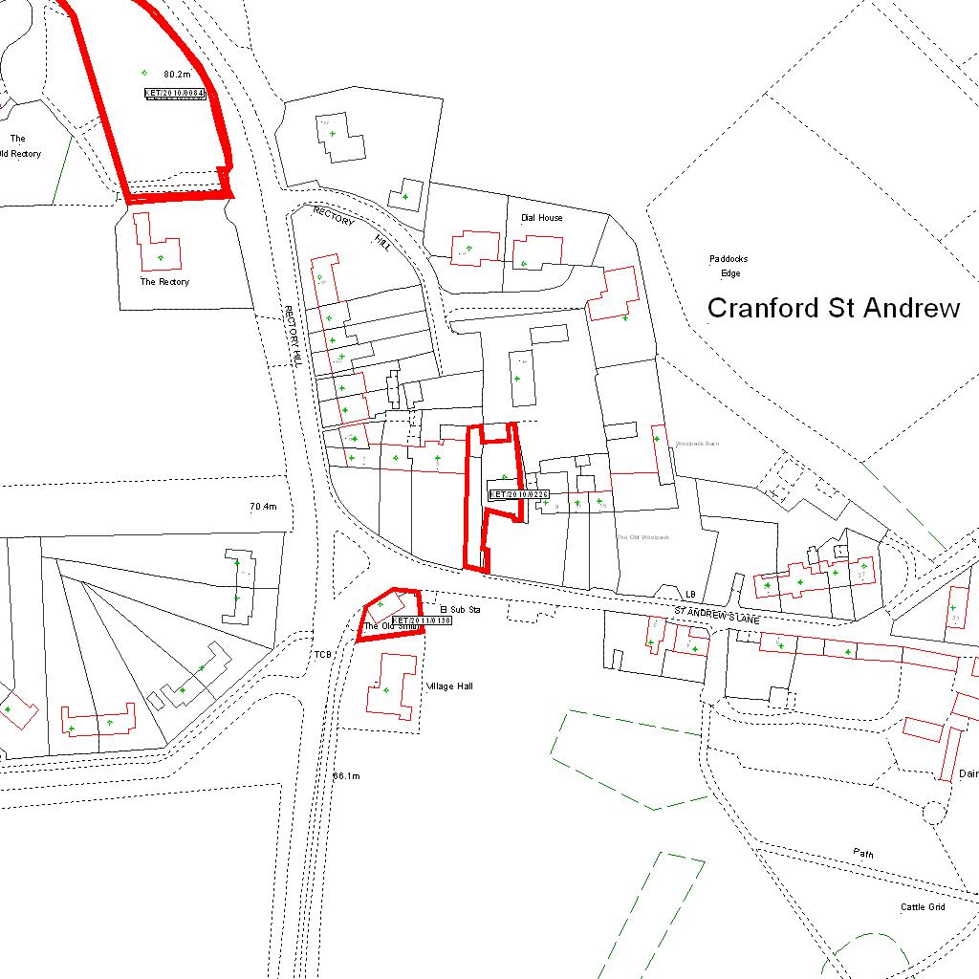

Reproduced from the Ordnance Survey mapping with the permission of the Controller of Her Majesty’s Stationery Office © Crown copyright. Unauthorised reproduction infringes Crown copyright and may lead to prosecution or civil proceedings.  LA078344 |  | N
Date: 24/03/2011 Do not scale from this map. For illustrative purposes only.

