BOROUGH OF KETTERING

Committee | Full Planning Committee - 24/05/2011 | Item No: 5.3
Report Originator | Michael Boniface  Development Officer | Application No:  KET/2011/0096
Wards Affected | William Knibb
Location | 93 & 95 Lower Street, Kettering
Proposal | Full Application: Two storey rear extension and conversion of existing dwelling to create 6 no. apartments
Applicant | Mr S Culbert Lower Street Developments,

1. PURPOSE OF REPORT

  - To describe the above proposals
  - To identify and report on the issues arising from it
  - To state a recommendation on the application

2. RECOMMENDATION

THE DEVELOPMENT CONTROL MANAGER RECOMMENDS that this application be APPROVED subject to the following Condition(s):-

1. The development hereby permitted shall be begun before the expiration of 3 years from the date of this planning permission.
REASON: To comply with Section 91 of the Town and Country Planning Act 1990 (as amended) and to prevent an accumulation of unimplemented planning permissions.

2. No development shall commence on site until details of the types and colours of all external facing and roofing materials to be used, together with samples, have been submitted to and approved in writing by the Local Planning Authority. The development shall not be carried out other than in accordance with the approved details.
REASON: In the interests of the visual amenities of the area in accordance with policy 13 of the North Northamptonshire Core Spatial Strategy.

3. The landing and bathroom window at first floor level on the west elevation shall be glazed with obscured glass and thereafter shall be permanently retained in that form.
REASON: To protect the privacy of the adjoining property and to prevent overlooking in accordance with policy 13 of the North Northamptonshire Core Spatial Strategy.

4. The development hereby approved shall not be carried other than in accordance with the Sustainable Construction and Energy Efficiency measures proposed in Section 6 of the submitted Design and Access Statement.
REASON: In the interests of energy efficiency and sustainable construction in accordance with policy 14 of the North Northamptonshire Core Spatial Strategy.

5. Unless otherwise agreed in writing by the Local Planning Authority, development other than that required to be carried out as part of an approved scheme of remediation shall not commence until parts A - D have been complied with. If unexpected contamination is found after development has begun, development shall be halted on that part of the site affected by the unexpected contamination to the extent specified by the Local Planning Authority in writing until part D has been complied with in relation to that contamination.

A. Site Characterisation An investigation and risk assessment, in addition to any assessment provided with the planning application, shall be completed in accordance with a scheme to assess the nature and extent of any contamination on the site, whether or not it originates on the site. The contents of the scheme are subject to the approval in writing of the Local Planning Authority. The investigation and risk assessment must be undertaken by competent persons and a written report of the findings must be produced. The written report is subject to the approval in writing of the Local Planning Authority. The report of the findings must include:
(i) a survey of the extent, scale and nature of contamination;
(ii) an assessment of the potential risks to:
- human health,
- property (existing or proposed) including buildings, crops, livestock, pets, woodland and service lines and pipes,
- adjoining land,
- groundwaters and surface waters,
- ecological systems,
- archeological sites and ancient monuments;
(iii) an appraisal of remedial options, and proposal of the preferred option(s). This must be conducted in accordance with DEFRA and the Environment Agency's 'Model Procedures for the Management of Land Contamination, CLR 11'

B. Submission of Remediation Scheme A detailed remediation scheme to bring the site to a condition suitable for the intended use by removing unacceptable risks to human health, buildings and other property and the natural and historical environment must be prepared, and is subject to the approval in writing of the Local Planning Authority. The scheme must include all works to be undertaken, proposed remediation objectives and remediation criteria, timetable of works and site management procedures. The scheme must ensure that the site will not qualify as contaminated land under Part 2A of the Environmental Protection Act 1990 in relation to the intended use of the land after remediation.

C. Implementation of Approved Remediation Scheme The approved remediation scheme must be carried out in accordance with its terms prior to the commencement of development other than that required to carry out remediation, unless otherwise agreed in writing by the Local Planning Authority. The Local Planning Authority must be given two weeks written notification of commencement of the remediation scheme works. Following completion of measures identified in the approved remediation scheme, a verification report (referred to in PPS23 as a validation report) that demonstrates the effectiveness of the remediation carried out must be produced, and is subject to the approval in writing of the Local Planning Authority.

D. Reporting of Unexpected Contamination In the event that contamination is found at any time when carrying out the approved development that was not previously identified it must be reported in writing immediately to the Local Planning Authority. An investigation and risk assessment must be undertaken in accordance with the requirements of part A, and where remediation is necessary a remediation scheme must be prepared in accordance with the requirements of part B, which is subject to the approval in writing of the Local Planning Authority. Following completion of measures identified in the approved remediation scheme a verification report must be prepared, which is subject to the approval in writing of the Local Planning Authority in accordance with part C.

REASON (common to all): To ensure that risks from land contamination to the future users of the land and neighbouring land are minimised, together with those to controlled waters, property and ecological systems, and to ensure that the development can be carried out safely without unacceptable risks to workers, neighbours and other offsite receptors.

6. No development shall take place on site until a scheme for insulating the dwellings from noise sources both within and outside the site has been submitted to and approved in writing by the Local Planning Authority. The development shall not be carried out other than in accordance with the approved scheme.
REASON: To ensure that the buildings, structures and plant are adequately sound proofed in the interests of the amenities of the occupants of nearby premises in accordance with policy 13 of the North Northamptonshire Core Spatial Strategy.

7. Prior to the commencement of the development, full details of lockable bin and cycle storage facilities including their design, materials, location, exact dimensions and openings shall be submitted to and approved in writing by the local planning authority. The bin and cycle stores shall be provided in accordance with the approved details prior to the first occupation of the development and shall be permanently retained in that form for the purposes of storing bins and cycles only.
REASON: To ensure adequate amenities are provided for this development in accordance with policy 13 of the North Northamptonshire Core Spatial Strategy.

Notes (if any) :-
- NONE

Justification for Granting Planning Permission

The proposal is in accordance with national and local policies as set out in Planning Policy Statements/Guidance Notes 1, 3, 13 and 23, Policy 2 of The East Midlands Regional Plan, Policies 1, 7, 9, 10, 13 and 14 of the North Northamptonshire Core Spatial Strategy and Policy 35 of the Local Plan for Kettering Borough. There are no material considerations that indicate against the proposal.

Officers Report

3.0 | Information

Relevant Planning History
KET/2006/0452 - 2 No. two bedroom apartments – APPROVED 22/06/2006
KET/2005/0779 – Four bedroom dwelling – APPROVED 19/10/2005
KET/2005/0612 – Two storey rear extension – APPROVED 24/08/2005

Site Description
Officer's site inspection was carried out on 17/03/2011.

The site comprises a two storey dwellinghouse and a two storey building that accomodates 2no. flats. The buildings are set back from the highway at a significantly higher level behind a stepped access and parking area to the front. The rear gardens slope gently downwards to the south where they meet the car park associated with Morrisons supermarket. Open space adjoins the site boundary to the east whilst residential properties otherwise surround.

Proposed Development
Two storey rear extension and conversion of existing dwelling to create 6no. apartments.

Any Constraints Affecting The Site
None.

4.0 | Consultation and Customer Impact

Highway Authority
No objection. The proposed development would not have any additional parking on-site and on-street parking restrictions are in place which could be enforced in necessary.

Environmental Health
No objection subject to conditions requiring the submission of a contaminated land investigation, a scheme of acoustic insulation and details of the proposed refuse storage facilities.

Environmental Care
No objection.

Northamptonshire Fire and Rescue
No objection.

Neighbours
Objections from 5 households for the following reasons:
- Traffic, congestion and insufficient parking.
- Disturbance and inconvenience.
- Plans relate to 95 Lower Street.
- Density and overdevelopment.
- Loss of privacy through works to wall.
- Loss of views and green open appearance.
- Overlooking.
- Overshadowing/loss of light.
- Garden grabbing.

5.0 | Planning Policy

National Policies
PPS1 – Delivering Sustainable Development
PPS3 – Housing
PPG13 – Transport
PPS23 – Planning and Pollution Control
PPG24 – Planning and Noise

Development Plan Policies

East Midlands Regional Plan
2 – Promoting Better Design

North Northamptonshire Core Spatial Strategy
1 – Strengthening the Network of Settlements
7 – Delivering Housing
9 – Distribution and Location of Development
10 – Distribution of Housing
13 – General Sustainable Development Principles
14 – Energy Efficiency and Sustainable Construction

Local Plan
35 – Housing: Within Towns

Emerging Policies (Local Development Framework)

Kettering Town Centre Area Action Plan (Submission Document, December 2010)

6.0 | Financial/Resource Implications
 | None
7.0 | Planning Considerations
The key issues for consideration in this application are:-

- Principle of Development;
- Design, Character and Appearance;
- Residential Amenity;
- Environmental Matters;
- Highways and Parking;
- Energy Efficiency and Sustainable Construction.

1. Principle of Development
PPS3 encourages the efficient use of land within existing settlements where future occupants can benefit from established amenities and public transport.

The Core Spatial Strategy (CSS) defines Kettering as a ‘Growth Town’, a primary focus for development; as such, the town is considered an appropriate location for the proposed development and this is further strengthened by policy 35 of the adopted local plan which supports the provision of housing within towns.

Policy 13 of the CSS is supportive of development subject to a number of sustainable development criteria including that the proposals do not result in adverse impact upon neighbouring properties or the highway network and that schemes present a good standard of design.

The site falls within the New Residential Quarter designated in the emerging Kettering Town Centre Area Action Plan (Submission Document, December 2010). It is envisaged that this area will become a vibrant and welcoming place, home to a new residential community. New residential development is therefore appropriate in this part of the town.

2. Design, Character and Appearance
The site comprises a two storey dwellinghouse and a two storey building that accomodates 2no. flats. The buildings are set back from the highway at a significantly higher level behind a stepped access and parking area to the front. Further residential properties stand adjacent to the west and form a strong and active frontage to Lower Street. This would be maintained by retention of the existing frontage buildings with the development impacting upon the rear elevation. The east site boundary is bounded by a tall brick wall, beyond which is an area of landscpaed open space associated with Morrisons supermarket. The proposed development presents an opportunity to provide a frontage to this aspect and increase natural surveillance.

It is proposed to construct a two storey extension to the rear of 93 Lower Street which would stretch back across the length of the garden. The scheme would achieve a density of approximately 100 dwellings per hectare which is appropiate for this town centre location and comparable to that of the opposing flats. Although the addition would be of a significant scale, its mass is successfully broken down into smaller elements through reduced ridge heights and set-backs at various points. This helps to reduce the perception of mass along with the use of gables and dormer windows which break up the roof line. The extension would utilise matching red brick, render and concrete tiles in order to create an appropriate visual relationship with the host building. The fenestration style would match that of the existing building although a series of French doors are included at first floor level to maximise views across the adjacent open space.

The development will have very limited impact on the street scene when viewed from the front but would provide a beneficial frontage on views down Lower Street to the west. This would provide a means of enclosure, an active frontage and natural surveillance and is considered positive. The proposals also involve the creation of an opening within the east boundary wall in order to allow direct access to the adjacent open space creating permeability and adding to vibrancy in this part of the town.

3. Residential Amenity
The 6no. flats created by this development would share amenity space with the remaining 2no. flats at 95 Lower Street and these are all within the ownership of the applicant. The space is considered sufficient for the resulting number of units, particularly given the town centre location of the site where various public open spaces are easily accessible.

The proposed development would be substantial in scale but is sufficiently removed from neighbouring properties as to avoid significant detriment in terms overbearing impact of overshadowing. The mass of the building is successfully broken down as discussed above and this reduces its visual impact. It is noted that some overshadowing will result to the rear garden curtilage within the site however this will be confined to the morning given the orientation of the buildings relative to the suns daily path. Good levels of daylight will be achieved for the remainder of the day.

The building has been designed to minimise any impacts on neighbouring properties in terms of overlooking with principal windows and the majority of habitable rooms located in the east elevation with views over the adjacent open space. A first floor landing and bathroom would be served by windows within the west facing elevation and these would result in potential for direct overlooking of the neighbouring gardens. These are not habitable room windows however and it is therefore suggested that a condition require obscure glazing in order to avoid any loss of privacy to neighbours. Two further first floor windows are proposed however these would be screened by 95 Lower Street which would prevent any direct views.

4. Environmental Matters
Due to the underlying geology present across Northamptonshire which commonly presents high levels of naturally occurring arsenic, vanadium and chromium, a contaminated land investigation should be required to ensure suitable conditions for future occupiers. A condition is proposed accordingly.

The site is located in a busy part of the town centre and adjacent to a large supermarket. A scheme of acoustic insulation should therefore be required in order to secure appropriate living conditions for future occupants.

5. Highways and Parking
The site currently accommodates 4 off road parking spaces and these would be maintained resulting in provision of 0.5 spaces per dwelling. This level of parking is more than sufficient given that the proposed dwellings would be located in the town centre for Kettering where future occupants would benefit from good access to existing shops, services and public transport in a sustainable manner and in accordance with PPG13. The Highway Authority has raised no objection and confirms that parking restrictions are operational in the vicinity of the site which could be enforced if necessary.

6. Energy Efficiency and Sustainable Construction
Policy 14 of the Core Spatial Strategy states that developments should meet the highest viable standards of resource and energy efficiency and reduction in carbon emissions. Applicants should demonstrate that development incorporate techniques of sustainable construction and energy efficiency, makes provision for waste reduction and recycling, and provision for water efficiency and water recycling. Part 6 of the applicants Design and Access Statement deals with this matter suggesting measures including the use of low use water appliances, low energy embodied materials and the installation of solar panels. A condition should require accordance with these proposals.

Conclusion

The proposed development accords with both national and local planning policy and there are no material planning matters that indicate against the scheme; as such, planning permission should be granted.

Background Papers |  | Previous Reports/Minutes
Title of Document: |  | Ref:
Date: |  | Date:
Contact Officer: | Michael Boniface, Development Officer on 01536 534316

SITE LOCATION PLAN

93 & 95 Lower Street, Kettering
Application No.: KET/2011/0096

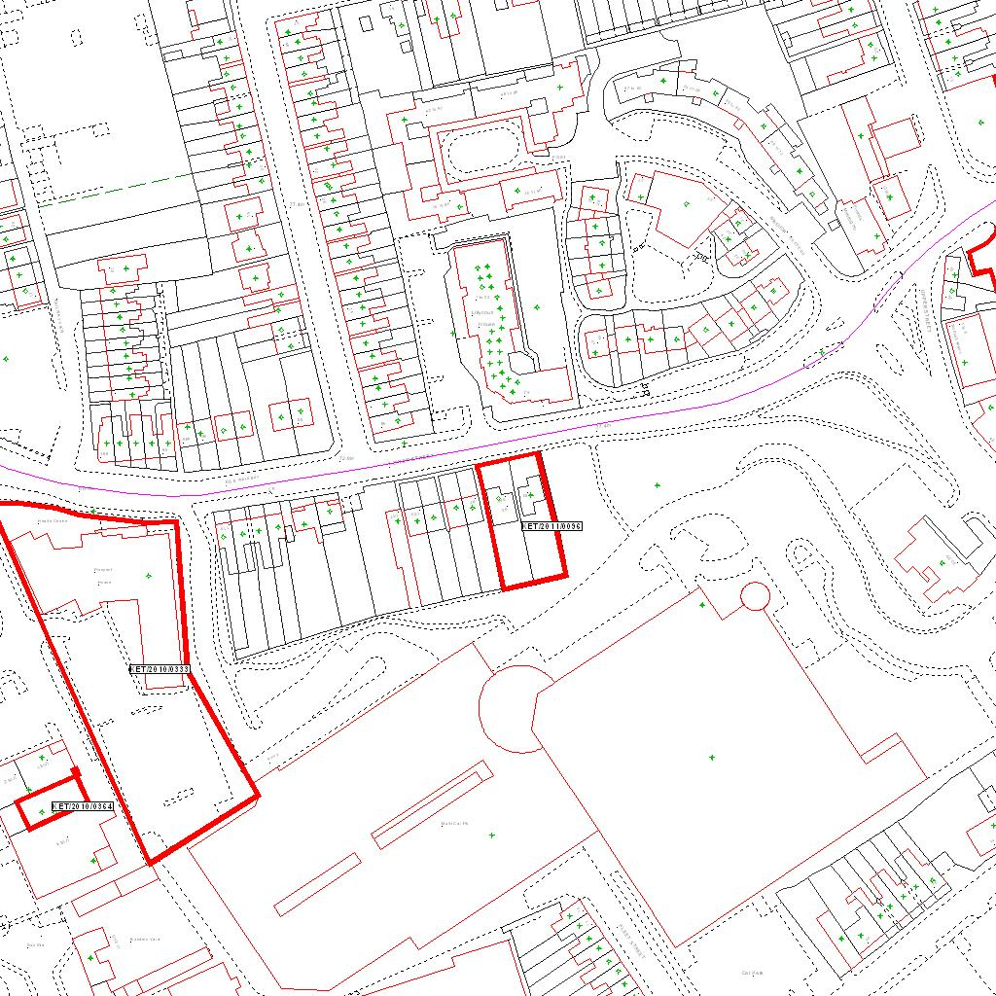

Reproduced from the Ordnance Survey mapping with the permission of the Controller of Her Majesty’s Stationery Office © Crown copyright. Unauthorised reproduction infringes Crown copyright and may lead to prosecution or civil proceedings.  LA078344 |  | N
Date: 22/02/2011 Do not scale from this map. For illustrative purposes only.

