BOROUGH OF KETTERING

Committee | Full Planning Committee - 24/05/2011 | Item No: 5.2
Report Originator | Michael Boniface  Development Officer | Application No:  KET/2011/0090
Wards Affected | Slade
Location | Cedar House, Loddington Road, Orton
Proposal | Full Application: Construction of Manege
Applicant | Mrs N Thomas c/o Blueprint Architectural Design,

1. PURPOSE OF REPORT

  - To describe the above proposals
  - To identify and report on the issues arising from it
  - To state a recommendation on the application

2. RECOMMENDATION

THE DEVELOPMENT CONTROL MANAGER RECOMMENDS that this application be REFUSED for the following reason(s):-

1. National and local planning policy presume against development in the countryside except in particular exceptional circumstances. The proposed development comprising of a 100sqm surfaced ménage, post and rail fencing, and the creation of a hard surfaced access track all for the private use of the occupiers of the neighbouring residential property, does not amount to an exception to the policy presumption against development in the open countryside. Consequently the development would result in an unjustified and incongruous form of development impacting adversely upon the open and natural character and appearance of the countryside. As such the proposed development conflicts with the aims and objectives of local and national policies; Policy 7:'Environment: Protection of the Open Countryside' of the Local Plan for Kettering Borough; Policy 1:Strengthening the Network of Settlements', Policy 9:'Distribution and Location of Development' and Policy 13(o) of the North Northamptonshire Core Spatial Strategy; PPS1:'Delivering Sustainable Development' and PPS7:'Sustaianble Development in Rural Areas'.

Notes (if any) :-
- NONE

Justification for Granting Planning Permission

Not applicable

Officers Report

3.0 | Information

Relevant Planning History

KET/2003/1042 – Permanent use for existing stables and storage – APPROVED 23/12/2003
KET/1999/0621 – Alterations to previously approved design for replacement dwelling – APPROVED 05/11/1999
KET/1999/0082 – Demolition of existing house and replacement with new dwelling – APPROVED 17/03/1999
KET/1998/0634 – Extension to dwelling – APPROVED 07/01/1999
KET/1993/0213 – Timber stables and storage for private use – APPROVED 22/04/1993

Site Description
Officer's site inspection was carried out on 03/03/2011.

The site comprises a grassed area of land adjacent to the residential curtilage of the Cedar House. The area is undulated and a general downward slope to the south east can be noted. An existing field gate provides access from Loddington Road and a small timber building is in existence. The site adjoins the Cedar House directly to the south east and is close to the village of Loddington, although outside of the settlement boundary.

Proposed Development
Menage consisting of a 20m x 50m Carpita Fibre surface enclosed by a 1.2m timber post and rail fence. The existing vehicular access is also to be resurfaced with gravel.

Any Constraints Affecting The Site
Public Right of Way adjacent to the site.

4.0 | Consultation and Customer Impact

Loddington Parish Council
Objection for the following reasons:
- Effect on neighbours/environment.
- Flood lights may be unnecessary and cause light pollution.
- There is insufficient information on the proposed lighting and this has the potential to impact on amenity.

Orton Parish Council
No objection subject to the following comments:
- Insufficient detail of the proposed lights.
- The verge is only 2.5m wide adjacent to the vehicular access.
- Any gates should open inwards.
- Turning space does not appear to be available for a horse box.
- The field does not appear to have commercial status; it is used for stock grazing and prior to this as arable land.

Highway Authority
No objection although the vehicular access should have a hard bound surface for the first 5m from the edge of the highway boundary. Gravel and other loose materials are not appropriate as this can discharge onto the highway and create hazards. Gates should be hung to open inwards. Any lighting should be shielded to prevent glare to passing drivers. If the ménage were to be used for commercial purposes and the use therefore intensified, the gates should be set back from the highway boundary to allow a vehicle and trailer/horse box to pull clear of the highway while opening the gates.

Environmental Health
Any external lighting should accord with advice from The Institution of Lighting Engineers and be secured by condition.

Neighbours
Objections from 4 neighbours for the following reasons:
- Impact on adjacent footpath.
- Land ownership.
- Light pollution/nuisance.
- Impact on views.
- Insufficient consultation.

5.0 | Planning Policy

National Policies
PPS1 – Delivering Sustainable Development
PPS4 – Planning for Sustainable Economic Growth
PPS7 – Sustainable Development in Rural Areas
PPG13 – Transport

Development Plan Policies

North Northamptonshire Core Spatial Strategy
1 – Strengthening the Network of Settlements
9 – Distribution and Location of Development
13 – General Sustainable Development Principles

Local Plan

7 – Environment: Protection of the Open Countryside

6.0 | Financial/Resource Implications
 | None
7.0 | Planning Considerations
The key issues for consideration in this application are:-

- Principle of Development;
- Design, Appearance and Impact on the Countryside;
- Residential Amenity;
- Highways and Parking.

1. Principle of Development

The application proposes a ménage for private use by the occupants of Cedar House. The development would be located adjacent to this dwelling but outside of its residential curtilage. Both Cedar House and the proposed site fall outside of the settlement boundary for Loddington and as such, stand in open countryside.

PPS7 states that “Planning Authorities should continue to ensure that the quality and character of the wider countryside is protected, and where possible, enhanced”. Policy 9 of the Core Spatial Strategy states “New building development in open countryside outside the Sustainable Urban Extensions will be strictly controlled”. Furthermore, policy 13(o) of the CSS seeks to conserve and enhance landscape character. Policy 7 of the Local Plan for Kettering Borough suggests that development will not be acceptable in open countryside except where provided for within the plan; there is no policy provision for private ménages on agricultural land in open countryside. There is therefore a strong policy presumption against this form of development in this location.

The applicant suggests that the land is currently used as a paddock however no planning permission has been granted for any change of use. Whilst the grazing of horses on the land would not constitute development, keeping horses on the site would constitute a material change of use for which planning permission would be necessary. As no change of use has been granted, the application must be considered as a proposal for development of agricultural land in open countryside.

The above policies seek to prevent development in open countryside in order to promote more sustainable patterns of development and to protect the intrinsic rural character of the countryside. Development should therefore be contained within existing settlements. Whilst it is recognised that equestrian activity is a country pursuit, this does not justify development which encroaches on open countryside. The applicant should instead be encouraged to make use of existing facilities which are suitably located.

2. Design, Appearance and Impact on the Countryside

The site falls within the ‘Central Northamptonshire Plateaux and Valleys’ area defined by the Northamptonshire Environmental Character Assessment. This document offers an evaluation of the differing landscape characteristics across the county and suggests that the area in question is likely to be sparsely settled, retaining a remote, vacant character with wide views over the surrounding landscape. Furthermore, it is noted that pasture on steeper land and surrounding villages represents an important contrast to the prevailing arable character. The site is considered to accord with this character description and presents a distinctly rural appearance.

The proposed ménage would comprise a semi-hard surface (Carpita Fibre) covering an area of 50m x 20m and would be surrounded by a 1.2m high post and rail fence. The operational development involved is relatively modest although views would be possible through gaps in the hedgerow boundary from the public highway and the adjacent public right of way (GV2). The proposed ménage is not conducive to an agricultural use and would therefore represent an anomaly in its open and rural countryside setting.

It is proposed that an existing field access be utilised and this could avoid the need for further removal of the hedgerow boundary. It is however proposed to re-surface the access with gravel which would have a domesticating appearance. It is unclear why vehicles would need to access the site directly if the ménage is to be used privately be the occupiers of Cedar House. The stables approved by planning permission KET/2003/1042 are contained within the curtilage of Cedar House which is already served by its own vehicular access. The proposed access improvements would further compound the adverse impact on the character of the countryside.

The application originally proposed floodlighting to allow use of the ménage during the evenings however this element of the scheme has since been withdrawn in response to the concerns raised by consultees and to minimise visual impacts.

3. Residential Amenity

With the exception of Cedar House itself, the site is well removed from all residential properties. The ménage would be used for personal use only and would not be intensive or disruptive in its nature. Whilst distant views of the ménage may be possible from properties within Loddington, the visual impact of the development will be very small and would not result in significant detriment to residential amenity. A number of concerns have been raised by third parties about the impact of proposed flood lighting however this has now been removed from the scheme.

4. Highways and Parking

The development would be served by the existing field access from Loddington Road although the applicant intends to install a gravel surface. The Highway Authority has raised concerns about the use of gravel as this has the potential to discharge onto the public highway and create a hazard for users. The visual appearance of the surface must also be considered however given the countryside setting of the development. A hard bound surface could lead to an over-engineered and highly domesticated appearance which would fail to reflect the character and appearance of the rural setting. Subject to the ménage remaining for private use however, use of the vehicular access would not be significantly intensified and no improvements would therefore be necessary. Re-surfacing could be prevented by condition if planning permission were granted.

Conclusion

The proposed development would be located in an unsustainable location in open countryside and erode the open and rural character of the area; as such, the proposal is contrary to policies 9 and 13 (o) of the North Northamptonshire Core Spatial Strategy, Policy 7 of the Local Plan for Kettering Borough 1995 and the guidance contained within PPS1 and PPS7.

Background Papers |  | Previous Reports/Minutes
Title of Document: |  | Ref:
Date: |  | Date:
Contact Officer: | Michael Boniface, Development Officer on 01536 534316

SITE LOCATION PLAN

Cedar House, Loddington Road, Orton
Application No.: KET/2011/0090

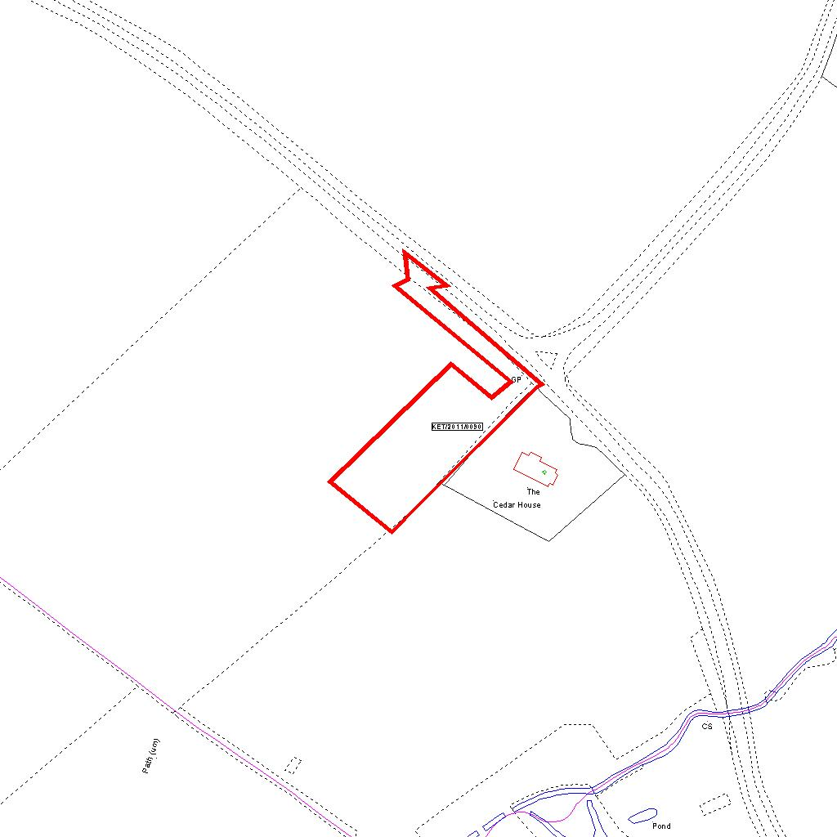

Reproduced from the Ordnance Survey mapping with the permission of the Controller of Her Majesty’s Stationery Office © Crown copyright. Unauthorised reproduction infringes Crown copyright and may lead to prosecution or civil proceedings.  LA078344 |  | N
Date: 01/03/2011 Do not scale from this map. For illustrative purposes only.

