To all Members | Direct Line: (01536) 534398  Email: anneireson@kettering.gov.uk  Our Ref: AI  Your Ref:  Date: 18th May 2011

Dear Councillor

You are summoned to attend the ANNUAL MEETING of the BOROUGH COUNCIL, to be held in the Council Chamber, Municipal Offices, Kettering on Wednesday 18th May 2011 at 6.30 pm.

Yours faithfully

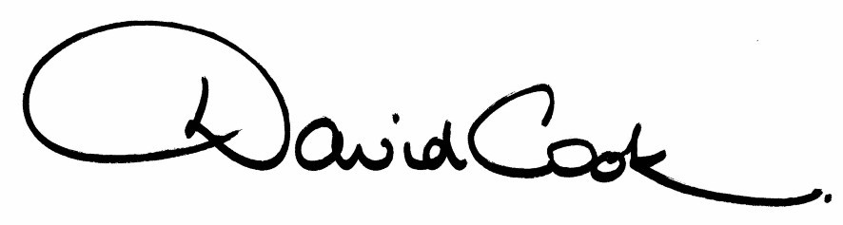

Chief Executive

R E V I S E D A G E N D A

- Apologies

2. Election of Mayor

3. Appointment of Deputy Mayor

4. Appointment of Mayor’s Chaplain

5. Presentation of Commemorative Mayoral Badges to the retiring Mayor and Consort

6. Councillor Freer to propose a vote of thanks to outgoing members.

7. The minutes of the meeting of the Council held on 24th February 2011 to be approved as a correct record and signed by the Mayor

8. Declarations of Interest
(a) Personal
(b) Prejudicial
9. To consider any motions received in accordance with Council Procedure Rule 16.

Proposed by Councillor Jonathan West and Seconded by Councillor Russell Roberts that:-

"this Council refers to the Research and Development Committee the task of carrying out research into a formula to guide nominations to the position of Mayor, which is fair and transparent, and an options report be brought back to Council in the autumn for consideration."

10. To receive announcements from the Mayor.

11. To receive any report of the Chief Executive

12. To elect the Leader

13. To indicate a preference for nomination of the Deputy Leader

14. To receive notification of the appointment of Leader of the Opposition.

15. To indicate a preference for the number of members to be appointed to the Executive.

16. To receive notification of the appointment of members of the Executive, if available.

17. To decide the allocation of seats (and substitutes) to Committees.

18. To appoint members (including Chairs and Deputy Chairs) to committees, sub-committees and forums identified in the Programme of Meetings.

19. To approve a programme of ordinary meetings of the Council for the year (previously circulated).

20. To appoint councillors to serve on outside bodies.

21. Any other items of business the Mayor considers to be urgent.

10.5.11
Fire Alarm

All meetings shall be adjourned immediately on the sounding of the fire alarm. The alarm is a continuous two-tone siren. On hearing the alarm please leave the building by the nearest emergency exit. There are emergency exits at both ends of the corridor outside the meeting rooms. On leaving the building please cross the car park and assemble on the grassed area by the church. Do not attempt to drive out of the car park as this may impede the arrival of emergency vehicles. Please do not return to the building until you are told it is safe to do so by a Council employee.

Toilets

There are toilets in the corridor off the main entrance to the building you came through to get to the meeting room.

Facilities for Babies and Children

If you wish to use a private area to feed your baby please ask a member of staff. There are changing facilities in the corridor off the main entrance adjacent to the toilets.

Access for Disabled People

There are allocated parking bays outside the main entrance to the Municipal Offices for disabled people. The meeting rooms are located on the ground floor and access is gained for wheelchair users via the main entrance. If you require assistance, please ask the attendant on duty in the reception area.

No Smoking

Smoking is not permitted in the Municipal Offices.

