BOROUGH OF KETTERING

Committee | Full Planning Committee - 26/04/2011 | Item No: 5.3
Report Originator | Alan Davies  Assistant Development Officer | Application No:  KET/2011/0130
Wards Affected | Queen Eleanor and Buccleuch
Location | The Old Forge, Grafton Road, Cranford
Proposal | s.73 Application: Variation of condition 4 of KET/2008/0699 in respect of opening hours
Applicant | Mr R Walker

1. PURPOSE OF REPORT

  - To describe the above proposals
  - To identify and report on the issues arising from it
  - To state a recommendation on the application

2. RECOMMENDATION

THE DEVELOPMENT CONTROL MANAGER RECOMMENDS that this application be APPROVED subject to the following Condition(s):-

1. The development hereby permitted shall be begun before the expiration of 3 years from the date of this planning permission.
REASON: To comply with Section 91 of the Town and Country Planning Act 1990 (as amended) and to prevent an accumulation of unimplemented planning permissions.

2. The parking spaces approved by permission KET/2010/0078 and shown on the plan received 08.02.2010 as part of that application shall be provided prior to the first occupation of the building hereby permitted and shall permanently retained and kept available for the parking of vehicles.
REASON: To ensure adequate on-site parking provision for the approved building and to discourage parking on the adjoining highway in the interests of local amenity and highway safety in accordance with Policy 13 of the North Northamptonshire Core Spatial Strategy.

3. Notwithstanding the provisions of Article 3 of the Town and Country Planning (General Permitted Development) Order 1995 (or any Order revoking and re-enacting that Order with or without modification) no change of use permitted by Classes A and C of Part 3 of Schedule 2 of the Order shall take place on the application site.
REASON: To retain planning control over changes of use falling within A1 and A2, which could have a detrimental traffic impact on the local area, in accordance with Policy 13 of the North Northamptonshire Core Spatial Strategy.

4. The premises shall not be open to the public before 10.00 hours or remain open after 16.00 hours on Mondays to Fridays, nor before 10.00 hours or after 16.00 hours on Saturdays and Sundays. The premises shall not open on any recognised public holidays.
REASON: To protect the amenities of the occupiers of nearby properties in the interests of amenity in accordance with policy 13 of the North Northamptonshire Core Spatial Strategy.

5. Any doors provided at the point of access to the building shall be hung so as to open inwards into the building only.
REASON: In the interests of highway safety in accordance with Policy 13 of the North Northamptonshire Core Spatial Strategy.

Notes (if any) :-
- NONE

Justification for Granting Planning Permission

The proposal is in accordance with national and local policies as set out in Planning Policy Statements 1 and 4, Policy Guidance Note 13 and Policies 1, 11 and 13 of the North Northamptonshire Core Spatial Strategy. There are no material considerations that indicate against the proposal.

Officers Report

3.0 | Information

Relevant Planning History

KET/2008/0699 - Change of use to tea rooms (A3 use). Approved 08/10/2008.

KET/2010/0078 – Variation of Condition 2 of KET/2008/0699 relating to parking. Approved 09/04/2010.

Site Description
Officer's site inspection was carried out on 24/03/2011.

The Old Smithy in Cranford St. Andrew is a single storey stone building that was converted into a tea room under planning permission KET/2008/0699. It is located on the eastern side of Grafton Road, which is a classified C Road that links the village of Cranford to Grafton Underwood. The building is a small single storey structure which was once a blacksmiths, although prior to the change of use in 2008 it was used as a small craft workshop. The property has a rear courtyard which has permission to be used for the parking of two vehicles clear of the highway. There is no other parking related to the property and therefore customers park on the highway in the nearby streets.

Proposed Development
To vary Condition 4 relating to opening hours of planning permission KET/2008/0699. This will allow for the premises to open to the public on Sundays from 10:00 until 16:00.

Any Constraints Affecting the Site
Cranford Conservation Area
C Road

4.0 | Consultation and Customer Impact

Parish/Town Council
Awaiting Response.

Highway Authority
There is no highway objection to this proposal.

Environmental Health
There is no objection to this proposal on environmental health grounds.

Neighbours
Five objections have been received from neighbouring residents. All five objections relate to the increased amount of traffic and parking on a Sunday that this proposal will have on the surrounding streets.

5.0 | Planning Policy

National Policies
PPS1. Delivering Sustainable Development
PPS4. Planning for Sustainable Economic Development
PPG13. Transport

Development Plan Policies

North Northamptonshire Core Spatial Strategy
Policy 1. Strengthening the Network of Settlements
Policy 11. Distribution of Jobs
Policy 13. General Sustainable Development Principles

6.0 | Financial/Resource Implications
 | None
7.0 | Planning Considerations
The key issues for consideration in this application are:-

1. Principle of development
2. Highway safety
3. Impact upon residential amenity

1. Principle of development
Section 73A of the Town and Country Planning Act 1990 allows for applications to vary or remove conditions attached to previously implemented planning permissions. Such planning applications must be determined in accordance with the Development Plan as defined by Section 38 of the Planning and Compulsory Purchase Act 2004. Therefore the proposal to remove Condition 4 of KET/2008/0699 must be considered against the relevant national planning policies and Development Plan policies. National planning policy PPS1: Delivering Sustainable Development encourages sustainable development and this proposal represents sustainable development as it seeks to achieve the most from an existing historic structure. PPS4: Planning for Sustainable Economic Development supports economic development and one of the main objectives is to ‘raise the quality of life and the environment in rural areas by promoting thriving, inclusive and locally distinctive rural communities whilst continuing to protect the open countryside for the benefit of all’, which is something this proposal seeks to achieve. PPG13: Transport, meanwhile, focuses development to appropriate areas which do not prejudice the safety of the highway network. Again, this proposal seeks to satisfy this objective and this is discussed in further detail below.

At local planning policy level policies 1, 11 and 13 of the North Northamptonshire Core Spatial Strategy support the principle of this application. Policy 1 aims to strengthen the network of settlements and encourages the reuse of buildings to meet local needs for employment. Whilst this application seeks to alter a condition of an existing permission it retains the use of a historic building for employment purposes and fosters economic activity within a village location. Policy 11 relates to the distribution of jobs and again the proposal to vary an extant condition follows the objectives of the policy, as it retains, if not increases economic activity within the village, albeit at a very small, but nevertheless appropriate level. Policy 13, which refers to general principles of sustainable development, requires development to not have a detrimental impact upon the lives of neighbouring residents or prejudice highway safety and whilst it is considered that this proposal accords with the policy it is discussed in further detail in sections 2 and 3 below.

Condition 4 of permission KET/2008/0699 restricts the opening time of the subject premises from 10.00am until 16.00pm Monday to Saturday. The proposal to vary the condition will allow for the premises to open on Sundays too. It is considered that the proposal accords with national and local planning policies and in particular policy 13 of the North Northamptonshire Core Spatial Strategy, which supports such proposals provided that they do not have a detrimental impact upon highway safety or the amenity of neighbouring residents. These considerations are discussed in further detail in the following two sections.

2. Highway safety
Five objections have been raised on the basis that this proposal will have a detrimental impact upon highway safety in respect of increased parking and localised traffic. The proposal seeks to vary, not remove, a condition which will allow for the premises to open on Sundays from 10.00am until 16.00pm, the same trading hours of the business from Monday to Saturday. The premises will still continue to use part of the rear courtyard for the parking of two vehicles for staff clear of the highway. Should this application be approved Condition 2 of KET/2010/0078, which requires these two parking spaces to be permanently retained, will continue to be attached to the permission.

The tea room is a small scale business and as a result it does not require a large number of staff. The Transport Statement submitted as part of planning permission KET/2008/0699 stated that the business only requires 2 members of staff at any time and therefore only two spaces clear of the highway are required for staff car parking. Any other car parking for customers will be in the surrounding streets. There has been no deterioration of highway safety recorded in the last year as a result of this business and in addition the Local Highway Authority has no objection to this proposal on highway safety grounds.

As with Monday to Saturday customers will have to park in the surrounding streets and the resulting parked cars will help to slow down through traffic using Grafton Road, therefore potentially improving highway safety. The capacity of the tea room will prevent the additional parked cars from reaching a level which could have a significantly detrimental impact upon the highway, as there is only sufficient internal space for 20 customers with some additional seating provided in the rear courtyard. The worst case scenario therefore is that the tea rooms would generate demand for the parking of an additional 20 cars on the highway. Whilst this is not ideal, and highly unlikely, there is sufficient capacity in the surrounding streets for such levels of parking without it compromising highway safety. This proposal is therefore considered to be in accordance with national planning policies PPS1 and PPG13, as it will not have a significant impact upon the safety of the highway network. It is also considered to satisfy part N of policy 13 of the North Northamptonshire Core Spatial Strategy.

3. Residential amenity
The lack of planned car parking spaces is characteristic of many historic villages and in this regard Cranford is no exception. The historic pattern of development means that the urban form is not designed to accommodate modern traffic volumes and the result is a high level of on-street parking. The 2007 Department for Transport guidance document ‘Manual for Streets’ actively encourages new development that exhibits similar characteristics as such settlements, as high levels of on-street parking encourage drivers to slow down and drive in a safer, more thoughtful manner. The result is increased highway safety and slower vehicles, which has less of a detrimental impact on residential amenity than vehicles that are able to travel through urban areas at speed. The parking of cars on Grafton Road does not block access to the highway for existing residents and they are parked at least 15m away from the boundary of the nearest residential dwelling. The cars parked on Grafton Road and the surrounding streets are perceived as being a nuisance, rather than actually having a demonstrable negative impact upon amenity and highway safety.

The impact of the variation of Condition 4 of KET/2011/0699 will result in extra vehicles parking on the highway on Grafton Road, or close by, on Sundays. At present the village hall is a significant generator of on-street parking and the combination of The Old Smithy and the hall increases the amount of parking in an area that lacks any formal car parking space. However, to refuse to allow this condition to be varied on the basis that it would result in an unacceptable impact on the amenity of neighbouring residents more so than at any time during the week is without basis. A condition which restricts the opening hours to between 10.00am and 16.00 seven days per week, with the exception of public holidays, will also be imposed in order to prevent the business from opening unsociable hours which could have an unacceptable impact upon the amenity of the surrounding residents. Therefore, with the inclusion of the recommended conditions, this proposal is considered to be in accordance with policy 13 of the North Northamptonshire Core Spatial Strategy as it will not have a detrimental impact upon neighbouring residents.

Conclusion

The proposal is considered to be in accordance with national and local planning policy. It will not have a significant detrimental impact upon residential amenity or highway safety. It is therefore recommended for approval.

Background Papers |  | Previous Reports/Minutes
Title of Document: |  | Ref:
Date: |  | Date:
Contact Officer: | Alan Davies, Assistant Development Officer on 01536 534316

SITE LOCATION PLAN

The Old Forge, Grafton Road, Cranford
Application No.: KET/2011/0130

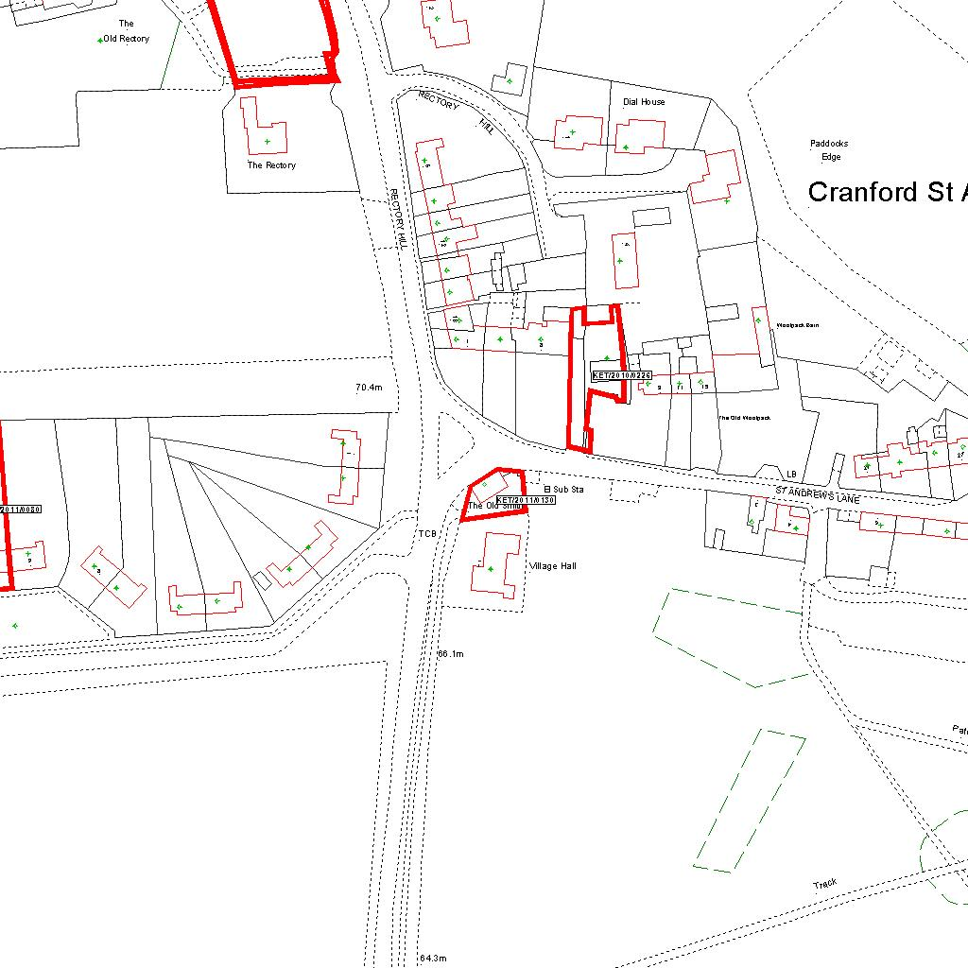

Reproduced from the Ordnance Survey mapping with the permission of the Controller of Her Majesty’s Stationery Office © Crown copyright. Unauthorised reproduction infringes Crown copyright and may lead to prosecution or civil proceedings.  LA078344 |  | N
Date: 08/03/2011 Do not scale from this map. For illustrative purposes only.

