BOROUGH OF KETTERING

Committee | Full Planning Committee - 26/04/2011 | Item No: 5.2
Report Originator | Alex Jelley  Assistant Development Officer | Application No:  KET/2011/0060
Wards Affected | Queen Eleanor and Buccleuch
Location | 42 Skeffington Close, Geddington
Proposal | Full Application: Single storey rear and first floor front extensions. Alterations to porch
Applicant | Mr & Mrs K Tate

1. PURPOSE OF REPORT

  - To describe the above proposals
  - To identify and report on the issues arising from it
  - To state a recommendation on the application

2. RECOMMENDATION

THE DEVELOPMENT CONTROL MANAGER RECOMMENDS that this application be APPROVED subject to the following Condition(s):-

1. The development hereby permitted shall be begun before the expiration of 3 years from the date of this planning permission.
REASON: To comply with Section 91 of the Town and Country Planning Act 1990 (as amended) and to prevent an accumulation of unimplemented planning permissions.

2. The materials to be used in the construction of the external surfaces of the development hereby permitted shall match, in type, colour and texture those on the existing building.
REASON: In the interests of visual amenity in accordance with policy 13 of the North Northamptonshire Core Spatial Strategy.

3. Notwithstanding the provisions of Article 3 of the Town and Country Planning (General Permitted Development) Order 1995 (or any Order revoking and re-enacting that Order with or without modification) no additional openings permitted by Schedule 2, Part 1 Classes A or C shall be made in the north elevation or roof plane of the extensions.
REASON: To protect the amenity and privacy of the occupiers of adjoining property in accordance with policy 13 of the North Northamptonshire Core Spatial Strategy.

Notes (if any) :-
- NONE

Justification for Granting Planning Permission

The proposal is in accordance with national and local policies as set out in Planning Policy Statements/Guidance Notes 1 and 22, Policy 2 of The East Midlands Regional Plan, and Policy 13 of the North Northamptonshire Core Spatial Strategy. There are no material considerations that indicate against the proposal.

Officers Report

3.0 | Information

Relevant Planning History
None

Site Description
Officer's site inspection was carried out on 09.03.2011

The application site consists of No. 42 Skeffington Close which is a two storey detached dwelling on the east side of the highway. It is red facing brick and brown interlocking concrete roof tiles. The dwelling has a two storey side extension with a flat roof to the north of the main building, and a two storey bay projection to the front. There is an integral garage located to the north, accessed via a short drive from Skeffington Close. The dwelling benefits from a decently sized rear garden, which is surrounded by a combination of brick walls and close boarded fencing.

The surrounding area is entirely residential in nature, and lies just outside of Geddington Conservation Area. The dwellings tend to be large detached two storey properties, though there are also a few semi-detached dwellings further north on Skeffington Close. There are various examples of similar development within the surrounding area.

Proposed Development
This application seeks permission for a single storey rear and first floor front extension with alterations to the roof and porch at No. 42 Skeffington Close, Geddington.

Any Constraints Affecting the Site
None

4.0 | Consultation and Customer Impact

Geddington, Newton and Oakley Parish Council
No objection.

Neighbours
One letter of objection was received. The concerns raised were in relation to loss of light at No. 41 Skeffington Close, and the impact of the proposed extension on the productivity of existing photovoltaic panels at the same property. These issues are addressed in full within Section 7.0 of this report.

5.0 | Planning Policy

National Policies
PPS1. Delivering Sustainable Development
PPS22. Renewable Energy

East Midlands Regional Plan
Policy 2. Promoting Better Design

North Northamptonshire Core Spatial Strategy
Policy 13. General Sustainable Development Principles

6.0 | Financial/Resource Implications
 | None
7.0 | Planning Considerations
The key issues for consideration in this application are:-

- Principle of Development
- Design and Character
- Residential Amenity

A. Principle of Development
Section 38(6) of the Planning and Compulsory Purchase Act 2004 requires local planning authorities to determine planning applications in accordance with the Development Plan unless material planning considerations indicate otherwise.

Policy 13 of the North Northamptonshire Core Spatial Strategy (CSS) provides for extensions to residential properties, in accordance with national policy guidance and the Development Plan, subject to specific criteria being satisfied. In particular; extensions should be suitable in terms of type, scale, positioning and design; they should respect the character of the existing building and surrounding area; and they should not detrimentally impact upon the amenity of existing or future occupiers of adjoining properties. Policy 2 of the East Midlands Regional Plan (EMRP) emphasises the need to ensure that new development takes account of existing local character trends. National policy guidance in the form of PPS1 promotes the sustainable use of existing land and buildings, highlighting the important roles played by the above issues in achieving this.

It is considered that the proposals are acceptable in principle, subject to the detailed matters discussed below.

B. Design and Character
The proposals involve a single storey rear extension, alterations to the roof of existing single storey and two storey extensions, and a first floor extension to the front. The overall effect of them is to the benefit of the original dwelling itself, and to the wider street scene. The alterations to the roof of the existing two storey side extension and porch will remove an incongruous flat roof element and result in a more homogenised style of development. The ridge height will be slightly lower than that of the main dwelling, resulting in a maintained subordinate role that is welcomed.

The alterations to the roof of the single storey extension behind the two storey extension will not be visible from the public realm and are considered to better match the rest of the dwelling than the existing flat roof arrangement. The single storey rear extension is in keeping with the rest of the dwelling and will not be visible from the public realm.

The first floor extension will bring the existing two storey side extension in line with the main building line to the front, above the garage. It will also remove an aesthetically unpleasing window design from the front elevation. Its replacement with a window more in keeping with the design and scale of other windows on the front elevation of the main building is considered to be a positive.

As a result of the above, it is considered that the proposals are in accordance with those elements of Policy 13 of the CSS that have regard to matters of design and character, as well as Policy 2 of the EMRP.

C. Residential Amenity
The application site is surrounded by residential properties and therefore amenity is a relevant material consideration. There are three potential issues to consider; loss of light; loss of privacy; and overbearance.

The proposals will result in a degree of light lost to windows on the south elevation of No. 41 Skeffington Close. These windows are either not onto habitable rooms, or, in the case of the kitchen, are not the main opening onto that room. The location of the development to the north of the existing two storey building means that the majority of the shadow cast by the proposals would fall within the shadow already cast by the existing built form. Particularly because the ridge line from the main dwelling runs east-west, meaning that there is a large area of shadow cast to the north. The concerns raised in relation to this issue are noted, however, it is considered that they do not represent a reason for refusal for the reasons outlined above.

Having assessed the rest of the proposals in relation to loss of light, and taken measurements, it is considered that no material loss of light will occur. The alterations to the roof of the single storey rear extension do not impact upon the 45 degree angle of light that is used as a basic standard. Though the alterations to the roof of the two storey element would fail this basic standard, the two storey extension already fails it, and it is not considered reasonable to refuse the application on these grounds. The single storey element to the rear will have no impact on light to No.43 Skeffington Close, to the south, as the passage of the sun is such that any shadow cast by this element would be to the north of it

Further to this point, concern was raised that the alterations to the roof of the existing two storey element would impact upon the operation of photovoltaic panels on the southerly aspect of the roof slope of No. 41 Skeffington Close. The Companion Guide to PPS22 states that “care should be taken when planting trees or locating buildings within 30 degrees of the southerly aspect as they can significantly reduce solar gain”. Case Study 4D within the same document refers to the angle of the sun as being 18 degrees in midwinter, 40 degrees at the Equinox, and 64 degrees in midsummer. Having assessed the plans with this information, it is clear that the proposed gable end projection would fall at roughly 40 degrees, which is acceptable in terms of the advice contained within the Companion Guide to PPS22.

There are no new windows proposed on the north elevation of south elevation of the resultant dwelling, and as such no concerns exist with regards to overlooking/loss of privacy at either No. 41 or No. 43 Skeffington Close. The two roof lights within the north slope of the roof of the single storey element will be high-level in nature, and will not offer views into adjoining properties. A condition removing Permitted Development Rights for new openings in the north elevation is considered necessary to ensure that no future concerns arise.

Though No. 42 Skeffington Close is very close to No. 41 Skeffington Close, it is considered that any overbearance of that property is as a result of the existing built form, and the proposed alterations will not materially alter it.

As a result of the above deliberations, it is considered that the proposed development is in accordance with the amenity-led criteria of Policy 13 of the CSS.

Conclusion
The application is in accordance with the Development Plan and there are no material planning considerations that would indicate against approval.

Background Papers |  | Previous Reports/Minutes
Title of Document: |  | Ref:
Date: |  | Date:
Contact Officer: | Alex Jelley, Assistant Development Officer on 01536 534316

SITE LOCATION PLAN

42 Skeffington Close, Geddington
Application No.: KET/2011/0060

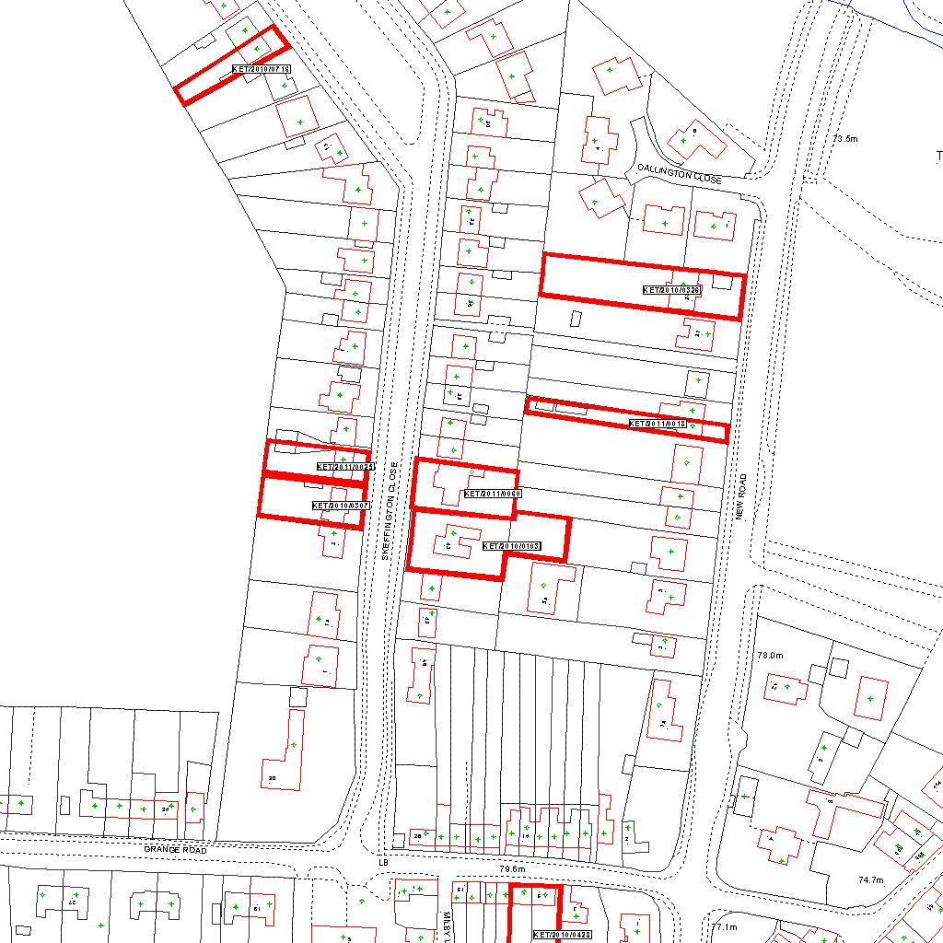

Reproduced from the Ordnance Survey mapping with the permission of the Controller of Her Majesty’s Stationery Office © Crown copyright. Unauthorised reproduction infringes Crown copyright and may lead to prosecution or civil proceedings.  LA078344 |  | N
Date: 08/02/2011
07/02/2011
07/02/2011
07/02/2011
07/02/2011
07/02/2011
07/02/2011
07/02/2011 Do not scale from this map. For illustrative purposes only.

