1. PURPOSE OF REPORT

- To inform members of progress to date on Suite 16.
- To celebrate our successes in Partnership working

2. BACKGROUND INFORMATION

2.1 Kettering Borough lies within the South East Midlands, which is predominately a growth area, and is expected to facilitate growth of some 13,100 homes and 16,200 new jobs by 2021.

2.2 Members have made their priorities for infrastructure and jobs-led growth clear – these are the prerequisites of growth. Members have indicated they wish to use the growth agenda to leverage three key and interrelated ambitions for the borough; namely:-

- A better offer for our town centres
- A better education and training offer
- A better employment offer – high grade, higher density jobs

  - The mutually supportive role of these three aspirations cannot be over-stated. The town centres and the skills base will be persuasive to inward investors. Similarly, high grade employment supports vibrant town centres.

  - The Council’s vision is to create town centres that are:

- Characterful
- Distinctive, and
- Fun

These three key words – enshrined in the Kettering Town Centre Area Action Plan - will help to ensure that the town centre is more than just a place to shop. It will have an experiential offer that encourages visitors to spend time in, and enjoy, our town centre.

- A CELEBRATION OF PARTNERSHIP SUCCESSES

  - In November 2009, the Executive received a report entitled ‘Medium Term Financial Strategy, Corporate Priorities and Partnerships’. This report recognised the importance of working with partners, particularly where those partners have ‘cultural similarities and a shared vision’. This partnership approach provides an ‘important avenue for delivering more effective and economic services’.

  - In the time since that report was written, the national political and economic picture has changed considerably, and as a result so too have the challenges we face in delivering our three key ambitions, namely:

- A better offer for our town centres
- A better education and training offer
- A better employment offer – high grade, higher density jobs

  - This report sets out why the partnerships that we have developed to date have been a success, so that we can seek to apply these successes to future challenges. It considers our partnerships under three key headings:

- Partners who share our vision
- Partners in Service Delivery
- Partners in Regeneration

Partners who share our vision (Part 1)

Tresham College

  - Our work over the years with Tresham College epitomises our success at working with partners who share our vision: The new campus at Windmill Avenue, and the impending redevelopment of the St Marys Road site will help to improve our educational offer. Our commitment to the objective of improving education has encompassed:

    - Support for the University Challenge bid in 2009/10 which has provided a platform for continued work with Further and Higher Education Organisations

    - Successfully making the case for £2,000,000 of money from the Homes and Communities Agency to be put into the redevelopment of the Tresham (St Marys Road) site, so as to bring the site forward at a time when the market could not.

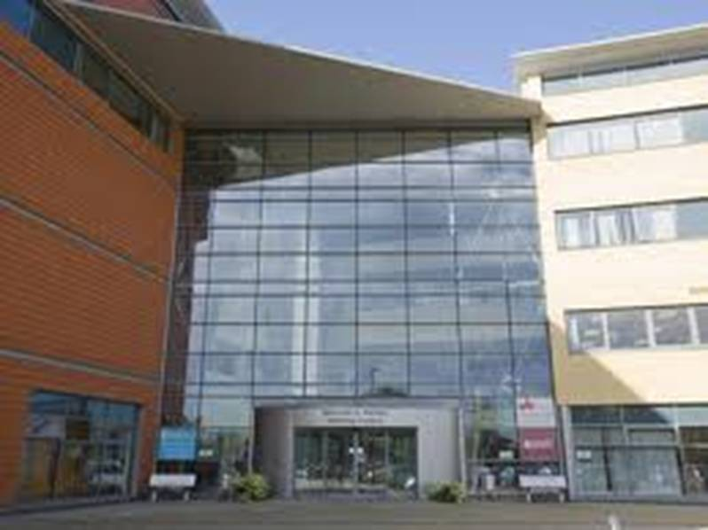 | - As Planning Authority, consenting extension to Tresham’s Windmill Avenue campus and approving redevelopment of the St Marys Road site.  - An agreement, in principle, to consider reinvesting any sum due to the council as a result of its interest in the land at St Mary's Road for the provision of further and better education facilities in Kettering Borough by Tresham.

Kettering Parish Church

  - Our ever-evolving relationship with Kettering Parish Church has been one of the big success stories of Suite 16 to date. This partnership was borne from the delivery of the new Market Place, and through this project – and more recently the Market Place Buildings and the current phase of the Public Realm enhancements – we have found that not only do we share a vision for this part of the town; we are also strong ambassadors for each other’s cause.

  - Our vision to better-connect the market place with the rest of the town has been embraced by Kettering Parish Church. The Church are conscious that the Parish Church Building is considered by many only as a magnificent landmark, rather than a community building that is accessible and relevant to the residents of, and visitors to, the town. Their vision to increase the accessibility of the church and make it a modern space for events and community focus, has many parallels with our own vision for the Market Place.

  - The support that Kettering Parish Church (and the Diocese of Peterborough) has given us throughout the planning and construction of the new Market Place Buildings has been a huge factor in their successful delivery. The partnership has allowed practical issues to be easily overcome (for example through the granting of a licence across church land in order to achieve a necessary fire escape, or the granting of a faculty to expedite the building works) and misguided views and opinions to be put straight (primarily with regard to the church’s thoughts on the ‘obscuring’ of the Parish Church).

  - The partnership has seen – and will continue to see – projects being implemented around the Parish Church that not only serve to enhance the Parish Church, but also improve the quality of the public realm (both functionally and visually) for the wider area. The re-laying and widening of the church driveway, which will (subject to planning approval) shortly be delivered through the current public realm project, is a good example of this; where the visual appearance of the church surrounds will be enhanced, and the parking provision for church is to be improved.
  - The church is currently embarking on a consultation exercise for its vision for the Parish Church building. If this vision is approved, the remodelling of the church’s interior will not only help the church to improve its ‘offer’ to the community, but will also see significant sums of investment in the town.

Partnerships in Regeneration

Northants County Council

  - The beginnings of the partnership in this context flowed from requiring approvals for works on the market place and the need to establish an agreed transport strategy for the whole of the town centre. The County Council are now a key delivery partner and are integral to the successful regeneration of the town centre. This partnership has enabled us to work together to secure and then spend GAF monies (for example, for the roundabouts at Northfield Ave junction) and Section 106 contributions (for example, for changes to bus services)

  - Much of this partnership potential is due to our shared stake in the development of the area, much is also down to the similar challenges that we are to face.

A Shared Stake

  - As a growth area we are to see more and more traffic attempting to enter our town centres and more and more people using the traffic and pedestrian systems that flow through it. The approval at East Kettering brought with it an accompanying Section 106 agreement that will see a developer contribution of £22,000,000 for us to continue our delivery of regeneration projects in Kettering Town Centre and around £18,000,000 for the County Council to carry out improvements to the town centre traffic system.

  - In addition to the specific sum secured for the County Council to deliver improvements to the town centre road network, the Section 106 agreement will also provide the County Council with:

- Up to £26,000,000 for 4 new primary schools
- Up to £15m for a new secondary school
- £500,000 towards local library facilities

  - Clearly, the most effective use of this money will see a partnership approach ensuring that infrastructure needs are considered alongside the delivery of key regeneration projects.

  - The work on the current phase of public realm works is a good example of where KBC and the County Council benefit from project delivery in Kettering Town centre: The public realm improvements deliver better transport links through the new bus area at Horsemarket and at the same time deliver our vision for a pedestrian-friendly Market Street, which will better link the Market place with the rest of the town centre.

  - We have also worked with the County Council in promoting and supporting the two new school buildings being developed at the Buccleuch Academy and the Kettering Science Academy. The development at the Buccleuch Academy has required us to think jointly about our property portfolios in and around the town; this area of work could well expand in the future as we both seek to make the most of our assets.

Stagecoach and East Midlands Trains

  - Two of our key transport partners are, arguably, also two of the agencies hit hardest by recent works to improve our town centre transport infrastructure:

  - Whilst Stagecoach have worked closely with us to develop new routes to serve the town centre, they have also had to endure temporary bus stops, planned road closures and emergency road closures in the run-up to the new Horsemarket Bus Area being opened. Our partnership has developed during this project so that – although conversations can sometimes be fraught as issues are addressed – we are working jointly to better the bus services for their customers and better the town centre for our own.

  - East Midlands trains have also had to suffer disruption to their business as work on the Northampton Road roundabouts restricted access for a number of months. Despite this, we are still able to work jointly on our plans for the development of the Station Quarter and to jointly support further investment in the rail infrastructure that serves the town.

Partnerships in service delivery

Kettering General Hospital and Inland Revenue (HMRC)

  - In recent times, we have seen two key organisations join our already excellent customer service offer. Although Kettering General Hospital’s Phlebotomy service and HMRC’s Inland Revenue front desk offer very different services, they have both joined us to release pressure on their own sites and to take advantage of our customer service centre’s central location.

  - This approach is integral to the Council’s ambitions to enhance its customer service offer (in the form of a one-stop-shop) and – in the case of the phlebotomy service - brings the added advantage of ‘linked-trips’ to the benefit of the town centre. For patients visiting the phlebotomy service at KGH there was only one option: pay for 2 hours (or more) parking and use this time to queue for and attend the phlebotomy clinic. For patients using KBC’s phlebotomy suite - particularly where those patients have booked ahead – there is free time to pop into town for some shopping or visit the museum, art gallery or Market Place, whilst still paying less to park than at the hospital.
  - The benefit for us is that we can offer our customers an even greater range of services, provide the town centre with an improved footfall, and benefit from greater car parking income.

  - There are likely to be many more opportunities to offer this kind of service in the future and we need to ensure that we have an appropriate strategy in place to accommodate new partners whilst providing appropriate accommodation for our own staff.

Partners who share our vision (Part 2)

Kettering Civic Society

  - Kettering Civic Society is an independent body which operates under four main aims:

  - To encourage high standards of architecture and planning in Kettering
  - To stimulate public interest in the town and its surroundings
  - To encourage the preservation, development and features of public amenity and historic interest
  - To inspire a sense of civic pride.

  - It says a lot for the projects that we have delivered, therefore, that the Civic Society have been one of our keenest supporters. Most notably, Chesham House has received the Rose Bowl, as has Chris Prout’s work in illustrating our Town Centre vision. The Civic Society have also supported our refurbishment of the Market Place and more recently have attended the Examination in Public into the Area Action Plan, again supporting key elements of the plan’s deliver (through Suite 16).

  - That we think of Kettering Civic Society as a partner which shares our vision should hopefully do nothing to question their status as an independent body!

Local Media

  - The Evening Telegraph’s I Love Kettering campaign, which was covered in last months report to Executive, is evidence of our good working partnership with the local press. It would be wrong to suggest that our relationship is perfect and that we don’t sometimes disagree about certain stories. There is, however, an understanding that we both have our jobs to do: they are working hard to keep their readers informed and we have a good story to tell.

Traders

  - Our works to improve the Market Place, and our current Public Realm project have required close consultation with traders and an understanding of their working hours and practices in order to keep disruptions to a minimum. It could be argued, however, that this is just good practice.

  - More recently, therefore, we have sought to work even closer with traders to help promote their businesses during the construction works and to respond to their needs and concerns on the day they are raised. Whilst this has been fairly resource-intensive we believe it is essential that those business who have put their faith in us to deliver them a better trading environment, are in a position to benefit from its completion.

  - We continue to push the message (to traders and shoppers alike) that the weeks and months of disruption caused by these works, is temporary, whilst the benefits of the much-improved public realm are to last for decades into the future.

Investors

  - The Executive has heard through previous reports and presentation about individuals and organisations that have made key investment decision for Kettering Town Centre:

  - The arrival of QD stores was a very significant event for the town; their occupation of the empty Woolworths unit came at a time when many High Streets across the Country still had vacant premises with ‘To Let’ signs hanging outside. In the two years since their arrival we have worked closely with QD Stores on a number of occasions, first of all in improving their store offer and more recently in helping us to lobby Central Government on issues such as the New Homes Bonus.

  - The Corn Exchange sold to a local group of investors in 2010, for 30% greater than its guide price. We continue to work with the new owners to help them realise their ambition of turning the Corn Exchange into a new business opportunity that helps to deliver the new Restaurant Quarter. The partnership is also utilising our own planning, conservation and investment skills to make the most of this important opportunity to restore and revitalise this key town centre building.

Residents and Visitors

  - Perhaps the ultimate partners under the heading of ‘Partners who share our vision’, are the people that vote with their feet. Our vision to make the town centre a focal point for shopping, eating, culture and family entertainment is nothing without the people who enjoy these activities:
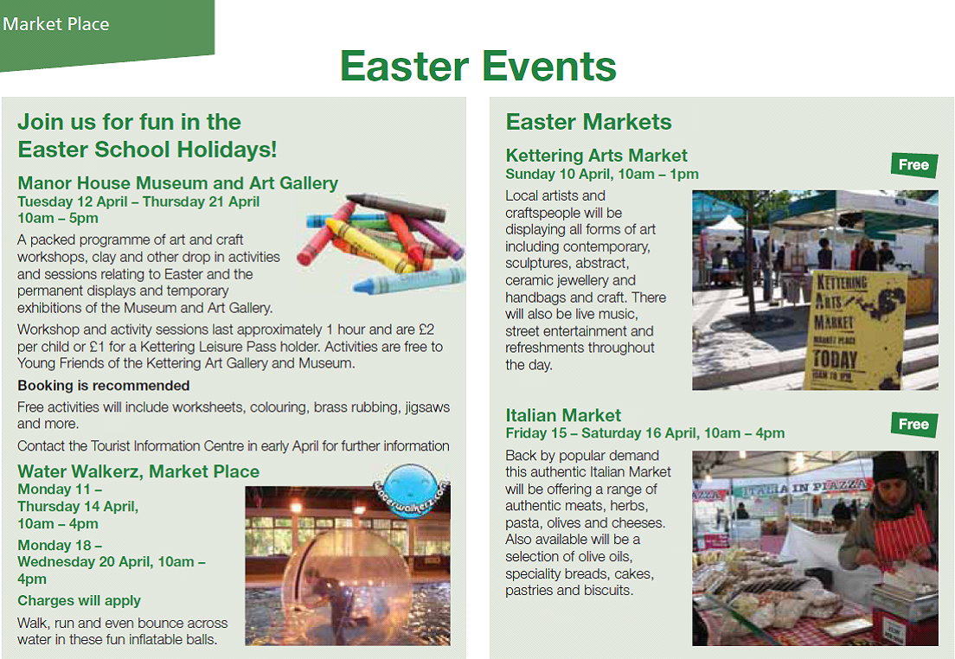

Kettering by The Sea also returns on the 25th July and runs until the 7th August

Summary

  - The partnerships discussed – and celebrated – above are by no means a definitive list of our valued partners or our current successes. They are just a few examples of where we have excelled in partnership working and delivered resultant improvements in service and project delivery.

  - Where we have succeeded, the partnerships have benefitted both sides of the partnership and delivered additional benefits for our ‘customers’ whether they be residents or businesses of the Borough.

- POLICY IMPLICATIONS AND USE OF RESOURCES

  - The Modelling for Recovery principles encourage Partnership working as an important avenue for delivering more effective and economic services.

5. RECOMMENDATION

That the Executive Committee:

- Supports the continued investment in, and delivery of, town centre projects through the Suite 16.
- Recognises the importance of Partnership working as a way of driving efficiencies and improving the experience of our customers.

