BOROUGH OF KETTERING

Committee | Full Planning Committee - 29/03/2011 | Item No: 5.5
Report Originator | Fjola Stevens  Development Officer | Application No:  KET/2011/0052
Wards Affected | Rothwell
Location | McDonalds Restaurants Ltd, A14 Eastbound, Kettering
Proposal | Advertisement Application: 7 no. illuminated and 1 no. non illuminated signs
Applicant | McDonald's Restaurant Ltd

1. PURPOSE OF REPORT

  - To describe the above proposals
  - To identify and report on the issues arising from it
  - To state a recommendation on the application

2. RECOMMENDATION

THE DEVELOPMENT CONTROL MANAGER RECOMMENDS that this application be APPROVED subject to the following Condition(s):-

1. No advertisement is to be displayed without the permission of the owner of the site or any other person with an interest in the site entitled to grant permission.
REASON: As required by the provisions of the Town and Country Planning (Control of Advertisements) Regulations.

2. No advertisement shall be sited or displayed so as to -
(a) endanger persons using any highway, railway, waterway, dock, harbour or aerodrome (civil or military);
(b) obscure, or hinder the ready interpretation of, any traffic sign, railway signal or aid to navigation by water or air, or
(c) hinder the operation of any device used for the purpose of security or surveillance or for measuring the speed of any vehicle.
REASON: As required by the provisions of the Town and Country Planning (Control of Advertisements) Regulations.

3. Any advertisement displayed and any site used for the display of advertisements, shall be maintained in a condition that does not impair the visual amenity of the site.
REASON: As required by the provisions of the Town and Country Planning (Control of Advertisements) Regulations.

4. Any structure or hoarding erected or used principally for the purpose of displaying advertisements shall be maintained in a condition that does not endanger the public.
REASON: As required by the provisions of the Town and Country Planning (Control of Advertisements) Regulations.

5. Where an advertisement is required under these Regulations to be removed, the site shall be left in a condition that does not endanger the public or impair visual amenity.
REASON: As required by the provisions of the Town and Country Planning (Control of Advertisements) Regulations.

6. The illumination of the proposed signs shall be of a static non-intermittent type.
REASON: In the interests of highway safety in accordance with policy 13 of the North Northamptonshire Core Spatial Strategy.

7. The illuminated advertisements hereby consented shall comply with the guidance and recommendations in the Institute of Lighting Engineers Technical Report TR05 Brightness of Illuminated Advertisements (2001).
REASON: In the interests of amenity and the interests of highway safety in accordance with policy 13 of the North Northamptonshire Core Spatial Strategy.

Notes (if any) :-
- NONE

Justification for Granting Planning Permission

The proposal is in accordance with national and local policies as set out in Planning Policy Statement Guidance Note 19, Policy 1 of The East Midlands Regional Plan, Policy 13 of the North Northamptonshire Core Spatial Strategy and Policy 33 of the Local Plan for Kettering Borough. There are no material considerations that indicate against the proposal.

Officers Report

3.0 | Information

Relevant Planning History
KET/2011/0051 – Refurbishment of restaurant abd patio area, including extensions, changes to elevations, reconfiguration of car park layout, installation of customer order display and canopy and new height restrictor UNDER CONSIDERATION

KET/2011/0053 – 4 no. internally illuminated roof signs and 1 no. order display unit UNDER CONSIDERATION

KET/2011/0063 – 2 no. appendage signs on existing totem sign UNDER CONSIDERATION

KET/2006/0101 – Replace existing menu boards and add a new board illuminated and non illuminated APPROVED 27/03/06

KET/1997/0685 – Extension to restaurant building to create additional space for crew room and refuse areas APPROVED 05/01/98

KET/1997/0478 – Proposed one bay extension and crew room APPROVED 31/03/98

KET/1995/0506 – Illuminated 70/50 pole sign (on 10m pole) REFUSED 17/10/95

KET/1995/0485 – Illuminated mansard roof sigh APPROVED 06/11/95

KET/1995/0484 – Illuminated series 2000 signs/traffic signs/gantry sign APPROVED 17/10/95

KET/1995/0483 – Illuminated 70/25 pole sign (on 6m pole) APPROVED 17/10/95

KET/1995/0482 – 2 No. illuminated flag poles REFUSED 17/10/95

KET/1995/0157 – McDonalds Drive Thru Restaurant APPROVED 13/11/95

Site Description
Officer's site inspection was carried out on 14th February 2011.

The application site lies on the northern side of the A14 trunk road to the south east of Rothwell. The site forms part of a service station and is occupied by a single storey fast food restaurant with ‘drive thru’. The site is accessed via a slip road from the eastbound A14 with car parking to the north of the building.

Proposed Development
This application seeks advertisement consent for 7 no. illuminated and 1 no. non-illuminated signs as detailed below.

1 x non-illuminated freestanding banner sign at entrance to site approx. 4.8m (w) x 2m (h) x 0.18m (d)
1 x internally illuminated freestanding post sign to east of ‘drive thru’ access approx. 1.7m (w) x 2.6m (h) x 0.15m (d)
2 x internally illuminated pivoting menu board signs to the west of the ‘drive thru’ access approx. 0.8m (w) x 2.5m (h) x 0.15m (d)
1 x internally illuminated double rotating triangular menu board sign to the west of the ‘drive thru’ access approx. 1.9m (w) x 2.5m (h) x 0.73m (d)
2 x directional sigs at entrance/exit of car park approx. 0.6m (w) x 2.1m (h) x 0.12m (d)
1 x internally illuminated gateway sign at entrance to ‘drive thru’0.75m (w) x 3.2m (h) x 0.2m (d) (the height restrictor attached to the sign projects 3.45m over the ‘drive
thru’ access)

Any Constraints Affecting The Site
Outside settlement framework
Trunk Road

4.0 | Consultation and Customer Impact

Rothwell Town Council
No Objection

Highways Authority
No Objection – recommend standard advertisement and illumination conditions

Highways Agency
No Objection – recommend illumination conditions

5.0 | Planning Policy

Development Plan Policies

East Midlands Regional Plan (EMRP)
P. 1 Regional core objectives

North Northamptonshire Core Spatial Strategy (CSS)
P. 13 General sustainable development principles

Local Plan for Kettering Borough (LP)
P. 33 Advertisement, signs and shop fronts

Financial/Resource Implications
None

Planning Considerations
In accordance with the Town and Country Planning (Control of Advertisement) Regulations 2007 the key issues for consideration in this application are:-

1. Impact upon amenity
2. Impact upon safety

1. Impact upon amenity

Policy 13(h) of the CSS states that new development should respect and enhance its surroundings and policy 33 of the LP states that signs should be sympathetic in style, siting and materials to the building on which they are displayed.

The existing restaurant benefits from a number of existing menu and other signs alongside the access to the ‘drive thru’ and a banner sign at the entrance to the site. Therefore the proposed signage would for the most part replace existing signs. With the exception of the proposed banner sign the signs would all be set back from the adjacent road and therefore although they would be visible from within the service station they would not have a significant impact upon the amenity of the wider area. It is also considered that due to the position of the replacement banner sign and its non-illuminated design it too would not have a significant impact upon the amenity of the wider area.

It is therefore considered that the proposed advertisements would not detract from the visual amenity of the existing building or the surrounding area in accordance with policy 13(h) of the CSS policy 33 of the LP. Consideration has also been given to the cumulative impact of the proposal in terms of the two additional applications for advertisement consent, and it is considered that the proposal remains acceptable.

2. Impact upon safety

Policy 13(n) of the CSS states that development should not have an adverse impact upon the highway network and policy 33 of the LP states that adverts should not prejudice highway safety. The proposed adverts would not be sited so as to obstruct the public highway and although they would be illuminated it is considered provided the illumination is static they would not cause a distraction to drivers. It is therefore considered that the proposed advertisements would not have a detrimental impact upon safety and therefore accords with policy in this respect.

Conclusion
The proposed advertisements by reason of their siting, size and appearance would not detract from the amenity of the building or the surrounding area and would not have an adverse impact upon safety. The proposal therefore accords with PPG19, policy 13 of the North Northamptonshire Core Spatial Strategy and policy 33 of the Local Plan and is recommended for approval subject to conditions.

Background Papers |  | Previous Reports/Minutes
Title of Document: |  | Ref:
Date: |  | Date:
Contact Officer: | Fjola Stevens, Development Officer on 01536 534316

SITE LOCATION PLAN

McDonalds Restaurants Ltd, A14 Eastbound, Kettering
Application No.: KET/2011/0052

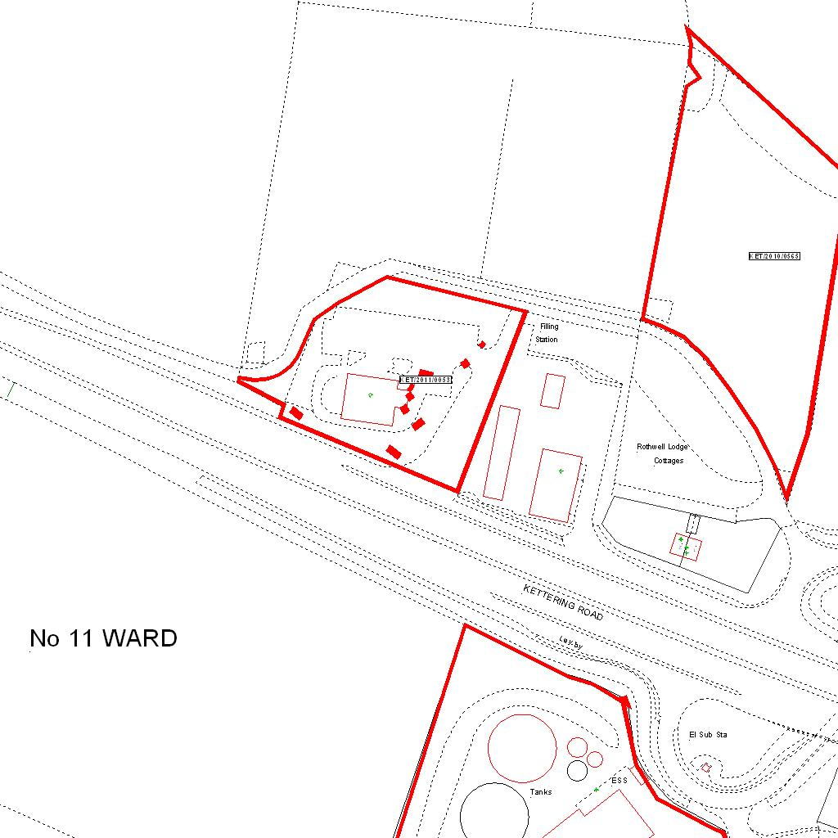

Reproduced from the Ordnance Survey mapping with the permission of the Controller of Her Majesty’s Stationery Office © Crown copyright. Unauthorised reproduction infringes Crown copyright and may lead to prosecution or civil proceedings.  LA078344 |  | N
Date: 03/02/2011 Do not scale from this map. For illustrative purposes only.

