BOROUGH OF KETTERING

Committee | Full Planning Committee - 29/03/2011 | Item No: 5.3
Report Originator | Fjola Stevens  Development Officer | Application No:  KET/2011/0046
Wards Affected | All Saints
Location | 120 Rockingham Road (land rear of) and 1 & 3 Charles Street, Kettering
Proposal | Full Application: 2 no. dwellings
Applicant | MFOR Associates Limited

1. PURPOSE OF REPORT

  - To describe the above proposals
  - To identify and report on the issues arising from it
  - To state a recommendation on the application

2. RECOMMENDATION

THE DEVELOPMENT CONTROL MANAGER RECOMMENDS that this application be APPROVED subject to the following Condition(s):-

1. The development hereby permitted shall be begun before the expiration of 3 years from the date of this planning permission.
REASON: To comply with Section 91 of the Town and Country Planning Act 1990 (as amended) and to prevent an accumulation of unimplemented planning permissions.

2. No development shall commence on site until details of the types and colours of all external facing and roofing materials to be used, together with samples, have been submitted to and approved in writing by the Local Planning Authority. The development shall not be carried out other than in accordance with the approved details.
REASON: In the interests of the visual amenities of the area in accordance with policy 13 of the North Northamptonshire Core Spatial Strategy.

3. Unless otherwise agreed in writing by the Local Planning Authority, development other than that required to be carried out as part of an approved scheme of remediation shall not commence until parts A - D have been complied with. If unexpected contamination is found after development has begun, development shall be halted on that part of the site affected by the unexpected contamination to the extent specified by the Local Planning Authority in writing until part D has been complied with in relation to that contamination.

A. Site Characterisation An investigation and risk assessment, in addition to any assessment provided with the planning application, shall be completed in accordance with a scheme to assess the nature and extent of any contamination on the site, whether or not it originates on the site. The contents of the scheme are subject to the approval in writing of the Local Planning Authority. The investigation and risk assessment must be undertaken by competent persons and a written report of the findings must be produced. The written report is subject to the approval in writing of the Local Planning Authority. The report of the findings must include:

(i) a survey of the extent, scale and nature of contamination;

(ii) an assessment of the potential risks to:

- human health,
- property (existing or proposed) including buildings, crops, livestock, pets, woodland and service lines and pipes,
- adjoining land,
- groundwaters and surface waters,
- ecological systems,
- archeological sites and ancient monuments;

(iii) an appraisal of remedial options, and proposal of the preferred option(s). This must be conducted in accordance with DEFRA and the Environment Agency's 'Model Procedures for the Management of Land Contamination, CLR 11'.

B. Submission of Remediation Scheme A detailed remediation scheme to bring the site to a condition suitable for the intended use by removing unacceptable risks to human health, buildings and other property and the natural and historical environment must be prepared, and is subject to the approval in writing of the Local Planning Authority. The scheme must include all works to be undertaken, proposed remediation objectives and remediation criteria, timetable of works and site management procedures. The scheme must ensure that the site will not qualify as contaminated land under Part 2A of the Environmental Protection Act 1990 in relation to the intended use of the land after remediation.

C. Implementation of Approved Remediation Scheme The approved remediation scheme must be carried out in accordance with its terms prior to the commencement of development other than that required to carry out remediation, unless otherwise agreed in writing by the Local Planning Authority. The Local Planning Authority must be given two weeks written notification of commencement of the remediation scheme works. Following completion of measures identified in the approved remediation scheme, a verification report (referred to in PPS23 as a validation report) that demonstrates the effectiveness of the remediation carried out must be produced, and is subject to the approval in writing of the Local Planning Authority.

D. Reporting of Unexpected Contamination In the event that contamination is found at any time when carrying out the approved development that was not previously identified it must be reported in writing immediately to the Local Planning Authority. An investigation and risk assessment must be undertaken in accordance with the requirements of part A, and where remediation is necessary a remediation scheme must be prepared in accordance with the requirements of part B, which is subject to the approval in writing of the Local Planning Authority. Following completion of measures identified in the approved remediation scheme a verification report must be prepared, which is subject to the approval in writing of the Local Planning Authority in accordance with part C.
REASON: To ensure that risks from land contamination to the future users of the land and neighbouring land are minimised, together with those to controlled waters, property and ecological systems, and to ensure that the development can be carried out safely without unacceptable risks to workers, neighbours and other offsite receptors.

4. No development shall take place until a plan prepared to a scale of not less than 1:500 showing details of existing and intended final ground and finished floor levels has been submitted to and approved in writing by the Local Planning Authority. The development shall not be carried out other than in accordance with the approved details.
REASON: To preserve the character of the area and to protect the amenities of neighbours in accordance with policy 13 of the North Northamptonshire Core Spatial Strategy.

5. The development hereby permitted shall not be occupied until the boundary treatments as shown on drawing no. 10/C/149/3A has been fully implemented in accordance with the approved details. The boundary treatment shall thereafter be retained as approved in perpetuity.
REASON: In the interests of the amenities and privacy of the neighbouring property in the interests of amenity in accordance with policy 13 of the North Northamptonshire Core Spatial Strategy.

6. Notwithstanding the provisions of Article 3 of the Town and Country Planning (General Permitted Development) Order 1995 (or any Order revoking and re-enacting that Order with or without modification) no building, structure or other alteration permitted by Classes A, B, C or E of Part 1 of Schedule 2 of the Order shall be erected, constructed or made on the application site.
REASON: In the interests of protecting the amenities of neighbours in accordance with policy 13 of the North Northamptonshire Core Spatial Strategy.

7. No development shall take place on site until details of the method of construction of the means of access, which shall include a hard bound surface for a distance of 5m from the edge of the carriageway, a positive means of drainage and a gradient of no more than 1 in 15 metres, have been submitted to and approved in writing by the Local Planning Authority. The agreed details shall be fully implemented before the access is first brought into use.
REASON: To ensure a satisfactory means of access to the highway in accordance with policy 13 of the North Northamptonshire Core Spatial Strategy.

8. Notwithstanding the details submitted visibility splays of 2 metres by 2 metres shall be provided, and these splays shall thereafter be permanently kept free of all obstacles to visibility over 0.6 metres in height above ground level.
REASON: In the interests of highway safety in accordance with policy 13 of the North Northamptonshire Core Spatial Strategy.

9. The access hereby permitted shall not be brought into use until the vehicle parking area has been constructed and surfaced in accordance with the approved details, and that area thereafter be retained for the parking and turning of vehicles in perpetuity.
REASON: In the interests of highway safety in accordance with policy 13 of the North Northamptonshire Core Spatial Strategy.

10. The development hereby permitted shall not be carried out other than in accordance with the Energy Efficiency and Waste Audit submitted with the application.
REASON: In the interests of sustainability in accordance with policy 14 of the North Northamptonshire Core Spatial Strategy.

Notes (if any) :-
- Due to the underlying geology present throughout Northamptonshire, the levels of naturally occurring arsenic, vanadium and chromium found throughout the borough frequently exceed the levels at which the risk from arsenic, vanadium and chromium to human health would be considered acceptable for residential land use (with and without plant uptake); it is expected that there may be unacceptable risks to future occupiers of the site therefore the required investigations must take these elements into consideration. Further guidance on Contaminated Land investigations can be found in the Northants Contaminated Land Group Developers Guide. This document is downloadable at:

http://www.kettering.gov.uk/downloads/developers_guide_may_04.pdf

If you wish to discuss the requirements of the investigations further please contact Mrs Alex Gratrix, Team Leader (Environmental Protection) on (01536) 534348; or email at contaminatedland@kettering.gov.uk

- The granting of planning permission does not give or infer permission to implement any works within the highway. No works of any nature may commence within the highway without the express written permission of the highway authority. Such permission would be subject to the completion of an appropriate licence under Section 184 of the Highways Act 1980.

- Existing utility plant or features such as inspection chamber covers, cabinets, poles etc may be affected by the creation of, or alteration to, a vehicular access or any works within the highway. The responsibility for arranging and agreeing alterations, protection or relocation of such plant and meeting all associated costs rests with the developer.

- Existing street furniture such as street lighting columns, signs, cabinets, post boxes, gullies, highway drainage covers etc may be affected by the creation of, or alteration to, a vehicular access. Works to such furniture and infrastructure would need to be agreed with the Highways Authority or whoever maintains such features. All costs associated with the alteration, protection, relocation or removal of such features rest with the developer.

- Most new dwellings will have connections to utilities and sewers that run within a highway. Such connections and associated highway work must be agreed with the Highways Authority. A license under Section 50 of the New Roads and Street Works Act 1991 is required in such circumstances.

Justification for Granting Planning Permission

The proposal is in accordance with national and local policies as set out in Planning Policy Statements/Guidance Notes 1, 2 and 13, Policies 1, 2, 3 and 11 of The East Midlands Regional Plan, Policies 1, 9, 10, 13 and 14 of the North Northamptonshire Core Spatial Strategy and and Policy 35 of the Local Plan for Kettering Borough. The proposal is also in accordance with adopted Supplementary Planning Document Sustainable Design. There are no material considerations that indicate against the proposal.

Officers Report

3.0 | Information

Relevant Planning History
KET/2010/0046 – Creation of vehicular cross-over UNDER CONSIDERATION

KET/2008/0803 – Demolition of existing garage and construction of new dwelling and associated parking REFUSED 14/11/2008

KET/1988/1377 – Outline for one dwellinghouse and demolition of existing garage on land between 3 and 5 Charles Street APPROVED 21/12/88

Site Description
Officer's site inspection was carried out on 10th March 2011.

The application site lies to the rear of 120 Rockingham Road and is accessed via Charles Street. The ‘L’ shaped site is 0.6ha in size and comprises of garden land previously connected to 120 Rockingham Road, there is an existing vehicular access onto Charles Street and a detached double garage is located close to the access. The land has been divided from the remaining garden at 120 Rockingham Road by a 1.8m close boarded fence and the site is otherwise bounded by brick walls between 1.6m and 1.8m in height. The site and the surrounding land is relatively flat, however there is a gentle slope down from the access to the north and east to west down towards Rockingham Road.

Proposed Development
This application seeks planning permission for a 2 storey 2 bed dwelling adjoining 3 Charles Street (dwelling 1) and a detached 4 bed chalet bungalow style dwelling on the land to the rear (dwelling 2). A vehicular access would be provided to serve the detached dwelling, which would benefit from a double garage with parking and turning area, whilst the 2-bed dwelling would benefit from on-street parking.

Dwelling 1 would measure approx. 4.7m (w) x 11.3m (d) x 7.6m (h).

Dwelling 2 would be a rough ‘T’ shaped dwelling with garage attached to eastern elevation. The maximum dimensions of the dwelling would be approximately 11.85m (w) x 13.5m (d) x 6.8m (h) with the attached garage measuring approx. 6m (w) x 6.1m (d) x 5.9m.

The proposed development has been amended since the application was submitted to overcome concerns about the impact of dwelling upon the streetscene and the width of the access to dwelling 2. These issues are set out in part 7 of this report.

Any Constraints Affecting The Site
None

4.0 | Consultation and Customer Impact

Highway Authority
16/03/11 (revised plans) – No objection.

02/03/11 (original plans) - No objection although some concerns about the excessive width of the access for a single dwellinghouse and therefore clarification on proposal requested. A width of 3m would be adequate for a single dwelling or 3.2m if pedestrian access is also required.

Environmental Health
No objection – recommend condition requiring the submission of a contaminated land survey

Neighbours
2 objection letters
- Would change house from semi-detached to terraced
- Traffic problems along Charles Street
- Creating a new dwelling without off-road parking is unacceptable
- Extra access would exacerbate existing dangerous environment

5.0 | Planning Policy

National Policies
PPS1 Delivering sustainable development
PPS3 Housing
PPG13 Transport

Development Plan Policies

East Midlands Regional Plan (EMRP)
P. 1 Regional core objectives
P. 2 Promoting better design
P. 3 Distribution of development
P. 11 Development in the southern sub-area

North Northamptonshire Core Spatial Strategy (CSS)
P. 1 Strengthening the network of settlements
P. 9 Distribution and location of new development
P. 10 Distribution of housing
P.13 Regional core objectives
P. 14 Energy efficiency and sustainable construction

Local Plan for Kettering Borough (LP)
P. 35 Housing: Within towns

SPGs
Sustainable Design SPD

6.0 | Financial/Resource Implications
 | None
7.0 | Planning Considerations
The key issues for consideration in this application are:-

- Principle of development
- Impact upon visual amenity and character of surrounding area
- Impact upon residential amenity of neighbours
- Impact upon highway safety
- Sustainability

1. Principle of development
PPS1, PPS3 and PPG13 all state that new development should be directed to existing built up areas. This is repeated in policies 1, 3 and 11 of the EMRP and policies 1, 9, 10 and 13 of the CSS. In addition policy 35 of the LP states that planning permission will normally be granted for residential development within towns where the proposal is compatible with other policies and proposals in the plan. The objective of these policies is to ensure that new development is located in sustainable locations where there is good access to jobs, facilities, amenities etc, and that these can be accessed via sustainable modes of transport such as walking, cycling and public transport.

The application site is located within an existing residential part of Kettering approximately 0.5km north of the town centre. It is therefore considered that due to the location of the application site in a sustainable location the construction of 2 new dwellings accords with national and local planning policies and is therefore acceptable in principle.

PPS3 was amended in June 2010 by de-classifying garden land as “previously developed land”. Although the revised PPS3 removes the priority to build on gardens, it does not prevent it. As before, applications for new dwellings on garden land may be acceptable subject to normal material planning considerations. Therefore despite the change to PPS3 the principle of the proposed dwelling would comply with the relevant national, regional and local planning policies.

2. Impact upon visual amenity and character of surrounding area

PPS1, policy 2 of the EMRP and policy 13(h) of the CSS all require new development to be high quality in design that is appropriate in its context and respects and enhances the surrounding area. The site at present does not contribute positively to the street scene; it features a vehicular access with high metal gates with a pre-fabricated garage beyond and a high brick wall which is overgrown in places. Therefore there is scope to enhance the quality and character of the street scene with sensitive development.

Dwelling 1 would be highly visible from the surrounding area due to its position at the front of the site. The elevational treatment of the proposal is in keeping with the adjoining property, reflecting the simple design of the existing dwellings and the scale and proportions of their fenestration. The dwelling has been set back to allow the necessary visibility splays to be achieved at the proposed access to dwelling 2, and although this is not in keeping with the adjoining properties to the west, the adjacent dwellings to the east are set back from the street behind small courtyard gardens. Therefore it is considered that the siting of the dwelling set back from the edge of the pavement would not detract from the visual amenity and character of the street scene. As a result of the set back the height of the dwelling is less than those which it adjoins, however it is considered that this would not harm the appearance of the street scene and is therefore also acceptable.

Dwelling 2 would not be particularly visible from the surrounding area due to its backland position, with views of the proposed garage being the only direct views from the street. Backland development forms part of the character of the locality with examples to the north east of the application site, and although the street has overall retained the strong character of a Victorian terraced street there are some examples of single storey detached buildings within the vicinity, including the dwellings to the south west and north east of the site. It is therefore considered that in principle the development of the backland site with a chalet-style bungalow would not have an adverse impact upon the character and appearance of the surrounding area.

For the reasons set out above it is considered that the proposed development would enhance the character and quality of the existing streetscene and the development of garden land in a backland position would not detract from the overall character and appearance of the locality. The proposal therefore accords with PPS1, policy 2 of the EMRP and policy 13(h) of the CSS.

3. Impact upon residential amenity of neighbours

Policy 13(l) of the CSS states that new development should not have an unacceptable impact upon neighbours by reason of noise, vibration, smell, light or other pollution, loss of light or overlooking.

Dwelling 1 would adjoin the blank flank wall of 3 Charles Street and would not exceed the depth of the adjoining dwelling, matching the 2 storey outshot and single store elements at the rear of the building. In addition the flank wall of the proposed dwelling would be 9.3m from the flank wall of the neighbouring dwelling to the east, and therefore it is considered that the dwelling would not have a significant impact upon the adjacent dwellings in terms of loss of light or being overbearing. It is also considered that the proposed dwelling would not be unacceptable in terms of overlooking due to the location of the proposed fenestration on the front and rear elevations only.

Dwelling 2 has been designed in a chalet-bungalow style in order to minimise its impact upon the neighbouring dwellings. The nearest neighbouring properties would be south of the development. The wall to wall distance between the proposed dwelling and the chalet bungalow to the south west would be 6.7m, whilst the wall to wall distance between the proposed dwelling and the 2 dwellings due south of the building would be 9m and 9.2m. Due to the siting and scale of the proposal the dwelling would not result in loss of light or have an overbearing impact upon these properties. The surrounding dwellings to the west, east and north east would all be further away from the proposed dwelling and again due to the siting and overall massing of the proposed dwelling it is considered that it would not have a significant impact upon the amenities of these neighbours. Directly north of the application site lies a substantial building currently used as a children’s nursery set within large grounds. The proposal therefore would not have a significant impact upon the property to the north.

Fenestration is limited to the east and west elevations at first floor level with only non-habitable room windows on the north elevation at ground floor level and a bedroom window on the south elevation. This window to window distance between proposed bedroom window on the south elevation and windows on the north elevation of dwelling 1 would be 16.3m (to ground floor patio doors) and 17.8m (to first floor bedroom window). It is considered that this distance is sufficient to ensure that the amenities of future occupiers of the 2 dwellings would not be affect by overlooking. The wall to wall distances between the proposed dwelling and the neighbouring dwelling to the east (12m) and the west (19.5m) are considered to be sufficient to ensure that dwelling 2 would not have an unacceptable impact in terms of overlooking.

Consideration has also been given to the relationship between both of the proposed dwellings and due to their siting and designs neither would have an unacceptable impact upon the amenities of future occupiers. The proposal would therefore accord with policy 13(l) of the CSS.

4. Impact upon highway safety
Policy 13(n) of the CSS states that new development should not have an adverse impact upon the highway network or prejudice highway safety.

The development of 2 dwellings would not result in a significant increase in traffic movements such as to affect the capacity of the surrounding highway network. Dwelling 1 would not have any off-road parking, however this is a small 2 bed dwelling located in a fairly central location within Kettering and within walking distance of the town centre. There is on-street parking within the vicinity and the addition of 1 small dwelling on this street would make very little difference to the availability of on-street parking. Therefore the lack of off-street parking is not a reason to refuse the application. Furthermore, dwelling 2 would benefit from ample off-road parking with turning area to ensure that vehicles enter and exit the site in a forward gear and the proposed access has been designed with the necessary pedestrian visibility splays to ensure that the access would not endanger pedestrians using the footpath. It is therefore considered that the proposed development would not have an adverse impact upon highway safety and therefore accords with policy 13(n) of the CSS.

5. Sustainability
Policy 14 of the CSS requires new development to meet the highest standards of resource and energy efficiency and reduction in carbon emissions. Development proposals should; incorporate techniques of sustainable construction and energy efficiency, provide for waste reduction/recycling and provide for water efficiency and water recycling.

The application is accompanied by an energy efficiency and waste audit, design and access statement and Sustainable Design SPD checklist which demonstrate that the proposal will; exceed the requirements of the 2006 Building Regulations for emissions; reduce waste generation during construction and reuse potential waste materials where possible; make use of highly rated insulation, low volume taps, dual flush low volume WC’s; provide adequate space to store recyclable materials; benefit from soakaways where possible to ensure that the development does not result in an increase in surface water run-off; and due to the location of the development within an established town with good sustainable transport options and access to a range of services, facilities and employment will limit car use and reduce car dependency.

It is therefore considered that the applicant has clearly demonstrated that the development would meet the objectives of policy 14 of the CSS and the Sustainable Design SPD checklist.

Conclusion

Section 38(6) states that applications for planning permission must be determined in accordance with the development plan unless material considerations indicate otherwise. The proposed development by reason of its location in a sustainable area, design and which is appropriate in its context, would enhance the character and appearance of the street scene, protect the amenities of neighbours and incorporates sustainable design measures would accord with PPS1, PPS3 and PPG13, Policies 1, 2, 3 and 11 of the East Midlands Regional Plan, Policies 1, 9, 10, 13 and 14 of the North Northamptonshire Core Spatial Strategies, Policy 35 of the Local Plan for Kettering Borough and the Sustainable Design Supplementary Planning Document. There are no material considerations that indicate against the proposed development and therefore it is recommended that planning permission should be granted.

Background Papers |  | Previous Reports/Minutes
Title of Document: |  | Ref:
Date: |  | Date:
Contact Officer: | Fjola Stevens, Development Officer on 01536 534316

SITE LOCATION PLAN

120 Rockingham Road (land rear of) and 1 & 3 Charles Street, Kettering
Application No.: KET/2011/0046

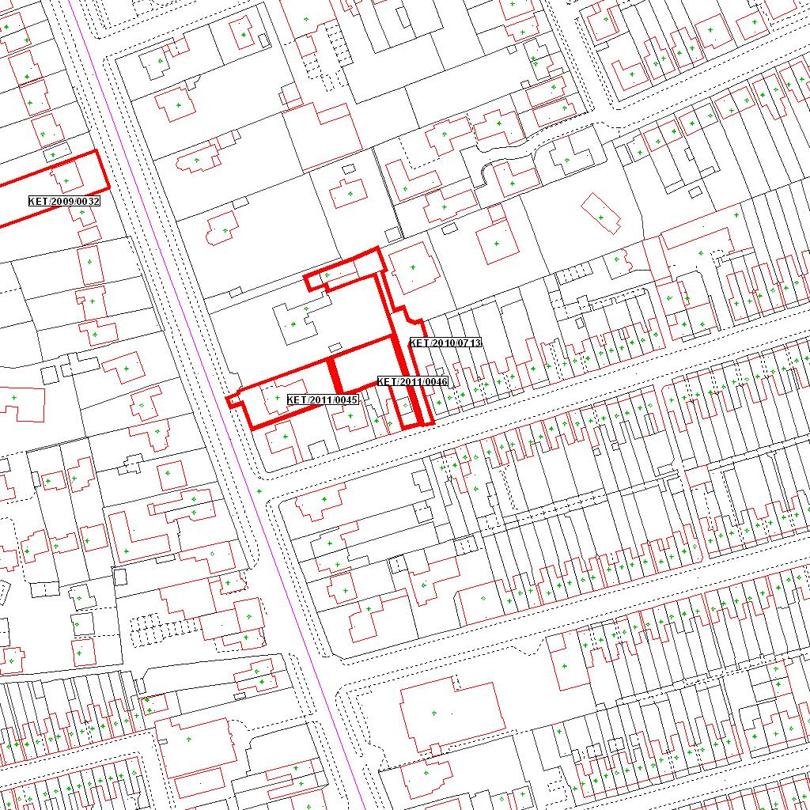

Reproduced from the Ordnance Survey mapping with the permission of the Controller of Her Majesty’s Stationery Office © Crown copyright. Unauthorised reproduction infringes Crown copyright and may lead to prosecution or civil proceedings.  LA078344 |  | N
Date: 02/02/2011 Do not scale from this map. For illustrative purposes only.

