1. PURPOSE OF REPORT

To inform members of progress to date on Suite 16.

2. BACKGROUND INFORMATION

2.1 Kettering Borough lies within the South East Midlands, which is predominately a growth area, and is expected to facilitate growth of some 13,100 homes and 16,200 new jobs by 2021.

2.2 Members have made their priorities for infrastructure and jobs-led growth clear – these are the prerequisites of growth. Members have indicated they wish to use the growth agenda to leverage three key and interrelated ambitions for the borough; namely:-

- A better offer for our town centres
- A better education and training offer
- A better employment offer – high grade, higher density jobs

  - The mutually supportive role of these three aspirations cannot be over-stated. The town centres and the skills base will be persuasive to inward investors. Similarly, high grade employment supports vibrant town centres.

  - The Council’s vision is to create town centres that are:

- Characterful
- Distinctive, and
- Fun

These three key words – enshrined in the Kettering Town Centre Area Action Plan - will help to ensure that the town centre is more than just a place to shop. It will have an experiential offer that encourages visitors to spend time in, and enjoy, our town centre.
- SUITE 16 UPDATE

Market Place

  - Kettering Market Place is soon to receive a spring-clean, during which the opportunity will be taken to correct some ‘snagging’ items that have become evident over the last 12 months. Much of this work is aesthetic and includes relaying some blockwork and replacing some steps under the performance canopy in order to ensure continuity of pattern. However, the stone retaining wall (which runs in front of Mr Rays and the Corn Exchange) succumbed to frost damage during the winter so there will be a period in the coming months when access around the wall is restricted in order for remedial works to be carried out. The water feature will also receive some improvements to ensure it continues to function throughout our busy events schedule.

  - Ordinarily, these works would have been carried out by the original contractor (Weldon) in order to release the final ‘retained’ payment. However, with Weldon having gone into administration the retention amount will be used to address the issues identified above. We will not have to use any of our own money in putting these elements right.

  - Over the last two years, Kettering Market Place has been considered for a series of National, Regional and local awards, the latest of which saw us as runners-up at two prestigious national events. Kettering Market Place came second at the Royal Town Planning Awards in February (having previously won the regional prize) and was also runner-up at the Urban Design Group Awards in the same month. Making the shortlist at these events has served to raise the profile of the Borough as a place where good design and good planning are at the forefront of our regeneration efforts.

Kettering Market Place Restaurants

  - The 9th March will have seen us celebrate the ‘topping-out’ of the Market Place Buildings with partners and local media. The ceremony marked the completion of roof works (including the chimneys) as the building skin nears completion. The new windows will be completed before the end of March, at which point the buildings will be fully weather-tight.

  - Construction works on the new buildings will be completed in May, after which the restaurant units will be ready for fit-out. The new apartments will also be completed in May.

Kettering Public Realm

  - The work to enhance Horsemarket and turn it into a new area for buses has taken a huge step forward this month with news that the Department for Transport (DfT) have approved a shared bus stop/taxi rank on the eastern edge of the Horsemarket island. The taxi rank will function from 8pm at night to 6 am in the morning, at which point bus services will utilise the stops. The new Taxi ranks at Dalkeith Place and Silver Street will continue to function 24/7, and we are currently seeking the views of taxi drivers as to how these ranks may be improved in tandem with their renewed use of Horsemarket.

  - February 28th saw the termination of bus services from Sheep Street and their temporary relocation to London Road as works to Market Street commenced. Horsemarket will be fully functional from the end of March when all bus services that used to use the Sheep Street stops will run from their new home.

  - February 28th also saw the start of the new bus routes that now serve the town:

    - A regular hop-on, hop-off service now runs from the top of Northampton Road and the Headlands to Horsemarket (and vice versa)
    - the new routes also take in Northfield Avenue and will eventually serve the train station and station road once the works on the double roundabout are complete.

We have worked closely with stagecoach and Northamptonshire County Council in order to achieve these routes and would like to thank them for their help and perseverance over the past few months.

  - The closure of Market Street commenced – in part – on the 28th February, with complete closure to through-traffic the following week. We made sure that all businesses along Market Street and Horsemarket were aware of what was happening and were able to plan for any changes to their normal access arrangements.

  - The temporary measures that will be in place - to allow the servicing of the businesses throughout the works on Market Street - will be replaced, on completion of the works, by a key-pad operated bollard. This will allow controlled access for those businesses who continue to require service and delivery access when the Market Street works are complete.

  - It is important to note that this phased road closure, and the resultant restricted access, is an essential requirement of the delivery of this project. Through the Suite 16 programme we are considering, and delivering, projects that will change the face of Kettering Town Centre for the better, for decades to come. This ‘short term pain’ must therefore be considered in relation to the ‘longer term gain’ of these projects.

  - We are now over half-way through the public realm project, with completion due in the summer.

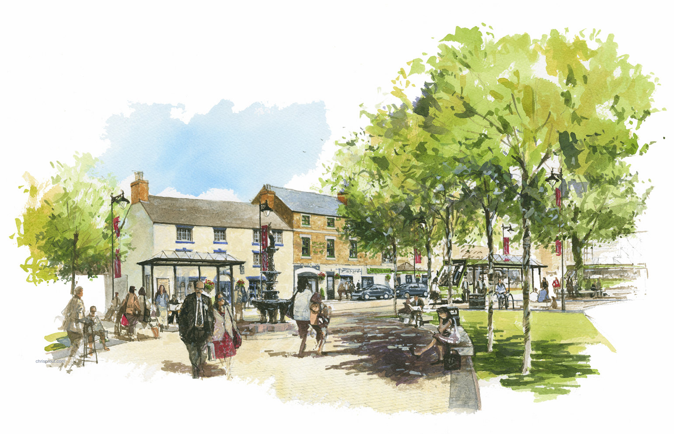 | 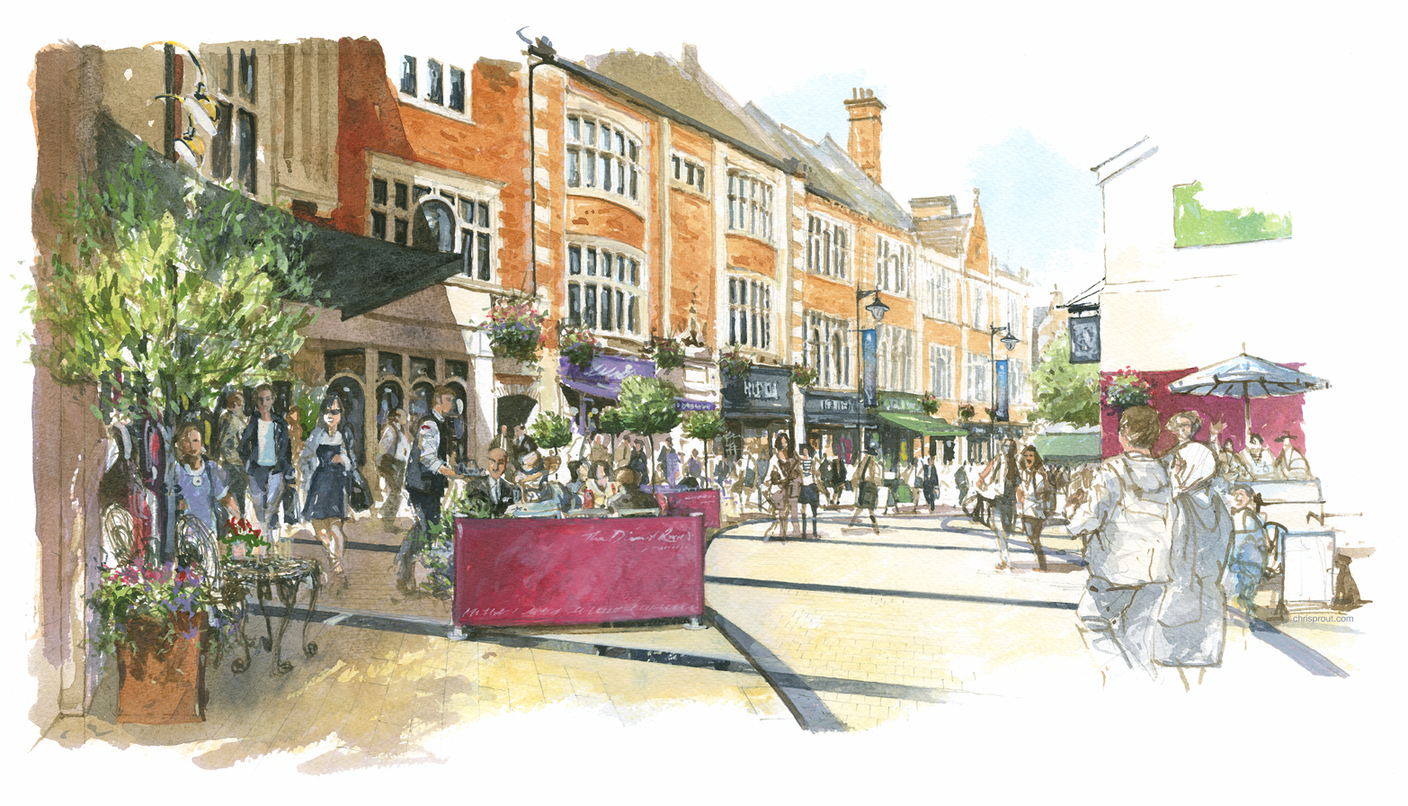
The new Horsemarket (to be completed at the end of March) | The new Market Street (works commence on 7th March for approximately 12 weeks)

Delivering the Transport Strategy for Kettering Town Centre

  - Northamptonshire County Council and their contractors, MGWSP, have continued to make good progress on the new double roundabout at the bottom of Northampton Road. The final phase of works will require the junction to be completely closed on a weekend in mid-March, and will be followed by works to complete the new road system towards the end of March.

Kettering Town Centre Health Check Update

  - The Executive may be aware, from an article in the Evening Telegraph, that the Newlands Centre has been put up for sale by its current owners, Cornerstone. We have been in contact with their agents and have put ourselves forward as a principal point of contact for any prospective purchasers. We feel it is essential that anybody thinking of investing in our town centre is fully aware of our vision for Kettering Town Centre and our desire to see to the town reach its full potential.

  - Cornerstone’s agents have advised that the initial process of selecting a preferred bidder will be concluded relatively quickly, although the legal due diligence that will ensue will take us towards the end of 2011 before the acquisition is completed.

  - We have written to Cornerstone’s Agents and have expressed our desire to meet with prospective bidders to discuss, with them, our ambitious regeneration programme for the town. We have supplied materials to support the agents through the sale process; including our town centre prospectus, the Town Centre Area Action Plan and copies of reports to the Executive which set out - in no uncertain terms – the Executive’s support for regeneration projects in Kettering Town Centre.

  - Although we may not be in a position – in this difficult economic climate – to support any improvement or redevelopment of the Newlands Centre financially, we will make every effort to work with the new owners to enable them to progress a scheme that is in accordance with our vision for the town centre. Any support we can offer will be in accordance with our Modelling for Recovery principles.

Kettering Chamber of Trade

  - As part of our ongoing engagement with Kettering Town Centre traders, we have begun regular update meetings with the Kettering Chamber of Trade. The Chamber of Trade has appointed new board members and is keen to become involved in town centre regeneration activities. These update meetings will continue and the Executive will be brought up to date on progress.

I Love Kettering 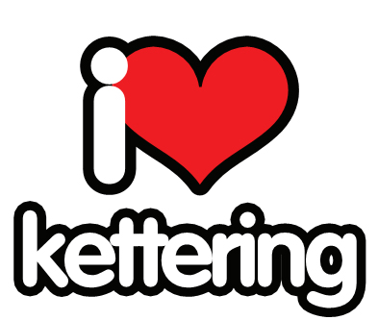

  - The Evening Telegraph has, over the past few weeks focussed their ‘I love’ campaign on Kettering Town. Neil Pickford – the ET’s current editor – says the campaign has encouraged civic pride:

“The Love Kettering campaign is the latest in a series of initiatives to focus on, and highlight, the positive aspects of the towns covered by the Evening Telegraph. The campaign aims to show people living and working in the town, and others, that there is much to be proud of and to shout about.

The campaign has been supported by Kettering Borough Council and a wide range of business and community groups in Kettering, notably The Newlands Centre, which was the main campaign sponsor.

The campaign has been well received by readers and those contacted to take part. It has also helped removed the unfounded view that the newspaper only reports bad news and shown people that they should be proud of their town.”

Hogs Head

  - The demolition of the Hogs Head commenced in earnest in the first week of March. The buildings, which have been an eyesore from a number of years, are being demolished using external challenge fund received through North Northants Development Company.

  - Once the buildings have been demolished, the area will be grassed in order to ensure that it does not detract from the newly-enhanced Horsemarket area. This landscaping approach is very much a temporary solution, to be put in place until such time as the site is redeveloped by the owner.

  - Future plans for the site are being developed by the owner, and we continue to maintain a dialogue with him to ensure that the proposals that come forward are supportive of the vision for the town centre. Part of the land will be used to modify the junction with Queen Street (and thus contribute to the delivery of the new two-way south-north route through the town)

- A BETTER EDUCATION OFFER

  - The application to redevelop the former Tresham site on St Marys Road is due to have been considered by the Planning Committee on 9th March. An update on the decision will be provided verbally at this meeting of the Executive.

  - Members will recall that a payment to release the covenant on the site was agreed, in the sum of £200,000, and that, furthermore, this money was to be recycled into educational provision in the Borough. £5000 of that has been committed towards the shared cost of feasibility work in extending Tresham’s Windmill Ave campus. The remaining money will need to be retained for a period, to deal with any matters arising from the covenant’s release. A further report on the expenditure of the remaining funds will be brought to the Executive at a future date.

- POLICY IMPLICATIONS

  - The Public Realm Phase 2/3 project and works to improve the Northampton Road/Northfield Avenue junction form an integral part of the Town’s Transport Strategy for Growth.

  - The Market Place Buildings are part of a second phase of works which will see the delivery of the Restaurant Quarter, which is promoted through the Kettering Town Centre Area Action Plan.

  - The Area Action plan for Kettering Town Centre is - at the time of this meeting of the Executive – currently going though its independent examination in public (EIP). The sitting is scheduled for three days from 15th March to 17th March.

6. USE OF RESOURCES

  - The projects currently being delivered have attracted significant levels of external bid funding. This funding will, in accordance with the grant funding agreements, be spent before the end of March 2011.

7. RECOMMENDATION

That the Executive Committee:

- Supports the continued investment in, and delivery of, town centre projects through the Suite 16.
- Extends its thanks to Stagecoach and Northamptonshire County Council in respect of the new bus routes that now serve the town.
- Places on record its thanks to the Evening Telegraph for the ‘I Love Kettering’ campaign.
- Welcomes progress made in respect of the demolition of the Hogs Head and notes the temporary nature of the landscaping on this development site.

