1. PURPOSE OF REPORT

To inform members of progress this month on Suite 16 projects.

2. BACKGROUND INFORMATION

2.1 Kettering Borough lies within the South East Midlands, which is predominantly a growth area, and is expected to facilitate growth of some 13,100 homes and 16,200 new jobs by 2021.

2.2 Members have made their priorities for infrastructure and jobs-led growth clear – these are the prerequisites of growth. Members have indicated they wish to use the growth agenda to leverage three key and interrelated ambitions for the borough; namely:-

- A better offer for our town centres
- A better education and training offer
- A better employment offer – high grade, higher density jobs

  - The mutually supportive role of these three aspirations cannot be over-stated. The town centres and the skills base will be persuasive to inward investors. Similarly, high grade employment supports vibrant town centres.

  - The Council’s vision is to create town centres that are:

- Characterful
- Distinctive, and
- Fun

These three key words – enshrined in the Kettering Town Centre Area Action Plan - will help to ensure that the town centre is more than just a place to shop. It will have an experiential offer that encourages visitors to spend time in, and enjoy, our town centres.

- SUITE 16 UPDATE

Better Town Centres

New Shops

3.1 Kettering is attracting new jobs and businesses: Midshires Clothing, a worker owned business that provides garment manufacturing, embellishment and alteration services, has set up shop in Kettering.

Kettering resident Hannah Macleod started the design brand Coulson Macleod in 2009 without any external financing. Hannah is one of three finalists for Small Business of the Year in the East Midlands ‘Women of Worth’ Awards. Along with Hannah, several other entrepreneurs have rolled up their sleeves and are creating businesses in our town centre. Within the last two months we have seen the opening of:

- A new florist, Sheep Street
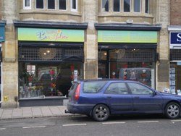

- Women’s boutique, Sheep Street

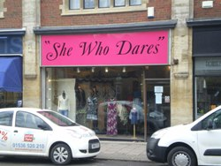

- Nail bar, Silver Street

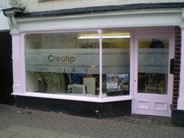

- Jewellery store, Gold Street

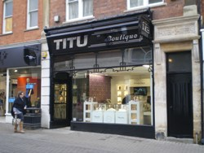

- Children’s clothing store, Market Street

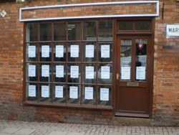

- Gadget Shop, High Street

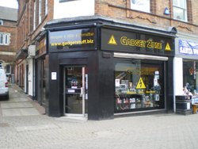

3.2 All businesses are now open in the town centre by local residents demonstrating that Kettering continues to show strong entrepreneurial activity.

Market Place Restaurants

3.3 The Market Place Restaurants continue to attract attention as they take shape and the quality of the design and materials becomes more apparent. We are discussing arrangements with Sisk for a ‘topping out’ ceremony to mark completion of a key phase of the project.

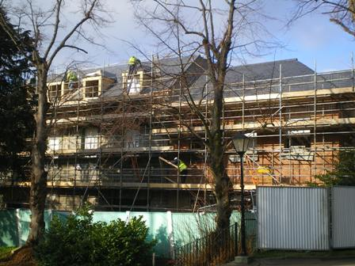

3.4 Business Link will be holding an event on Thursday 17th February ‘Calling All Businesses’ to help support retailers and provide them with a competitive edge. The free event should help retailers in the town to keep the tills ringing will be held in the George Hotel between 5.30 and 8.30pm.

Market Place Events / What’s On

3.5 Entertainment continues to be high on the agenda with events being planned for the year ahead. The Easter Holidays will see a variety of events which are being organised and will be reported at the next meeting.



3.6 The Museum and Gallery continues to attract high volumes of visitors with the next exhibition being local artist Walter Bonner Gash.
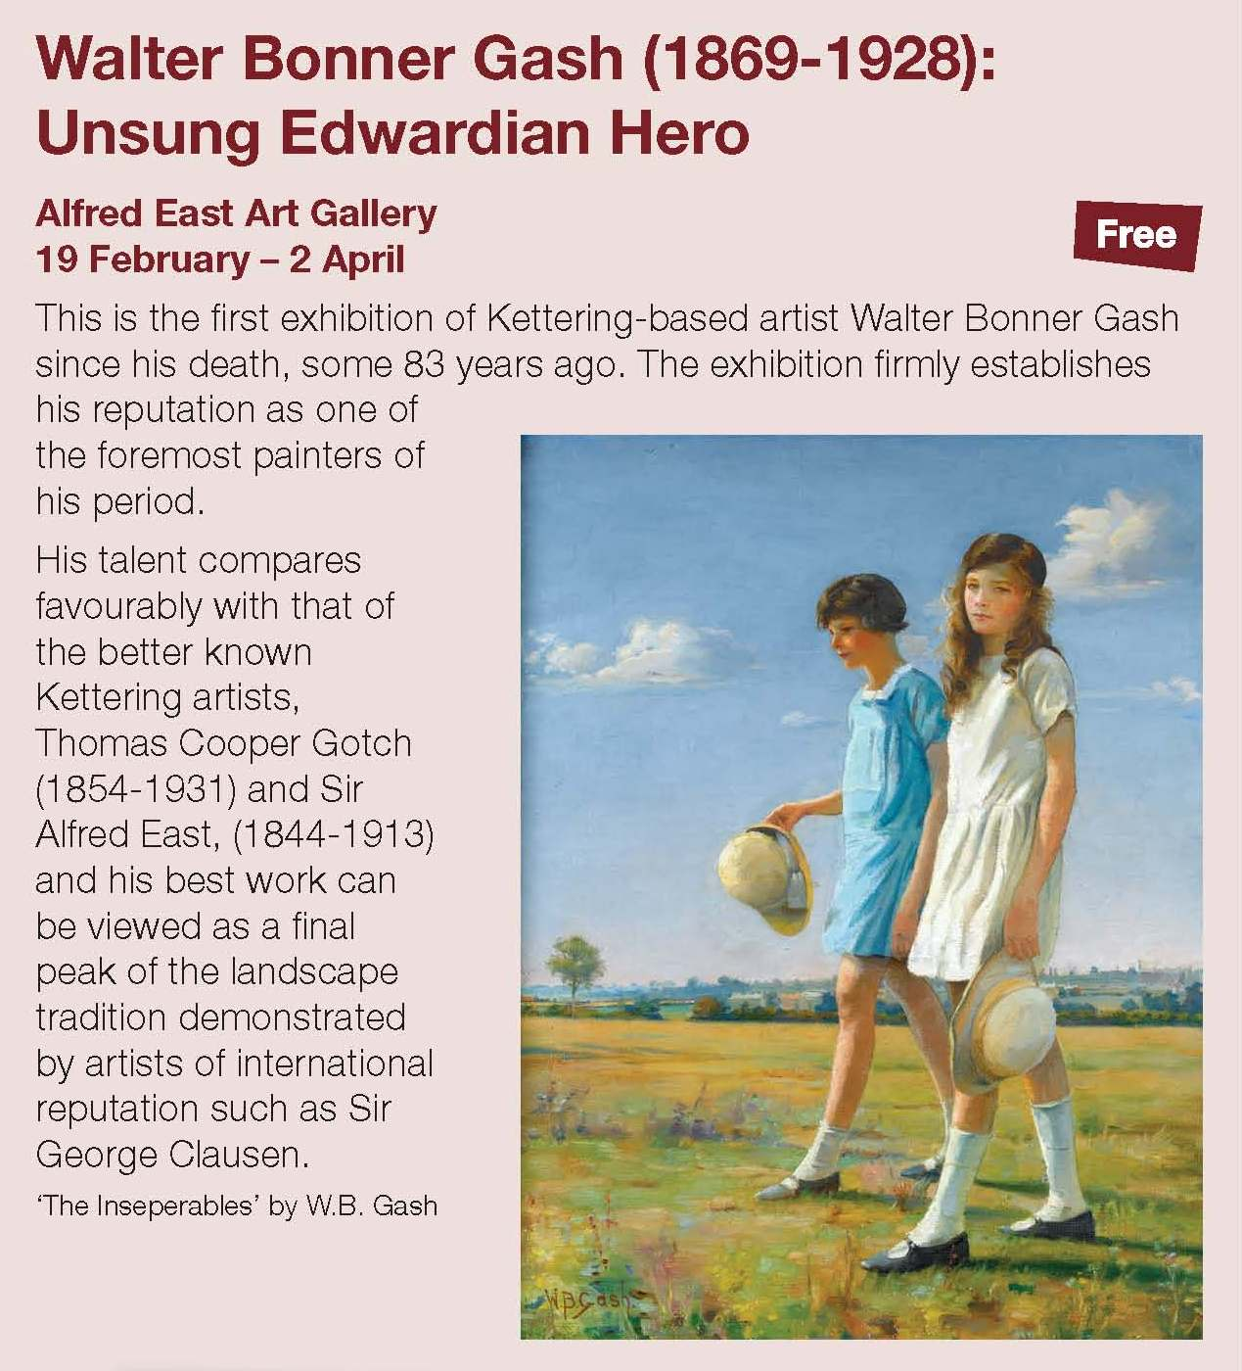

Kettering Public Realm/bus services

3.7 Works on the Horsemarket element of the public realm are scheduled to be completed by mid March, at which point the bus stops there will be operational. However, it will be necessary to stop bus access, (but not loading and unloading access) into Market Street in mid February. At this earlier point, there will be some temporary bus stops in London Road, as those in Sheep Street will no longer be in use. It is hoped that the alterations to bus services, which create new bus stops in Northampton Road, Station Road, Bowling Green Road and Headlands, will be in place at the same time although some temporary disruption may occur.

3.8 Public realm works to Market Street will commence at the end of February. This will trigger the agreed set of changes to bus routes, involving new services and bus stops in Northampton Road, Bowling Green Road and Headlands, and the cessation of the Market Street and Sheep Street bus routes. Pending the opening (at the end of March 2011) of new bus stops in Horsemarket, there will be temporary stops in London Road.

3.9 The public realm works in Market Street and Sheep Street are expected to be completed by June 2011.

3.10 The first phase of demolition of buildings on the Hogs Head site (those fronting Horsemarket) should be completed by the time Committee meets. KBC are working with NNDC, the landowner and other stakeholders to facilitate new development, which will bring forward the next stage of improvements in the area.

Delivering the Transport Strategy for Kettering Town Centre

3.10 The County Council’s junction improvement works at Northampton Rd/Northfield Avenue are currently on schedule. Although there has been disruption to traffic flows, which have caused problems for bus operators in keeping to timetables, the travelling public has responded well to the inconvenience caused. The roundabouts are now taking shape and it is expected that the works will be completed by the end of April.
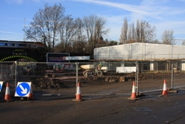
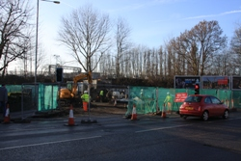

- POLICY IMPLICATIONS

  - The Public Realm Phase 2/3 project and works to improve the Northampton Road/Northfield Avenue junction form an integral part of the Town’s Transport Strategy for Growth.

  - The Market Place Buildings are part of a second phase of works which will see the delivery of the Restaurant Quarter, which is promoted through the Kettering Town Centre Area Action Plan.

  - The Area Action plan for Kettering Town Centre has been submitted to the Secretary of State, with the expectation of an Examination in Public (EIP) in the middle of 2011. Whilst the Area Action Plan moves through the planning process, the policies within it carry greater weight. The formal submission of the final document is, therefore, a significant step forward.

5. USE OF RESOURCES

  - The projects currently being delivered have attracted significant levels of external bid funding. This funding will, in accordance with the grant funding agreements, be spent before the end of March 2011.

6. RECOMMENDATION

That the Executive Committee notes the progress report

Background Papers: | Various Suite 16 project files
Title
Date | Various
Contact Officer | Paul Thomas

Previous Minutes/Reports: | Previous Executive reports
Ref:
Date: | Monthly

