1. PURPOSE OF REPORT

- To inform members of progress to date on Suite 16.
- To request approval for a jointly-funded feasibility study into the future enhancement of the new Tresham Campus in Kettering

2. BACKGROUND INFORMATION

2.1 Kettering Borough lies within the South East Midlands, which is predominately a growth area, and is expected to facilitate growth of some 13,100 homes and 16,200 new jobs by 2021.

2.2 Members have made their priorities for infrastructure and jobs-led growth clear – these are the prerequisites of growth. Members have indicated they wish to use the growth agenda to leverage three key and interrelated ambitions for the borough; namely:-

- A better offer for our town centres
- A better education and training offer
- A better employment offer – high grade, higher density jobs

  - The mutually supportive role of these three aspirations cannot be over-stated. The town centres and the skills base will be persuasive to inward investors. Similarly, high grade employment supports vibrant town centres.

  - The Council’s vision is to create town centres that are:

- Characterful
- Distinctive, and
- Fun

These three key words – enshrined in the Kettering Town Centre Area Action Plan - will help to ensure that the town centre is more than just a place to shop. It will have an experiential offer that encourages visitors to spend time in, and enjoy, our town centre.

- SUITE 16 UPDATE

Market Place Events
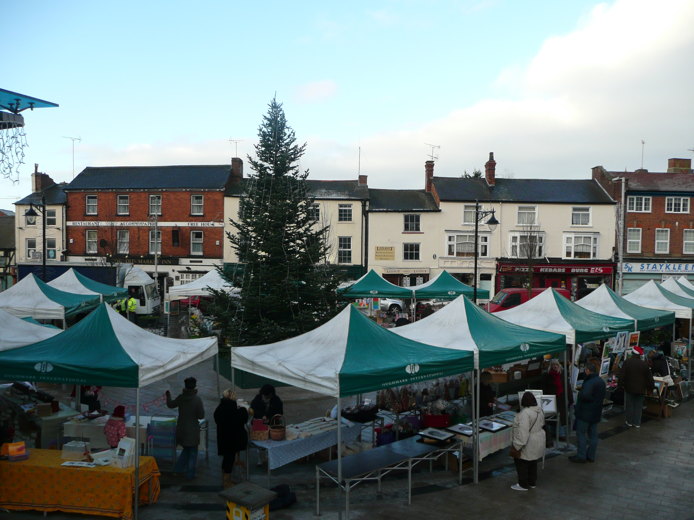
  - The Big Christmas Switch On (reported in last month's report to the Executive) marked the start of a very successful second Christmas for the new Market Place. The Christmas Market proved very popular for shoppers and stall-holders alike, and the Ice Rink saw over 250 people skating on the Market Place in the week leading up to Christmas.


  - Following appearances from David Van Day and Big Brother’s Nikki Graham at the Switch On; the cast of Aladdin returned to the Market place to mark the opening of the Ice Rink, where they were joined by 35 school children from Hawthorn Road School and the Deputy Mayor. Aladdin enjoyed a very good Christmas at the Lighthouse Theatre and it is always good to see some famous faces on the Market Place.

  - The support of two of the larger traders in the town was very much appreciated, as Asda helped us with the Switch On and Sainsburys used the Market Place Ice Rink to launch their ‘taste the difference’ give away.

Desborough, Lawrences Site

  - The planning applications for the demolition of the former Lawrences factory and the development of a new Tesco store (with associated car parking), have been received and consulted on. Statutory consultation on the planning application has commenced and will run until mid January.

  - There is an accompanying Conservation Area Consent application being considered for the demolition of the Lawrences factory. The two applications are likely to be determined in Spring 2011.

  - These are matters for the Planning Committee to consider.

Kettering Market Place Restaurants

  - Sisk returned to site on the 4th January after their Christmas break, although work is still being hampered by the cold weather. The construction work is still expected to complete in the Spring, although 3 weeks of particularly cold weather before Christmas have provided a real challenge to Sisk.

Kettering Public Realm

  - Our support for traders around Horsemarket continued right up to Christmas with a full-page advert in the Evening Telegraph and our very own ‘Gregg Clause’ handing out fliers to promote the local businesses. Balfour Beatty added their own touch of Christmas to the site with tinsel on the protective barriers.

  - Following a short break for Christmas, Balfour Beatty resumed on-site on the 4th January. The works to Horsemarket are expected to last into February, although other phases may well commence before Horsemarket is complete, as we continue to review the programme to make efficiency savings and reduce disruption to traders in the area.

Delivering the Transport Strategy for Kettering Town Centre

  - The second phase of roadworks, being carried out at the junction of Northfield Avenue and Northampton Road in Kettering, started on January 11. This next stage of the project will see the roundabouts start to take shape, with footpaths and crossing points also being constructed.

  - In order for the work to take place, the current 3-way traffic lights (whereby traffic from each of the roads approaching the junction is given its own green light) will be converted to 2-way traffic lights. The change to traffic lights will mean that only traffic approaching the town from Northampton Road will be able to carry on into the town centre; any traffic attempting to approach the town centre along Northfield Avenue will be diverted up Rothwell Road (past the hospital), along Gypsy Lane and back down Northampton Road.

  - Access will be maintained at all times to ATS, Morrisons Petrol Station, Sanders Honda Garage, Topps Tiles, Lidl, B&Q and all car parks and other stores in the vicinity. The County Council have also sought to improve traffic flows by preventing parking on Gypsy Lane between Northampton Road and Bowhill.

  - The County’s agents, MGWSP, have been in contact with residents and businesses in the immediate area and have also met with the St Thomas Moore school to discuss the implications of the traffic diversion and to make sure that all parents have been informed of the changes.
  - The Evening Telegraph also usefully produced a guide to dealing with the traffic disruption, and this appeared in Monday’s paper. The guide included alternative routes to the one suggested by MGWSP as well as coverage of the overall scheme and interviews with affected parties. Whilst it is clear that no one is particularly looking forward to the disruption caused by these new traffic management measures, the coverage has at least allowed readers to be fully informed about the works.

Kettering Town Centre Health Check Update

  - Members will recall from the last meeting of the Executive that the application to provide a unit for Dunelm at Northfield Avenue was approved, subject to the decision of the Secretary of State.

  - The decision was referred by Kettering Borough Council to the government office and they have concluded that the Secretary of State would not want to ‘call the decision in’. This means that the decision made by the planning committee stands, and the application to change the use of – and extend - the unit in question is approved.

Hogs Head

  - In October, the Executive received an update on GAF funding which reported an additional £290,000 being secured for regeneration schemes in Kettering Town Centre. Whilst the majority of the funding was for the Public Realm scheme, a sum of £70,000 was secured to demolish the Hogs Head Public House and the associated buildings fronting Horsemarket.

  - The demolition of the Hogs Head is a major milestone in the works to improve Horsemarket. These works will see the whole area transformed through high quality public realm; creating a pedestrian friendly link through Market Street to the Market Place and the High Street. The new public realm works will see the Horsemarket become a new arrival point for the town, with a new bus area around the island and – in time – changes in the flow of traffic that will see Queen Street become two-way, thus re-establishing the town’s South-North link.

  - Demolition of the Hogs Head is due to start in March, with a demolition contractor having been procured at the end of 2010. It may be possible to bring the demolition date forward if the utility companies that are required to carry out disconnections are able to commence their respective works earlier than has been currently indicated.

- A BETTER EDUCATION OFFER

  - The Executive agreed, in principle, in November 2010 to consider reinvesting any sum due to the council as a result of its interest in the land at St Mary's Road. This money was to be used for the provision of additional education facilities in Kettering Borough by Tresham Institute as part of a wider package of proposals which might be negotiated. This could include any additional contribution from ourselves that may be considered appropriate. Furthermore, Executive agreed that the sum due would be deferred until such time as Tresham had received the capital sum from the sale of the land.

  - Discussions have been ongoing with Tresham Institute regarding additional and improved facilities planned for the Windmill Avenue site. Tresham have requested that the Council jointly fund a feasibility study which will include the necessary professional drawings and structural engineering work which will enable costed proposals to be developed. The feasibility study will be shared between Tresham and the Council to assist future decision making regarding enhancements to the campus. The estimated cost of the feasibility study is circa £10,000 and members are invited to consider approving the use of up to £5,000 of the deferred capital sum for the purpose of the feasibility study.

  - The deferred capital sum due from Tresham to the Council would therefore stand at £195,000.

- POLICY IMPLICATIONS

  - The Public Realm Phase 2/3 project and works to improve the Northampton Road/Northfield Avenue junction form an integral part of the Town’s Transport Strategy for Growth.

  - The Market Place Buildings are part of a second phase of works which will see the delivery of the Restaurant Quarter, which is promoted through the Kettering Town Centre Area Action Plan.

  - The Area Action plan for Kettering Town Centre has been submitted to the Secretary of State, with the expectation of an Examination in Public (EIP) in the middle of 2011. Whilst the Area Action Plan moves through the planning process, the policies within it carry greater weight. The formal submission of the final document is, therefore, a significant step forward.

6. USE OF RESOURCES

  - The projects currently being delivered have attracted significant levels of external bid funding. This funding will, in accordance with the grant funding agreements, be spent before the end of March 2011.

7. RECOMMENDATION

That the Executive Committee:

- Supports the continued investment in, and delivery of, town centre projects through the Suite 16.
- Approves the use of up to £5,000 of the deferred capital sum from the sale of the St Marys Road site for the purpose of a joint feasibility study into the enhancement of the new Tresham Campus

