BUSINESS CONTINUITY STRATEGY

INTRODUCTION

1. This Business Continuity Strategy provides the framework within which Kettering Borough Council complies with the business continuity requirements of the Civil Contingencies Act 2004 and which is consistent with corporate governance best practice. Business Continuity plans will ensure that the Council can continue to deliver a minimum level of service in its critical functions following a significant incident.

2. The Head of Finance will provide the focal point for the production, coordination, validation and review of the Council’s business continuity activity. Industry best practice guidelines, produced by the British Standards Institute (BS 25999) have been used in the formulation of this strategy.

3. Corporate business continuity is closely linked to corporate risk management and this strategy should be read in conjunction with the Council’s Risk Management Strategy.

4. The basic principles of the Business Continuity Strategy have already been accepted by the Corporate Management Team (CMT).

SCOPE

5. This strategy applies to all parts of the Council. The requirement to plan applies to activities identified as critical through the Council’s Business Impact Analysis and agreed by the Management Team. This allows planning to be focused on the key Mission Critical Activities of the Council.

6. Business Continuity Planning includes the management of outsourced contracts, and requires those responsible for negotiating and managing them to ensure appropriate business continuity standards are included in contracts so that the service provider is able to deliver acceptable standards of service following a disruption to the Council or the supplying company.

7. The business continuity plan comprises of five key documents in the diagram below.

- This document (document 1) sets the high level policy. Document 2 the Business Impact Analysis focuses the planning on key priorities around threats and critical activities. Document 3 details how the council will manage the incident and documents 4:1 to 4:3 detail the strategies and actions for specific key threats.
Doc 1
BCP Policy & Strategy
Doc 2
Business Impact Analysis
Doc 3
Incident Mgmt Plan
Doc 4:1
Threat Plan: Loss of staff
Doc 4:2
Threat Plan: Loss of property
Doc 4:3
Threat Plan: Loss of ICT

DEFINITION

9. Business Continuity Management (BCM) can be defined as:

‘A holistic management process that identifies potential threats to an organization and the impacts to business operations that those threats, if realized, might cause, and which provides a framework for building organisational resilience with the capability for an effective response that safeguards the interests of its key stakeholders, reputation, brand and value creating activities.’
BS 25999 Business continuity management – Part 1: Code of Practice British Standards Institute

It is therefore about the Council preparing for a disaster, incident or event that could affect the delivery of services. The aim being that at all times key elements of service are maintained at an emergency level and brought back up to an acceptable level as soon as possible.

STATUTORY REQUIREMENTS

10. The Civil Contingencies Act 2004 requires the Council to:

a. Maintain plans to ensure that they can continue to exercise its critical functions in the event of an emergency as far as reasonably practicable.

b. Include within the Business Continuity Plan (BCP) arrangements for exercises, for the purpose of ensuring the plan is effective, and arrangements for the provision of training to those involved in implementing the plan.

c. Review its BCP and keep up to date.

d. Have regard to assessment of both internal and external risks when developing and reviewing its BCP.

e. Have a clear procedure for invoking the BCP.

f. Publish aspects of the BCP insofar as making this information available is necessary or desirable for the purposes of dealing with emergencies.

BENEFITS

11. Effective Business Continuity Management delivers a number of tangible and intangible benefits to individual services and to the Council as a whole, including:

a. Develops a clearer understanding priorities (business impact analysis).

b. Protects the organisation, ensuring that it can help others in an emergency (facilitated by the BCP).

c. Protects the reputation of the organisation (facilitated by the BCP).

d. Provides great confidence of arrangements and resilience to key threats.

e. Facilitates legislative compliance and good corporate governance (implementation of BCP and subsequent management).

METHODOLOGY

12. The process being used within the Council is based on the BCM model outlined in BS 25999 Business continuity management – Part 1: Code of practice published by the British Standards Institute.

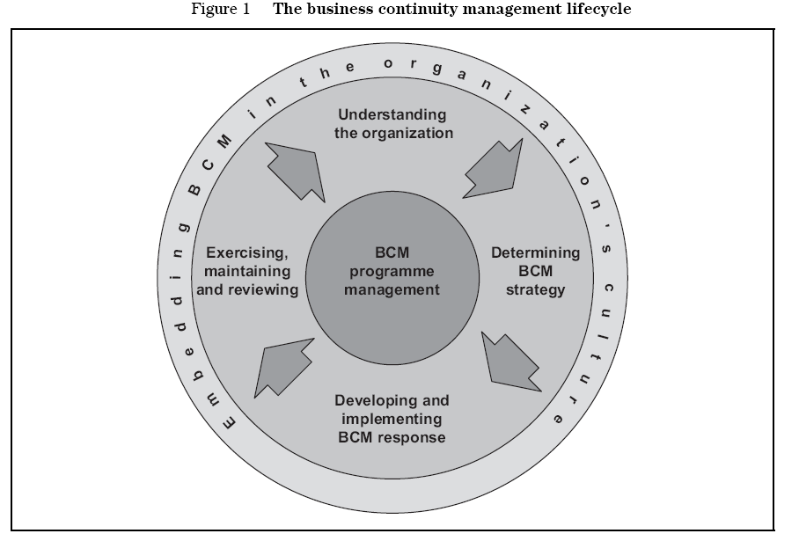

13. The diagram has at its core BCM programme management, which is catalyst for ensuring that robust business continuity plans are developed and maintained.

This includes:
• Assigning responsibilities for implementing and maintaining the BCM programme within the Council;
• Implementing business continuity in the Council – including the design, build and implementation of the programme;
• The ongoing management of business continuity – including regular review and updates of business continuity arrangements and plans.

14. The inner level of the diagram defines four stages to developing and maintaining the business continuity plan.

Step 1 - Understanding the organisation

The use of business impact and risk assessments to identify critical deliverables, evaluate priorities and assess risks to Council service deliveries.

• Business Impact Analysis (BIA) – identifying the critical processes and functions and assessing the impacts on the Council if these were disrupted or lost. BIA is the crucial first stage in implementing BCM, and helps measure the impact disruptions on the Council.
• Risk assessment – once those critical processes and functions have been identified, a risk assessment can be conducted to identify the potential threats to these processes.

Step 2 - Determining BCM strategy

The identification of alternative strategies to mitigate loss, and assessment of their potential effectiveness in maintaining the Council’s ability to deliver critical service functions.

The Council’s approach to determining BCM strategies will involve:
• Implementing appropriate measures to reduce the likelihood of incidents occurring and/or reduce the potential effects of those incidents;
• Developing remedial plans to ensure that strategies are workable;
• Taking account of mitigation measures in place;
• Providing continuity for critical services during and following an incident.

Step 3 - Developing and implementing a BCM Response

Developing individual Service Group responses to business continuity challenges and overarching Business Continuity Plan to underpin this. This Business Continuity Plan ensures that actions are considered for:
• The immediate response to the incident;
• Interim solutions or maintaining an emergency level of service, leading on to;
• Reinstating full services

Step 4 - Exercising, maintaining and reviewing

Ensuring that the Business Continuity Plan is fit for purpose, kept up to date and quality assured. An exercise programme will enable the Council to:

• Demonstrate the extent to which strategies and plans are complete, current and accurate and;
• Identify opportunities for involvement

15. The outer ring of the diagram is possibly the most crucial and elusive step in business continuity terms. This final element is embedding BCM in the organisation’s culture.

The embedding of a continuity culture by raising awareness throughout the Council and offering training to key staff on BCM issues.

This could also include:
• Incorporating BCM in the staff induction process;
• Items in staff newspapers;
• E-mail bulletins
• Intranet pages
• Booklets and prompt cards
• Contact details on building passes

ANNUAL REVIEW

16. If BCM processes are to remain effective and up to date they need to be reviewed on an annual basis. The review should address the following issues:

• Assess the adequacy of the plans and refresh through CMT and Monitoring & Audit Committee;
• Ensure that the Management Team support the main threat strategies;
• Update contacts;
• Test rigour (scenario testing);
• Review the Business Impact Analysis;
• Check ancillary arrangements with other bodies,
• Remind staff of plan (refresher);
• check plan covers appropriate areas of work,
• train new staff who have responder responsibilities,

ROLES AND RESPONSIBILITIES

11. Responsibility for the business continuity management within the Council rests as follows:

a. The Council (through Monitoring and Audit Committee) will exercise responsibility for maintaining plans to ensure that it can continue to perform its critical functions in the event of an emergency so far as reasonably practicable.

b. The Corporate Management Team will receive reports on Business Continuity Management from the Head of Finance (see annual tasks). It is the role of the Plan Owners to ensure that the Business Continuity Plans are kept up to date.

c. Responsibility for the effective delivery of services remains with the respective Heads of Service. All Heads of Services of Mission Critical Activities must ensure they are aware of and support the business continuity strategies and plans.

d. The Management Team provides the Council’s forum to discuss and manage business continuity issues at a senior management level and to monitor and support the review process.

e. The Head of Finance is the professional lead for business continuity within the Council and is responsible for:

(i) Review and development of the Council’s Business Continuity Policy in line with industry best practice and the priorities of MT.

(ii) Monitoring standards and compliance with policy.

(iii) Provision of support and guidance to Heads of Service.

(iv) Production of the Council’s overarching BCP using analysis and assessment work completed within individual Service Group Business Continuity Plans.

(v) Providing advice to local business and voluntary organisations on BCM.

(vi) Ensuring consistency between Emergency Planning and Business Continuity

