Business Base Increase
APPENDIX ‘E’
KETTERING’S BUSINESS BASE GROWTH – TOP OF THE POPS!

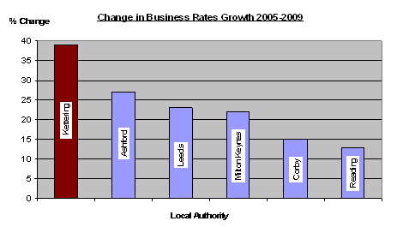
- Kettering’s business base grew by almost 40% during the period 2005 – 2009.

- This puts the borough in the top 10 when compared to the other 326 local authorities in the Country (and one of the best performing Districts)

- The increases in the business base in Kettering Borough is not only the best in Northamptonshire, it is the in the top 2 in the region and amongst the best performing local authorities in the Country.
Data Source: DLCG – Total Contribution to the National Non Domestic Rates Pool. Source NNDR 3 Returns 2005/06 – 2008/09

- When considered against the size of the area and its population base, the increase in the business base in Kettering is arguably amongst the most impressive growth statistics in the Country.

- The increase in business base is no accident, the Council has attracted businesses by its clear and focused strategy for regeneration and investment in the area – the Council’s three key objectives have clearly signaled its intent; these being;

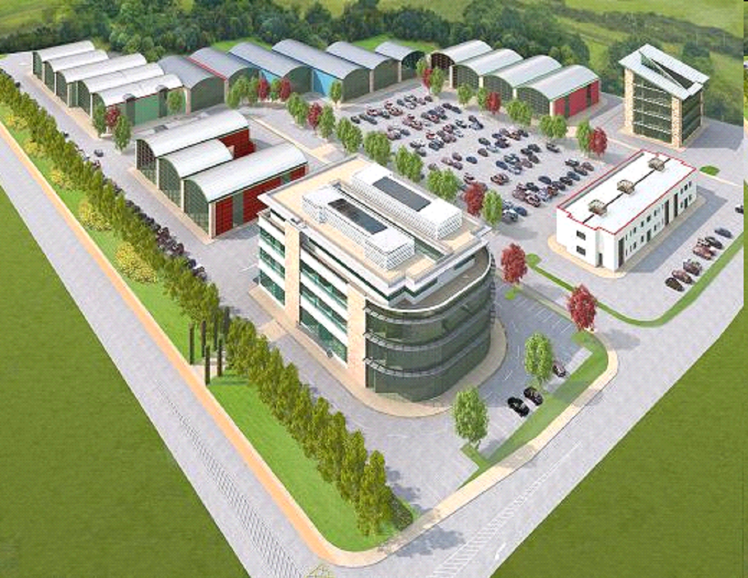
  - Better Town Centres
  - Better Education Offer
  - Better Jobs – higher grade, higher density

- The chart illustrates Kettering’s performance relative to some other areas, including those in growth areas – to be in the company of these more celebrated local authorities is impressive, not to mention significantly outperforming them!

- Examples of ‘big business’ coming to the area include;

  - Tesco
  - Oxford University Press
  - Argos
  - Holiday Inn
  - Harvester

