BOROUGH OF KETTERING

Committee | Full Planning Committee - 12/10/2010 | Item No: 5.1
Report Originator | Alan Davies  Assistant Development Officer | Application No:  KET/2010/0167
Wards Affected | All Saints
Location | 18-20 Lancaster Road, Kettering
Proposal | Full Application: Change of Use from offices/general industrial (B1/B2) to training/childcare/catering services/offices (B1/D1)
Applicant | Mrs M Don KCU Ltd,

1. PURPOSE OF REPORT

  - To describe the above proposals
  - To identify and report on the issues arising from it
  - To state a recommendation on the application

2. RECOMMENDATION

THE DEVELOPMENT CONTROL MANAGER RECOMMENDS that this application be APPROVED subject to the following Condition(s):-

1. The development hereby permitted shall be begun before the expiration of 3 years from the date of this planning permission.
REASON: To comply with Section 91 of the Town and Country Planning Act 1990 (as amended) and to prevent an accumulation of unimplemented planning permissions.

2. No development shall take place on site unless and until full details of all methods of improving the sustainable use and efficiency of the building have been submitted to and approved in writing by the Local Planning Authority. The details shall include insulation, rainwater harvesting or water use reduction and methods to reduce energy use. The development shall not be carried out other than in accordance with the approved details.
REASON: In the interests of satisfying sustainability principles contained within Policy 14 of the North Northamptonshire Core Spatial Strategy and achieving a sustainable development.

3. The use hereby permitted shall not be carried out before 08.00 hours or after 18.00 hours on Mondays to Fridays, nor before 08.00 hours or after 14.00 hours on Saturdays, nor open at any time on Sundays or any recognised public holidays.
REASON: To protect the amenities of the occupiers of nearby properties in the interests of amenity in accordance with policy 13 of the North Northamptonshire Core Spatial Strategy.

4. The parking spaces reserved for mobility scooters hereby approved shall be provided prior to the first occupation of the building hereby permitted and shall be permanently retained and kept available for the parking of such vehicles.
REASON: To ensure adequate on-site mobility scooter parking provision in the interests of local amenity, highway safety and promoting a sustainable and inclusive community in accordance with PPG13: Transport and Policy 13 of the North Northamptonshire Core Spatial Strategy.

5. Notwithstanding the submitted details for cycle storage the use hereby permitted shall not commence unless and until 12 cycle storage spaces have been provided on site in accordance with details which have been first submitted to and approved in writing by the local planning authority.
REASON: To ensure adequate on-site cycle storage in accordance with Policy 13 of the North Northamptonshire Core Spatial Strategy.

Notes (if any) :-
- NONE

Justification for Granting Planning Permission

The proposal is in accordance with national and local policies as set out in Planning Policy Statements 1 and 4, Planning Policy Guoidance 13 and Policies 1, 9, 11, 13 and 14 of the North Northamptonshire Core Spatial Strategy. The issues relating to parking are material planning considerations and, in reaching the decision to approve the proposal, have been carefully weighed against all relevant policy considerations.

Officers Report

3.0 | Information

Relevant Planning History
KET/1990/0840 - Change of Use: Storage and assembly of furniture and retail sales of furniture ancillary to the storage and assembly - Refused 06/11/1990

KET/1980/0433 - Alterations - Approved 23/06/1980.

KET/1975/0909 - Alterations - Approved 04/09/1975.

KB/1971/0684 - Toilet block - Approved 12/11/1971.

KB/1971/0567 - Change of use to light industrial (Suede and Leather garments) - Approved 22/09/1971.

KB/1953/0447 - Covering in yard - Renewed to 31/12/1976.

KB/1949/0014 - Additions to factory - Approved 24/02/1949.

Site Description
Officer's site inspection was carried out on 22/09/2010.

The application site lies on the southern side of Lancaster Road, a predominantly Victorian terraced area located approximately 600 metres in a north-eastern direction from Kettering town centre. The surrounding development is characterised by two storey red-brick terraced dwellings which abut the highway. The proposal site itself follows the existing character of the area, with a two storey red-brick element on the right side of the principle elevation and a yard area on the right which features a collection of single and two storey outbuildings of various designs. This yard is accessed from the highway via a 2 metre high double-gate. This access measures 3.5 metres.

Proposed Development
This application seeks permission for a change of use from B1/B2 (Offices/general industrial) to B1/D1 (Offices/Non-residential institution) at 18-20 Lancaster Road, Kettering. For further detail, please refer to Section 7.0 of this report.

Any Constraints Affecting the Site
None

4.0 | Consultation and Customer Impact

Highway Authority
No objection.

Environmental Health
No objection.

Neighbours
7 Objections received from local residents and a petition with 29 names which raise the following concerns:

- The Transport Assessment is not reliable.
- Difficulty in finding parking spaces will increase. Limited parking is allowed in Bath Road and so most of the residents of Bath Road park in Lancaster Road instead.
- People will be unwilling to walk to the proposed centre.
- There is concern that people will smoke in the street.
- We do not believe it is necessary for the centre to open on Saturdays.
- There will be a loss of privacy to bedroom windows opposite the proposed centre.
- It will be noisy during the construction phase.

2 letters of support were received which raise the following points:

- Up until 18 years ago I was co-owner of 20 Lancaster Road where we manufactured footwear, sometimes 7 days per week from 7.30am until 6.00pm or later if there was a large order.
- Lancaster Road is a residential area no longer suited to manufacturing.

5.0 | Planning Policy

National Policies
PPS1. Delivering Sustainable Development
PPS4. Planning For Sustainable Economic Growth
PPG13. Transport

North Northamptonshire Core Spatial Strategy
Policy 1. Strengthening the Network of Settlements
Policy 9. Distribution & Location of Development
Policy 11. Distribution of Jobs
Policy 13. General Sustainable Development Principles
Policy 14: Energy Efficiency and Sustainable Construction

6.0 | Financial/Resource Implications
 | None
7.0 | Planning Considerations
The key issues for consideration in this application are:-

- The Principle of Development.
- Design and Character
- Residential Amenity
- Highways
- Environmental Considerations
- Other issues raised by the proposal.

1. The Principle of Development

Section 38(6) of the Planning and Compulsory Purchase Act 2004 requires local planning authorities to determine planning applications in accordance with the Development Plan unless material planning considerations indicate otherwise.

National planning policy, in particular PPS1, supports such proposals with a strong emphasis upon ensuring all development is sustainable by making best use of brownfield sites. PPS4 states that local planning authorities should adopt a positive approach to economic development. PPS4 also highlights the importance of the accessibility of a site, the energy/resource efficiency of the proposals, its impact on local employment, the social benefits of the proposals, and the importance of local services. Paragraph 49 of PPG13: Transport states that it is essential to reduce the amount of parking in new development or changes of use in order to promote sustainable travel choices. At the same time, such developments must provide good quality cycle storage facilities in order to promote more cycle use. It is considered that this proposal will satisfy these particular national planning policies as detailed in subsequent sections.

Policy 1 of the North Northamptonshire Core Spatial Strategy states that development will be principally directed towards the urban core, with a focus on the Growth Towns of Corby Kettering and Wellingborough. Furthermore, it establishes an emphasis on regeneration, and the provision of mixed-use developments that incorporate cultural activities in order to provide jobs and services, deliver economic prosperity and support the self sufficiency of the Growth Towns.

Policy 9 of the North Northamptonshire Core Spatial Strategy states that priority for new development will be given to the reuse of suitable previously development land and buildings within urban areas. It establishes that preference will be given to locations that are accessible by a choice of means of travel. Policy 11 of the North Northamptonshire Core Spatial Strategy safeguards existing employment sites, while allowing for the resolution of existing conflicts of uses through change of use applications.

Policy 13 of the North Northamptonshire Core Spatial Strategy provides for changes of use of the kind proposed subject to specific criteria being satisfied. The criteria that are relevant for this application, and a summary of their content follows:
  - a) Incorporate flexible/adaptable building design
  - c) Improve accessible local/community services
  - d) Satisfactory means of access, parking, manoeuvring
  - e) Contribute to 20% modal shift in transport user hierarchy (pedestrian-cyclist-public transport-private vehicle)
  - k) Allow for foot/cycle/public transport use
  - l) Not result in detrimental impact on amenity of existing or future occupiers of adjoining properties
  - m) Reuse existing structures and materials
  - n) Not have an adverse impact on highway
  - q) Not lead to increased flood risk

These issues will be addressed in greater detail in the sections to follow.

Policy 14 of the North Northamptonshire Core Spatial Strategy establishes the need for new development to incorporate techniques of sustainable construction and energy efficiency.

As a result of the above it is considered that the proposed change of use is acceptable in principle, subject to the following detailed issues being satisfactorily addressed.

2. Design, Character and Appearance

There are very few physical alterations proposed as part of this change of use application. The building itself has a long and varied history as a manufacturing site and these small-scale workshops interspersed with Victorian terraces close to the town centre are typical of Kettering’s urban character. The two storey red-brick element on the front elevation which abuts the highway has a very similar mass and scale to the surrounding residential properties and there are no proposed alterations to this elevation. This will therefore not have a detrimental impact upon the existing character and appearance of the area, as the small scale changes to provide for the change of use will not have a noticeable visual impact. It is therefore considered to be in accordance with PPS1: Delivering Sustainable Development.

3. Residential Amenity

Objections have been received which relate to the potential for the site to generate increased noise. The current use of the site is B1/B2, which is business and general industrial use. This use was permitted in 1971 (KB/1971/0567) and no hours conditions were placed upon the premises. Therefore under its current permission the site could be operated for 24 hours a day, 7 days per week as a manufacturing plant. Such use has the potential to generate significantly more noise disturbance to local residents as a result of both operationally generated noise and deliveries to, and despatches from, the site than this proposed use. The proposed use will remove the possibility for machine-generated noise and will lessen the number of vehicles coming to and going from site. Both changes will lessen the amount of noise generated from the site and an educational use for this site is considered to be far more suitable for a predominantly residential area than general industrial use would be.

In addition, the main hours of use of the site will be Monday to Friday from 9.00 am until 5.00 pm and Saturday from 9.00 am until 12.00 pm. These are times considered to be normal business hours. The level of noise generated by the proposed use will therefore not be during times considered to be detrimental to the amenity of neighbouring occupants. As a result, this proposal is in accordance with PPS1 and Policy 13 of the North Northamptonshire Core Spatial Strategy.

4. Highways

National planning policy PPG13 is concerned with transport and the provision of parking for new developments or changes of use. It encourages the use of maximum parking standards to dissuade people from using the car and it promotes the use of sustainable alternatives, particularly for sites which are located in close proximity to town centre areas or existing public transport corridors, which this site is. The current use of the site assumes any employees working at the site would have to use existing on-street parking and the proposed use does not alter this. Given that many neighbouring residents will be at work during the hours of 9.00 am until 5.00 there will be considerably less pressure on the existing on-street parking than in alternative locations.

The submitted Transport Assessment states that 72% of students of KCU, the proposed occupant of the site, live within a 1 mile radius of 18-20 Lancaster Road. Therefore, given the existing parking constraints, it is likely that a high proportion of the sites users will choose to walk. The Transport Assessment indicates that a reasonably high proportion of users of the site would not travel to site by car. Factors relating to this include the high percentage of local people, unemployed and young people who are considered to be less car dependent than other sections of society.

It is proposed to provide cycle racks and a covered area for the parking of pushchairs, buggies, prams and wheelchairs. This accords with PPG13 and again will help the proposed centre lessen the need for its users to travel to site by car. In addition, the building is located 600 metres from the north-eastern edge of the town centre and within 5 minutes walk of Kettering’s main bus station on Newland Street. Therefore this proposal will not have any greater impact upon car parking than the current use and may well lessen the pressure for students to travel by car due to its proximity to existing public transport links. It is therefore considered to be in accordance with PPG13.

5. Environmental Considerations

Policy 14 of the North Northamptonshire Core Spatial Strategy states that developments should meet the highest viable standards of resource and energy efficiency and reduction in carbon emissions. All developments should incorporate techniques of sustainable construction and energy efficiency, provide for waste reduction/recycling and water efficiency and recycling. While the submitted Sustainability Statement makes reference to these matters, it is considered that more clear and definitive methods need to be identified, along with a scheme for their implementation, in order for the requirements of policy 14 of the North Northamptonshire Core Spatial Strategy to be met. Therefore it is appropriate to attach a condition requiring further details for implementation. So long as the proposed improvements can reduce the environmental impact of the building in terms of heat loss, rainwater reuse and the reduction in the amount of energy the building uses. The imposition of such a condition will allow the building to satisfy Policy 14 of the North Northamptonshire Core Spatial Strategy and PPS1: Delivering Sustainable Development.

A resident has raised concerns over flooding in the street. However, there is no change proposed to the footprint of the existing building and the site is outside of any Environment Agency flood risk zone, being included in Zone 1, which is land which has less than 1 in 1000 annual probability of flooding in any year (<0.1%). The proposed canopies over the pushchair storage area and escape route will not exacerbate the amount of existing rainwater run-off, but in the interests of satisfying Policy 14 of the North Northamptonshire Core Spatial Strategy details are required to demonstrate how this scheme will recycle rainwater to provide a sustainable development.

6. Other Issues Raised by the Proposal

One of the objections relates to the potential for this proposal to reduce the value of their property. This is not a material planning consideration and therefore it is not relevant in determining this application. Matters relating to construction vehicles and skips can be controlled by existing Environmental Health legislation, but it is not considered that the scale of alterations to be made will have a detrimental impact upon the existing residents during the refurbishment period.

Conclusion

It is considered the impact upon local residents as a result of on-street parking will not be of any greater detriment than the current permitted use and as a result this proposal is considered to be an appropriate change of use to allow the sustainable reuse of an existing building.

Subject to the proposed conditions it is considered that the proposal is in accordance with the Development Plan policies and national planning guidance. There are no material considerations which would outweigh the policy presumption in favour of the development as stated in Section 38(6) of the Planning and Compulsory Purchase Act 2004. The application is therefore recommended for approval.

Background Papers |  | Previous Reports/Minutes
Title of Document: |  | Ref:
Date: |  | Date:
Contact Officer: | Alison Riches, Development Officer on 01536 534316

SITE LOCATION PLAN

18-20 Lancaster Road, Kettering
Application No.: KET/2010/0167

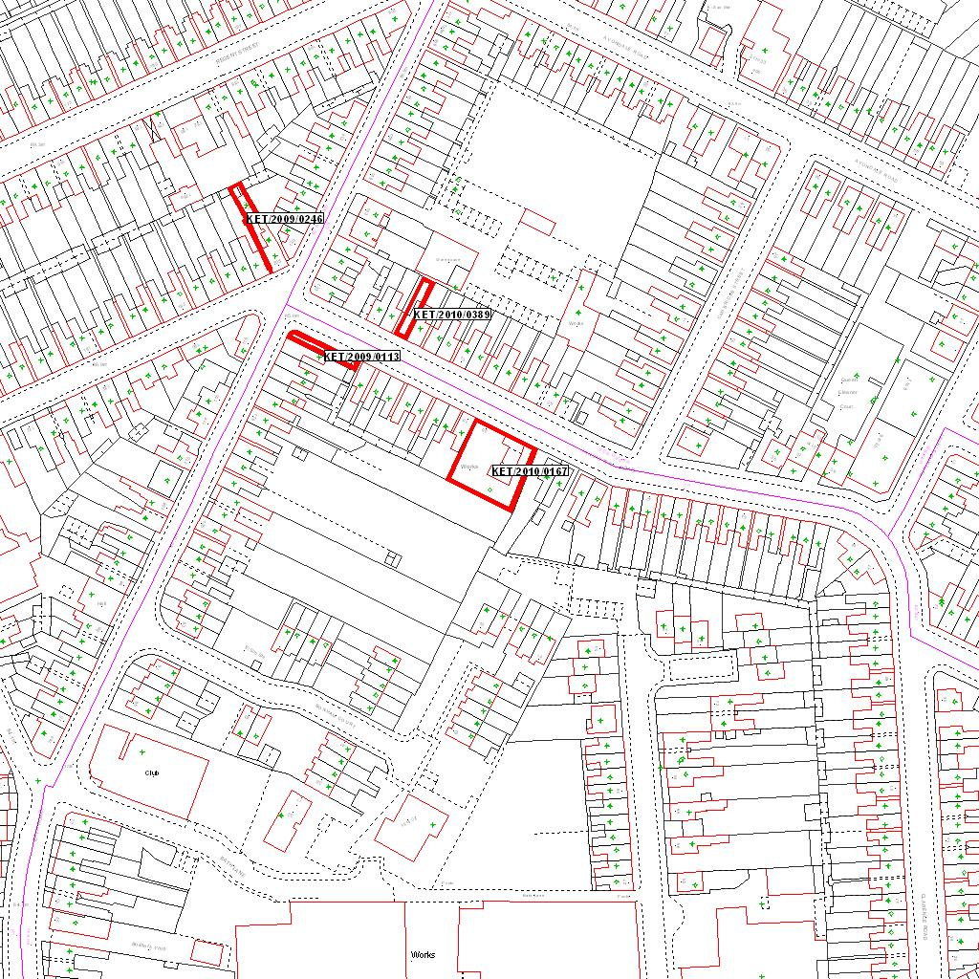

Reproduced from the Ordnance Survey mapping with the permission of the Controller of Her Majesty’s Stationery Office © Crown copyright. Unauthorised reproduction infringes Crown copyright and may lead to prosecution or civil proceedings.  LA078344 |  | N
Date: 18/06/2010 Do not scale from this map. For illustrative purposes only.

