1. PURPOSE OF REPORT

To inform members of progress to date on Suite 16 and to seek support for the compilation of a package of quick-spend projects which can be delivered should any grant underspend become available.

2. BACKGROUND INFORMATION

2.1 Kettering Borough lies within the Milton Keynes and South Midlands (MKSM) growth area and is expected to facilitate growth of some 13,100 homes by 2021.

2.2 Members have made their priorities for infrastructure and jobs-led growth clear – these are the prerequisites of growth. Members have indicated they wish to use the growth agenda to leverage three key and interrelated ambitions for the borough; namely:-

- A better offer for our town centres
- A better education and training offer
- A better employment offer – high grade, higher density jobs

  - The mutually supportive role of these three aspirations cannot be over-stated. The town centre and the skills base will be persuasive to inward investors. Similarly, high grade employment supports a vibrant town centre.

  - The Council’s vision is to create town centres that are:

- Characterful
- Distinctive, and
- Fun

These three key words – enshrined in the Kettering Town Centre Area Action Plan - will help to ensure that the town centre is more than just a place to shop. It will have an experiential offer that encourages visitors to spend time in, and enjoy, our town centre.

- SUITE 16 UPDATE

One of the key strands of ensuring the existing population benefits from new growth in business and homes is the delivery of better town centres. Consequently, it is particularly gratifying to report progress in the three ‘A6’ market towns, as well as Kettering Town.

Burton Latimer Town Centre

  - The former Health Centre in Burton Latimer had been vacant for approximately 5 years, ever since the new facility had been created to the east of the town. Burton Latimer Town Council acquired the building from Northants PCT using monies secured though Section 106 for Morrisons and a loan provided by the Borough Council.

  - Works to refurbish the building commenced in September 2009, and a year later the new facility was complete. The official opening will take place in late October/beginning of November.

  - Most of the work to refurbish the building was carried out by the probation service through their payback scheme. The windows were replaced through a separate contract, with every single pane of glass having been smashed during the period which the building lay vacant.

  - The new facility now houses:

- A Council Chamber in the Central Atrium
- A youth drop-in centre, coordinated by Groundwork
- Space for lectures (the County Council have already booked the facility for language courses and are looking to extend the current offer)
- A Heritage Centre, relocated from the first floor of the old Council offices
- Space for businesses (Henley Centre has already taken up two of the units)

3.5 The scheme was delivered by Burton Latimer Town Council, using its own expertise to manage the refurbishment and to administer the use of the space. Whilst most of the funding came through s106 contributions and the loan by the Borough Council, contributions were also received from the three ward Councillors, using their Ward Initiative funding, and by the precepting of Burton Latimer residents.

3.6 The scheme epitomises everything that is best about the Suite 16 programme, it has used a large proportion of ‘other peoples’ money, it has regenerated a part of Burton Latimer Town Centre through the re-use of a vacant property and it has been delivered through clever partnership working, with the support – but not necessarily intense staff resourcing – from the Borough Council.

Rothwell Velux 2020 Homes

  - The Velux 2020 scheme is for two houses in a semi-detached arrangement on the site of the second phase of the Bovis development ‘Charter House’, on the outskirts of Rothwell. The homes are to form part of the VELUX Model Home 2020 initiative and will demonstrate methods for reducing the carbon impact of housing and of those who live in the homes.

  - The scheme is intended to showcase many of VELUX renewable technologies (Solar thermal) allowing the users to reduce energy bills and overall CO2 emissions associated with heating and lighting a conventional building regulation compliant house. This proposal offers the opportunity for a unique residential development constructed with a high environmental agenda which will set a benchmark for future new communities in the area and beyond.

  - The scheme was officially launched in a ground-breaking ceremony attended by Lord Best, the President of the Local Government Association. Lord Best was in Kettering to see for himself the innovative partnership working that has helped Kettering to deliver successful regeneration schemes, environmentally friendly affordable housing developments, award-winning customer services and support innovative ventures such as the Velux 2020 Homes.

Desborough Lawrences Site

3.10 Executive Committee agreed in September that its preferred option was to sell the site so that it could be developed as a supermarket.

3.11 A full procurement exercise followed which resulted in the Council agreeing Heads of Terms with Greatline Developments for the sale of the site.

3.12 Recently, the Council has agreed a contract for the sale of the site to Greatline Developments – this is subject to a number of conditions which includes the removal of the restrictive covenant.

  - Discussions are ongoing with the Co-op about removing the covenant through negotiation, the Executive Committee have also agreed in ‘principle’ that it will use its statutory planning powers (s237 powers) to remove the covenant should a negotiated settlement not be forthcoming.

  - The applicants have received pre-application planning advice and will be commencing a consultation on their plans very shortly, After this, it is anticipated that they will formally submit their plans for determination.

Kettering Market Place Restaurants

  - Prior to his attendance at the Velux 2020 Homes groundbreaking, Lord Best also visited the site of the new Market Place restaurants. Whilst Lord Best was clearly impressed with the scheme as a whole, he also congratulated officers on the imagination shown in bringing the scheme forward; with the innovative use of the town centre shop and the ‘You Said, We Did’ approach.

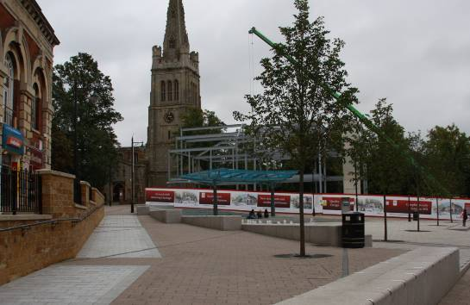 | 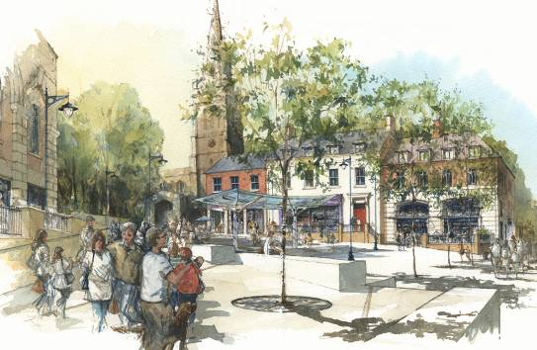
The erection of the steelwork has moved forward at considerable speed, and the shape of the new buildings is fast becoming evident to passers-by.

  - The Market Place Restaurants project is on-track for completion in spring 2011. The fit-out of the restaurants will follow once the building work is complete, with a scheduled opening for Autumn 2011.

Kettering Public Realm Phase 2/3

  - The next phase of Public Realm works will commence shortly. The works will better connect the northern shopping quarter with the restaurant quarter and yards to the south. The re-establishment of this north-south route will be further reinforced when the Transport Strategy scheme is fully implemented and traffic is able to flow once again from the south of the town, northwards.

  - The first phase of works will focus on Horsemarket, where works will continue up to, and after, Christmas. Works on Horsemarket will complete in February 2011.

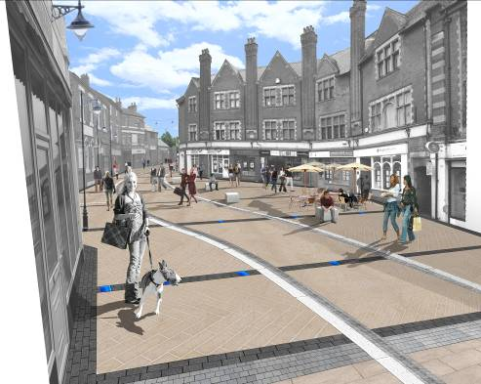 | 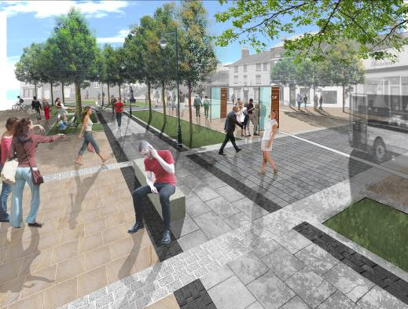
Market Street and Horsemarket will be transformed* into pedestrian-friendly spaces that better-link the north and south of the town centre
(*Artists impressions of the scheme)

  - The Phasing of the Public Realm works means that the Market Place area (including Sheep Street and Market Street) will be free from construction works during the Christmas period. Kettering Borough Council officers and Balfour Beatty have worked hard to ensure that the needs of those businesses around the Horsemarket area are known – and served – during the period of works, in order to ensure that disruption over the Christmas period is kept to a minimum. It is important to recognise that this short-term inconvenience will deliver lasting benefit.

  - Discussions with Stagecoach and the County Council, regarding the new hop-on hop-off bus service between Northampton Road and Horsemarket, are on-going. The aim is to have the scheme up and running for when the new bus area opened at Horsemarket.

Kettering Market Place

3.21 Kettering Borough Council and its partners attended the Homes and Communities Agency Award night on the 23rd September. Whilst the Kettering Market Place scheme did not receive an award, it was still a great achievement to have been shortlisted from a total of no fewer than 283 entries from across the country. In feedback after the award ceremony we wre advised that the Market Place scheme was still relatively “young” and that a resubmission next year, once the next pieces of the Restaurant Quarter puzzle has been put in place, would be most welcome. It was also gratifying to hear some additional positive feedback about the energy and commitment the judges saw in our team.

3.22 The disappointment on Thursday 23rd September was soon forgotten as Friday 24th September saw the Market Place being shortlisted for two categories in the East Midlands Centre for constructing the Built Environment (emcbe) awards for 2010. The Market Place Timeline has been shortlisted for the Heritage Award and the Market Place itself is up for the Infrastructure Award.

3.23 The Market Place has also been nominated for the Council for the Protection of Rural England (CPRE) awards.

4. POLICY IMPLICATIONS

  - The Public Realm Phase 2/3 scheme forms an integral part of the Town’s Transport Strategy for Growth.

  - The Market Place Buildings are part of a second phase of works which will see the delivery of the Restaurant Quarter, which is promoted through the Kettering Town Centre Area Action Plan.

5. USE OF RESOURCES

  - At the last meeting of the Executive, Members were informed that North Northants Development Company had re-allocated a proportion of the Growth Area Funding (GAF) grant money previous approved for the East Northants Leisure Scheme to Kettering Borough. The sum of £290,000 has been allocated as follows:

    - £70,000 for the demolition and re-landscaping of the Hogs Head Site on the Horsemarket in Kettering Town Centre. The scheme will remove an eyesore and prepare a brownfeld site for redevelopment
    - £80,000 towards the re-signalling of the Queen Street Junction. The scheme is part of the phase 2/3 Public Realm Works (permitting new traffic movements as the direction of traffic around Horsemarket is revered) and will also be future-proofed so that the same signal control equipment can be used when Queen Street becomes two-way.
    - £140,000 towards the public realm works on Horsemarket. This scheme will help to close the gap in funding created by last year’s cuts in the Growth Area Fund allocations.

  - All of the GAF-funded projects are required to achieve full grant-spend by the end of the financial year (i.e. end of March 2011). The current programmes for the Market Place Buildings and Public Realm Phase 2/3 achieve this with some comfort.

  - The weeks and months leading to the end of any funding period is a time when it becomes clearer which projects are able to meet their funding deadline. Some projects will fail to spend all of their funding allocation, and this money will often be made available for other districts to bid for. These monies are termed ‘Underspend’ and Kettering Borough Council has been very good in the past at (a) not having any and (b) spending anything that becomes available from other districts failure to spend on time.

  - In order to be best-placed to bid for monies that do become available, and in order to be able to spend that money on projects that continue to deliver the Borough Council’s aspirations for Better Education, Better Jobs and Better Town Centres, a package of quick-spend projects is being compiled by officers. It may be necessary - in order to be able to spend this money - to act quickly, both in terms of selecting which projects are to be promoted for ‘quick spend’ and in gaining necessary approvals.

  - Executive’s approval is requested in respect of these two considerations.

6. RECOMMENDATION

That the Executive Committee supports:

- the continued investment in, and delivery of, town centre projects through the Suite 16.

- the principle of the Suite 16 programme being ‘light on its feet’ in delivering quick-spend projects a the end of the 2010/11 financial year.

Burton Latimer Community Building
Before | After
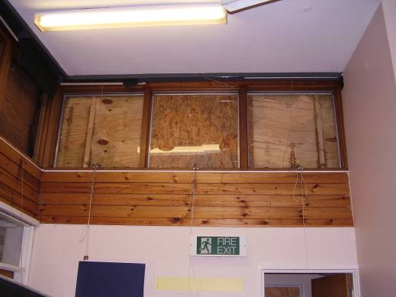 | 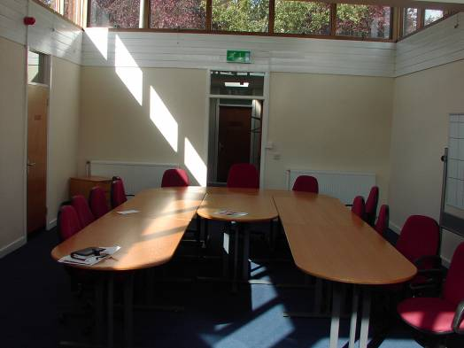
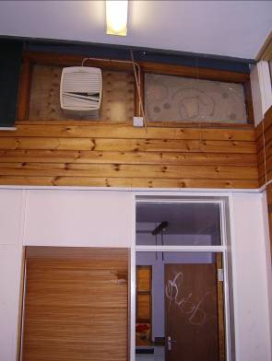 | 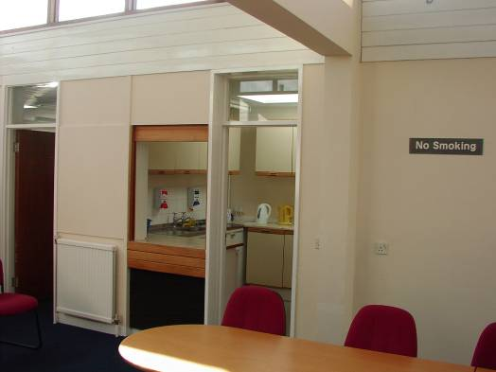
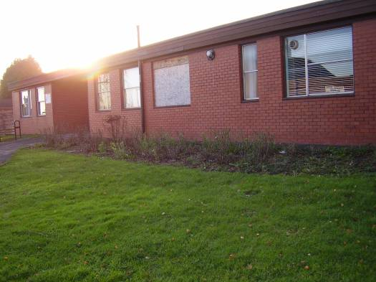 | 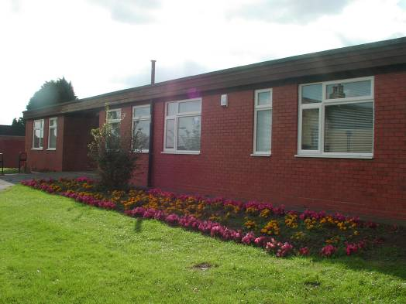
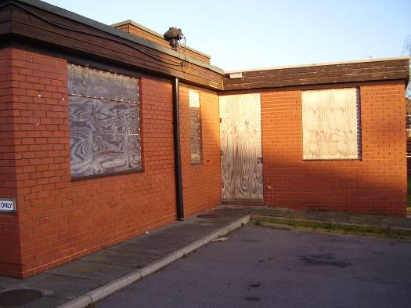 | 