To all Members | Direct Line: (01536) 534398  Email: anneireson@kettering.gov.uk  Our Ref: AI  Your Ref:  Date: 21st September 2010

Dear Councillor

You are summoned to a meeting of Kettering Borough Council to be held in the Municipal Offices, Bowling Green Road, Kettering on Wednesday, 29th September 2010 at 7.00 pm.

Yours faithfully

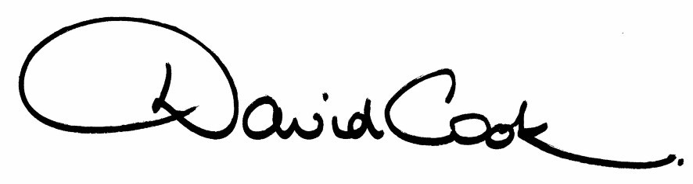

D Cook
Chief Executive

A G E N D A

1. Apologies.

2. Minutes of the meeting of the Council held on 30th June 2010 to be approved as a correct record and signed by the Mayor

3. Declarations of Interest:-

- Personal
- Prejudicial

4. To receive any announcements from the Mayor or the Leader of the Council.

5. Report of the Chief Executive.

6. The Mayor to ask members of the public present if they want to speak on any item on the agenda

7. Northamptonshire NHS Trust – Presentation by Ron Shields, Chief Executive.

8. New Executive Arrangements

9. Standards Committee Annual Report 2009-2010

10. Standards Committee - Reappointment of Independent Members

11. To consider motions received in accordance with Council Procedure Rule 14.

12. To receive questions from members.

13. Any matters of urgency that the Mayor decides should be considered

21.9.10
Fire Alarm

All meetings shall be adjourned immediately on the sounding of the fire alarm. The alarm is a continuous two-tone siren. On hearing the alarm please leave the building by the nearest emergency exit. There are emergency exits at both ends of the corridor outside the meeting rooms. On leaving the building please cross the car park and assemble on the grassed area by the church. Do not attempt to drive out of the car park as this may impede the arrival of emergency vehicles. Please do not return to the building until you are told it is safe to do so by a Council employee.

Toilets

There are toilets in the corridor off the main entrance to the building you came through to get to the meeting room.

Facilities for Babies and Children

If you wish to use a private area to feed your baby please ask a member of staff. There are changing facilities in the corridor off the main entrance adjacent to the toilets.

.Access for Disabled People

There are allocated parking bays outside the main entrance to the Municipal Offices for disabled people. The meeting rooms are located on the ground floor and access is gained for wheelchair users via the main entrance. If you require assistance, please ask the attendant on duty in the reception area.

No Smoking

Smoking is not permitted in the Municipal Offices.

