1. PURPOSE OF REPORT

To provide an update to members on the following;

- A reminder of the Council's Medium Term Financial Policy
- An update of the latest budget position
- Information on recent government announcements
- An update on the work that is taking place on the ‘budget delivery framework’ and a reminder of the key decision dates

2. BACKGROUND

2.1 The ‘maintaining a durable budget’ report is now a standing report to every meeting of the Executive Committee.

  - The Council’s financial strategy and budget were approved at February’s meeting of Full Council. The key messages in relation to the General Fund budget were;

- Council Tax is below the national average (around £3 per week)
- The Council has a strong financial platform (no reliance upon reserves)
- There is no ‘structural operational deficit’ (commonly referred to as a ‘black hole’) in the budget
- 2010/11 is a balanced budget (provided trajectory of past efficiency savings continues)
- Future financial position is ‘difficult but doable’ – the main uncertainty being future levels of Central Government Grant
- Service delivery in priority areas continues to improve and is above average
- The Council continues with a counter cyclical approach to help the local economy.
  - The previous ‘maintaining a durable budget’ reports have outlined the context for the Council’s current 'strong financial platform' and the approach being adopted to manage the Council through the current and future funding cuts. The key elements of these are summarised in the following paragraphs.
  - The Council, unlike many authorities, has a 'strong financial platform'. This is largely due to the long-term success of its Medium Term Financial Strategy. The foundation of the strategy are the 'guiding principles' and 'modelling for recovery principles' which are set out below: -
Guiding principles:

- Revenue balances should not fall below £1m and overall revenue reserves should not fall below 10% of net revenue expenditure;

- In setting the Council Tax, members should consider the medium term to ensure that a sustainable budgetary position is preserved (with due regard being given to any penalties that might apply);

- The level of household Council Tax to increase each year in line with inflation at least, where the budget is in deficit, to ensure resources remain consistent with budgeted costs;

- When setting the Capital Programme, consideration is given to allocating capital resources to schemes that are beneficial to the Council’s overall revenue budget position;

- To maximise the resources available to the Authority, the Council will actively lobby the Government on relevant issues (e.g., grant distribution/ planning fees).

  - The guiding principles have been instrumental in delivering the Council to a position where it has no 'black hole.' The principles discourage the use of one-off reserves to balance the budget in favour of more sustainable methods like proactive budget management, ongoing efficiency savings and attracting external funding.
  - The Council has recognised that as a major economic engine in the Borough it has an important role as a stimulus for the economy and as support to other local businesses. The Council hosted an extremely successful Credit Crunch summit in December 2008 and was able to work with a local construction company to complete the regeneration of the market place when the original contractor ceased trading.
  - In addition to this the Council committed to a set of counter cyclical 'modelling for recovery' principles. The principles were designed to help the Council continue to invest in both infrastructure and services and to help achieve its major objectives of higher grade higher density jobs, better town centres and a better education offer.

Modelling for recovery principles

- Wherever possible, continue with all planned investments and programmes, to protect the local economy and lever in other investments;

- Given that we currently have no long-term debt, we should be prepared to consider debt-funding as a means of programme delivery or stimulus – if this can be shown to be sustainable and have a wider economic benefit;

- Organise our fiscal structures and business models to attract and retain the maximum amount of revenue within the local economy;

- To ensure all possible avenues are used within procurement rules to source locally;

- Protect the performance of Council services which come under particular strain;

- Work closely with partners in the voluntary, public and private sectors, to ensure optimum efficiency.
2.8 Whilst the 'guiding principles' and 'modelling for recovery' principles have provided a robust framework to work within the success comes from an ability to deliver. The Council has an excellent track record of delivering in three key areas spending to budget, driving efficiency savings and attracting external funding.

3. LATEST BUDGET POSITION

  - A budget update based upon the period 1st April – 31st July 2010 for each of the Council’s three main accounts (Housing Revenue, Capital and General Fund) is set out below.
Housing Revenue Account
  - The updated Housing Revenue Account monitoring statement as at 31st July 2010 is attached at Appendix A along with reasons for major variances. A summary of the projected outturn position is shown in the table below: -
  - In general terms, The Housing Revenue Account is currently projected to be ‘on’ budget (with a small underspend of £6,000 currently predicted).
Capital Programme
  - The updated Capital Programme monitoring statement as at 31st July 2010 is attached at Appendix B. A summary of the projected outturn position is shown in the table below: -
  - The capital programme reflects no major variations in schemes at this stage in the year. This will continue to be closely monitored by the Corporate Asset Management Team.
General Fund Revenue Account
  - The updated General Fund Revenue monitoring statement for July 2010 is attached at Appendix C. A summary of the projected outturn position is shown in the table below: -
  - The reasons for major variances are attached at Appendix D and are summarised in the table below. A number of the expected savings reported in July have now been resilience tested and incorporated into the projected outturn. However projected overspends have now been identified for both planning and search fees. Whilst the gap should still be closed by expected savings on waste collection, close monitoring of big ticket items will remain critical for the whole of the financial year.

4. GOVERNMENT ANNOUNCEMENTS - UPDATE

New Homes Bonus Scheme

  - The previous report to this committee outlined the implications of the Government announcement in June to immediately end the Housing and Planning Delivery grant. At the time of the announcement, it was mentioned that there would be a replacement grant to reward / incentivise housing growth but no details were available at that time.

  - Local authority leaders were sent a letter on 9th August from Rt Hon Grant Shapps MP outlining the Governments commitment to a ‘new homes bonus’. A copy of the letter is attached at Appendix E.

  - Although the letter doesn’t provide any specific details about how the scheme may operate, it does importantly signify an intention to have a replacement scheme and describes the benefit as 'direct' and 'substantial.'

  - Officers have, in line with the Council’s agreed approach on lobbying, already had an extremely productive meeting with officials from CLG and taken a lead in two workshops run jointly by CLG and the LGA.

  - A consultation on the proposed scheme is expected in the next couple of months to inform an announcement as part of the spending review in October. Officers are assisting the CLG with both the high level policy objectives of the new grant and its mechanics through the modelling of different scenarios.

Local Search Fees

  - Members will recall that the Council has previously lobbied the Government that the statutory fee for land charge information was too low. The charge was £11 per search and this was mainly accessed by commercial search companies who would then sell on the information to their clients at a significantly increased fee.

  - The Council has consistently argued that services such as these should, as a minimum, be charged at cost. This would ensure that the activities of commercial companies are not being subsidised by local council tax payers. This position is backed up in the Council's core principles for its ‘fees and charges’ and has also been backed by other local authorities, the local land charges institute and the LGA.

  - Following a review by CLG, the statutory fee level was increased to £22 last year. Although this did not meet the request of full cost recovery, it was a step in the right direction. Following the increase, a legal challenge was made by the private search companies who cited European Law as the basis that no charge should be made for access to the local land charges register.

  - Following a lengthy legal process, the Government have now changed the regulations. This effectively means that local authorities can no longer charge the £22 statutory fee. Local authorities (through the LGA) are currently reviewing the implications of this change, Kettering Borough Council collected income of £22,000 during 2009/10 in relation to the statutory fee – it estimates that the income covered about 45% of the actual cost of providing the data.

  - The local government community is very disappointed with the current position. If the position remains it will result in local council tax payers continuing to subsidise the profits of private companies but to a larger extent than in the past.

  - The subsidy per council tax payer will now be around £7 per annum.

- BUDGET DELIVERY FRAMEWORK UPDATE
  - It has been clear for some time that Local Government will face significant cuts in funding in the forthcoming years. It is expected that this will require savings at a level greater than those generated in recent years, which in turn will require an even greater focus on a comprehensive, consistent and coherent approach if the Council is to continue to meet its objectives, retain its strong financial and balanced budget position.
  - The Council has already identified the importance of building from its current position of strength and acting early to ensure that savings identified are both accurate and resilient. The success has also shown the need to stick to a clear strategy to resist the temptation to seek silver bullets and to work steadily and diligently across the organisation to identify the required savings.
  - A formal framework has been established to achieve this and is illustrated below: -
  - This budget framework update focuses mainly on the prioritisation, fees and charges and staff suggestion work streams. Members may wish to note that work has commenced on the eight work streams and that each one is being progressed by a dedicated team of staff.
Prioritisation Work Stream

  - Members will recall that the key objectives of this work stream are:

- To ensure that priorities and spending plans are aligned
- To assist develop future priorities
- To help identify lower priorities (to assist with future resource allocation plans)

  - The Council’s current corporate objectives and priorities are attached at Appendix F. They were originally adopted in 2006 and are refreshed annually through the budget, service planning and corporate improvement programme process. As part of the Prioritisation Review, it will be necessary to undertake a review of priorities so that a framework exists from which lower priorities can be identified in a transparent manner.

  - The Research and Development Committee are scheduled to participate in this work stream at their meeting on 20th October and Monitoring and Audit Committee will also consider the work stream on 23rd November, so that the results can feed into the budget setting process for 2011/12.
  - The following table sets out a framework that can be used for such a reference point;

 | Issue to be considered | Reference Information
1 | Is the service fundamental to our local community? | Community Plan  Corporate Objectives  Customer Surveys
2 | Is the service at the heart of the core ambitions of the council? | Customer Surveys  Benchmarking  Performance Data
3 | Does the service have to be provided by the Borough Council at all? | Statutory / Discretionary
4 | What is the current standard/level of provision and is that consistent with 1-3 above? | Benchmarking
6 | What value added could be gained by working with partner(s)? | Partner aspirations/ plans

7 | What would be the wider impact on the economy and community if the service was reduced or rationalised?  Customer Numbers affected?  Wider Economic Impact = high / medium / low | Customer profiling

  - In order to test the suggested framework, in a way which will produce results which are justifiable and transparent, a pairing - and other prioritisation – exercise(s) will be undertaken over the coming weeks.

  - That process, supported by officers, will help formulate new corporate priorities and identify lower priority services. The results will be brought back to the Executive for consideration.

  - The results from these exercises should also impact on other work streams such as Fees and Charges and Capital Review for example for fees and charges we could add a principle as follows: -

Where services are identified as lower priority and fees and charges apply, or could apply, the service should aim to be self financing. Where this is felt to be unachievable through adjusting fees, consideration should be given to ceasing or scaling back the service to minimise tax payer subsidy.

Staff Suggestions Work stream

  - As previously reported, suggestions from staff during last year resulted in a number of very good ideas for savings. To date, these have helped the Council make in the region of £200,000 of budget savings. There is about the same level of savings still to come through the pipeline when other savings have been harvested. The suggestions for savings fell into three broad categories;

- The way we operate;
- How we procure goods and services;
- How we use assets.

  - The staff suggestions scheme is still in operation and ideas that have come through this process have been supplemented by the recent series of staff sessions. Suggestions will be evaluated and then the work stream will set about planning and implementing the ideas in a coordinated manner.
Fees and Charges Work Stream

  - Members will recall that the key objectives of this work stream are:
a) Review and refresh the existing policy;
    - Assess the potential to raise additional income;
    - Make explicit choices between the ‘user pays’ or ‘council taxpayer pays’ or the most appropriate mix in each case;
    - Review of the Council’s concessions policy;
    - Identify Trading Opportunities.

  - The guiding principles that underpin the council's current ‘best practice’ approach are reproduced below for members information:

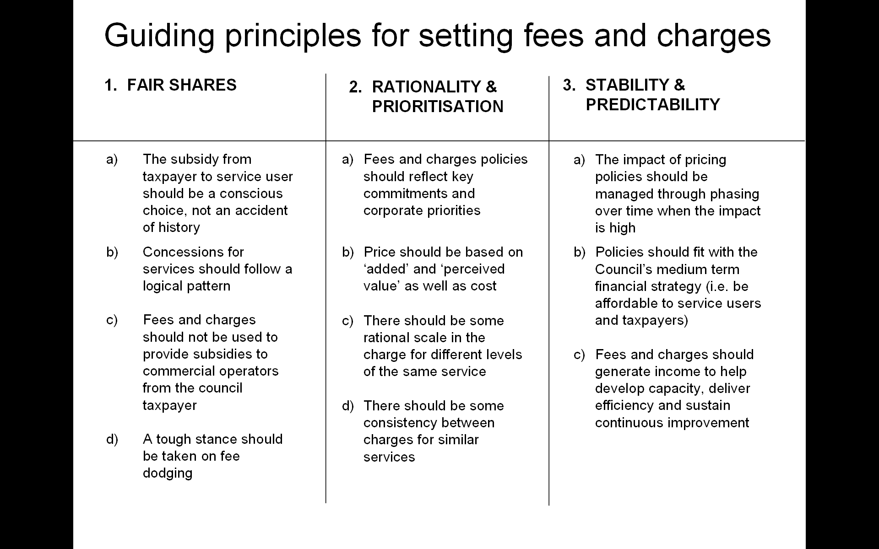

  - Unless members advise to the contrary, the above ‘principles’ will still form the basis of the Council’s fees and charges policy. The current economic climate may require them to be more rigorously applied.

  - When further analysis has been undertaken and new proposals formulated, it is likely the key areas for consideration will be in relation to ensuring that the ‘price point’ for each service is at the correct ‘base’ level (from which to operate the principles) and also to ensure that the price point is unfettered by an individual's ability to pay for the service (which will be fully and properly considered by reviewing the concessions policy that runs alongside the fees and charges principles).

  - It is considered good practice to standardise the date at which fees and charges are adjusted each year. It has been alluded to in previous reports that the date should be at the beginning of January each year – this would bring the rest of the council's fees and charges in line with the practice that has operated for some time in relation to car parking charges. As part of the background work, any practical issues in relation to this will need to be considered and dealt with.

- CONSULTATION AND CUSTOMER IMPACT

The work to be undertaken through the budget delivery framework will provide the basis for the Council’s budget for 2011/12. The formal consultation process will be set out at the December Executive with consultation commencing early in 2011.

- POLICY IMPLICATIONS

There are no direct policy implications in this report.

- USE OF RESOURCES

The implications on the Council resources are considered throughout the report.

9. RECOMMENDATIONS
That the Executive: -
  - Note the current year budget position for the Council’s three main accounts.
  - Endorses the approach for delivering the prioritisation workstream as set out in section 5 of the report.
  - Endorses the approach for delivering the fees and charges workstream as set out in section 5 of the report.

Background Papers: Previous Reports/Minutes:

Title of Document: Various Ref: Exec Report
Date: Sept 2010 Date: July 2010
Contact Officer: Paul Sutton

