***Item 10 Appendix A***

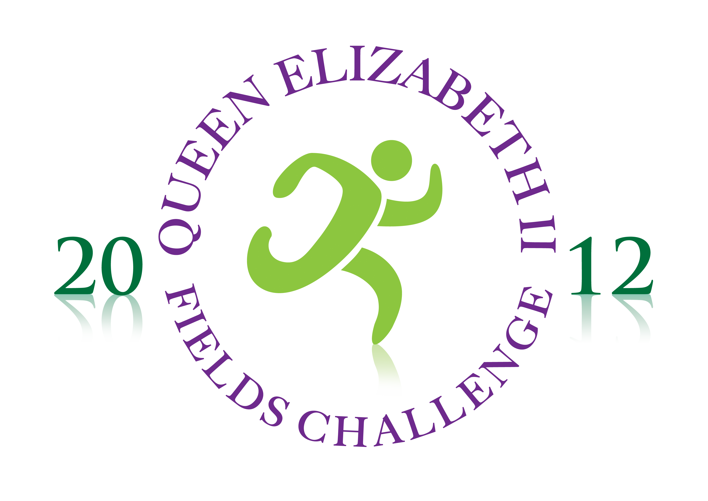

**FREQUENTLY ASKED QUESTIONS**

**1 What is the initiative all about?**

The QEII Fields Challenge aims to safeguard hundreds of playing fields in perpetuity for future generations in celebration of the Diamond Jubilee and as a permanent tribute to Queen Elizabeth II. The initiative has particular pertinence given the other landmark event scheduled to take place in the UK in 2012: the London Olympics.

**2 Why is access to green space such an important issue at this time?**

Access to outdoor space is vital for communities and plays an important role in providing a place for both physical activity and relaxation. Sport and play are essential tools for developing confidence, self-esteem and learning the importance of team work. It is well documented that community recreation reduces alienation, loneliness and anti-social behaviour whilst also promoting ethnic and cultural harmony.

The recent Inverdale report published in May 2010 states that there is evidence that the number of playing fields has reduced from 26,000 in 1992 to 20,000 in 2009 and so it is vital that we take action.

**3 How many fields actually need to be secured to reach the 2,012 target? How many do you have already?**

Around 1,500 need to be secured to make the 2,012 target. At present, Fields in Trust currently protects 1,271 fields.  Many of these are already dedicated to specific people or purposes, notably the King George V Memorial Playing Fields, which were established as a memorial to the late Monarch after his death in 1936, and total 471 fields.  Some other sites that make up the 1,271 fields are very localised and small and do not meet the criteria established for the Queen Elizabeth II Fields.  Therefore, the total number of existing sites that can be included is approximately 550 leaving the total of new dedications to be found between now and 2012 at around 1,512.

**4 Are you creating any new fields? Or are they all existing fields?**

It is anticipated that the vast majority of the fields commemorating The Queen’s Diamond Jubilee will be existing playing fields – where they are valued and supported by the votes of local people it is very important that they are protected. However we also hope to help create some brand new fields by protecting outdoor space within new housing estates, persuading private landowners to donate land for recreational use – especially in rural areas – and potentially through the conversion of public wasteland.

**5 Aren’t you just re-naming existing fields after The Queen?**

Absolutely not, Fields in Trust exists to safeguard fields through legal means by placing covenants on the land, meaning they have to remain playing fields forever. Decades of urban development have seen the stock of playing fields reduce substantially. Once lost, playing fields are lost for good. FIT’s aim is to safeguard existing fields for the future. The QEII Fields Challenge will boost *existing* numbers of safeguarded fields for the benefit of future generations.

**6 Once the 2,012 target is reached, will the programme end?**

It’s too early to say. At the moment, the target is for 2,012 fields, but Fields in Trust has an ongoing programme of saving and enhancing playing fields, so we would always be interested in more.

**7 Is there a deadline for acquiring the 2,012 sites - 2012?**

FIT will be working to secure as many Queen Elizabeth II Fields as possible by 2012 but some fields may come on line after this date if negotiations are protracted. As the Challenge heralds the beginning of an exciting decade of sporting events in the UK we are very happy that the project may extend beyond 2012.

**8 What is the role of the UK Government in this programme?**

The previous and current governments have both been very broadly supportive of this initiative to protect outdoor spaces for sport, play and recreation in the landmark year of 2012. An endorsement of the campaign from Hugh Robertson, Minister for Sport and the Olympics is on our website.

**9 Who are you targeting with this initiative?**

FIT aims to engage the whole nation with this exciting legacy initiative. At the outset we are chiefly targeting the larger local authorities as their support for the project is absolutely the key to its success. We want each Local Authority throughout the United Kingdom to nominate a series of playing fields in their area that they would be happy to protect as a Queen Elizabeth II Field (to be known as a Queen Elizabeth field in Scotland. We will then target the public at large by putting these fields forward to a vote allowing the general public to vote for their favourite local playing field to be protected. We hope that the public will be excited by the chance to be involved in creating a permanent and tangible legacy to benefit their community both now and in the future. We also hope that Local Authorities will see the great benefits that protecting these spaces will have in terms of addressing some of their key agendas around increasing physical activity, promoting social cohesion and improving the environment, alongside celebrating Her Majesty’s 60 years on the throne in a long-lasting way for their communities.

On a secondary level we also want to encourage any town, parish or community council; sports club, recreational charity; voluntary body or private landowner who might want to get involved with the initiative and so will be accepting submission of individual fields to the scheme providing they meet the set criteria. This will provide a great opportunity to create some brand new playing fields.

**11 Why should Local Authorities get involved with this initiative?**

Local Authority elected members and officers take many important decisions and The Queen Elizabeth Fields Challenge presents an opportunity to safeguard a community facility that will not only benefit people today but also generations to follow, securing for communities access to outdoor spaces for sport, recreation and play. At a time when one in three children under 12 is overweight or obese, protecting and encouraging greater use of local parks and playing fields is vital.

**12 How will people vote for their nominated field?**

The public will vote for their favourite local playing field through our new website [www.qeIIfields.com](http://www.qeIIfields.com). All playing fields nominated by Local Authorities will be uploaded to this site so that people can search for their area and cast a vote for the field they would like to be protected as a Queen Elizabeth II Field. We are hoping to provide a mechanism to enable the public to cast votes by phone and text. Voting will commence in 2011.

**13 How can the public support the Challenge?**

The public can support the Challenge in a number of ways including by actively voting for playing fields to be protected and encouraging their Local Authority to sign up to the initiative. Donations from the public to the Challenge would, of course, also be welcomed!

**14 Will Scotland, Wales and Northern Ireland be as interested in a campaign that has the London Olympics as one of its pillars?**

The project aims to create playing fields in perpetuity for future generations across the UK as a lasting legacy of the Diamond Jubilee. Clearly there is relevance to the many other sporting events this decade: Olympics in London and the Commonwealth Games in Glasgow, together with other landmark events as the Rugby World Cup scheduled for 2015.

**15 How is a playing field defined and what are the criteria to be met?**

There are many ways to define a field but what we are primarily interested in are sites used for outdoor sport, physical recreation and play. We do however also recognise the importance of informal use and therefore there will be sites of real community value which function as general open space. We want to include these where appropriate.

**16 Does Fields in Trust lobby Government for a change in the law?**

FIT’s primary aim is to secure better access to outdoor space for sport, play and recreation for everyone, and so part of their core work involves campaigning to strengthen the statutory protection of playing fields. FIT have had considerable success lobbying government over the years and helped to secure greater protection for both school and community playing fields and will continue to seek enhancement of this legislative protection.

**17 Does FIT try to influence Local Authorities in their decision making?**

Fields in Trust has worked very closely with Local Authorities since its formation in 1925, and of course continues to do so.  We recognise fully the contribution made by many Authorities in terms of providing and managing playing fields and other forms of open space for local communities.  We have had a positive impact in terms of recommending facility standards for sport and play, recreational planning matters including the widely used *Planning and Design for Outdoor Sport and Play* (aka *The Six Acre Standard*), direct protection of sites owned and managed by authorities (about 50% of the 1271 we protect) and indirect protection through planning and educational legislation.

**19 Why are you putting this to a public vote? Why not protect all the nominated fields?**

We want to create a real sense of public engagement around the project so that communities not only feel that something relevant and tangible is created as a legacy but that they have played a part in helping to create it. FIT’s model works very much on the basis of local ownership and management and so we are pleased to be able to extend this community involvement to the new campaign. Our goal is 2,012 fields protected by 2012 but, with sufficient funds, we’d be delighted to include more fields in the overall tally. On this occasion first past the post will operate – maybe it will engender some local competition!

**21 How is a playing field defined for this programme? What criteria need to be met?**

Existing sites protected by Fields in Trust and new sites to be afforded protection by Fields in Trust need to satisfy the following criteria if they are to be accepted into the Fit for the Future Programme. The criteria are:

* Evidence of title permitting site use for outdoor, sport, play and/or recreation must be produced.
* Sites may be provided with facilities and equipment or used as general open space, and established for that purpose by way of planning requirements
* Each site’s principal use should be outdoor sport, play and/or recreation, though FIT wants to be flexible and in this context dedications also including indoor leisure facilities, village halls or other buildings enabling community recreation will be considered
* The minimum acceptable size is 0.2 hectare (0.5 acre)
* Sites need to be accessible in terms of location
* Sites need to be accessible in terms of affordability for the community concerned
* Sites should be open to the public, and established charitably or, as facilities held by a sports club under the CASC regime or as Public Open Space
* All sites will need local managers, who will be responsible for the quality of facilities, their maintenance and development, improving participation and use, and financial and operational sustainability
* Compliance with existing legislation relating to sport, play or open space

**22 What is the legal process for protecting these sites?**

With the larger local authorities we aim first to agree a Memorandum of Understanding governing our joint commitments to matters relating to site identification, nomination and selection. When the actual sites have been selected following the community voting process, each site will be made subject to a deed of dedication safeguarding it in the longer term. Our objective is to protect sites in perpetuity but in special circumstances we would consider protecting a site for a fixed period of time, but not normally less than 100 years.

**23 How flexible is the process?**

FIT has developed a number of options which we hope will suit all landowners. These include:

* protection in perpetuity or for a fixed time period, as mentioned above
* establishing the site on charitable trusts or protecting it as a non-charitable site
* protecting the land for general open space purposes, specifically for sport or games or for outdoor and indoor recreational purposes, depending on present and foreseen use

**24 Will the specific playing field always be protected?**

Fields in Trust does accept that on rare occasions communities change and land use changes accordingly. Parts of sites, or very rarely, whole sites can therefore be disposed of provided the disposal is of clear advantage, and in the best interests of the community, from a recreational perspective. The criteria which FIT applies to replacement facilities are that they should be of:

* at least equal size
* better quality
* serving the same community in terms of catchment area.

Additionally, and very importantly, the entire proceeds of any disposal should normally be re-applied to new sport, recreation and/or play facilities, with priority given to outdoor prior to indoor facilities

**25 Can previously dedicated fields be included?**

It depends on the terms of the dedication but where any site is dedicated as a memorial to one or more deceased people, FIT regards it as inappropriate for inclusion in the Queen Elizabeth II Fields Challenge.

**26 Will FIT take over the management of a field?**

No, all the sites protected by FIT are locally managed. Local communities, landowners and users are in a far better position to know how local facilities can best be provided, used and enhanced. All aspects of management and maintenance are determined locally. FIT’s role is custodial and advisory. We see protection by these means as having a light touch but being absolutely effective. We ensure that the fact of protection of these sites is in the public domain and that any change of use or any buildings which fall outside the terms of protection need our specific advance consent.

[**www.qe2fields.com**](http://www.qe2fields.com)

[**fields@fieldsintrust.org**](mailto:fields@fieldsintrust.org)

