1. CONTEXT

  - The report follows on from the previous reports to Executive and begins to deliver previous resolutions on the existing adopted policy of the council with regards to financial strategy and budget setting.

  - The economics of the country are currently very fluid. Public services will become even more crucial to local people over the coming years. The Executive have previously set out their strategy for protecting the local economy and service delivery and this report sets out a comprehensive, coherent and detailed strategy for delivering those ambitions.

  - The report contains the following sections:

Background Information
- Guiding principles
- Modelling for recovery principles
- Delivering to Budget
  - Efficiency Savings
  - External Funding
- Framework

Outturn Position
- General Fund
- Capital Programme
- Housing Revenue Account

Recent Government Funding Announcements
- Abolition of Housing and Planning Delivery Grant
- LAA Reward Grant
- Free Swimming Scheme

Budget Update 2010/11
- HRA
- Capital Programme
- General fund Revenue Account

Coalition Government Budget

- Public Sector Pay Freeze
- Government Departments funding cuts
- Council Tax incentive scheme
- VAT increase

Impact on Medium Term Financial Strategy

Budget Delivery Framework
- Fees and charges
- Capital Review
- Lobbying
- Prioritisation
- Total Place / Front Desk
- Innovation Group
- Staff Savings
- Service Plans

Recommendations

Appendices

A – Housing Revenue Account
B – Capital
C – General Fund Revenue
D – General Fund Revenue with variations
E – Fees and Charges
F – Capital Programme Links
G – Fees and Charges Presentation

2. BACKGROUND INFORMATION

2.1 The ‘maintaining a durable budget’ report is now a standing report to every meeting of the Executive Committee.

  - The Council’s financial strategy and budget were approved at February’s meeting of Full Council. The key messages in relation to the General Fund budget were;

- Council Tax is below the national average (around £3 per week)
- The Council has a strong financial platform (no reliance upon reserves)
- There is no ‘structural operational deficit’ (commonly referred to as a ‘black hole’) in the budget
- 2010/11 is a balanced budget (provided trajectory of past efficiency savings continues)
- Future financial position is ‘difficult but doable’ – the main uncertainty being future levels of Central Government Grant
- Service delivery in priority areas continues to improve and is above average
- The Council continues with a counter cyclical approach to help the local economy.
  - The previous ‘maintaining a durable budget’ reports have outlined the context for the Council’s current “strong financial platform” and the approach being adopted to manage the Council through the current and future funding cuts. The key elements of these are summarised in the following paragraphs.
  - The Council unlike many authorities has a “strong financial platform.” This is largely due to the long-term success of its Medium Term Financial Strategy. The foundation of the strategy are the “guiding principles” and “modelling for recovery principles” which are set out below: -
Guiding principles:

- Revenue balances should not fall below £1m and overall revenue reserves should not fall below 10% of net revenue expenditure;

- In setting the Council Tax, members should consider the medium term to ensure that a sustainable budgetary position is preserved (with due regard being given to any penalties that might apply);

- The level of household Council Tax to increase each year in line with inflation at least, where the budget is in deficit, to ensure resources remain consistent with budgeted costs;

- When setting the Capital Programme, consideration is given to allocating capital resources to schemes that are beneficial to the Council’s overall revenue budget position;

- To maximise the resources available to the Authority, the Council will actively lobby the Government on relevant issues (e.g., grant distribution/ planning fees).

  - The guiding principles have been instrumental in delivering the Council to a position where it has no “black hole.” The principles discourage the use of one-off reserves to balance the budget in favour of more sustainable methods like proactive budget management, ongoing efficiency savings and attracting external funding.
  - The Council has recognised that as a major economic engine in the Borough it has an important role as a stimulus for the economy and as support to other local businesses. The Council hosted an extremely successful Credit Crunch summit in December 2008 and was able to work with a local construction company to complete the regeneration of the market place when the original contractor ceased trading.
  - In addition to this the Council committed to a set of counter cyclical “modelling for recovery” principles. The principles were designed to help the Council continue to invest in both infrastructure and services and to help achieve its major objectives of higher grade higher density jobs, better town centres and a better education offer.

Modelling for recovery principles

- Wherever possible, continue with all planned investments and programmes, to protect the local economy and lever in other investments;

- Given that we currently have no long-term debt, we should be prepared to consider debt-funding as a means of programme delivery or stimulus – if this can be shown to be sustainable and have a wider economic benefit;

- Organise our fiscal structures and business models to attract and retain the maximum amount of revenue within the local economy;

- To ensure all possible avenues are used within procurement rules to source locally;

- Protect the performance of Council services which come under particular strain;

- Work closely with partners in the voluntary, public and private sectors, to ensure optimum efficiency.
  - Whilst the “guiding principles” and “modelling for recovery” principles have provided a robust framework to work within the success comes from an ability to deliver. The Council has an excellent track record of delivering in three key areas spending to budget, driving efficiency savings and attracting external funding. This is described and illustrated below:-
GOOD TRACK RECORD

Value Added

  - The Council’s ‘Guiding principles’ and ‘Modelling for Recovery’ principles drive a different approach to business modelling. The typical model focuses on reducing funding and resources (inputs) without considering the impact on service delivery (outputs) and can be extremely counter productive;

  - The Council’s approach is to identify and understand the value of the services being delivered (outputs). The focus is then given to ensuring that the process for delivering the service is sound and “fit for purpose” adding value to the funding and resources. Using this approach the Council has been successful in delivering “more for the same” or in many cases more for less. The approach is illustrated in the diagram below:

Delivering to Budget
  - The Council has an exemplary record of annually delivering the budget within very small tolerances. Best practice advice suggests that if a local authority delivers its annual budget within 2.5% of budget that this represents good performance – the following chart illustrates the Council’s performance since 2004/05;
Efficiency Savings
“Good Practice Range”
  - The Council has taken the delivery seriously for many years and the instigation of the next steps service reviews ensured that the continued delivery of efficiency savings is inbuilt into the fabric of the service planning and budget process. The graph below shows savings achieved in the last 6 years.
External Funding
  - The Council has recognised for many years the importance of both attracting external funding but also using it effectively and on time. The graph below shows the amount of funding attracted through performance or bidding in the last 5 years. The Council is also awarded a number of general grants, which means that in the last 5 years for every £1 the Council has collected in Council Tax it has raised in excess of £1 from external sources.

  - It has been clear for some time that Local Government will face significant cuts in funding in the forthcoming years. It is expected that this will require savings at a level greater than those generated in recent years, which in turn will require an even greater focus on a comprehensive, consistent and coherent approach if the Council is to continue to meet its objectives, retain its strong financial and balanced budget position.
  - The Council has already identified the importance of building from its current position of strength and acting early to ensure that savings identified are both accurate and resilient. The success has also shown the need to stick to a clear strategy to resist the temptation to seek silver bullets and to work steadily and diligently across the organisation to identify the required savings.

BUDGET DELIVERY FRAMEWORK

  - A formal framework has been established to achieve this and is set out below: -

  - This report focuses specifically on the following issues;

- The financial implications of the out-turn figures for last year (now that the statement of accounts have been approved by a meeting of full Council).

- The possible implications of recent announcements by the Government including;

    - The abolition of Housing & Planning Delivery Grant
    - The reduction in LAA Reward Grant
    - The early termination of funding for the national free swimming scheme
- A Budget Update for 2010/11, which incorporates the implications of the recent announcements and the updated outturn figures.
- An early assessment of the likely implications of the Coalition Government’s budget that was announced on 22 June 2010. Including: -

    - Public sector pay freeze (for two years from 2011/12);
    - Government Departments funding cut of 25% over 4 years;
    - An incentive scheme to support a Council Tax freeze (for 2011/12);
    - VAT increase to 20% (effective from 4 January 2010)
- The impact the budget has on the Medium Term Financial Forecast and a review of the key assumptions.

- Further details about the Councils budget delivery framework - including the eight key work streams previously agreed together with the outline action plans and milestones.

  - As a reminder, the illustration at 2.14 above outlines the eight key work streams that will be progressed over the coming months. These are discussed in more detail later in the report.

3. OUT-TURN POSITION (2009/10)

General Fund (Revenue)

  - The outturn for the General Fund resulted in the General Fund working balance increasing to £1.384m – this is £51,000 more than budget and represents an outturn position that is within 0.5% of net revenue budget. In effect, the out-turn for the year represented a £51,000 surplus.

  - The following table is an extract from the Councils Statement of Accounts that was approved by Council on the 30 June 2010;

 | Revised
 | Budget | Actual | Variance
 | £000 | £000 | £000
Expenditure
Net Service Expenditure | 14,730 | 15,756 | 1,026
Capital Financing Adjustments | (1,315) | (2,401) | (1,086)
Total Net Expenditure | 13,415 | 13,355 | (60)
Income
Revenue Support Grant | (1,341) | (1,341) | 0
Business Rates | (5,810) | (5,810) | 0
Met by local council taxpayers | (6,136) | (6,136) | 0
Collection Fund Surplus | (100) | (91) | 9
Total Income | (13,387) | (13,378) | 9
(Surplus)/Deficit for the year | 28 | (23) | (51)
Balance brought forward | (1,361) | (1,361) | 0
Balance carried forward | (1,333) | (1,384) | 51

  - Given the adverse national economic conditions (in particular the pressure on income sources) achieving an outturn within a tolerance of 2.5%, represents a good performance for the year.

  - This position maintains the Council’s track record of bringing in its budgets on target. The chart below shows that the Council has consistently managed the budget within the best practice tolerance and in the last 4 years within 1% of net budget. This discipline will provide the Council with a solid platform from which to address the difficulties that will undoubtedly be faced in 2010/11 and beyond.

“Good Practice Range”

  - The out-turn for the year is generally in line with the Council’s Medium Term budget forecast.

Capital Programme

  - The outturn for the Capital Programme showed that expenditure during 2009/10 was £7.461m compared to the revised budget of £7.997m - 93% of the approved programme was actually spent during the year.

  - The following table is an extract from the Councils Statement of Accounts that was approved by Council on the 30 June 2010;

 | Revised
 | Estimate | Actual | Variance
 | £000 | £000 | £000
Expenditure
Council Housing Schemes | 2,511 | 2,429 | (82)
Private Sector Housing Improvement | 951 | 845 | (106)
Investment & Repair Programme | 723 | 548 | (175)
Community Project Schemes | 3,196 | 3,177 | (19)
E-government investment programme | 586 | 462 | (124)
Other General Fund Schemes | 30 | 0 | (30)
Total Capital Expenditure | 7,997 | 7,461 | (536)

  - Capital expenditure incurred on Housing schemes was principally financed from the Major Repairs Allowance (in accordance with the Council’s capital financing strategy), and General Fund schemes were financed from a mix of capital receipts, Government grants, other capital contributions and notional external borrowing.

  - The ‘real’ budget variance will be within 1% of the net programme after carry-forwards are included. This represents good delivery on an £8m programme

Housing Revenue Account (HRA)

  - The outturn for the HRA resulted in expenditure being £5,000 less than net budget - this represents a variance of 0.04%.

  - In 2008/09 HRA balances had fallen below the ‘minimum level’ the Council had identified as part of its Medium Term Forecast. This was caused largely by the fluctuations in the housing subsidy mechanism. Whilst, the mechanism is still in place the Council has managed to restore the HRA balance back to £305,000

  - The medium term financial strategy for the HRA, states “the account must operate in a surplus position and this is achieved by adopting the principle that an agreed minimum balance of £300,000 should be the HRA’s primary strategic aim over the medium to long term.”

  - Given the economic conditions and issues with housing subsidy, returning the HRA balance back to the agreed minimum in one year whilst maintaining service levels and introducing a new appointments system is a significant achievement.

      - RECENT GOVERNMENT FUNDING ANNOUNCEMENTS

  - Prior to the Coalition Government Budget on the 22 June, a number of announcements were made in relation to other strands of government funding. In relation to KBC’s budget, the following three are worthy of further comment;

        - Abolition of Housing and Planning Delivery Grant
        - Local Area Agreement (LAA) Reward Grant (reduced by 50%)
        - Ending of funding for national free swimming scheme

Abolition of Housing and Planning Delivery Grant (HPDG)

  - The following sections are reproduced from the June report;

    - As previously explained to Members in the budget report, the Council has benefitted from this performance reward grant in the last 5 years. The current revenue base budget includes an income estimate of £711,000 for HPDG.

    - The Council’s medium term financial strategy assumes that from 2011/12 the level of income from HPDG will reduce by 1/3 each year over a three year period. This was made alongside another assumption that core government grant would reduce by 10% in 2011/12.

    - A recent announcement was made by the new Coalition Government that approximately £1.2bn would be taken out of local government funding during the current year. The Government has stated that this will not be taken from core government grant. On 10th June, they announced that they would be abolishing HPDG with immediate effect, meaning that we would not be receiving any grant in this financial year.

    - The coalition government has promised, in its Programme of Government, that it would develop new incentives for growth. For this authority, an incentive package would be welcome, since the Borough has delivered:-
    - the most jobs of any authority in North Northamptonshire between 2004-09 (3216 in that period, half of the total for North Northamptonshire). This is illustrated below: -

Source – Annual Population Survey, ONS Crown Copyright Reserved [9 April 2010]

    - The greatest increase in the business base in North Northamptonshire, as measured by rateable value, (39% increase between 2005 and 2009), which is twice the rate of the next highest authority. This is illustrated below: -

Source – Local Authority returns to Central Govt (NNDR3)
    - The most new homes of any Borough in the county (4539 since 2001), and the only Borough to have exceeded its national target. This is illustrated below: -

Source – North Northamptonshire Joint Annual Monitoring Report (January 2010)
    - The most affordable homes in the county and by far the greatest rate of improvement in the region (over 2.5 new affordable homes per 1000 population, compared to a rate of just one per 1000 population in the rest of the region). This is illustrated below: -

    - It is therefore very disappointing that the withdrawal of HPDG comes before an announcement is made on the shape of the future set of economic incentives that have been promised. A vigorous lobbying campaign to ensure that those new incentives are put in place as quickly as possible will be needed to try and mitigate the impact of the withdrawal of one before the introduction of a replacement.

    - As stated above, the Council’s medium term financial plan envisaged a three year phasing out of HPDG starting in 2011/12, rather than its abolition in 2010/11, but the plan did not envisage a replacement set of economic incentives being introduced, so the opportunity still exists to help reduce the impact of the loss of HPDG, by seeking to influence their shape and speed of introduction.

  - The abolition of HPDG has significant implications on the budget for 2010/11 these are considered in detail in section 5. However, given that the withdrawal of HPDG was already factored into the Councils medium term financial plan, its abolition in 2010/11 effectively means that ongoing savings identified in the plan need to be brought forward. It doesn’t, however, increase the total of the savings that need to be made.

LAA Reward Grant (reduced by 50%)

  - The Government also announced on the 10th June that the previously announced levels of funding for LAA reward grant are being reduced by 50% with immediate effect.

  - Although this will have no direct impact on the Councils budget (because it was not part of the base budget) it may impact on some anticipated positive outcomes that might have come from the projects it was going to fund. The LAA performance reward grant was to have been used to: -

- Refund local partners for their contributions toward the cost of the Partnership Support Unit to date - £30,000 over three years for the Council and to provide a payment “holiday” for a further year.
- Support three strands of activity, which arose from the CAA, LAA and local economic circumstances. These were: -

- Helping to implement the Alcohol Harm Reduction Strategy;
- Supporting the Fittest County proposals already agreed by the Public Service Board;
- Tackling worklessness in the County;
- Improving public confidence in Crime and Anti-Social Behaviour.
With the reduction in the amount available county wide, these priorities will need to be revisited.

Ending of funding for national free swimming scheme

  - The Government announced on the 21 June that funding for the national free swimming scheme would end on 31 July 2010. The scheme commenced on 1st April 2009 and was initially funded until 31 March 2011; this has now been cut short by eight months.

  - The Council receives approximately £80,000 revenue funding per annum to participate in the scheme. The funding of £28,000 for April up to 31 July 2010 is secure.

  - The Council entered into an agreement with Parkwood its external leisure provider whereby they provided the scheme in return for the government grant awarded to the Council. The operator effectively accepted the risks and benefits associated with the scheme.

  - If in response to the withdrawal of funding, the Council decides to stop the free swimming scheme, there will be no budget implications. There is a report later on this agenda that considers this issue in more detail.

      - BUDGET UPDATE 2010/11

  - A budget update for each of the Council’s three accounts Housing Revenue, Capital and General Fund is set out below. The General Fund position takes account of the position regarding HPDG and the additional one off grant for Concessionary Fares.
Housing Revenue Account
  - The updated Housing Revenue Account monitoring statement for June 2010 is attached at Appendix A along with reasons for major variances. A summary of the projected outturn position is shown in the table below: -
  - The Housing Revenue Account is currently projected to spend at budget. There are only minor variances, which are expected to be managed during the year.
Capital Programme
  - The updated Capital Programme monitoring statement for June 2010 is attached at Appendix B. A summary of the projected outturn position is shown in the table below: -

  - The capital programme reflects no major variations in schemes at this stage in the year. This will continue to be closely monitored by the Corporate Asset Management Team.
General Fund Revenue Account
  - The updated General Fund Revenue monitoring statement for June 2010 is attached at Appendix C. The reasons for major variances are at Appendix D. A summary of the projected outturn position is shown in the table below: -
  - Members are reminded that when the 2010/11 budget was approved, £550,000 of identified efficiency savings were included in the budget, the latest position in relation to these is illustrated below;

Item | Saving (£) | Status | Confidence
Waste & Recycling | £100,000 | Being Delivered – On  target | High
Next Steps | £165,000 | Being Delivered – On  target | High
Income & Purchasing | £205,000 | Being Delivered – on target | High
Minimum Revenue Provision (MRP) | £80,000 | To be agreed with KPMG as part of outturn. | Medium / High

  - The current projected over spend is caused principally by the abolition of HPDG. Members will note that the projected outturn reflects the receipt in 2010/11 of an additional one off grant for concessionary fares (£370,000).
  - This grant has been used to offset part of the impact of HPDG and reduces the projected overspend in this year’s budget to £341,000, before other measures are taken into account. Officers are now working on how to meet that remaining gap.

  - Good progress is being made to identify the £341,000 of on-going savings for 2010/11. This is likely to include the following;

  - As has been previously stated the abolition of HPDG has a timing impact on the Council medium term financial plan and budget assumptions. These are considered in more detail in section 6.

      - COALITION GOVERNMENT BUDGET

  - The Coalition Government announced its ‘emergency budget’ on 22 June 2010. The most immediate key issues that will have an impact on the Council include the following;

- Public sector pay freeze (for two years from 2011/12)

- Government Departments funding cut of 25% over 4 years

- Incentive scheme to support a Council Tax freeze (for 2011/12)

- VAT increase to 20% (effective from 4 January 2010)
  - The following paragraphs look at each one of these issues in turn.
Public sector pay “freeze”

  - A public sector pay freeze for two financial years (from 2011/12) has been announced by the Government. Details about how this will be administered are currently unknown. It has been announced that employees earning less the £21,000 per year will be exempted, and will receive an annual increase of at least £250.

  - The estimated net effect of this decision on the Council’s Net Budget is an ongoing saving of £110,000 in 2011/12 and 2012/13.
If a similar assumption is made for 2010/11, the national pay award is yet to be determined

  - A similar assumption and saving has been made for 2010/11, the national pay award has yet to be determined, but indications are that a freeze will apply. The table in section 4.5 assumes that this saving would be available to help deal with funding gap created by the abolition of HPDG.

Government Departments Funding Cuts

  - The budget headlined that Government Departments would be facing a 25% funding reduction over the next four years. The Department for Communities and Local Government, which is the main source of government grant funding for shire districts, is one of those Departments.

  - At this stage there is little additional information as to how individual Government Departments will achieve their budget reductions and indeed what a 25% reduction over 4 years actually means. If the reductions take account of growth (effectively inflation) then the actual amount cut could be significantly less than the 25%. As an example a cash freeze in grant over 4 years with inflation at 3.5% would be a 14% real reduction.

  - Some sources at the Local Government Association (LGA) speculate that core grant levels may fall by 2.5% (cash) per annum for 4 years with larger percentage reductions coming from other direct grants and programs. Indeed the in-year reductions for 2010/11 followed this pattern of 100% reduction in some areas with less in others.

  - The position should start to become clearer at the conclusion of the proposed Spending Review, which is due to be published on 20 October. The local government grant settlement is then likely to be announced in early December.

  - The impact that this has on the assumptions contained in the Medium Term Financial Forecast is considered in Section 7.

Incentive scheme to support a Council Tax Freeze

  - The Government confirmed in the budget that there would be an incentive scheme to assist Local Authorities to freeze Council Tax levels for 2011/12. The Government have made the following statements in as part of the budget and ensuing debate: -

‘The Government will work in partnership with local authorities in England to implement a Council Tax freeze in 2011/12’

“If you can keep your cost increases low, then we will help you freeze Council Tax for one year from next April.

  - It is currently unclear how the incentive scheme will operate in practice; further details are expected at the conclusion of the spending review in October.

  - In the Conservative Party manifesto for the general election, there was a commitment to have a system in place that would allow a council tax freeze to be levied if a local authority intended to increase its local council tax by up to 2.5%. Details of how this would operate were not released; presumably some form of special grant would be used. It is possible that a similar system could be implemented by the government.

  - Members will recall that each 1% increase in Council Tax generates income of £63,000 per annum. The Councils budget model illustrates a council tax increase of 3.5% for 2011/12; clearly any budget reduction required to join the scheme would need to be identified prior to setting the budget.
VAT Increase

  - The budget statement outlined that the standard rate of VAT would increase from 17.5% to 20% with effect from 4th January 2011.

  - The Councils budget is ‘net’ of VAT (because we reclaim the vat that we ‘pay’) therefore the increase will not have any impact on the Council expenditure budgets.

  - The Council does charge VAT on a number of fees and charges (e.g. car parking charges). Members will recall that in December 2008 when VAT was reduced the Council agreed to the following approach.

  - Where there are a relatively low number of high value transactions and the change is easy to administer, the benefit is passed on directly to the customer. This applies to the majority of fees.”

  - Where there are a high number of lower value transactions and the change is more complex to administer then the Executive may wish to consider ‘pooling’ the benefit to re-invest in services, to avoid a disproportionate amount of the benefit being absorbed by administrative effort.

 |  |  | Volume
 |  |  | H  (High user numbers &/or few high transactions) | L  (Few users &/or few transactions)
VAT Saving in Fee Level | (Pounds) | H | Implement ASAP | Implement ASAP
VAT Saving in Fee Level | (Pence) | L | Pool benefit & reinvest | No action (admin costs disproportionate to value)

  - The Council will need to make decisions regarding individual fees and charges to implement the changes for January 2011. This will be incorporated in the Fees and Charges review because of the timing, however the Council is not in the business of buffering or profiting from tax changes.

- IMPACT ON THE MEDIUM TERM FINANCIAL FORECAST

  - With all of the recent announcements and speculation it is important to ensure that the Council’s Medium Term Financial Forecast remains as robust and accurate as possible. The Forecast has also been updated to reflect the 2009/10 outturn position and updated Budget Position for 2010/11.
  - The Council’s current Medium Term Financial Forecast, which was approved by Council in February 2010 is set out below
  - Members will recall that the Medium Term Financial Forecast was approved after the Council considered a number of assumptions for future levels of Government Grant and HPDG. The assumption used in the Forecast was a 10% reduction in “core” Government Grant and a three year phase out of Housing, Planning Delivery Grant (HPDG) The impact of these changes are: -
  - The recent Government budget has resulted in some known changes in HPDG and a stated intention to freeze Public Sector pay for two years. The impact of these is shown in the table below and has been incorporated into the Medium Term Financial Forecast shown below.
  - There remains a lack of clarity around the Governments intentions for both Revenue Support Grant and the incentive scheme to support a Council Tax freeze. It does seem likely, from the Governments announcements, that any reductions in grant will be spread over 4 years. The current assumption of a 10% reduction in 2011/12 in isolation might seem high; however using this to target savings early in the forecast would put the Council in a strong position to deal with further reductions from 2012/13. It is therefore thought to be sensible to leave the 2011/12 assumption for Revenue Support Grant and await details of the spending review before changing assumptions for forecast years and Council Tax freeze.

  - The updated Medium Term Financial Forecast is shown below: -

- BUDGET DELIVERY FRAMEWORK
  - At the May 2010 meeting of the Executive, a delivery framework was agreed to provide the council with a robust yet flexible approach to deal with tightening national economic and funding conditions. The framework will supplement the Councils already well established medium term financial strategy, the ‘modelling for recovery’ principles and performance management framework.
  - This section of the report will look at each of the eight key work-streams and start to develop objectives, timelines, deliverables and outline the likely decision making route.

  - By developing a strategy that looks at all eight key work streams, the Council will develop a basket of measures (and alternatives) from which it can choose how to best respond to the budget position that may develop post the spending review in the autumn.

Fees and Charges

  - The fees and charges work stream is reproduced below;


Fees and Charges
Build on commended approach
Review / refresh the Policy
Re-consider subsidy vs user
Scope for new income streams
  - The Council introduced a new methodology for determining its fees and charges in 2005. At the same time, the Council introduced a new concessions policy that is applied to charges once they are determined. The new approach was introduced after consideration by a Member Task and Finish group, Scrutiny and the Executive.

  - The key principles of the approach centred on:

  - ensuring charges set are fair, both in terms of the service user, and non-users of the service who may subsidise the cost;

  - making sure that the Council’s corporate priorities are considered when setting fees and charges and that resultant fees are rational when compared with other services;

  - ensuring fees and charges are stable and any changes in price are predictable, helping both customers and the Council budget effectively.

The full guiding principles are set out in the table below and background reports are available on the Council’s website (referenced at the end of this report).
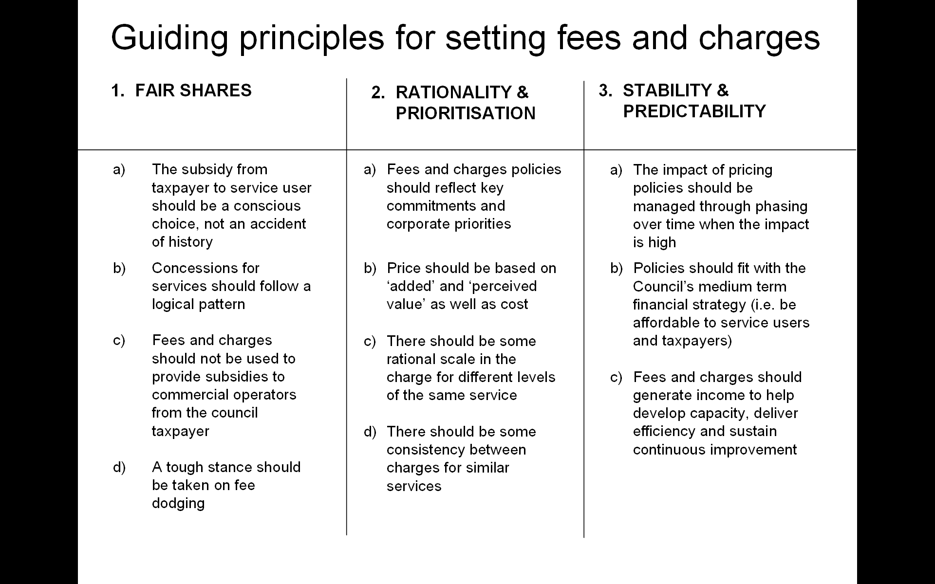

  - The Council’s approach was acclaimed by external bodies as an example of best practice. It was included in the Audit Commission’s publication ‘Positively Charged’, and an extract of the report has been provided at Appendix E.

  - A refresher of the methodology was due to be completed later this year however it would seem appropriate to carry out a more detailed review (possibly through the scrutiny process) to assist the Council with its response to current circumstances.

  - The key objectives are to;

- Review and refresh the existing policy;
- Assess the potential to raise additional income;
- Make explicit choices between the ‘user pays’ or ‘council taxpayer pays’ or the most appropriate mix in each case;
- Review of the Council’s concessions policy;
- Trading Opportunities.

  - A suggested timeline is provided below;

Timetable: Review of fees and charges:

DONE

- Comprehensive framework already in place to base the councils approach to fees and charges (new approach introduced following scrutiny and executive consideration in 2005)
- Principles based approach continued to be used and fees and charges internally reviewed on an ongoing basis (at least annually)
- Approach submitted for commendation and received commendation and inclusion in audit commission national study of best practice.
- Medium term strategy in place for car parking charges (covering a 4 year period)

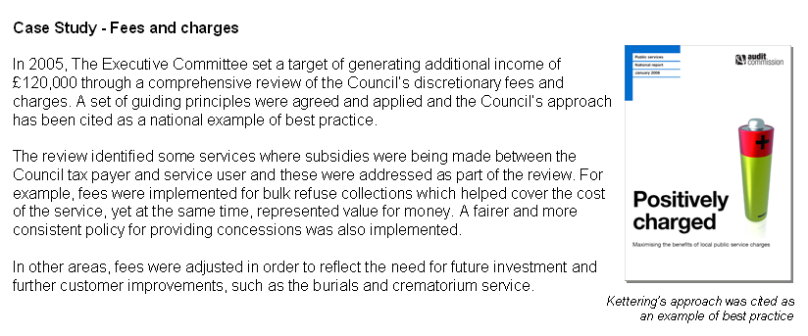

DOING
What? | Who? | When?
Updating, research and review | Corporate Management Team | During August / September 2010
Assessment of current approach and opportunities (including potential for new income streams) | Corporate Management Team / Senior Management Team | September 2010
Assessment and consideration by Scrutiny | Research and Development Committee | 20 October 2010
Assessment and consideration by Cabinet | Executive Committee | 17 November 2010
Adoptions of any new approach / fees and charges | Corporate Management Team / Senior Management Team | As per decisions of the Executive Committee
TO DO

- Regular review of the framework (establish regular timescale)
- Update framework for changes in legislation or other relevant changes
- Continue to showcase the Councils award winning approach
- Continue to lobby for more freedoms and flexibilities for setting fees and charges

  - Members may wish to consider whether an additional income ‘target’ is established to help ‘guide’ the review. During the previous review, a target of £120,000 was set by the Executive Committee.

  - Given the current financial circumstances the review will encompass all fees and charges and take account of the proposed VAT rate change in January 2011.

  - For Members information attached at Appendix G is a copy of a presentation that the Council gave to an external event in 2007. This provides some additional context that might be useful for the workstream.

Capital Review

  - The capital review workstream is reproduced below;
Capital Review
Priorities?
Revenue versus Capital
Modelling for recovery
Emphasise income generation
  - As reported to members as part of the budget setting process, capital expenditure has implications to the Councils finances not just in relation to capital spend, but there are also revenue budget implications in relation to financing charges.

  - The Councils latest capital programme is outlined in Appendix F. Also included in the appendix is an analysis of how the capital schemes match to the Councils corporate priorities.

  - To prepare for the oncoming budget process (and also to assist the debate about prioritisation), it seems sensible to review the current capital programme so that a framework is set prior to the formal consideration of the budget later in the year.

  - The key objectives of the review are;

- Re-appraise the capital programme v corporate objectives;
- Establish ‘guiding principles’ for future years’ programme;
- Suggest an ‘affordable’ programme level for 2011/12 to 2013/14;
- Investigate alternative funding sources;
- To consider the phasing of projects in the light of: -
    - The closeness to corporate priorities;
    - There revenue impact;
    - There fit with the “modelling for recovery” principles;
    - The extent to which they facilitate the Council’s stated overall ambitions of: -
      - Higher grade higher density jobs;
      - Better Town Centres;
      - Better Education Offer.

  - A suggested timeline and key decision dates is provided below;

DONE

- The Council has in place an approved detailed capital programme.
- Robust review mechanisms are already in place through the Corporate Asset Management Team, the councils Performance Review Framework (including reporting to members)
- Regular updates are already brought to Committee
- The Capital Programme is already mapped to Corporate Objectives
- The revenue implications of capital schemes are considered fully as part of the budget process.

DOING
What? | Who? | When?
Commence an early review of the current capital programme:  - Information assessment and review  - Consideration of the review  - Formal Report on the review | Corporate Asset management Team  Corporate Management Team / Senior Management Team  Executive Committee | By the end September 2010  October 2010  17 November 2010
Ensure proper tie-up with the work stream looking at prioritisation | Senior Management Team / Cabinet | December 2010
Review feeds into the budget process for 2011/12;  Draft Capital Programme for consideration / consultation: | Executive Committee  Research & Development  Monitoring & Audit  Executive Committee  Council | 19 January 2011  25 January 2011  8 February 2011  16 February 2011  24 February 2011
TO DO
- Review and enhance (if required) the monitoring arrangements
- Regular updates via the durable budget reports to the Executive Committee
- Ensure that there are mechanisms in place to be flexible and reactive to respond to any external funding opportunities that may be available (re: amendments to the capital programme)
Lobbying

  - The lobbying workstream is reproduced below;

Lobbying
Big ticket issues
Identify / agree issues
Member / officer roles
Past successes

  - The key objectives of the review are;

- Agree key lobbying ‘issues’ (Big Ticket Items)
- Determine who does what by when
- Identify critical success factors and feedback mechanisms.

  - The Council has a good track record of lobbying on critical issues over the past few years. Examples of these include;

- Planning Fees;
    - Getting the nationally set fee for a major planning application raised from £50,000 to £250,000;
    - Twice encouraging Government to raise the commercial fees more toward cost recovery levels whilst protecting domestic fees at more modest levels befitting the lower costs involved.

- Concessionary Travel Grant – campaigning for the funding that was introduced in 2009 to be paid by way of a ‘special grant’ rather than through mainstream grant.
- Encouraging the Government to revise the Planning Delivery Grant so that it recognised Housing Delivery and favoured growth authorities.
  - Previous lobbying activity has resulted in some significant financial gains for the Council. Quite often, due to the size of the funding ‘quantum’, only minor methodology changes are sometimes required to have a significant financial impact on a local authority.

  - Potential areas for future lobbying activity could include the following;

- Council Tax / Growth – establishing (and influencing) the governments current thinking about how a replacement growth incentive could operate. In previous correspondence with the LGA on this issue, the Council suggested that any replacement scheme should have the following attributes;

  - Schemes should be simple and transparent

  - Public service offers should be clustered around customers

  - Any public policy incentives should operate at the level of decision

  - We should move from a ‘regulation and requirement’ regime, to an ‘incentive and encouragement’ regime

  - Energy should be channelled into customer deliverables and not process management

- Income Generation – to continue the medium term dialogue around planning fees and land charges whilst also ascertaining whether there are any other areas (especially nationally set fees) where additional flexibilities and freedoms would be welcomed.

- Infrastructure – to continue to make the case (through bodies such as MKSM) of the need for investment in infrastructure to assist with the growth programme.

  - A suggested timeline and key decision dates is provided below;

DONE

- Inclusion of lobbying as a key factor in the Councils guiding principles for its Medium term Financial Strategy
- Corporate resources deployed to lobby on ‘big ticket’ issues
- Previous successes include good work on planning fees, land charges, central government grant formula (and distribution), concessionary travel, local area business growth incentive funding formula

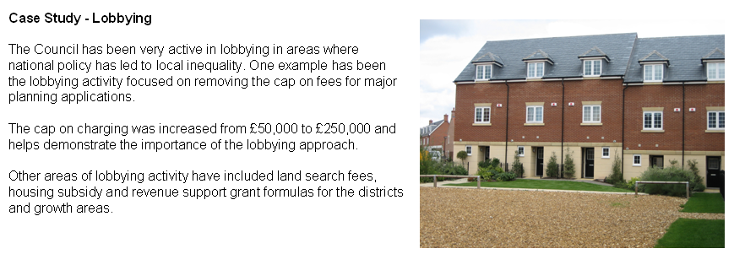
DOING
What? | Who? | When?
Agree the key issues for lobby work:  - those for Immediate Attention  - those for ongoing Attention | Senior Management Team / Cabinet  Senior Management Team / Cabinet | Now (July 2010)  As part of the budget process (December 2010 – February 2011)
Agree lobbying strategy | Senior Management Team / Cabinet / Executive | Now (July 2010)
Confirm roles and responsibilities for lobbying activity | Senior Management Team | As soon as possible
Feedback on activity | ALL | Durable budget reports to the Executive Committee (Sept 2010, Oct 2010, Nov 2010, Dec 2010…….)
TO DO

- Regular review of success, actions and strategy
- Ensure consistent, comprehensive and effective approach to dialogue

Prioritisation

  - The prioritisation workstream is reproduced below;

Prioritisation
Priorities Review
Ensure main priorities match
Identify lower priorities
Be ready to take action

  - The key objectives of the review are;

- To ensure that priorities and spending plans are aligned
- To assist develop future priorities
- To help identify lower priorities (to assist with future resource allocation plans)

  - A suggested timeline and key decision dates is provided below;

DONE

- The Council has an agreed set of corporate objectives that are refreshed annually through the budget, service planning and corporate improvement programme process.
- Priorities and matched to budget areas and an assessment made of the indicative cost to deliver each high level priority
- Delivery against key priorities is routinely tracked and reported through the councils performance framework

DOING
What? | Who? | When?
Ensure that the current priorities are clearly understood | Senior Management Team / Cabinet | 15 September 2010 (durable budget report to the Executive)
Start to assess where lower priority areas may be | Senior Management Team / Cabinet | During September 2010
Initial formal consideration;  - Cabinet  - Scrutiny | Executive Committee  Research and Development  Monitoring and Audit | 13 October 2010  20 October 2010  23 November 2010
Review feeds into the budget process for 2011/12;  Priorities (as part of the budget proposals) for consideration / consultation: | Executive Committee  Research & Development  Monitoring & Audit  Executive Committee  Council | 19 January 2011  25 January 2011  8 February 2011  16 February 2011  24 February 2011
TO DO

- Further reviews (or refreshes) may be required depending on the budgetary situation thereafter.

Total Place / Front Desk (Partnership)

  - The prioritisation workstream is reproduced below;
Total Place / Front Desk (Partnerships)
Policy established
Progress with public sector providers
Good partnership working base

  - The Council approved a new partnership working policy at its meeting of December 2009, this is set out below: -
  - It is inevitable that the Council must work in partnership with other agencies, ideally those with cultural similarities and a shared vision. Partnerships will provide an important avenue for delivering more efficient, effective and economic services. Whilst the corporate priorities framework highlights some specific opportunities for partnership working it hasn’t set out the Council’s strategic approach before. Clearly, the Council recognises that any partnership arrangement must compliment and support it in delivering its ambitious corporate priorities and not distort them. There are two types of partnership to identify – partnerships of scope and partnerships of scale.

Partnerships of Scope
  - This report has described, in several areas of work, the sort of partnership working already underway, which has sought to provide joined up working for the benefit of our customers. For the future, the Council is working with other public and third sector agencies for a potential partnership, to share front and back office space and services. To that end a formal agreement was reached with Northamptonshire Police Authority in June 2009 to share the cost of feasibility work.

  - These type of partnerships are aimed at improving the connectivity of public services for the benefit of our customers and residents, reducing the need to cross refer people and issues. At the same time, it is felt that shared back and front offices, between the Council and other partners, can reduce costs, remove duplication, improve connectivity at operational, middle and senior management levels, and enable pooling of effort for the benefit of citizens. These partnerships can be characterised as partnerships of scope.

  - As referred to above, the government has recognised and begun to embrace the value of partnerships of scope and is increasingly looking to chase out both financial and customer benefits from these.

Partnerships of Scale
  - Previously, the Government White Paper Strong and Prosperous Communities published in 2006 emphasised the importance of partnership working to drive efficiency savings. In response to this, the Council was a member of the Enhanced Local Government in Northamptonshire (ELGIN) group. The group, comprising the seven District authorities in Northamptonshire, explored a number of potential partnership opportunities. Whilst there have been successes e.g. Northants Area Procurement Service (NAPS) and ConnectLaw, the scale and number of such cross boundary partnerships is smaller than originally envisaged. This Council therefore has had more success in working with county wide and national agencies, as well as the voluntary sector, to make most progress in joining up services. There have been individual projects – kleensweep, the credit crunch summit, keephealthy@kettering, various community safety initiatives, the Jobs Fair, all of which have demonstrated the value of working with other agencies in this Borough. Nevertheless, opportunities which arise from partnerships of scale can still be taken, particularly as other authorities seek to minimise the impact of budget costs on their own organisations. The Council will remain open to these opportunities as and when they arise.

  - The Council has a number of partnership working arrangements currently in operation, and has a number in the pipeline. Some of these are listed below for members information;

Current Partnerships | ‘Pipeline Partnerships’
Customer Services offering with;  - NCC  - Voluntary Services  - Inland Revenue  - Police / PCSO’s | Health Services, including;  - Blood Services  - Health Shop
Connect Law | Police – further joint working
Consortium Audit | Fire – further joint working
Joint Planning Unit | Registrars Service
Joint Licensing Unit | Building Control
Abandoned Cars (ELVIS)
NAPS Procurement Partnership
C D R P

  - The key objectives of the review are;

- To ensure that future partnership activity is aligned to the approved policy;
- To ensure the council’s attention continues to deliver the dual benefits of improving the customer experience and reducing costs

  - A suggested timeline and key decision dates is provided below;

DONE

- Formal Council Policy approved on partnership working (December 2009)
- Many partnerships already established including examples of both partnerships of ‘scope’ and partnerships of ‘scale’ – a list is contained in the main body of this report
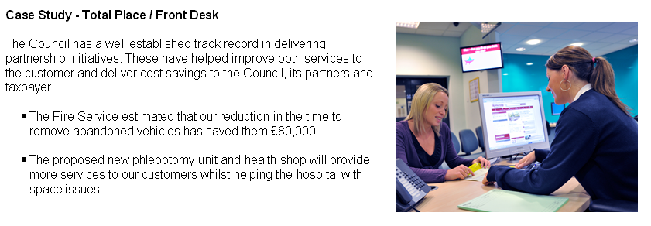
DOING
What? | Who? | When?
Continue to progress pipeline partnerships;  - Joint working with Health (blood services, health shop)  - Discussions ongoing with other public sector partners to improve customer service offering (police, fire, health, registrars, etc…)  - Discussions ongoing with public sector partners in relation to other shared service opportunities  - Continue to identify new opportunities | Senior Management Team / Cabinet  Senior Management Team  Senior Management Team  Corporate Management Team / Senior Management Team | Service available by December 2010-07-16  Ongoing  Ongoing  Ongoing
TO DO

- Progress discussions and agreements through to delivery
- Monitor customer take up and satisfaction levels to ensure objectives being delivered

Innovation Group

  - The innovation group work stream is reproduced below;

Innovation Group
Connect with Activity Managers
Generate new staff suggestions

  - An innovation or “More from Less” group will be set up consisting of a small number of staff from across the organisation and at all levels. They will be tasked to come up with innovative ways of ‘using what we have only better’ and / or ‘doing the same with less’.

  - In addition, existing networks and forums such as the Activity Managers Forum will be used to identify opportunities. Corporate capacity that was supporting audit and inspection work that has now been removed will be refocused on supporting efficiency and innovation initiatives with the aim of saving money and generating income.

  - Work has already commenced on these areas and a number of ideas for savings have been identified, some of which are currently being progressed – this includes reviewing external contracts on service areas such as waste collection. The work of the group and associated activities will have regular contact with, and a steer from the council’s management team.

  - The key objectives of the innovation group and associated activities are;

- Generate ‘ideas from the floor’ and assess their potential
- Continue to generate innovative service delivery changes, that can contribute to the Council’s already impressive record of delivering efficiency savings
- To stimulate ideas about how to maintain staff morale and focus during the more difficult financial times that are ahead.

  - A suggested timeline and key decision dates is provided below;

DONE

- Activity managers group already in existence
- Close links with the staff suggestions and suggestions scheme
- SMT/CMT engaged and considering membership
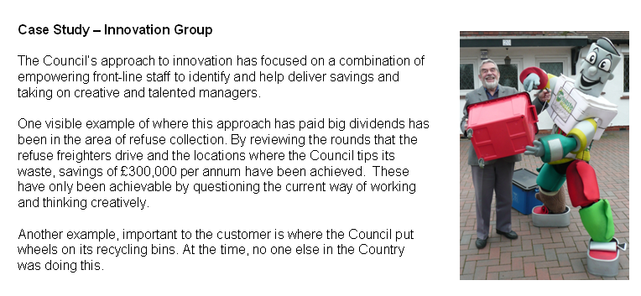
DOING
What? | Who? | When?
- Reviewing existing contracts  - exploring options for alternatives solutions to service delivery  - Proposals to SMT  - Proposals to Executive (if necessary) | CMT  Innovations Group  Innovations Group  SMT | Now  August / September  October 2010  17 November 2010
TO DO

- Establish membership
- Agree TOR and parameters

Staff Suggestions

  - The prioritisation workstream is reproduced below;
Staff Suggestions
Currently being evaluated
Activity Managers to progress
Some implemented
Framework in place

  - A number of staff suggestions were generated at last summer’s staff suggestions and as a result of a staff suggestions scheme implemented earlier in the year. Some suggestions have already been implemented whilst some will have a longer implementation timeline. These will be reviewed and updated at this summer’s staff sessions

  - The outcomes from the staff sessions will be feed into the innovation group for evaluation and implementation (as appropriate).

  - A suggested timeline and key decision dates is provided below;

DONE

- 2009 suggestions analyse and implemented where appropriate
- A number of savings have already been delivered.

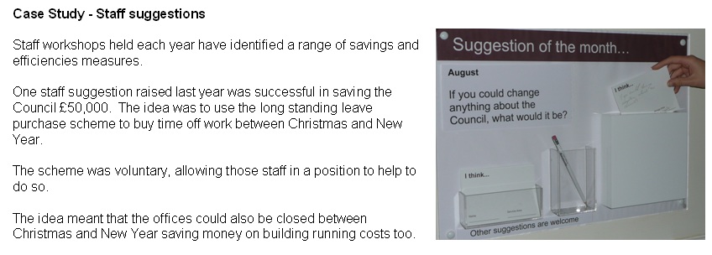
DOING
What? | Who? | When?
- 2010 staff sessions planned  - Implement if straightforward  - Refer to Innovation Group if further work required | Senior Management Team  Corporate Management Team  Senior Management Team | August 2010  September 2010  September 2010
TO DO

- Monitor delivery and feed into future budget process

Service Plans

  - The service plan workstream is reproduced below;

Link to Service Plans / Delivery
Section in each service plan
Track delivery and options
Engagement with front-line staff

  - The service plans are ‘living documents’ and any changes to service delivery or priorities will need to properly documented in them. This will ensure that Heads of Service can track priorities through to implementation and delivery.

  - This will also ensure that performance can be tracked through the Council’s performance monitoring framework and that consistency of approach is followed. The internal performance clinics will also be refreshed to assist with this process.

  - The following matrix attempts to bring together the key objectives and indicative timelines for each of the workstreams.

- CONSULTATION AND CUSTOMER IMPACT
  - The work to be undertaken through the Budget Delivery Framework will provide the basis for the Council’s Budget for 2011/12. The formal consultation process will be set out at the December Executive with the consultation commencing early in 2011.
- POLICY IMPLICATIONS
  - There are no direct policy implications in this report.
- USE OF RESOURCES
  - The implications on the Council’s resources are considered throughout the report.

- RECOMMENDATIONS
That the Executive: -
  - Re-affirms the Guiding Principles and Modelling for Recovery Principles, previously adopted as set out in paragraphs 2.4 – 2.8 of the report;
  - Recognises the need for an even greater focus on the comprehensive, consistent and coherent approach to achieving savings, whilst continuing to meet corporate objectives;

  - Maintains its position of strength by acting early to ensure savings identified are delivered accurately and resiliently;

  - Notes the revised outturn position for the General Fund , HRA and Capital Programme as set out in Section 3 of the report;

  - Notes the impact of recent government announcements on the Medium Term Financial Strategy, as set out in section 6 of the report and endorses the revised MTFS set out in section 7 at paragraph 7.6 accordingly;

  - Notes the good progress being made in identifying and delivering the ongoing efficiency savings of £550,000 and £341,000 during 2010/11;

  - Considers the establishment of savings targets for each of the eight work streams set out in the delivery framework;

  - Requests that the Research and Development Committee, as a matter of urgency undertakes a comprehensive review of Fees and Charges which will be reported back to Executive by Winter 2010;

  - Endorses ‘big ticket’ items upon which to concentrate lobbying activities and begins lobbying activity immediately;

  - Undertakes a review of the Capital Programme as a matter of urgency and brings a revised draft Capital Programme to the Executive in Winter 2010.

Background Papers: Previous Reports/Minutes:

Title of Document: Maintaining a Durable Budget Ref:
Dates: May 2010 and June 2010. Date:
Contact Officer: Paul Sutton

