BOROUGH OF KETTERING

Committee | Full Planning Committee - 20/07/2010 | Item No: 5.6
Report Originator | Fjola Stevens  Development Officer | Application No:  KET/2010/0284
Wards Affected | Rothwell
Location | Rothwell Town FC, Off Cambridge Street (land at), Rothwell
Proposal | Renewal of Extant Permission (Outline - Major): KET/2005/0307 (Renewal of KE/01/0175: Outline for residential development)
Applicant | Persimmon Special Projects

1. PURPOSE OF REPORT

  - To describe the above proposals
  - To identify and report on the issues arising from it
  - To state a recommendation on the application

2. RECOMMENDATION

THE DEVELOPMENT CONTROL MANAGER RECOMMENDS that this application be APPROVED subject to a s.106 obligation being entered into by 16th August 2010 or refused if not completed by that date.

1. Approval of the details of the access, appearance, landscaping, layout and scale (hereinafter called "the reserved matters") shall be obtained from the Local Planning Authority in writing before any development is commenced.
REASON: In order to secure a satisfactory development.

2. Plans and particulars of the reserved matters referred to in condition 1 above, relating to the siting, design and external appearance of any buildings to be erected, the means of access to the site and the landscaping of the site, shall be submitted in writing to the Local Planning Authority and shall be carried out as approved.
REASON: In order to secure a satisfactory development.

3. Application for approval of the reserved matters shall be made to the Local Planning Authority before the expiration of 3 years from the date of this planning permission.
REASON: To comply with Section 92 of the Town and Country Planning Act 1990 and to prevent an accumulation of unimplemented planning permissions.

4. The development hereby permitted shall be begun either before the expiration of three years from the date of this permission or before the expiration of 2 years from the date of approval of the last of the reserved matters to be approved, whichever is the later.
REASON: To comply with Section 92 of the Town and Country Planning Act 1990 (as amended) and to prevent an accumulation of unimplemented planning permissions.

5. Unless otherwise agreed by the Local Planning Authority, development other than that required to be carried out as part of an approved scheme of remediation must not commence until conditions 1 to 4 have been complied with. If unexpected contamination is found after development has begun, development must be halted on that part of the site affected by the unexpected contamination to the extent specified by the Local Planning Authority in writing until condition 4 has been complied with in relation to that contamination.

1. Site Characterisation

An investigation and risk assessment, in addition to any assessment provided with the planning application, must be completed in accordance with a scheme to assess the nature and extent of any contamination on the site, whether or not it originates on the site. The contents of the scheme are subject to the approval in writing of the Local Planning Authority. The investigation and risk assessment must be undertaken by competent persons and a written report of the findings must be produced. The written report is subject to the approval in writing of the Local Planning Authority. The report of the findings must include:

(i) a survey of the extent, scale and nature of contamination;

(ii) an assessment of the potential risks to:
- human health,
- property (existing or proposed) including buildings, crops, livestock, pets, woodland and service lines and pipes,
- adjoining land,
- groundwaters and surface waters,
- ecological systems,
- archaeological sites and ancient monuments;
(iii) an appraisal of remedial options, and proposal of the preferred option(s).

This must be conducted in accordance with DEFRA and the Environment Agency's 'Model Procedures for the Management of Land Contamination, CLR 11'.

2. Submission of Remediation Scheme

A detailed remediation scheme to bring the site to a condition suitable for the intended use by removing unacceptable risks to human health, buildings and other property and the natural and historical environment must be prepared, and is subject to the approval in writing of the Local Planning Authority. The scheme must include all works to be undertaken, proposed remediation objectives and remediation criteria, timetable of works and site management procedures. The scheme must ensure that the site will not qualify as contaminated land under Part 2A of the Environmental Protection Act 1990 in relation to the intended use of the land after remediation.

3. Implementation of Approved Remediation Scheme

The approved remediation scheme must be carried out in accordance with its terms prior to the commencement of development other than that required to carry out remediation, unless otherwise agreed in writing by the Local Planning Authority. The Local Planning Authority must be given two weeks written notification of commencement of the remediation scheme works.

Following completion of measures identified in the approved remediation scheme, a verification report (referred to in PPS23 as a validation report) that demonstrates the effectiveness of the remediation carried out must be produced, and is subject to the approval in writing of the Local Planning Authority.

4. Reporting of Unexpected Contamination

In the event that contamination is found at any time when carrying out the approved development that was not previously identified it must be reported in writing immediately to the Local Planning Authority. An investigation and risk assessment must be undertaken in accordance with the requirements of condition 1, and where remediation is necessary a remediation scheme must be prepared in accordance with the requirements of condition 2, which is subject to the approval in writing of the Local Planning Authority.
Following completion of measures identified in the approved remediation scheme a verification report must be prepared, which is subject to the approval in writing of the Local Planning Authority in accordance with condition 3.

REASON: To ensure that risks from land contamination to the future users of the land and neighbouring land are minimised, together with those to controlled waters, property and ecological systems, and to ensure that the development can be carried out safely without unacceptable risks to workers, neighbours and other offsite receptors in accordance with Policy 13 of the North Northamptonshire Core Spatial Strategy.

6. No development shall commence on site until details of the types and colours of all external facing and roofing materials to be used, together with samples, have been submitted to and approved in writing by the Local Planning Authority. The development shall not be carried out other than in accordance with the approved details.
REASON: In the interests of the visual amenities of the area in accordance with policy 13 of the North Northamptonshire Core Spatial Strategy.

7. No development shall take place until there has been submitted to and approved in writing by the Local Planning Authority a scheme of landscaping which shall specify species, planting sizes, spacing and numbers of trees and shrubs to be planted. The approved scheme shall be carried out in the first planting and seeding seasons following the occupation of the building. Any trees or plants which, within a period of 5 years from the date of planting, die, are removed or become seriously damaged or diseased shall be replaced in the next planting season with others of similar size and species.
REASON: To improve the appearance of the site in the interests of visual amenity in accordance with policy 13 of the North Northamptonshire Core Spatial Strategy.

8. No development shall take place until there has been submitted to and approved in writing by the Local Planning Authority a detailed scheme indicating the positions, design, materials and type of screen walls and fences to be erected. The screen walls and fences shall be erected as approved before the adjacent dwellings are first occupied and shall be retained thereafter.

REASON: In the interests of the privacy of the occupiers of adjoining residential properties in the interests of amenity in accordance with policy 12 of the North Northamptonshire Core Spatial Strategy.

9. The development hereby permitted shall not be occupied until accesses, parking and turning areas have been constructed, surfaced and marked out in accordance with details shall have first been submitted to and approved in writing by the Local Planning Authority.
REASON: To ensure adequate on-site parking provision for the approved building and to discourage parking on the adjoining highway in the interests of local amenity and highway safety in accordance with Policy 13 of the North Northamptonshire Core Spatial Strategy.

10. Prior to the commencement of development a scheme for the provision of the surface and waste water drainage shall be submitted to and approved in writing by the Local Planning Authority. The development shall not be carried out other than in accordance with the approved scheme.
REASON: To prevent pollution of the water environment in accordance with policy 13 of the North Northamptonshire Core Spatial Strategy.

11. No development shall commence until a plan of not less than 1:500 showing the existing and intended final ground and finished floor levels have been submitted to and approved in writing by the Local Planning Authority. The development shall be carried out in accordance with the approved details.
REASON: In order to preserve the character of the area and to protect the privacy of the occupiers of neighbouring dwellings in accordance with Policy 13 of the North northamptonshire Core Spatial Strategy.

12. No development shall commence on site unless and until suitable replacement sports facilities as approved under KET/2007/0315 have been provided in full, in accordance with those approved plans.
REASON: The re-development of land for residential use is only acceptable provided that replacement sports facilities have been provided in accordance with Policy 13 of the North Northamptonshire Core Spatial Strategy.

Notes (if any) :-
- This planning permission extends the time limit for the outline permission for residential development approved under KET/2005/0307. It does not purport to extend the time limit for the implementation of the reserved matters previously approved under KET/2008/0515, and therefore a subsequent applications will be required for the approval of the matters reserved by this outline.

Justification for Granting Planning Permission

Not applicable

Officers Report

3.0 | Information

Relevant Planning History

KET/2008/0515 - Erection of 17 dwellings – APPROVED 28/08/2008

KET/2005/0307 - Renewal of KE/01/0725: Outline for residential – APPROVED 07/06/2005

KET/2001/0725 – Outline for proposed change of use to residential – APPROVED 03/09/2001

Site Description
Officer's site inspection was carried out on 29th May and 9th June 2010.

The site has outline consent for residential development on a 0.4ha site to the western end of Cambridge Street, Rothwell and to the west of residential development along Oxford Street. The narrow rectangular site, which currently forms part of the Rothwell Town Football Club grounds adjoins open countryside to the north and residential development to the east; the remaining boundaries adjoin the football ground.

The land is currently grassed and used for training, although it is not laid out as a pitch and is limited in size with buildings in the centre.

Proposed Development
This application seeks to renew the outline approval granted previously for residential development.

Although the reserved matters have been approved under KET/2008/0515, this application does not seek to renew the reserved matters. A further reserved matters application can be submitted subsequently if planning permission is granted.

Any Constraints Affecting The Site

None

4.0 | Consultation and Customer Impact

Town Council
No objection

Highway Authority
No objection – advised that comments in relation to KET/2005/0307 & KET/2001/0725 still stand.

Environmental Health
No objection – condition recommended requiring a contaminated land survey and the implementation of any necessary remediation

Police
No objection – conditions recommended to ensure development meets recognised safety standards

Northamptonshire County Council
Contributions required for libraries and fire & rescue

Neighbours
None received

5.0 | Planning Policy

National Policies
PPS1 Delivering Sustainable Development
PPS3 Housing
PPG13 Tranport

Development Plan Policies

North Northamptonshire Core Spatial Strategy (CSS)

P1 Strengthening settlement networks
P9 Distribution and local of development
P13 General sustainable development principles
P14 Energy efficiency and sustainable construction

SPD
Sustainable Design SPD
Open Space SPD

Emerging Policies (Local Development Framework)

Rothwell & Desborough Urban Extension Area Action Plan (AAP)

6.0 | Financial/Resource Implications
This application seeks outline permission for a residential development. In accordance with national and local planning policy if 15 dwellings or more are constructed 30% of the dwellings should be affordable housing. In order to secure the affordable housing a S106 obligation is required.

In addition, NCC has requested monies for libraries and fire & rescue, however the sums were based on the reserved matters being extended via the current application. The reserved matters has now been withdrawn from consideration and since the document upon which NCC are relying has not yet been adopted it is considered that it would not be reasonable to pursue this matter.

Although previously an education contribution was required there is now sufficient capacity within the local schools to accommodate the need that may arise from the proposed development and therefore an education contribution is no longer required. In addition, there is no requirement for a contribution for open space provision because this application is a renewal application, and under the open space SPD this type of application can not seek an open space contribution.

7.0 | Planning Considerations
This application is a relatively new type of application to extend the time limit to implement an existing planning application, introduced in November 2009. When determining this type of application Local Planning Authority’s (LPA’s) should consider the proposal in line with the development plan, however regard should be had to the fact that the principle of the development has previously been judged as acceptable. Therefore LPA’s should focus attention on the development plan policies and other material considerations that have changed significantly since the original grant of planning permission.

Since the outline application was approved in 2005 PPS3 has been published and the North Northamptonshire Core Spatial Strategy has been adopted. However, no objections or comments have been received from any consultees that would change the previous decision.

Therefore in this instance the main consideration is whether the principle of the proposed development is still in accordance with policy.

1. Principle of development

The main consideration is therefore whether the proposed development would still accord with the development plan. Detailed consideration of the impact upon neighbours, character of area, highway design etc will be considered when the reserved matters have been submitted.

PPS1, PPS3 and Policies 1, 9 and 13 of the CSS require new development to be focused within existing built up areas in order to ensure new developments are located in sustainable locations. The application site lies within the existing built up area of Rothwell relatively close to the town centre and a nearby school. The application site is therefore located in a sustainable location where residents can access jobs, shops and other amenities easily and via a range of transport modes, including by foot or cycle. The proposed development therefore lies in sustainable location and in principle the development is considered to be acceptable.

Comments on other points raised by proposal

The application site lies on part of the Rothwell Town Football Club grounds. Previously there was a requirement for the training facility to be replaced prior to the commencement of development. Subsequently planning permission was secured for a replacement training area. A separate application has now been submitted to renew the permission for the replacement training area, and this is currently under consideration. It is therefore considered appropriate for the same condition requiring the replacement training facility to be provided prior to the commencement of development.

 | Conclusion
 | The proposed residential development lies in a sustainable location close to Rothwell Town Centre where the principle of residential development accords with PPS1, PPS3 and Policies 1, 9 and 13 of the North Northamptonshire Core Spatial Strategy. Therefore, although there has been a significant change in planning policies since KET/2005/0307 was approved, there has been no material change in circumstances that would warrant a different decision being reached now. The proposal is therefore considered to be acceptable and approval is recommended, subject to conditions and completion of a satisfactory s.106 obligation confirming the provision of 30% affordable housing for 15 or more dwellings.

Background Papers |  | Previous Reports/Minutes
Title of Document: |  | Ref:
Date: |  | Date:
Contact Officer: | Fjola Stevens, Development Officer on 01536 534316

SITE LOCATION PLAN

Rothwell Town FC, Off Cambridge Street (land at), Rothwell
Application No.: KET/2010/0284

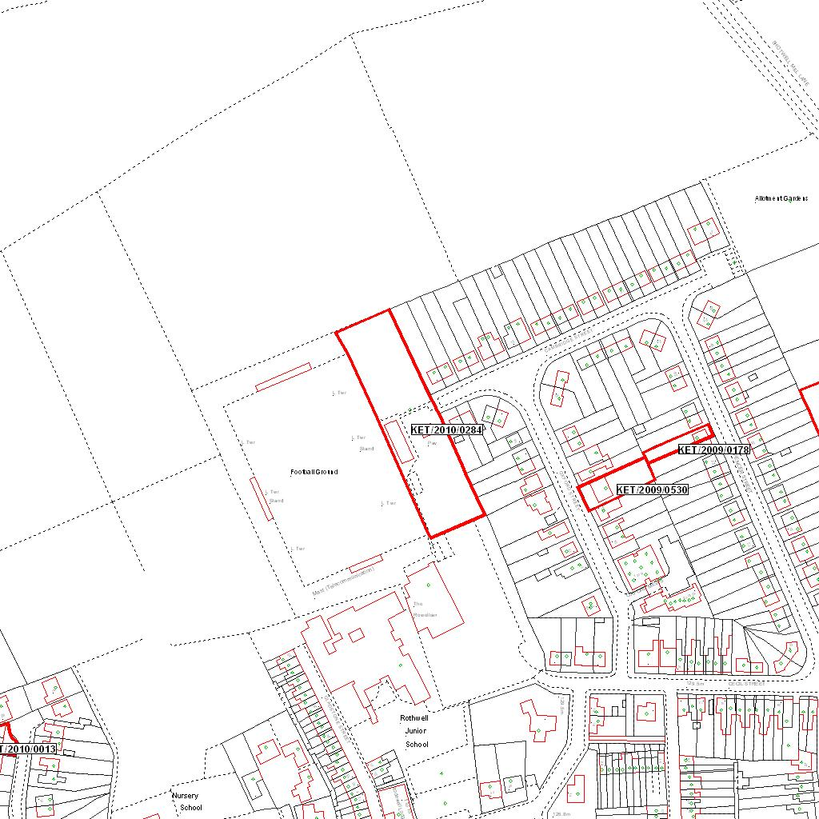

Reproduced from the Ordnance Survey mapping with the permission of the Controller of Her Majesty’s Stationery Office © Crown copyright. Unauthorised reproduction infringes Crown copyright and may lead to prosecution or civil proceedings.  LA078344 |  | N
Date: 04/05/2010 Do not scale from this map. For illustrative purposes only.

