BOROUGH OF KETTERING

Committee | Full Planning Committee - 20/07/2010 | Item No: 5.5
Report Originator | Michael Boniface  Development Officer | Application No:  KET/2010/0273
Wards Affected | William Knibb
Location | 15A & 15B Silver Street, Kettering
Proposal | Full Application: Extension to 15B Silver Street into part of 15A and change of unauthorised use of that property to A5. Change of use and new shop front of remaining part of 15A from A1 to A3, conversion and extension of first floors of 15A & 15B to 3 no. flats
Applicant | Mr R Altunkaynak

1. PURPOSE OF REPORT

  - To describe the above proposals
  - To identify and report on the issues arising from it
  - To state a recommendation on the application

2. RECOMMENDATION

THE DEVELOPMENT CONTROL MANAGER RECOMMENDS that this application be REFUSED for the following reason(s):-

1. The proposed change of use would result in the loss of two retail (A1) units within the Established Shopping Area and Restricted Shopping Frontage for Kettering Town Centre. The applicant has failed to demonstrate that the development would not adversly impact the vitality and viability of the town centre and the proposal is therefore contrary to policy K20 of the Local Plan for Kettering Borough and advice contained in PPS4. Furthermore, the development is contrary to the Emerging Kettering Town Centre Area Action Plan (Preferred Options, August 2008) which seeks to protect A1 uses within the Primary Shopping Area, provide a concentration of A3 uses at the proposed Restaurant Quarter and disuade further A5 uses.

Officers Report

3.0 | Information

Relevant Planning History
KET/2009/0460 – Change of use from A1 to A3 and A5 at 15A Silver Street. A5 use to be subdivided and incorporated within existing A5 unit at 15B Silver Street. Creation of 3 dwellings to first floor – WITHDRAWN 20/11/2009

KET/2009/0127 – Extraction system to rear of property – REFUSED 24/08/2009

ENFO/2008/00043A - Enforcement Notice against unathorised change of use from A1 to A5 and associated operatioal development – ISSUED 26/11/2008

ENFO/2008/00043B – Enforcement Notice against unathroised shop front – ISSUED 26/11/2008

KET/2007/1188 – Conversion and change of use to a hot food take-away, including new velux windows, shop front and extraction system – APPEAL DISMISSED 17/11/2008

KET/2008/0166 – Externally illuminated fascia and projecting sign – APPROVED 28/04/2008

KET/2008/0165 – New shopfront with roof lights front and rear – APPROVED 30/05/2008

KET/2008/0009 – Fascia sign – WITHDRAWN 18/02/2008

KET/2007/1188 – Conversion and change of use to a hot food take-away, including new velux windows, shop front and extraction system – REFUSED 12/02/2008

Site Description
The property is located within a terrace of properties of various heights and designs on the west side of Silver Street, most of which have commercial, retail and restaurant activities with shop fronts at ground floor level. Silver Street is a shopping street of mixed character that is part of the Established Shopping Area of Kettering. Both 15A and 15B Silver Street fall within a designated Restricted Shopping Frontage as defined by the Local Plan. The property is also located within the Kettering Town Centre Conservation Area.

Commercial premises adjoin either side of the site, with a public house, taxi rank and commercial garage to the rear of the site.

Proposed Development
- Extension to 15B Silver Street into part of 15A Silver Street.
- Change of use of the existing and resulting 15B Silver Street to A5 (take-away), including regularisation of the existing take-away use.

- Change of use and new shop front to 15A Silver Street from A1 (retail) to A3 (restaurant).
- Conversion and extension of first floors of 15A and 15B to create 3 no. flats.

Any Constraints Affecting The Site
- A Road
- Conservation Area
- Restricted Shopping Frontage

4.0 | Consultation and Customer Impact

Highway Authority
No objection.

Environmental Health
The proposed A3 use at 15A Silver Street would not require a high level of odour control based upon the proposed activities. The A5 use at 15B Silver Street would require a high level of odour control for the type of cooking suggested and the proposed entry point for the flue is adjacent to a residential balcony and habitable room window. An odour and noise assessment would be necessary. The submitted noise assessment does not adequately address this issue. A condition would need to require accordance with the submitted noise assessment in order to achieve appropriate living conditions for residents. A condition should require details of a ventilated and pest proof bin store.

Northamptonshire Police
No objection but conditions/comments suggested in respect of security measures/standards to prevent crime and anti-social behaviour.

Neighbours
2 letters of objection for the following reason:
- There is a number of legally trading take-away uses along Silver Street whose business would be adversely affected.
- A number of applications have been refused for a restaurant use at number 15A in the past.
- The existing take-away use at 15B is unauthorised and little regard has been shown to the planning system.
- Granting planning permission would be the easy option.
- Proposal is contrary to policy K20 which prevents changes of use within the restricted shopping frontage.
- Proposals would conflict with Council’s Restaurant Quarter aspirations.
- Long access corridor does not comply with Building Regulations.

5.0 | Planning Policy

National Policies
PPS1 – Delivering Sustainable Development
PPS3 – Housing
PPS4 – Planning for Sustainable Economic Growth
PPS5 – Planning for the Historic Environment
PPG13 – Transport
PPS23 – Planning and Pollution Control
PPG24 – Planning and Noise

Development Plan Policies

North Northamptonshire Core Spatial Strategy
7 – Delivering Housing
8 – Delivering Economic Prosperity
9 – Distribution and Location of Development
10 – Distribution of Housing
13 – General Sustainable Development Principles
14 – Energy Efficiency and Sustainable Construction

Local Plan
33 – Environment: Advertisements, Signs and Shop Fronts
35 – Housing: Within Towns
99 – Leisure: Class A3 Uses
K9 – Kettering: Shop Front Design
K20 – Kettering: Changes of Use in the Established Shopping Area

Supplementary Planning Guidance
SPG5 - Urban Design and the Street Scene

Emerging Policies (Local Development Framework)

Kettering Town Centre Area Action Plan (Preferred Options, August 2008)

6.0 | Financial/Resource Implications
 | None
7.0 | Planning Considerations
The key issues for consideration in this application are:-

- Principle of Development;
- Design, Character and Appearance;
- Impact upon the Conservation Area;
- Neighbouring Amenity and Environmental Matters;
- Parking and Highway Matters;
- Crime and Disorder;
- Sustainable Design and Construction.

1. Principle of Development
The application site falls within the ‘Established Shopping Area’ for Kettering and within a row of buildings designated as a ‘Restricted Shopping Frontage’ along Silver Street. Saved policy K20 of the Local Plan restricts changes of use in such locations in order to prevent an over-concentration of non-retail uses, maintain the primary shopping function of the area and avoid adversely impacting the vitality and viability of the town centre. This policy states that planning permission to change from class A1 to A3 or other non-retail uses within the established shopping area will not be granted at ground floor level within the shopping frontages shown as ‘restricted’ on the proposals map. This represents the primary policy consideration in this instance and indicates against the proposal.

The emerging Kettering Town Centre Area Action plan: Preferred Options (August 2008) provides further guidance with regards to changes of use within the ‘Primary Shopping Area’. The emerging plan builds upon the principles outlined in PPS4, supported by the North Northamptonshire Core Spatial Strategy, to protect the vitality and viability of town centres through designation of primary and secondary frontages and the creation of high quality and safe environments. While limited weight is placed upon the emerging AAP (due to its current status in the LDF), the document offers an indication of the continuing policy emphasis towards maintaining retail uses within this important area at the core of the town centre.

PPS4 defines a restaurant/café/take-away (A3 and A5) as a main town centre use suggesting that such establishments should be located within town centres where they can add to a diverse mix of uses that are easily accessible to members of the public, though this should be balanced against aims to protect the retail offering of town centres as a primary function. As set out above, the development plan makes it clear that ‘restricted’ frontages are to be retained for A1 purposes though provision is made for alternative uses in order to compliment the established retail offering. ‘Unrestricted’ Shopping Frontages are therefore designated, in addition to a number of town centre units which are not subject to any restriction.

The Development Plan therefore indicates strongly against the proposed development due to the loss of two A1 units and the adverse impact that would result upon the vitality and viability of the town centre. It is noted that a change of use was considered at 15B Silver Street during 2008 and that the Inspector considered that limited evidence was provided to suggest that an A5 use would detract from the vitality and viability of the town. Since this time, the Council has published and consulted upon it Preferred Options document ‘Kettering Town Centre Area Action Plan (Preferred Options, August 2008)’ as discussed above and this has been informed by a firm evidence base.

Numerous studies have demonstrated that the current town centre offer, both in terms of daytime and night-time uses, is imbalanced, particularly in the area around Silver Street. The Kettering Town Centre Framework (Atkins, 2005) highlights the current poor image of the night time economy within Kettering created by poor quality pubs, limited food and drink offer and an over concentration of hot food takeaways. It also states the need to manage the night economy, balance evening and day time uses and offer an alternative to drinking and takeaways. The Town Centre Area Action Plan Preferred Options Baseline Report (Savills, August 2008) outlines the need to limit the current over-concentration of A4 and A5 uses and promote policies which encourage diversification of the evening economy, protect the retail function of the town centre, and enhance the public realm and feelings of public safety.

The findings of the studies are backed up by consultation responses received during both Issues and Options (2006) and Preferred Options (August, 2008) consultation on the AAP. Significant public concern has been expressed with regards to the proliferation of A5 uses located on Silver Street, Montagu Street and Dalkeith Place, despite the supposed restrictive function of Local Plan policy K20.

An exercise was conducted to quantify the scale of this problem and further inform the AAP in the form of a town centre Use Class survey conducted in summer 2009 which charted the use of every unit within the town centre. As required by PPS4, the findings of the survey were reported to Planning Policy Committee in the Kettering Town Centre Health Check Monitoring Report: 2008-2009 (to be reported annually). The findings show that there is currently a high concentration of A5 uses, a lack of leisure facilities and an evening economy of limited quality and choice based largely around a high number of large/super-pubs, nightclubs and takeaways. The Health Check shows some 13 A5 uses currently operate within the Secondary Shopping Frontages (as defined within the emerging AAP) - a total of 9% of all units. Along the western stretch of Silver Street (from the corner with Gold Street to the end of Dalkeith Place), of the 22 frontages in the vicinity, only 8 have A1 use (36%) whilst 5 have A5 use (23%) and there are 3 pubs (14%).

It is clear that in this area there exists an over-provision of non-retail uses which cause high levels of anti-social behaviour, disturbance and litter. A concentration in one area can result in unacceptable ‘cumulative impacts’ where concentrations of drinkers queue at fast food outlets and for public transport. Queuing in turn often leads to conflict, disorder and anti-social behaviour. The marked proliferation of such uses around Silver Street / Dalkeith Place has eroded the character of the area, undermined its primary retail function and contributed to a poor quality and unattractive streetscape and public realm.

The development is therefore considered contrary to policy K20 of the Local Plan which seeks to prevent the loss of retail units within the Restricted Shopping Frontages, and would result in an adverse impact to the vitality and viability of the town centre. Furthermore, the proposal would conflict with the aims contained within the emerging Kettering Town Centre Area Action Plan. Planning permission should therefore be refused.

Residential units have also been proposed within the scheme at first floor level. Policy 10 of the CSS and saved policy 35 of the Local Plan support the provision of housing within town centres, Kettering being identified as a Growth Town. The properties would occupy a highly sustainable town centre location and add to the vibrancy of this evolving part of the town. This element of the scheme is considered to accord with the development plan in principle, however this does not outweigh the considerations set out above.

2. Design, Character and Appearance
The physical works proposed involve replacement of the shop front at unit 15A, including the installation of a separate personnel door for access to the first floor flats, along with first floor rear extensions to provide 3 dwellings. Planning permission has already been granted for a replacement shop front to unit 15B under reference KET/2008/0165 and this is shown on the submitted drawings.

The proposed shop front at 15A Silver Street adopts a relatively traditional design and appearance as is encouraged within SPG5. Timber pilasters, stall risers and fascia are to be installed with reference to the shop front approved within the adjacent unit and others of merit within the street scene. A condition would need to secure the use of timber and require details of the proposed colour and finish. Subject to such conditions, the replacement frontage would in fact improve the character and appearance of the unit which currently incorporates a modern aluminium shop front. Any replacement signage would need to be considered as a separate matter under the Advertisement Regulations. The front elevation of the building would otherwise remain unaltered.

The proposed first floor additions would infill an area currently occupied by single storey structures between two storey buildings attached to either side. The additions involve two pitched roof, gable ended protrusions presenting a reasonably traditional form to the rear of the terraced properties. This is contrasted by the modern fenestration style, balconies and glazed canopy to the central pedestrian access. Existing modern extensions are evident on the adjacent units to the north. The structures would appear subordinate to the principal building fronting Silver Street and would be constructed of red brick under concrete tiles matching that of the existing building. The additions would largely be screened from the public realm by the surrounding two storey buildings, and while views would be possible from the adjacent taxi rank and commercial garage, the extensions would not result in visual intrusion within their context. Glancing views may also be possible from Jobs Yard and Meeting Lane however the structures would not be prominent or visually intrusive given the distances involved and the surrounding roofscape. Again, subject to conditions securing appropriate materials, the design and appearance of the works are considered acceptable.

3. Impact on the Conservation Area
The building falls within a designated conservation area; section 72 of the Planning (Listed Buildings and Conservation Areas) Act 1990 requires that “special attention shall be paid to the desirability of preserving or enhancing the character or appearance of that area”.

As described above, the proposed design and appearance of the development is considered appropriate to its context. The scheme would not adversely impact the character of the conservation area and the proposed shop front would in fact enhance its character from a prominent public viewpoint within Silver Street.

4. Neighbouring Amenity and Environmental Matters
The proposed A3 and A5 units would occupy existing A1 units and these are surrounded by further commercial uses. Silver Street stands within the core of the town centre and is a busy shopping street. The commercial use of the ground floor units is therefore consistent with their context and would not result in uncharacteristic activity or unacceptable disturbance to nearby residential uses.

The Council’s Environmental Health department have suggested that the proposed A3 use at 15A Silver Street would not require a high level of odour control based upon the proposed activities which are to involve re-heating food only, with initial cooking and preparation occurring off site. A re-circulating hood containing a carbon filter as an alternative to full ventilation and extraction facilities is likely to be sufficient for these purposes in order to avoid the need for full extraction and ventilation equipment. This could be secured by condition if planning permission were granted.

The A5 use at 15B Silver Street would require a high level of odour control for the type of cooking suggested and the proposed entry point for the flue is adjacent to a residential balcony and habitable room window. A further odour and noise assessment would be necessary and this could again be secured by condition if planning permission were granted.

The noise report submitted suggests mitigation measures to achieve a noise climate for the first floor flats appropriate for a ‘good’ nights sleep despite the late opening hours of 15B Silver Street. The development would need to be carried out in accordance with these details if planning permission were granted.

Although the general area for refuse storage has been identified within the site a condition would be necessary to secure details of a ventilated and pest proof bin store if planning permission were granted.

5. Parking and Highway Matters
The proposed A3 and A5 uses are unlikely to generate additional traffic or parking requirements compared with the extant A1 uses. Furthermore, the units fall within the core of the town centre where they are accessible by a range of transport modes including public transport and walking and cycling. Public car parks are also available in close proximity. The Highway Authority has raised no objection to the proposal and the scheme is considered acceptable in this respect.

6. Crime and Disorder
Northamptonshire Police has raised no objection to the development but suggests that a number of security measures could be employed in order to reduce the potential for crime and anti-social behaviour impacting upon the development. This may include high specification doors and windows and secure bin and cycle facilities etc. A condition could therefore require details of security measures/standards to be incorporated within the scheme.

7. Sustainable Design and Construction
Policy 14 of the Core Spatial Strategy requires that development meet the highest viable standards of resource and energy efficiency and reduction in carbon emissions. Schemes should demonstrate techniques of sustainable construction and energy efficiency, provision for waste recycling/reduction and provision for water efficiency and water recycling. Although the applicant has completed the Council’s Sustainable Design Checklist, this provides very little detail or specific proposals to demonstrate compliance with these requirements. A condition would therefore be necessary to secure additional information.

Conclusion

The development is contrary to policy K20 of the Local Plan which seeks to prevent the loss of retail units within the Restricted Shopping Frontages, and would result in an adverse impact to the vitality and viability of the town centre. Furthermore, the proposed would conflict with proposals contained within the emerging Kettering Town Centre Area Action Plan. Planning permission should therefore be refused.

Background Papers |  | Previous Reports/Minutes
Title of Document: |  | Ref:
Date: |  | Date:
Contact Officer: | Michael Boniface, Development Officer on 01536 534316

SITE LOCATION PLAN

15A & 15B Silver Street, Kettering
Application No.: KET/2010/0273

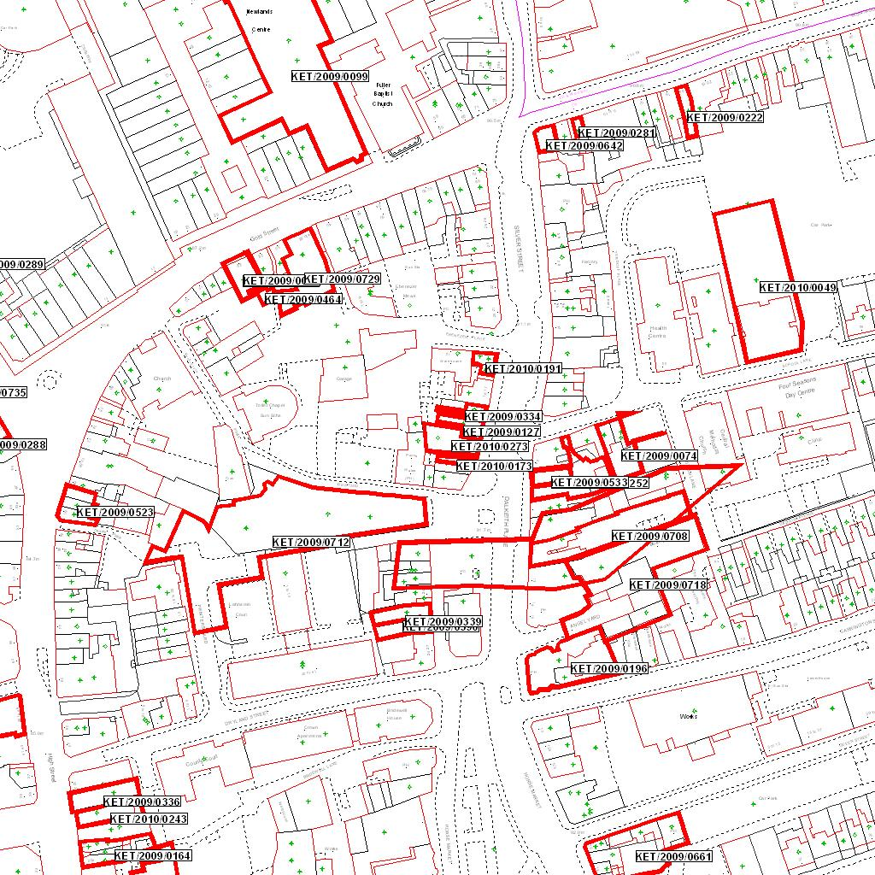

Reproduced from the Ordnance Survey mapping with the permission of the Controller of Her Majesty’s Stationery Office © Crown copyright. Unauthorised reproduction infringes Crown copyright and may lead to prosecution or civil proceedings.  LA078344 |  | N
Date: 30/04/2010 Do not scale from this map. For illustrative purposes only.

