1. PURPOSE OF REPORT

To update the members on the improvement and performance of the street cleansing service, and consider new initiatives to enhance the service further.

2. INFORMATION

    - Following the last Research and Development Committee meeting (2nd June 2010)it was resolved that the committees work programme would have added to it (minute 10.RD.07) “ A report detailing ways forward in respect of Street Cleanliness including the examination of new initiatives particularly in respect of developing partnership working and enhancement of the ‘Ward Walkabout’ programme.”

    - To enable us to consider how to enhance the service further, it is important to understand where we are in terms of current performance this report will cover this, but will be complemented by a presentation/discussion which will enable the committee to explore the options to enhance performance and community/partnership engagement further.

    - This content of this report is:

- 2.2 Street cleansing definition, the resources allocated
- 2.3 Inspection methodology and performance information
- 2.4 How improvements were delivered with examples
- 2.5 Other environmental issues
- 2.6 Benchmarking data
- 2.7 Partnership working
- 3.0 Community engagement
- 3.1 Conclusion
- 4.0 Policy implications
- 5.0 Use of resources
- 6.0 HR implications
- 7.0 Legal issues
- 8.0 Recommendation
There will also be a presentation on future development ideas around the wider community engagement and partnership working.

    - The Government had identified Local Environmental Quality (LEQ) as one of the chief concerns of local communities. This was reinforced by the Local Government Association who concluded that cleaner and safer streets were issues that are of concern to everyone.

    - National Indicator 195 covers litter, detritus, graffiti and fly-posting, and has been developed by Keep Britain Tidy (KBT), to measure the cleanliness of the local environment, as a member of the public would see it. This indicator has been useful for much of the decision making this year when prioritising resources which will be covered in this report.

    - Kettering Borough Council has responsibility to keep relevant land, which is maintained at pubic expense, so far as is practicable clear of litter detritus, fly posting and graffiti.

    - This report describes the main functions of the service and its current resources, but more importantly explains the reasoning behind the recent prioritisation of different functions. Explanations are factual and auditable and use the site based analysis in evaluating how the council is performing.

2.2. STREET CLEANSING COVERS:
- The removal and disposal of litter, refuse, debris, leaves, vegetation, animal carcasses, dead birds and excrement from roads, pavements, pedestrian precincts, shopping areas, amenity areas, car parks, etc. within our remit.
- The removal and disposal of windblown litter gathered on walls, fences, hedges, shrubs etc. (public property only).
- The mechanical sweeping of road channels throughout the Borough.
- The emptying of litter bins and dog faeces bins.
- The removal of illegally dumped fly tipping and assisting the Environmental Health Service on their investigations.
- The removal of graffiti and fly posting on public land and public buildings
    - THE TEAM
The Cleansing Team are managed by an activity manager with a technical officer (modern apprentice) as support.

There are 13 operatives covering the district. This information is provided for indicative purposes only as there is staff movement between different functions, to ensure the flexibility required is available to respond to events and problems.

1 orderly – zone 1 Kettering
1 orderly – zone 2 Kettering
1 orderly – zone 1 & 2 Burton Latimer
1 orderly – zone 1 Desborough
1 orderly – zone 1 Rothwell
1 orderly for Litter Bin emptying
1 orderly for clinical waste collections/emptying of dog bins and clearance of bring bank sites
1 orderly for the ‘Grotbuster’/fly-posting/graffiti and street washing
2 orderlies for rural roads
2 orderlies as the fast road crew and rural

2.2.2 MACHINERY

The team is supported by three specialist drivers who operate our mechanical sweepers:
1x large mechanical sweeper (Johnson 600)
2x small mechanical pavement sweepers (Schmidt Swingo 250)

2.3 NI 195 METHODOLOGY

The NI 195 is scored using 900 site inspections across 10 land uses each year taking place every 4 months.

Land uses for the survey are split as follows:

- Main Retail and Commercial Area (Primary retail)
- Other Retail and Commercial Area (Secondary retail)
- High Density Housing Area
- Medium Density Housing Area
- Low density Housing Area
- Industrial, Warehousing and Retail Sheds
- Main Road
- Rural Roads
- Other Highways
- Recreational Areas

2.3.1 The surveys cover each of the four elements, litter detritus, graffiti and fly-posting. They show the percentage of sites that fall below a grade B. this has been deemed by Keep Britain Tidy as an acceptable level of cleanliness. See Appendix C – Litter Grading sample sheet and Appendix D Detritus grading sample sheet (Keep Britain Tidy guides)

2.3.2 The surveys are undertaken by officers and provide valuable information on the extent of litter, detritus, graffiti and fly-posting and therefore the success of the cleansing regimes. (See examples of survey data Appendix E Inspection data and Appendix F Inspection photos)

2.3.3 PERFORMANCE MONITORING (NI 195)

NI 195 results 09/10 – Tranche 1 (April-July 2009) the first 300 inspections

Land Use | Litter | Detritus | Graffiti | Flyposting
Main Retail and Commercial | 2% | 3% | 0% | 0%
Other Retail and Commercial | 13% | 13% | 0% | 0%
Higher Obstruction Housing | 5% | 37% | 0% | 0%
Medium Obstruction Housing | 3% | 0% | 0% | 0%
Low Obstruction Housing | 0% | 7% | 0% | 0%
Industry and Warehousing | 10% | 0% | 0% | 0%
Main Road | 23% | 0% | 0% | 0%
Rural Roads | 0% | 3% | 0% | 0%
Other highways | 15% | 18% | 12% | 0%
Recreation | 8% | 3% | 0% | 0%
All areas | 8% | 9% | 1% | 0%

SUMMARY

Litter - the biggest issue with litter was on Main Roads with 23% (highlighted green) and Other Highways at 15%

Detritus - the problems were High Obstruction Housing 37%, Other Highways 18% (highlighted in yellow) Graffiti and Fly-posting were not a problem on these inspections.

NI 195 results 09/10 – Tranche 2 (August-November 2009) second 300 inspections

Land Use | Litter | Detritus | Graffiti | Flyposting
Main Retail and Commercial | 8% | 0% | 0% | 0%
Other Retail and Commercial | 8% | 0% | 3% | 0%
Higher Obstruction Housing | 28% | 22% | 2% | 0%
Medium Obstruction Housing | 12% | 13% | 0% | 0%
Low Obstruction Housing | 0% | 10% | 0% | 0%
Industry and Warehousing | 12% | 7% | 0% | 2%
Main Road | 17% | 5% | 0% | 0%
Rural Roads | 10% | 9% | 0% | 0%
Other highways | 10% | 3% | 13% | 0%
Recreation | 5% | 6% | 8% | 0%
All areas | 11% | 8% | 3% | 0%

SUMMARY

Litter- showed High Obstruction Housing (mainly social housing) a problem at 28% and Main Roads again high at 17% as the areas which really stood out

Detritus- showed High Obstruction Housing at 22% and Medium Obstruction Housing at 13%.

NI 195 results 09/10 – Tranche 3 (December-March 2009/2010) third 300 inspections

Land Use | Litter | Detritus | Graffiti | Flyposting
Main Retail and Commercial | 0% | 3% | 0% | 0%
Other Retail and Commercial | 7% | 0% | 0% | 0%
Higher Obstruction Housing | 2% | 3% | 0% | 0%
Medium Obstruction Housing | 2% | 0% | 0% | 0%
Low Obstruction Housing | 2% | 7% | 0% | 0%
Industry and Warehousing | 5% | 3% | 0% | 0%
Main Road | 5% | 0% | 0% | 0%
Rural Roads | 0% | 0% | 0% | 0%
Other highways | 3% | 20% | 0% | 0%
Recreation | 2% | 0% | 3% | 0%
All areas | 3% | 4% | 0% | 0%

LITTER- there are no obvious areas showing particular issues therefore maintain current performance with the awareness of previous tranche information.

DETRITUS – the only area showing particular concerns is other highways at 20%.

2.4 HOW IMPROVEMENTS WERE DELIVERED

The pattern of improvements in the local inspections from Tranche 1 to Tranche 3 were down to changes in operations and the movement of resources to deal with the problems highlighted in the results. Below are examples of how this was carried out.

2.4.1 DETRITUS

Detritus in general was an area showing good performance; however percentages in Tranche 2 showed that levels of detritus were significantly higher in some areas than others.

As a direct result of this, extra resource in the form of a hired road sweeper was brought in to bring these roads up to the same high standard as the rest of the borough. Results of the NI 195 for February 2010 show a significant improvement in these areas for detritus.

Also an investigation of management data such as vehicle tracking and brush engagement analysis information has lead to the rescheduling of mechanical sweeper routes and greater outputs from this machinery. This has lead to approximately 30% more detritus being removed from the streets/footpaths with the same resources.

2.4.2 HIGH OBSTRUCTION HOUSING (HIGH DENSITY HOUSING)

The NI 195 guidance by Defra UK considers properties where the proportion of dwellings with purpose made off street parking is less than or equal to 50% as ‘high obstruction housing’. In terms of the Borough these are usually those streets where the majority of residents live in flats or terrace houses. The guidance also makes note that there is a high risk of mechanical channel sweeping operations being obstructed due to parked cars.

Due to the obstruction of vehicles on these high density sites practices such as, the use of leaflet drops and A boards were met with little success so the team now use hand brush and shovels to tackle these areas. Working with the Housing Service resources are to be allocated from existing budgets for a new ‘man and a van’ solution to tackle social housing areas. This proposal is designed to cover wider issues such as Graffiti, fly tipping and fly posting.

The results of this show a significant improvement from Tranche 2 showing 28% and 22% to 2% and 3% on this type of area.

50 tons of detritus is collected mechanically in the Borough each week (an increase over the last tranche of nearly 30%) this waste is also now recycled adding to our recycling levels and our income with recycling credits.

2.4.3 LITTER (RURAL AND MAIN ROADS)

The A14 which runs through the Boroughs remit is used by 23,564 cars every day (6 million vehicles every year so it was important to address that 23% of these users were experiences below acceptable levels of litter.

Tranche 1 and 2 reflect when these roads were litter picked once annually. Since then plans have come into action starting in February 2010 that the A14 is now litter picked four times a year. Rural roads were also targeted and will be litter picked twice a year. This prioritising of resources has lead to improvements which are reflected in Tranche 3. Along with extra litter picks a new 2 man fast road crew has been established by reallocating existing budget to compliment the extra litter picks.

Approximately 12000 bags of rubbish were taken off our highways in 2009.
Between January 2010 and April 2010 12000 bags of rubbish had already been removed, largely from main roads.

2.4.4 OTHER HIGHWAYS

This land class includes lay-bys, pedestrian bridges and underpasses alleyways and redundant highway infrastructure still accessible to the public and access roads to future development sites.

Results have consistently shown at least detritus, graffiti or litter scored higher than 10%. Measures are now being put in place to address this. All alleyways have been visited and measured resulting in a list of alleyways that are able to be cleansed with a mechanical sweeper. Others, which are currently obstructed by bollards and too narrow for a sweeper are cleansed by hand.

We are currently working with Northamptonshire County Council replace fixed bollards with drop bollards to allow us access with a mechanical sweeper.

Photographs to show improvements to an alley way in the Borough after it has been mechanically swept.
Before After
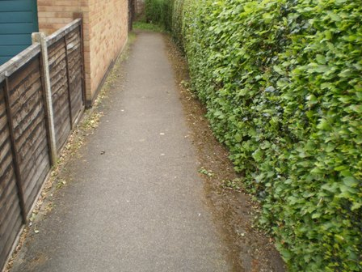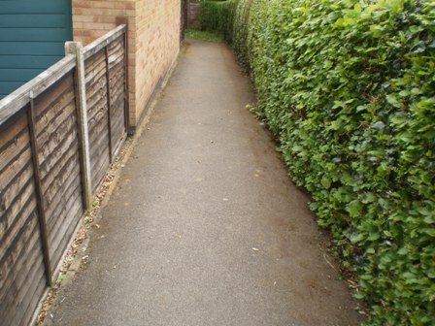

2.5 OTHER ENVIRONMENT ISSUES

The NI 195 inspections are an auditable and valuable tool in ensuring improvements and the prioritising of resources are performance lead. They do not however cover everything the public sees and another tool used to highlight problems is the feedback from the Councillor Ward Walkabouts.

2.5.1 WEED SPRAYING THE HIGHWAY

Weed spraying is a Northamptonshire County Council function and KBC carry out this in Kettering and Barton Seagrave on their behalf. Other areas of the Borough are covered by NCC contractors.
A need to improve the weed spraying function has become evident thorough the Ward Walkabouts and there has also been a change in the availability of chemicals which are licensed to use on the streets. Until fairly recently highway weed control was carried out in Kettering and Barton using chemicals such as 'Diuron'. This is residual and very effective at killing both plant and seed. It was subsequently discovered that levels of Diuron and similar chemicals were building up in rivers and watercourses and causing damage to our waterways and the environment. Whilst the majority of the chemicals came from agricultural use, quite correctly they were withdrawn and alternatives had to be found for highway weed control.
The chemical currently employed by most highway authorities is 'Glyphosate' which is much friendlier to the environment. It controls weeds by 'contact', being absorbed into the plant when it contacts the leaves. Whilst Glyphosate is an effective means of controlling weeds it does not perform as well as the residual chemicals formerly used as it doesn’t stay in the soil stopping seeds from germinating. At present there are no more effective herbicides coming onto the market which will be licensed to use on streets.
To improve the performance of our current weed spraying operation greater emphasis has been placed on the coordination between the weed praying operation (Grounds Maintenance) and the subsequent removal of dead weeds and seeds cleansing operation (Street Cleansing) Particular consideration is given to main roads and paved areas. This clean up by the mechanical sweepers reduces the chance of germination which prolongs the effects of the herbicide and unsightly dead foliage on streets. Site inspections will take place to monitor the performance.

2.6 BENCHMARKING

Kettering Borough Council along with Corby Borough is the top performing authorities in Northamptonshire. In relation to the regional performance Kettering for both Litter and Detritus are considered high performing authority with low costs. (The main technical benchmarking data that supports this item is covered within the presentation)

2.7 NORTHAMPTONSHIRE LAA GROUP

To ensure the continual improvement of the Street Cleansing function, KBC, as part of the LAA group have developed an action plan. This group has tried to ensure that there is a consistent and auditable approach to monitoring, training of officers carrying out 195 surveys. Keep Britain Tidy are also represented on this panel.

Currently KBC are acting as a lead authority/mentor (critical friend) to other authorities within this LAA group sharing with them our best practice and management and monitoring regimes. This should improve their performance over the next 12 month period.

3. CONSULTATION AND CUSTOMER IMPACT

KLEEN SWEEP

Kleen Sweep forms a significant element of Kettering's response to the wider Greener Safer agenda. The project seeks to bring various public sector agencies together with community groups to address localised environmental issues.

The scheme works by identifying problems though a number of processes such as Ward Walkabouts and developing workable partnership approaches to tackling them. This means partnering with bodies ranging from the Probation Service to parish councils to develop responses to wider environmental issues that would normally be outside of the Borough Councils remit or capacity to respond to in a timely fashion.

As part of the scheme there has been allocated a large supply of equipment that is lent to communities who wish to undertake community clean ups. This includes litter pickers and bibs advertising the scheme.

During March and April 2010 there were 20 local community groups and parish councils being supported by KBC on their community spring clean projects?

Photograph of residents from the Headlands on a Kleen Sweep working with the police
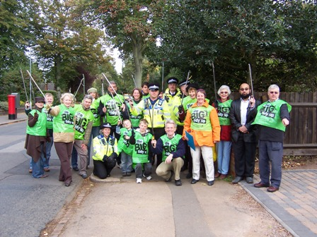

SCHOOLS AND EDUCATION

Presently engagement with schools has been limited however a typical example of a project with schools if when junior schools in the Borough named the two new mechanical sweepers in 2009.

Photograph and Sweepy being named Photograph of Litterbug being named
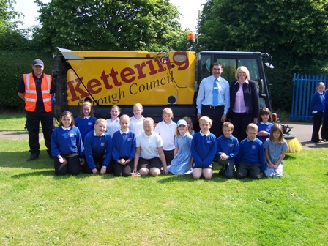

The NI 195 results are improving rapidly and nationally KBC are performing well. The following tables show where Kettering are in terms of value and performance and in the areas of litter and detritus Kettering scores high on performance and low on cost. This information is supplied by the East Midlands improvement and efficiency group from work they have carried out with Keep Britain Tidy.

3.1 CONCLUSION

The ward walkabouts carried out this year clearly demonstrate consistent outcomes to our own NI195 monitoring, namely that public land that we control is of a very high standard but efforts to tackle issues on private land will inevitably need to continue.

With this in mind we will look to the future to develop community engagement with various projects, stronger engagement with members of the pubic, using education as a prevention, co-ordinated working with other agencies on enforcement and continued performance and improvement in the street cleansing function.

4. POLICY IMPLICATIONS

There are no policy implications as a result of this report at present.

5. USE OF RESOURCES

Discussed in main body of report.

6. HUMAN RESOURCE IMPLICATIONS

6.1 As part of our ongoing service improvement plan we are looking in a very critical way at how we can improve the service still further. With the every increasing development and improvement of Kettering Town Centre and the Suite 16 agenda we are aware that in particular more emphasis will be made on a presence not just at the weekends of our workforce but also particularly on summer evenings.

6.2 With this in mind we are looking for greater flexibility going forward from our workforce to enable us to provide an improved summer working arrangement, in areas with the most footfalls. It is initially intended that we will achieve this within existing resources, but this will be monitored to ensure that the existing quality at other times does not slip as a result.

6.3 The current modern apprentice role within the Street Cleansing team has also proven to be a vital part of our development plan. As the officer who plans and analyses the NI195 monitoring it is our intention to develop this post to further involve wider technical support to the Cleansing Manager. It is again envisaged that any permanent post will be within existing budget provisions.

7. LEGAL ISSUES

There are no implications at this stage

8. RECOMMENDATION

The committee consider the contents of this report and comment accordingly

Background Papers: Previous Reports/Minutes:

Title of Document: Ref:
Date: Date:
Contact Officer:

