Archaeology

The first phase of archaeological investigation works – comprising geophysical surveys has been competed. Areas excluded from the survey work include woodland, where the works would disturb wildlife and areas where quarrying has taken place, as this activity destroys archaeological remains.

It is anticipated that a report detailing the results of the survey work will be submitted to KBC within the next 2 to 3 weeks. Based on the results of the survey work the report will propose areas of the site requiring trial trenching, and a timetable for these works. We will consult with the County Archaeological Advisor (based at Northamptonshire County Council) before deciding whether to approve the report.

Broadholme

Anglian Water’s Business Plan for 2010 to 2015 confirms one of its key objectives as providing for growth in the region in a changing climate. The Business Plan provides for an increase of £179m (68%) to accommodate the significant growth that is planned for the Anglian Water region. A total of £443m will be required over the next five years to provide for growth and climate change. Contained within these plans are strategic network reinforcements including a key sewerage reinforcement scheme at Broadholme to support future growth.

This committed investment is a culmination of the work carried out by Kettering Borough Council and all partners over a number of years, which has resulted in a policy framework being in place. This framework has given Anglian Water the confidence to commit funding to the improvement of Broadholme. Anglian Water have not scheduled in investment elsewhere in their area, where similar plans are not in place.

A14: J10/J10 A

Meetings took place in April of this year with parishes and local business to discuss the implications of altering access to/from the A14. Some very useful information was gained, which has informed a brief given to independant highway consultants who have been appointed to investigate this issue. The work will be overseen by KBC, and will be funded by Alledge Brook. The brief comprises the following:

- A review of a similar proposal to alter access arrangements on the M20 at Ashford.

- A review of the improvement options for Junction 10 previously considered. This work will include liaison with previous highway consultants were necessary.

- The development of various options for improvements to Junction 10 that will ensure the junction can accommodate the East Kettering Sustainable Urban Extension. A particular focus will be on the west bound on slip road and the constraint of the bridge to the west as well as direct connection to Junction 10 rather than via Barton Road.

- Junction 10a improvement options. Alternatives for the A6 link road which avoid a direct connection with Cranford Road/Church Street in Burton Latimer will be explored.

This work is ongoing; the report is expected to be with Kettering Borough Council by the end of July. The results will be shared with local businesses and people and Alledge Brook and will form the basis for discussions with the Highways Agency and Local Highway Authority.

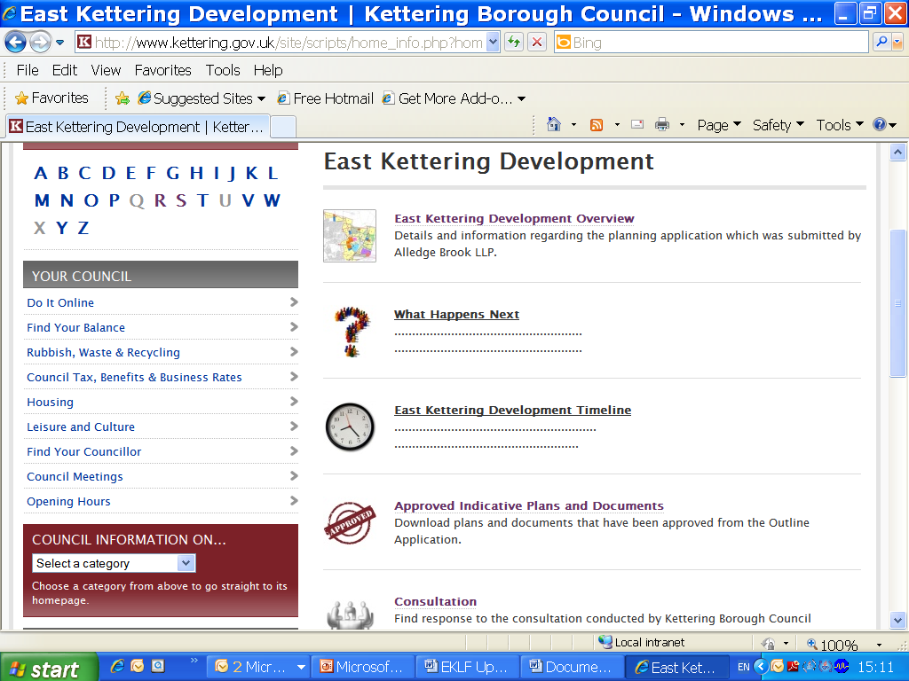
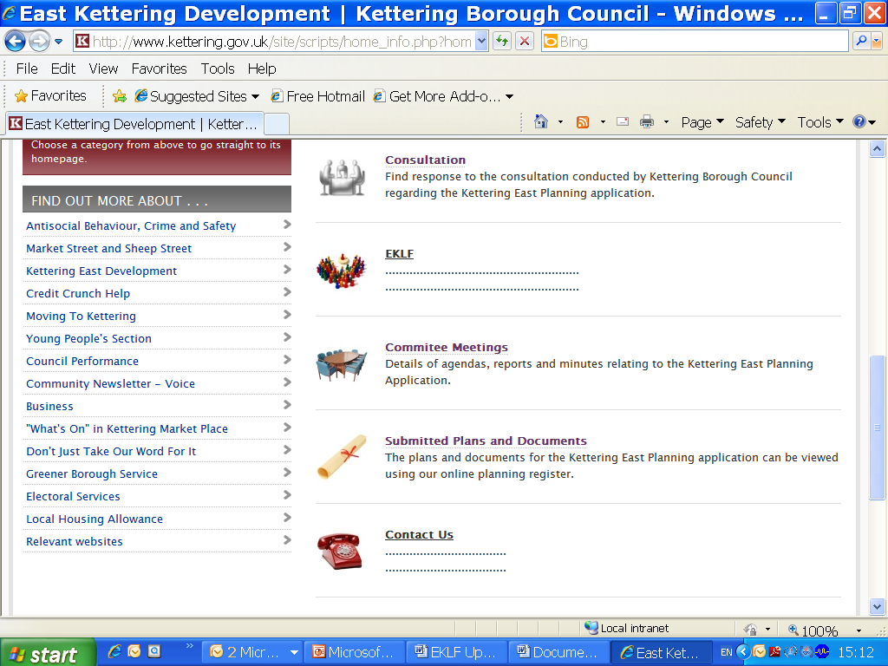
Web Site
Work has begun on updating the East Kettering Development web pages. The name of the link and the Home Page has been changed to reflect the fact the proposal now has consent.

The site includes an Overview of the application process from receipt of application to the granting of outline planning permission, and ‘What happens next page’ which will include updates about the East Kettering Sustainable Urban Extension as and when necessary.

A Development Timeline showing the order in which things should happen has been produced. Approximate timings for the delivery of housing and key infrastructure, based on the Housing Trajectory discussed in the September

Committee Report has been included in the Timeline. The timeline in future, will also include background information, for example, clicking on the phrase ‘Design Code’, ‘FRA’ etc will take you to a brief description of its the role/purpose. We hope to add to this over time, giving a description of all documents/strategy required.

All plans and documents explicitly referred to in the conditions have been grouped together for ease of reference, under the heading Approved Indicative Plans and Documents. All documents and plans submitted with the application have to be included in our online planning register; this list currently stands at over 600 documents and is not particularly user friendly. We intend to alter this to a similar format as the ‘Approved Indicative Plans and Documents’ pages in the near future.

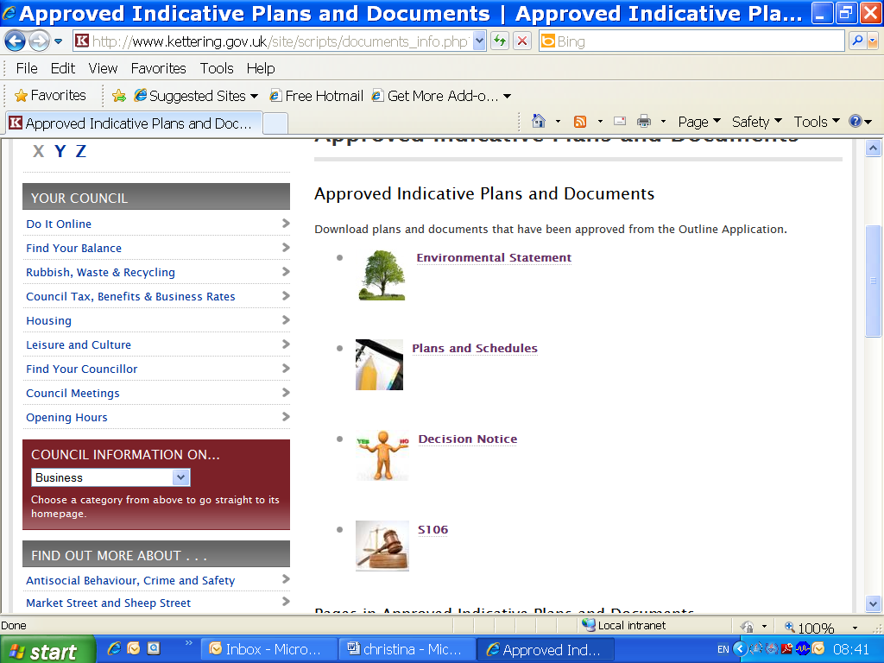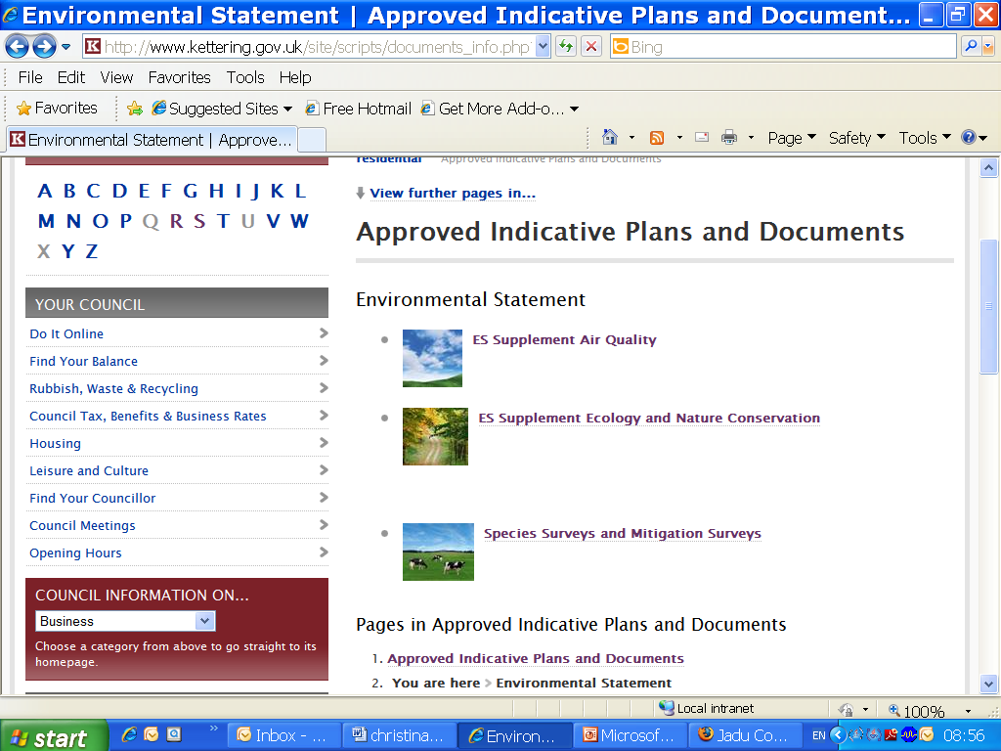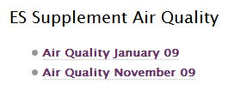

Details of the consultation carried out before and during consideration of the application are included here. Consultation on areas not included within, but directly affected by the Sustainable Urban Extension, such as the meetings held with Parish Councils and local businesses to discuss access from the A14 J10 and J10A will also be included here.

The EKLF has its own pages on the site, which currently shows the forum’s ‘Terms of reference’.

Committee Reports and Minutes relating to East Kettering can also be accessed via the Home Page.

