BOROUGH OF KETTERING

Committee | Full Planning Committee - 22/06/2010 | Item No: 5.2
Report Originator | Fjola Stevens | Application No:  KET/2010/0266
Wards Affected | Rothwell
Location | 12 Bridge Street, Rothwell
Proposal | Full Planning Permission: Change of use of first floor from office (B1) to gymnasium (D2)
Applicant | Mr S Vincent

1. PURPOSE OF REPORT

  - To describe the above proposals
  - To identify and report on the issues arising from it
  - To state a recommendation on the application

2. RECOMMENDATION

THE DEVELOPMENT CONTROL MANAGER RECOMMENDS that this application be APPROVED subject to the following conditions:

- The development hereby permitted shall be begun before the expiration of 3 years from the date of this planning permission.
REASON: To comply with Section 91 of the Town and Country Planning Act 1990 and to prevent an accumulation of unimplemented planning permissions.

- The use hereby permitted shall not be carried out before 09.00 hours or after 22.00 hours.
REASON: To protect the amenities of the occupiers of nearby properties in accordance with policy 13 of the North Northamptonshire Core Spatial Strategy.

Notes (if any) :-
  - This permission authorised change of use only and does not authorise any works or alterations that may require planning permission, and does not permit the display of advertisements which require consent under the Town and Country Planning (Control of Advertisements) Regulations 2007.

Justification for Granting Planning Permission

The proposal is in accordance with national and local policies as set out in Planning Policy Statements 1, 4 and 5, Planning Policy Guidance Notes 13 and 24, Policies 1, 3, 11, 22 and 27 of the East Midlands Regional Plan, and Policies 1, 9 and 13 of the North Northamptonshire Core Spatial Strategy. There are no material considerations that indicate against the proposal.

Officers Report

3.0 | Information

Relevant Planning History

KET/2008/0909 - Change of use from second floor offices to two bedroom flat- Withdrawn 30/12/2008

A previous application for a change of use of the first floor of the building was withdrawn after concerns were raised by environmental health about the impact noise in the locality would have upon future occupiers of the proposed residential accommodation. A noise impact assessment was requested by the Local Planning Authority and the application was withdrawn so that the assessment could be carried out. The application was not re-submitted.

Site Description
Officer's site inspection was carried out on 13th May 2010.

The application property lies on the northern side of Bridge Street, one of the principal shopping streets within Rothwell, within the Rothwell Conservation Area.
To the east of the site lies the Rothwell House Hotel which has a vehicular access and car park directly adjacent to the application property. The hotel is a Grade II Listed, 3 storey Georgian building with a modern 2 storey extension at the rear. To the west, adjoining the application site is a 3 storey building which is occupied by a take-away unit at the ground floor level with the upper floors appearing to be residential.

The application relates to the first floor of the building at 12 Bridge Street. The ground floor of the building is currently occupied by the Rothwell Post Office and the application form indicates that the building is in a single ownership, with the first floor currently being advertised as ‘to let’. The building is a yellow brick construction with white upvc windows and panels at first floor level and a flat roof. To the rear of the building there is a garden area, beyond which there are residential properties. Access to the first floor is achieved via a recessed door way on the front elevation at ground floor level and this arrangement would remain.

There is a distinct difference between the ground level where the application building sites and the surrounding land, with the car park of the adjacent hotel and the neighbouring dwellings to the rear being situated on higher ground.

Proposed Development
This application seeks planning permission for the change of use of the 1st floor from offices (B1) to a gym (D2). The premises would be accessed from the existing front door at ground floor level and no external alterations are proposed.

The applicant is related to a member of staff or an elected member and therefore the application must be determined by the Development Control Committee.

Any Constraints Affecting The Site
C Road
LB (Setting of)

4.0 | Consultation and Customer Impact

Town Council
No Objection

Highway Authority
No Objection

Environmental Health

No Objection

Neighbours
None received

5.0 | Planning Policy

National Policies
PPS1 Delivering Sustainable Development
PPS4 Planning for Sustainable Economic Growth
PPS5 Planning for the Historic Environment
PPG13 Transport
PPG24 Planning and Noise

Development Plan Policies

East Midlands Regional Plan (EMRP)
Policy 1 Regional Core Objectives
Policy 3 Distribution of New Development
Policy 11 Development in the Southern Sub-area
Policy 22 Regional Priorities for Town Centres and Retail Development
Policy 27 Regional Priorities for the Historic Environment

North Northamptonshire Core Spatial Strategy (CSS)
Policy 1 Strengthening the network of settlements
Policy 9 Distribution and Location of development
Policy 13 General Sustainable Development Principles

6.0 | Financial/Resource Implications
 | None

7.0 | Planning Considerations
The key issues for consideration in this application are:-
- Principle of proposed development
- Impact upon occupiers of surrounding properties
- Impact upon historic assets

1. Principle of the proposed development
PPS1 outlines that key objectives of planning, stating that planning should facilitate and promote sustainable economic development, protect and enhance the historic environment, and ensure that developments contribute to creating sustainable communities. PPS 4 sets out the planning policies for economic development to back up the Government’s overarching objective to secure sustainable economic growth. Specifically, policy EC10 of PPS4 requires Local Planning Authorities to take a positive approach towards planning applications for economic development, whilst considering whether proposals have been planned; over the lifetime of the development; to be accessible by a range of transport modes including walking, cycling, public transport and car; to be of a high quality design taking opportunities to improve the character and quality of an area and the way it functions; to take account of the impact on economic regeneration; and to take account of the impact upon local employment.

Policies 1, 3, 11 and 22 of the EMRP and Policies 1, 9 and 13 of the CSS re-iterate that development should; be directed towards existing urban areas; with priority given to the re-use of previously developed land and buildings; enhance the quality of urban settlements; improve economic prosperity; be accessible; and reduce the causes of climate change.

The proposed development lies in a very accessible location within a town centre, it would bring an existing vacant unit back into use, provide a new employment opportunity, provide economic development and improve the way the town functions, and it would not detract from the character of the area.

In conclusion, the proposed development accords with PPS1, PPS4 and the relevant policies of the EMRP and the CSS, therefore the principle of the proposed use in the location proposed is considered to be acceptable.

The proposed development would not benefit from any private parking, however bearing in mind the location of the site within the town centre and the access to public transport it is considered that this would not result in a detrimental impact upon highway safety and therefore the proposal accords with PPG13 and Policy 13 of the CSS. As such, the lack of parking would not prevent the proposed development from being acceptable in principle.

2. Impact upon surrounding properties
Policy 13 of the CSS states that development should not result in an unacceptable impact on the amenities of neighbouring properties or the wider area by reason of noise, vibration, smell, light or other pollution.

It is recognised that the proposed gym use could potentially result in an increase in noise when compared to its existing use as an office and as such the impact of the proposal upon the occupiers of the neighbouring properties, some of which are residential has been considered carefully. The environmental health team have been consulted and they have confirmed they have no objection to the proposal on noise grounds.

Regard has been had for the location of the application site in a town centre location adjacent to a take-away and hotel, and above a post office/shop. It is considered that the proposed use would not have a detrimental impact upon the occupiers of the surrounding properties; however it would be appropriate to limit the hours of opening to those proposed by the applicant to prevent the gym operating during the quieter night-time hours when it may have a greater impact upon the nearby residential properties. Subject to an opening hours condition it is considered that the proposed development would not have a significant impact upon the living and working conditions of neighbours and therefore it accords with Policy 13 of the CSS.

3. Impact upon historic assets
PPS5 advises that heritage assets, which are defined as parts of the historic environment that have significance because of their historic, archaeological, architectural or artistic interest, should be conserved and enjoyed for the quality of life that they bring to this and future generations. PPS5 outlines the need to provide development that is sustainable, would conserve England’s heritage assets, and would contribute to our knowledge and understanding of the past. Policies 1 and 27 of the EMRP and Policy 13 of the CSS also require new development to protect and enhance historic assets.

The Rothwell Conservation Area and the Rothwell House Hotel are both heritage assets, which by virtue of their designation as considered to be of significant value. Since the planning application relates to a change of use only with not external alterations, and the proposed use is one that would be appropriate within a town centre location, it is considered that the proposal would not have a significant impact upon either; the character or appearance of the conservation area, or the special historic or architectural character of the listed building. The proposed development would therefore not have an adverse impact upon the local historic assets and would accord with PPS5, Policies 1 and 27 of the EMRP and Policy 13 of the CSS.

Other issues raised by the proposal

The applicant has not submitted any details of the proposed waste storage area, and therefore the applicant has been asked to provide details. It is not anticipated that there will be a problem providing suitable waste storage/disposal bearing in mind the application related to existing commercial premises. The details will be provided in the update sheet.

Conclusion

The proposed development by virtues of its location within Rothwell Town Centre accords with the national, regional and local policy objectives to direct new leisure development to existing built up areas. In addition, due to the siting of the proposed development within a town centre it is considered that the noise that may potentially be generated by the proposed use would not have an adverse impact upon the occupiers of surrounding residential and commercial properties. Furthermore, the proposed change of use would not have a significant impact upon the character and appearance of the Rothwell Conservation Area or the setting of the neighbouring grade II listed building. There are no material considerations that indicate against the proposal and the proposed development would accord with PPS1, PPS4, PPS5, PPG13, PPG24, Policies 1, 11, 22 and 27 of the East Midlands Regional Plan and Policies 1, 9 and 13 of the North Northamptonshire Core Spatial Strategy.

Background Papers |  | Previous Reports/Minutes
Title of Document: |  | Ref:
Date: |  | Date:
Contact Officer: | Fjola Stevens, Development Officer on 01536 534316

SITE LOCATION PLAN

12 Bridge Street, Rothwell
Application No.: KET/2010/0266

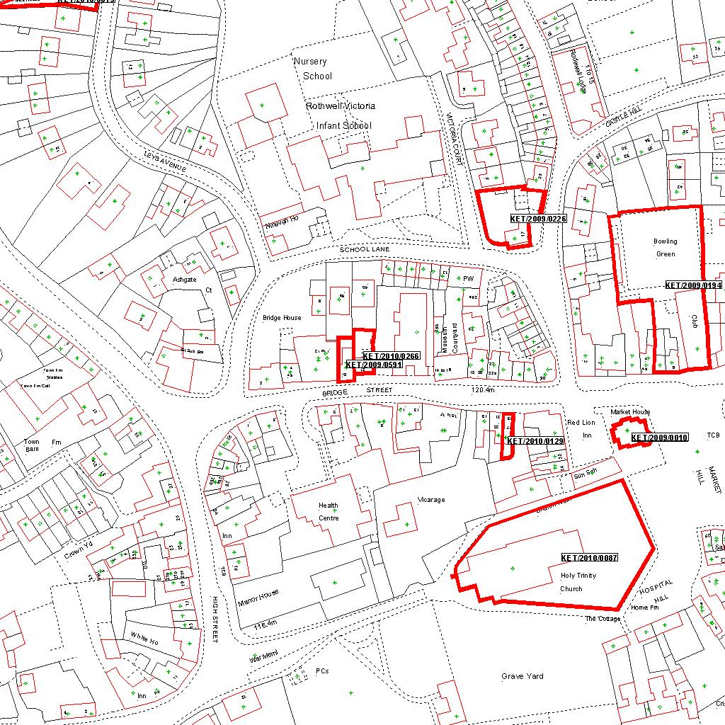

Reproduced from the Ordnance Survey mapping with the permission of the Controller of Her Majesty’s Stationery Office © Crown copyright. Unauthorised reproduction infringes Crown copyright and may lead to prosecution or civil proceedings.  LA078344 |  | N
Date: 28/04/2010 Do not scale from this map. For illustrative purposes only.

