1. PURPOSE OF REPORT

The purpose of the report is to;

- Provide a reminder of the Council’s Financial Strategy
- Consider the Council’s track record of delivering to budget, making efficiencies, and attracting external finance
- Provide an update on the Council’s latest financial projections
- Outline a comprehensive financial monitoring and delivery framework to assist the Council when making future budgetary decisions

2. CONTEXT

  - The Council’s financial strategy and budget were approved at February’s meeting of Full Council. The key messages in relation to the General Fund budget were;

- Council Tax is below the national average (around £3 per week)
- The Council has a strong financial platform (no reliance upon reserves)
- There is no ‘structural operational deficit’ (commonly referred to as a ‘black hole’) in the budget
- 2010/11 is a balanced budget (provided trajectory of past efficiency savings continues)
- Future financial position is ‘difficult but doable’ – the main uncertainty being future levels of Central Government Grant
- Service delivery in priority areas continues to improve and is above average
- The Council continues with a counter cyclical approach to help the local economy – See ‘Modelling for Recovery’ principles below:
Modelling for recovery principles

- Wherever possible, continue with all planned investments and programmes, to protect the local economy and lever in other investments;

- Given that we currently have no long-term debt, we should be prepared to consider debt-funding as a means of programme delivery or stimulus – if this can be shown to be sustainable and have a wider economic benefit;

- organise our fiscal structures and business models to attract and retain the maximum amount of revenue within the local economy;

- To ensure all possible avenues are used within procurement rules to source locally;

- Protect the performance of Council services which come under particular strain;

- Work closely with partners in the voluntary, public and private sectors, to ensure optimum efficiency.

  - The ‘Modelling for Recovery’ principles above were a specific response to the current economic position. They supplemented the ‘Guiding Principles’ that underpin the Financial Strategy. These are listed below. Members will be familiar with these from the budget process.
Guiding principles:

- Revenue balances should not fall below £1m and overall revenue reserves should not fall below 10% of net revenue expenditure;

- In setting the Council Tax, members should consider the medium term to ensure that a sustainable budgetary position is preserved (with due regard being given to any penalties that might apply);

- The level of household Council Tax to increase each year in line with inflation at least, where the budget is in deficit, to ensure resources remain consistent with budgeted costs;

- When setting the Capital Programme, consideration is given to allocating capital resources to schemes that are beneficial to the Council’s overall revenue budget position;

- To maximise the resources available to the Authority, the Council will actively lobby the Government on relevant issues (e.g., grant distribution/ planning fees).

  - The Council has used the above ‘principles’ to ensure that service delivery continues to improve in priority areas whilst remaining flexible by switching resources between service areas as required.
3. COUNCIL TRACK RECORD

Value Added

  - The Council’s ‘Guiding principles’ and ‘Modelling for Recovery’ principles drive a different approach to business modelling. The typical model focuses on reducing funding and resources (inputs) without considering the impact on service delivery (outputs) and can be extremely counter productive;
  - 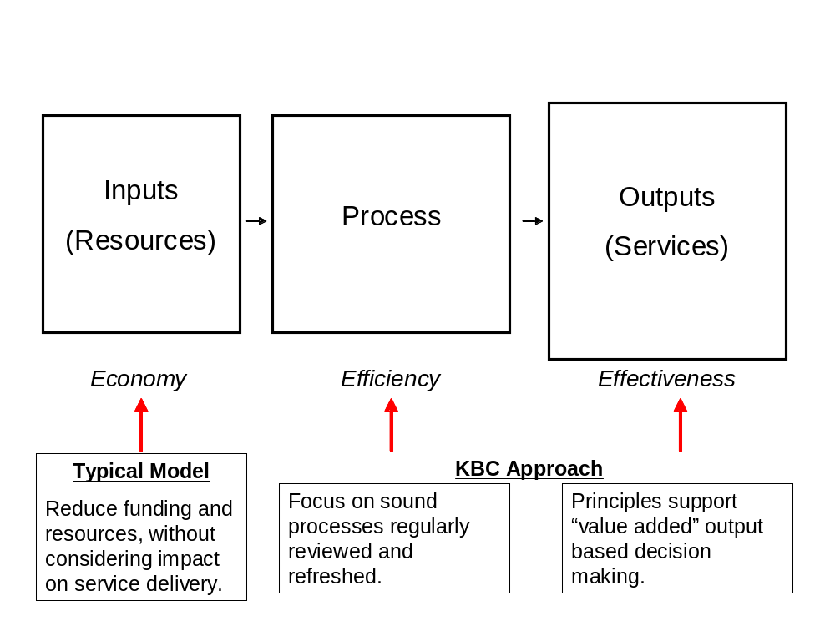The Council’s approach is to identify and understand the value of the services being delivered (outputs). The focus is then given to ensuring that the process for delivering the service is sound and “fit for purpose” adding value to the funding and resources. Using this approach the Council has been successful in delivering “more for the same” or in many cases more for less. The approach is illustrated in the diagram below:

Delivering To Budget

3.3 The Council has an exemplary record of annually delivering the budget within very small tolerances. Best practice advice suggests that if a local authority delivers its annual budget within 2.5% of budget that this represents good performance – the following chart illustrates the Council’s performance since 2004/05;

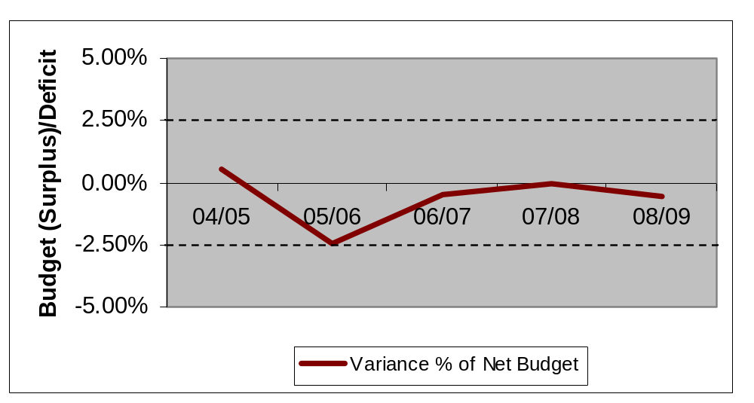

3.4 Although the outturn figures for last year (2009/10) are still being validated, it is likely that the above trend will continue in spite of the fact that it continues to be ever more challenging.

Efficiency Savings

  - The Council has taken the delivery seriously for many years and the instigation of the next steps service reviews ensured that the continued delivery of efficiency savings is inbuilt into the fabric of the service planning and budget process.

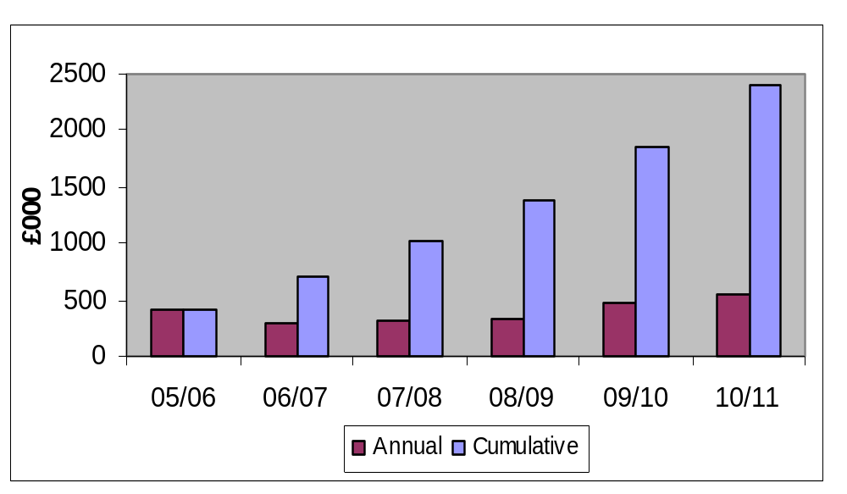
  - The following chart shows the levels of efficiency savings that the Council has made since it began to maintain records;

  - The chart shows that in the five year period to the end of 2009/10, the Council achieved efficiency savings of around £2m. This will increase to around £2.5m if the efficiency savings that have been identified (and inbuilt into the base budget for 2010/11) are achieved.

  - Unlike the practice adopted by many local authorities, when Kettering Borough Council approves its annual budget it ensures that if efficiency savings are required to balance the budget that specific savings are identified against budget headings (rather than using unidentified global savings targets). When the 2010/11 budget was approved, £550,000 of identified efficiency savings were included in the budget, the latest position in relation to these is illustrated below;

Item | Saving (£) | Status | Confidence
Waste & Recycling | £100,000 | Being Delivered – On  target | High
Next Steps | £165,000 | Being Delivered – On  target | High
Income & Purchasing | £205,000 | Being Delivered – on target | High
Minimum Revenue Provision (MRP) | £80,000 | To be agreed with KPMG as part of outturn. | Medium / High

External Funding

3.9 The delivery of a number of Council priorities and ensuring that the Council continues to maintain a strong financial platform has been complemented by the level of external funding that the Council has achieved in recent years. The following chart illustrates the levels achieved;
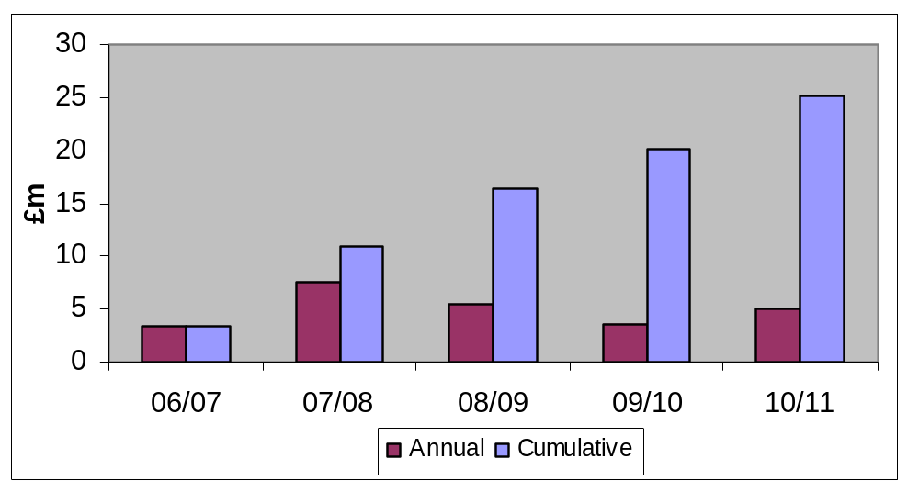

  - The Council has had significant external funding successes in both capital and revenue. Capital successes include securing significant Growth Area Funding, which has been and continues to be used to kick start the regeneration of the borough’s town centres. In addition, significant Local Area Business Growth Incentive (business rate growth) funding has been secured. This is a performance reward grant, which has also been earmarked for regeneration schemes.
  - In revenue the Council has consistently achieved the highest Housing and Planning Delivery Grant (HPDG) awards in North Northamptonshire and amongst the highest in the East Midlands. This is a performance reward grant, which is equivalent to an 11% increase in Council Tax. The Council has also secured one off “Trailblazer” grants for its innovative work in Housing and Customer services generating in £425,000.

Budget Assumptions

  - The Council has always prided itself on the robustness of its budget process; including within this is the consideration and regular review of key budget assumptions. The use of the ‘swing-o-meter’ for budgeting and monitoring purposes ensures that the Council has identified and understands its key business drivers.

  - As part of the last budget process, it was highlighted to Members that there was much uncertainty about the level of Central Government grant funding from 2011/12 onwards. To this end, Members were presented with different scenarios for grant funding and decided to adopt a model that assumed a 10% immediate reduction in core grant, and a three year phased withdrawal of Housing and Planning Delivery grant. The savings required from this are included in the table below:
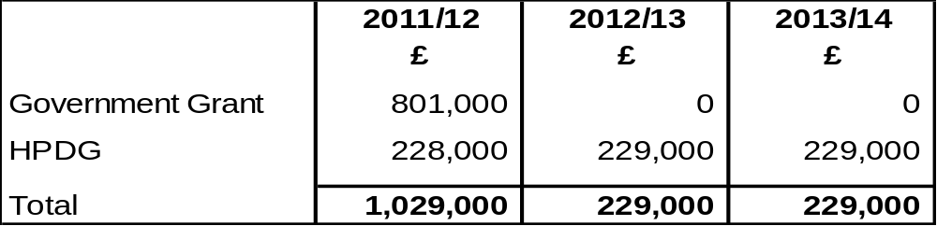

  - Whilst the assumptions will continue to be reviewed and re-assessed as the national funding picture becomes clearer during this year. What is clear is that Members made a conscious choice about what assumptions to include in the budget model and understood the implications – the assumptions adopted are still considered to be reasonable and should not expose the Council to undue risk in its financial planning. For comparison, the following table illustrates the assumptions used by some local authorities.
Core Grant Funding Assumptions

KBC | 10% one-off reduction from 2011/12
Local Authority 1 | 11% increase from 2011/12
Local Authority 2 | 5% reduction 2011/12, 2012/13 & 2013/14
Local Authority 3 | 10% one-off reduction from 2011/12

Latest Budget Projections

  - For information, the Councils approved budget model is shown at Appendix A This illustrates that;

- The Council has a balanced budget position for 2010/11.
- The Council does not have a structural deficit for 2011/12. I.e. if Government funding is maintained at current levels the Council would have a balanced budget for 2011/12.
- If the assumptions for Government funding in 2011/12 are correct approximately £1.1m will need to be removed from the budget to balance it.
- The general election result makes an early announcement on the Comprehensive Spending Review and Government funding unlikely. The Government has however announced plans to deliver a “budget” on the 22nd June 2010.

  - As outlined earlier in the report, the Council needs to achieve £550,000 of efficiency savings during 2010/11. These have already been incorporated into the budget and paragraph 3.6 highlights that delivery of these is on target.

  - Given that the main uncertainty remains around Government funding for 2011/12 and beyond and that the likelihood is that specific funding announcements won’t happen in the near future. The Council must adopt a robust framework of measures to navigate a path toward a balanced budget firstly for 2011/12 and then beyond.

4. MONITORING AND DELIVERY FRAMEWORK

  - Although the Council’s financial position is strong, it would be a mistake if it did not ensure that it has different options at its disposal should circumstances change in the future. To this end, a standing report will be presented to every future meeting of the Executive Committee. This will build on the already strong corporate performance framework that is reported to all members through the Key Performance Booklet.

  - An outline framework has been prepared and is detailed below. The framework identifies the type of measures that will be undertaken by the Council to help it prepare not only for the 2011/12 budget cycle but for managing the business in the medium and longer term. Their aim is to ensure that the Council remains in both a strong financial position, can adapt quickly when funding announcements are made (whilst always understanding the policy and financial implications) and can continue to deliver against the key priorities set.

  - The individual elements of the framework are outlined below and further reports will be brought monthly to the Executive. Given the emergency budget on 22nd June 2010 the first report in July will focus on the outcome of this and consider what implications it has for the Council’s current assumptions on grant levels and indeed any wider financial and service implications.
  - Reports thereafter will identify the specific measures being taken within the framework to deal initially with the revised assumptions for the budget gap for 2011/12 identified in the Medium Term Financial Strategy (Appendix A). The reports will also include any updates on Government funding as and when they are received.

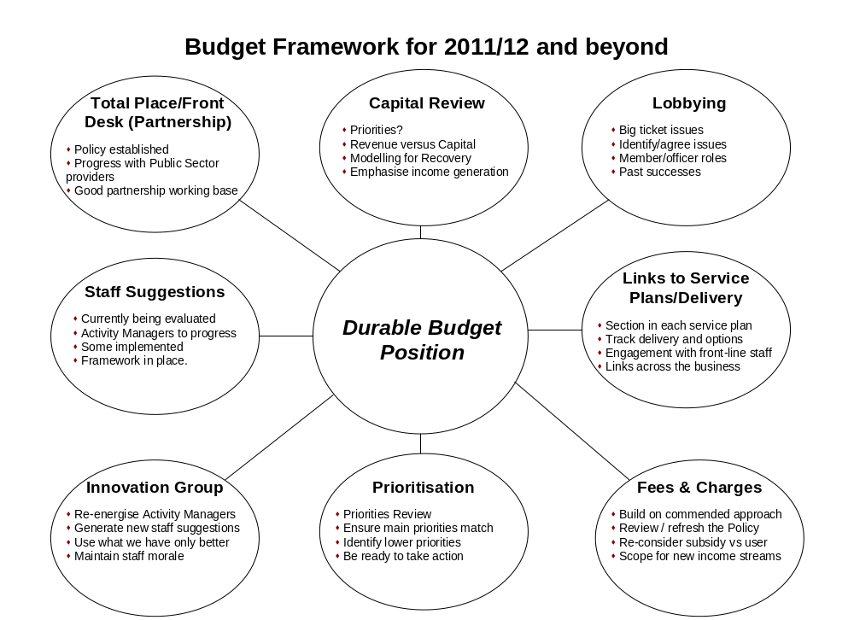

Total Place/Front Desk (Partnership)

  - The Council’s approach to partnership working was endorsed by the Executive in November and approved by Council in December 2009. The Council has had significant success in working with county wide and national agencies, as well as the voluntary sector in joining up services and delivering “partnerships of scope.” There have been individual projects – kleensweep, the credit crunch summit, keephealthy@kettering, various community safety initiatives, the Jobs Fair, all of which have demonstrated the value of working with other agencies in this Borough.
  - The Council is committed to extending such partnerships around the locality, which centre around the needs of the customer and indeed progress continues to be made with potential partners to deliver both a front and back office partnership.
Capital Review

  - The medium term is likely to see resources for both revenue and capital becoming tighter. Capital grants like Housing Growth Funding are likely to reduce if not disappear completely.

  - It is therefore important to ensure that the Council uses the resources it does have effectively. A review of the Council’s capital programme will therefore be undertaken and will look at two specific elements: -

  - Priorities – The review will ensure the capital programme schemes deliver the Council’s key priorities;
  - Funding and Revenue – The review will seek to ensure that funding is maximised and the revenue relationship reviewed considering the wider economic engine and use of “modelling for recovery” principles.
Lobbying
  - The Council has had some notable successes lobbying Government in recent times i.e. Increases in planning fees, revenue support grant and concessionary travel grants.
  - There are still many “big ticket” issues where the Council could be disadvantaged financially (e.g. Local Search Fees and Concessionary Travel) and others where there are potential financial gains (e.g. Planning Fees and Government Grant. The issue of growth area funding and the new Governments intentions around Council Tax increases also warrants attention.
  - If the Council’s successes are to be repeated it is critical that its strategy continues to be refined. Deciding when to influence individually, collectively or through supportive institutions and when officer or member input is required will continue to be the key to success.
Links to Service Plans/Delivery
  - The Council has a strong framework in place for service planning and delivery. However this will need to be enhanced to link even better with key priorities to provide greater information for future decision making. The service plans, which appear on this Executive agenda for approval, have sections that deal with the Council’s efficiency agenda and tracks delivery and options.
  - It is important to note that this element of the service plans will continue to be developed and improved. The service plans are working documents and it is important that they can be adapted “in year” to deliver changes and allow the Council to remain flexible.
Fees and Charges
.
  - The Council’s approach to fees and charges has been commended by the Audit Commission and they have used the Council as an exemplar. The policy is now over four years old and during forthcoming budget cycle will be reviewed and refreshed.
  - The review will focus around four key areas: -
- Who pays? – The review will consider explicit choices as to whether the user pays, the taxpayer pays or what the appropriate “mix” is if both pay.
- Role of Concessions – The Council’s concessions policy will be fully reviewed and the future of delivering “free” events considered.
- Government funding withdrawn – The review will consider what happens if funding is reduced or withdrawn for schemes such as concessionary travel or free swimming.
- New income streams – the review will seek to identify potential new income streams.
Prioritisation
  - If the level of savings required to balance the budget for 2011/12 are in line with the Council’s assumptions i.e. approximately £1m it is extremely unlikely that this will be found from efficiency savings alone. It is important that priorities are reviewed and lower priorities identified. If the Council is to remain in a strong financial position it must be ready to take action, which may mean taking difficult decisions. It is however better to do this in a planned way rather than reacting to a situation, which may present itself down the line.
Staff Suggestions
  - A list of suggestions was compiled after sessions were held with all staff last year, which informed staff of the Council’s financial circumstances and asked for their help in making the Council more efficient. The feedback has been excellent and officers are working through the list.
  - Some of the suggestions have been implemented already e.g. the change in Waste and Recycling measures. Activity managers are being tasked with evaluating and implementing any remaining suggestions.

  - Maintaining morale through this time is critical to delivering :-

- Flexibility;
- Further efficiency savings;
- Excellent customer service;
- Improved partnership working.
Innovation Group

  - A new group is in the process of being set up, which is designed to act as a vehicle to complete the evaluation of existing suggestions. It will also generate new suggestions and consider how messages are delivered to front-line staff to keep them engaged and maintain staff morale.
- CONCLUSIONS
  - The Council has a strong budgetary position from which to deal with future resource challenges, due mainly to the excellent track record of delivery of its budget, making efficiency savings, delivering external funding and understanding its business.
  - The efficiency target for the current year is already being delivered.
  - From July a report will be brought to each future meeting of the Executive looking in more detail at each of the components that compromise the “monitoring and delivery framework” as outlined in section 4. The first report will consider the implications of the Government’s budget to be delivered on 22nd June 2010.

6. RECOMMENDATIONS

It is recommended that:

  - A monthly report is considered by the Executive on this subject from July.
  - The July financial report is likely to focus on the Government’s budget.
  - The service plans are developed further to deal with the efficiency agenda;
  - Post July the areas for earliest consideration are ranked i.e. Capital Programme review, fees and charges review and prioritisation review

Background Papers: Previous Reports/Minutes:

Title of Document: Ref:
Date: Date:
Contact Officer:

