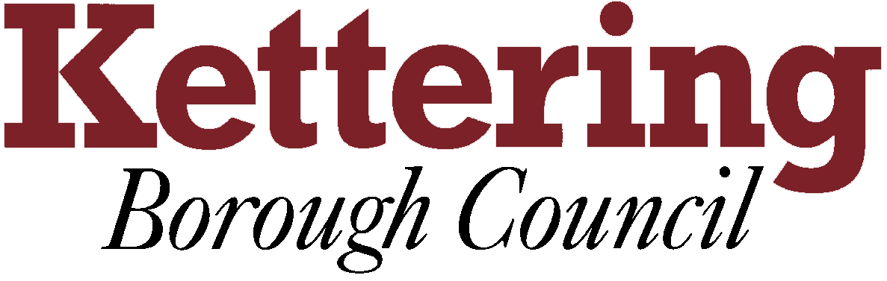

KETTERING BOROUGH TENANTS FORUM

Thursday, 13 May 2010

SUB-REGIONAL CHOICE BASED LETTINGS

This report asks the Tenants Forum to note the progress made in developing a choice based allocations scheme for social rented, shared ownership and privately rented homes across the local authority boroughs of Kettering, Corby and Wellingborough.

1 Background information

  - Central government have asked all local authorities across the country to develop allocations schemes which give housing applicants a greater say over where they live, and have set a deadline of 2010 for implementation.

  - Keyways, Kettering Borough Council’s choice based allocations system, was launched in our borough in January 2009. Since its launch, over 800 social rented homes owned by the Council and housing associations, and 14 homes owned by accredited private landlords, have been allocated to households in housing need on the Council’s housing register.

  - The government has also encouraged local authorities to join with neighbouring authorities to develop sub-regional choice based lettings schemes by awarding grants to support their implementation. In December 2008, Kettering, Corby and Wellingborough Councils were successful in bidding to central government for a grant to launch a sub-regional scheme across the three boroughs.

2 Implementation of Sub-Regional Choice Based Lettings

2.1 As the only authority in the group to have already launched a choice based allocations scheme, Kettering Borough Council were asked to project manage implementation of the sub-regional scheme. As a result, Dan Hannam, Housing Options Development Officer at Kettering Borough Council, has provided dedicated advice and support to our two partner authorities to ensure legislative compliance and timely delivery of the new scheme which is due to go live in late 2010.

  - The new scheme offers a number of important benefits to housing applicants:

- Households looking for somewhere to live tend not to recognise administrative boundaries. Therefore, it will be much easier for housing applicants to apply, as only one application form will be used across the three boroughs for both Council and housing association accommodation.
- Both Corby and Wellingborough have agreed to adopt the Keyways banding scheme, giving applicants the same priority across the three boroughs.
- Housing applicants can apply to any one of the three councils and their application will be managed by their ‘host’ council. This is determined by the area in which they currently reside, or if living outside the three boroughs, the one in which they most wish to live.
- There are currently 5,300 social rented homes in Kettering Borough, but the number of homes in the property pool will increase significantly once council and housing association homes in Corby and Wellingborough are added. Experience elsewhere has shown that this will increase customer choice and flexibility over where they can live.

  - There are additional benefits for the three local authorities:

- Funding from central government has provided sufficient income to allow the three councils to adopt the same Abritas IT system. This will allow each local authority access to information held on all housing applicants across the three boroughs, which will greatly enhance our ability to prevent and detect fraud.
- Adopting the same IT system will also reduce our annual on costs, and allow us to make significant savings in future years.
- Housing associations have homes located across many difference local authority areas. Therefore, adopting the same approach across the three administrative districts will simplify the nominations process for those housing associations with housing stock in more than one of our boroughs, and achieve economies of scale.

  - All three councils have entered into a contract with Abritas to install new IT systems which will be developed and delivered in summer 2010, and applicants on their housing registers will be notified of the new sub-regional scheme prior to launch in October or November 2010.

  - Outcomes from the new scheme will be monitored carefully, and a review conducted in partnership with Corby and Wellingborough Councils and housing association partners six months after launch date.

- Summary

  - The Tenants Forum are asked to note the progress made to date in preparing for the launch of a sub-regional choice based allocations scheme across Kettering, Corby and Wellingborough.

Sue Hottinger
Housing Strategy & Options Manager

28 April 2010

