BOROUGH OF KETTERING

Committee | Full Planning Committee - 27/04/2010 | Item No: 5.4
Report Originator | Alison Riches  Development Officer | Application No:  KET/2010/0199
Wards Affected | Desborough Loatland
Location | 47 Gold Street (rear of), Desborough
Proposal | Full Application: Detached chalet style dwelling
Applicant | Mr N Bapodara

1. PURPOSE OF REPORT

  - To describe the above proposals
  - To identify and report on the issues arising from it
  - To state a recommendation on the application

2. RECOMMENDATION

THE DEVELOPMENT CONTROL MANAGER RECOMMENDS that this application be APPROVED subject to the following Condition(s):-

1. The development hereby permitted shall be begun before the expiration of 3 years from the date of this planning permission.
REASON: To comply with Section 91 of the Town and Country Planning Act 1990 (as amended) and to prevent an accumulation of unimplemented planning permissions.

2. Before the development hereby permitted is begun, a scheme demonstrating how the development will incorporate techniques of sustainable construction and energy efficiency, provision for waste reduction and recycling and provision for water efficiency and recycling shall have been submitted to and approved in writing by the Local Planning Authority. The development shall not be carried out other than in accordance with the approved details.
REASON: In the interests of energy efficiency and sustainable construction in accordance with policy 14 of the North Northamptonshire Core Spatial Strategy.

3. No development shall commence on site until details of the types and colours of all external facing and roofing materials to be used, together with samples, have been submitted to and approved in writing by the Local Planning Authority. The development shall not be carried out other than in accordance with the approved details.
REASON: In the interests of the visual amenities of the area in accordance with policy 13 of the North Northamptonshire Core Spatial Strategy.

4. No development shall take place on site until a scheme for boundary treatment, including elevational plans, has been submitted to and approved in writing by the Local Planning Authority. The dwellinghouse shall not be first occupied until the approved scheme has been fully implemented in accordance with the approved details.
REASON: In the interests of the amenities and privacy of the neighbouring property in accordance with policy 13 of the North Northamptonshire Core Spatial Strategy.

5. The dwellinghouse hereby approved shall not be first occupied until the existing lean-to structure has been removed and the vehicular access has been constructed in accordance with details which have been submitted to and approved in writing by the Local Authority.
REASON: To ensure a satisfactory means of access to the highway in accordance with policy 48 of the East Midlands Regional Plan.

6. Notwithstanding the provisions of Article 3 of the Town and Country Planning (General Permitted Development) Order 1995 (or any Order revoking and re-enacting that Order with or without modification) no additional openings permitted by Schedule 2, Part 1 Classes A, B or C shall be made in any elevation or roof plane of the building.
REASON: To protect the amenities and privacy of the occupiers of adjoining properties in accordance with policy 13 of the North Northamptonshire Core Spatial Strategy.

7. Notwithstanding the provisions of Article 3 of the Town and Country Planning (General Permitted Development) Order 1995 (or any Order revoking and re-enacting that Order with or without modification) no building, structure or other alteration permitted by Classes A or E of Part 1 of Schedule 2 of the Order shall be erected on the application site.
REASON: To protect the amenities of the occupiers of adjoining properties in accordance with policy 13 of the North Northamptonshire Core Spatial Strategy.

Notes (if any) :-
- This permission does not convey any legal or civil right to undertake works that affect land or premises outside of the applicant's control. Care should be taken upon commencement and during the course of building operations to ensure that no part of the development, including the foundations, eaves and roof overhang will encroach on, under or over adjoining land without the consent of the adjoining land owner.

The applicant is reminded of the provisions of the Party Wall etc Act 1996 which may require notification of the works hereby permitted to all affected neighbours. More detailed information regarding the provisions of 'The Act' should be obtained from an appropriately qualified professional with knowledge of party wall matters.

Justification for Granting Planning Permission

The proposal is in accordance with national and local policies as set out in Planning Policy Guidance Note 13, Planning Policy Statements 1 and 3, Policies 2 and 48 of The East Midlands Regional Plan and Policies 9, 13 and 14 of the North Northamptonshire Core Spatial Strategy. There are no material considerations that indicate against the proposal.

Officers Report

3.0 | Information

Relevant Planning History
KET/2002/1054. Addition of conservatory and detached garage to dwelling previously approved. Approved 12/03/2003.

KET/2002/0119. Detached bungalow. Refused 09/04/2002. Allowed on appeal 12/09/2002. (Appeal reference: APP/L2820/A/02/1089584).

KE/2001/0815. Detached bungalow. Refused 11/12/2001. Allowed on appeal 12/09/2002. (Appeal reference: APP/L2820/A/02/1089743).

KE/2001/0600. 3-bedroomed detached dwelling with single garage. Refused 11/09/2001.

Site Description
Officer's site inspection was carried out on 09/04/2010.

The application site is located to the west of Desborough Town Centre and is currently the rear garden area for No.47 Gold Street, a mixed residential and retail property also known as Oak Tree Stores. Gold Street is the main east-west through road that joins the former A6, Harborough Road to the new A6 Desborough Bypass between Kettering and Market Harborough.

The site is bounded to the west and rear (north) by 1.8 metre high gapped vertical boarded fencing. The east boundary is a 3 metre high brick wall formed from the rear elevations of a run of outbuildings at the bottom of the rear gardens of Nos.17 to 35 Gold Street, with the exception of Nos.27 and 29 where there is no brick outbuilding and the wall is approximately 1 metre in height. No.29 has a corrugated metal outbuilding in place of the brick building, abutting the brick wall, and No.27 has no boundary treatment other than the 1 metre high brick wall. There is currently no southern boundary to separate the application site from No.47 Gold Street.

The surrounding area contains a mixture of dwelling types and uses. Residential roads surround the site with terraced properties occupying an off-shoot of Gold Street to the east and semi-detached properties occupying Oak Tree Close to the west. The rear gardens of these properties bound the site.

Proposed Development
The proposal is a full planning application for the construction of a three-bedroomed chalet bungalow on what is presently the garden area at the rear of No.47 Gold Street. Access is to be provided via an existing drive that currently leads to an existing garage at the rear of the store. An existing single storey lean-to extension on the west elevation of No.47 is to be demolished to allow the access drive to be widened to allow two vehicles to pass in the driveway.

The proposal is a resubmission of the scheme approved at appeal under reference KE/01/0815, with the addition of a conservatory but with the removal of the garage, as approved under reference KE/02/1054, and has been submitted owing to the footings being laid out not in accordance with the approved plans.

Any Constraints Affecting the Site
C Road

4.0 | Consultation and Customer Impact

Desborough Town Council
- Objection.
- At least two previous proposals have been refused for backland development, too dense, access difficulties from the existing shop and exit onto Gold Street too close to bus stop (vision/safety).
- An inappropriate backland development. There should be no more backland development.

Highway Authority
- No comments received.

Environmental Health Department
- Contaminated land condition requested.

Neighbours
29 Gold Street
- Objection.
- Looking at the plans it is extremely large and high for a chalet with two floors. It is the same height as a normal house.
- The proposed plans show a fence placed on the masonry wall which is not theirs.
- The main reason I object is the increase in traffic along a road already with car parking issues along the side.
- The entrance is on a busy road with cars quite often parked outside the shop.
- There are already a number of new builds which have to use Gold Street as their only entrance to their houses.

5.0 | Planning Policy

National Policies
PPG13. Transport
PPS1. Delivering Sustainable Development
PPS3: Housing

Development Plan Policies

East Midlands Regional Plan
Policy 2. Promoting Better Design
Policy 48. Regional Car Parking Standards

North Northamptonshire Core Spatial Strategy
Policy 9. Distribution and Location of Development
Policy 13. General Sustainable Development Principles
Policy 14: Energy Efficiency and Sustainable Construction

6.0 | Financial/Resource Implications
 | None
7.0 | Planning Considerations
The key issues for consideration in this application are:-

- The principle of development.
- The effect of the proposal on the character and appearance of the wider street scene and surrounding development.
- The effect of the proposal on the living conditions of residents either side/nearby.
- The effect of the proposal on the highway network and highway safety.

1. Principle of Development
The application site is within walking distance of Desborough Town Centre and all its amenities where the principle of residential development is strongly supported by the aims and objectives of policies within the Development Plan. Policies 2 and 48 of the East Midlands Regional Plan and policies 9, 13 and 14 of the Northamptonshire Core Spatial Strategy all seek to ensure that Brownfield sites are given priority for residential development; that residential development is of a high standard of design and is sustainable in its construction techniques; it meets renewable and efficient energy objectives, will not detrimentally impact upon the lives of others and is located in a sustainable location which minimises the need for reliance on car ownership to access local facilities.

The Development Plan objectives are further supported by National policy advice contained within PPS1: Delivering Sustainable Development, PPS3: Housing and PPG 13: Transport.

At the site there have been two relevant previous planning applications at the site under references KE/01/0815 and KE/02/0119. KE/01/0815 was for a three-bedroomed chalet bungalow with rooms in the roof space and is identical to the scheme in this application. KE/02/0119 was for a two-bedroomed bungalow with all accommodation on the ground floor. Both applications were refused contrary to officer recommendation but subsequently approved at appeal. Since these decisions were issued the Local Plan for Kettering Borough, The Northamptonshire County Structure Plan, the Regional Spatial Strategy and PPG3 have been superseded by the North Northamptonshire Core Spatial Strategy, the East Midlands Regional Plan and PPS3; however, the policy provision has not changed and these decisions therefore carry weight in the consideration of this application.

As such, the proposed development is strongly supported by the aims and objectives of the Development Plan policies as listed in this report.

2. Character and Appearance
The proposal would not have an adverse impact on the wider street scene as it will only be partially visible from Gold Street and would be of a comparable size to surrounding dwellings. It is also screened from the existing mix of residential properties in the off-shoot of Gold Street and in Oak Tree Close by the existing boundary treatments and would therefore not have an adverse impact on their character and appearance. This is borne out by the Planning Inspector in the appeal decisions who concluded that ‘the character of this part of Desborough is mixed and I do not consider that either of the appeal proposals would be out of keeping or harm its appearance. Although small, the plot is of adequate size for the scale of dwellings proposed so that neither appeal scheme would amount to overdevelopment.’ The Inspector found the development policies covering these matters were satisfied.

Provided the materials used are compatible with those used on surrounding dwellings, it is considered that the proposal, owing to its location at the rear of the plot, would not appear incongruous within the wider area, or against surrounding development.

As such, the scheme proposed conforms to policy 48 of the East Midlands Regional Plan and policy 13 of the North Northamptonshire Core Spatial Strategy which requires new development to reflect and respect the character and appearance of its surroundings.

3. Residential Amenity
The separation distance of the proposal from surrounding development is such that there will be no issues of overlooking from any elevation of the proposed dwellinghouse.

The north (rear) elevation of the proposal contains two dormer windows at first floor level. The window at the eastern end of the rear elevation is at least 11.7 metres from the rear boundary and faces onto the brick boundary wall with the neighbouring properties in the Gold Street off-shoot. The window at the western end of the rear elevation, at least 10.2 metres from the rear boundary. The rear site boundary abuts the end of the rear garden of No.10 Oak Tree Close.

Both side elevations have no openings at first floor level but a door is proposed at ground floor level in the west elevation. As the proposed dwellinghouse abuts the eastern site boundary and is less than 1 metre from the western site boundary, a condition is to be added to prevent any further openings at first floor level in either the east or west elevations, to overcome any issues of potential overlooking.

The south (front) elevation has one dormer window at first floor level which is located at least 18.4 metres from the rear elevation of the existing building on site and at least 25 metres from the rear elevation of the adjacent property to the west at No.49 Gold Street. To the east, the first floor front dormer faces onto the brick boundary wall with the neighbouring properties in the Gold Street off-shoot.

In the appeal decision, in relation to the first floor rear dormer windows in the chalet bungalow (KE/01/0815) facing the ends of the gardens of Nos.10 and 12 Oak Tree Close, the Planning Inspector did ‘not consider that there would be undue loss of privacy to the occupiers of these properties which already have views into each other’s gardens. Any views would be oblique and they are well separated … so that loss of privacy would not be significant.’ With respect to the front dormer, facing the existing flats above Oak Tree Stores, the Inspector concluded that ‘the flats already share their surroundings with the shop activities and I do not consider that this minor intrusion would reduce privacy to an unacceptable level nor conflict with development plan policies.’

In terms of the loss of amenity space to the occupiers of the existing residential unit above Oak tree Stores, the previous appeals were granted with the Planning Inspector concluding that the loss of amenity space can be set against ‘the benefit to the housing stock of an additional dwelling in line with the guidance of PPG3 regarding making good the use of previously developed land. On balance, I consider that the loss of amenity space for the flats is not sufficient in itself to conflict with the development plan and justify the refusal of planning permission.’

Since the appeal was granted PPG3 has been replaced with PPS3: Housing, which states that the priority for development should be previously developed land. Policy 9 of the North Northamptonshire Core Spatial Strategy also reiterates this point stating that ‘priority will be given to the reuse of suitable previously developed land’ and ‘preference will be given to locations that are accessible by a choice of a means of travel’.

For the reasons given above, the proposed scheme is acceptable and conforms to policies 9 and 13(l) of the North Northamptonshire Core Spatial Strategy which requires that development should not result in an unacceptable impact on the amenities of neighbouring properties.

4. Highway Network and Highway Safety
As described previously the Development Plan policies support the location of residential development which is not reliant upon car use. The application site is located approximately 250 metres from Desborough Town Centre, within walking distance of all its amenities.

One of the objectives of PPG13: Transport, in paragraph 4.3 is to ‘reduce the need to travel, especially by car’ by ‘accommodating housing principally within existing urban areas, planning for increased intensity of development for both housing and other uses at locations which are highly accessible by public transport, walking and cycling’ (paragraph 6.3).

Paragraph 49 states that ‘reducing the amount of parking in new development is essential…to promote sustainable travel choices’.

PPS1 and PPS3 also promote development that is easily accessible and well connected to public transport which reduces the need to travel.

Although the scheme proposed provides some on-site parking, the area set aside is not considered sufficient to allow a vehicle to enter the site in a forward direction and then manoeuvre so as to leave the site in a forward direction. Given the proximity of the site to Desborough Town Centre and all its amenities, and the bus stops in close proximity to the application site, there is no policy requirement to provide on-site parking.

The Highway Authority did not object to either of the two previous schemes and the Planning Inspector did not consider that ‘there is evidence to substantiate refusal on road safety grounds’. As such, the proposed development meets the aims and objectives of the Development Plan policies and National planning policy guidance referred to previously.

The scheme is therefore considered to be acceptable and will not adversely impact on the highway network in line with the aims and objectives of the Development Plan and PPG13.

Conclusion

Section 38(6) of the Planning and Compulsory Purchase Act 2004 requires that this planning application must be determined in accordance with the Development Plan unless material considerations indicate otherwise. In this regard the proposed development is strongly supported by the aims and objectives of the Development Plan policies listed in the report, and there are no material considerations which would outweigh the Development Plan subject to the imposition of the recommended planning conditions.

Background Papers |  | Previous Reports/Minutes
Title of Document: |  | Ref:
Date: |  | Date:
Contact Officer: | Alison Riches, Development Officer on 01536 534316

SITE LOCATION PLAN

47 Gold Street (rear of), Desborough
Application No.: KET/2010/0199

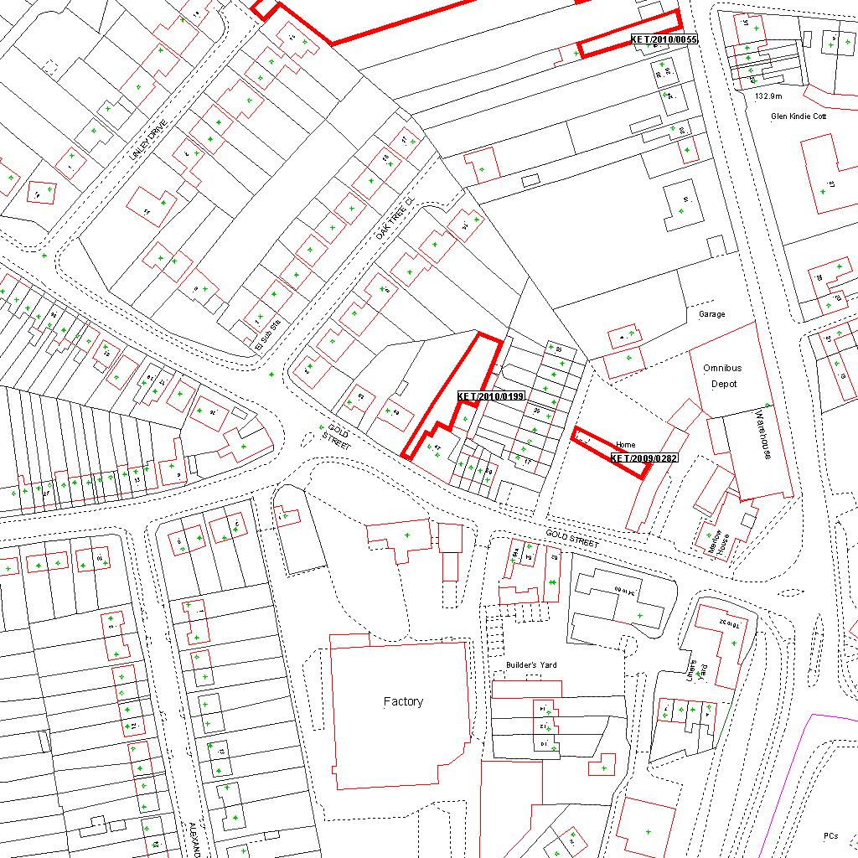

Reproduced from the Ordnance Survey mapping with the permission of the Controller of Her Majesty’s Stationery Office © Crown copyright. Unauthorised reproduction infringes Crown copyright and may lead to prosecution or civil proceedings.  LA078344 |  | N
Date: 22/03/2010 Do not scale from this map. For illustrative purposes only.

