BOROUGH OF KETTERING

Committee | Full Planning Committee - 27/04/2010 | Item No: 5.3
Report Originator | Alex Jelley  Assistant Development Officer | Application No:  KET/2010/0175
Wards Affected | Desborough Loatland
Location | Linley Drive (land off), Desborough
Proposal | s.73 Application: Variation of condition nos. 3 (provision of garages) and 6 (in respect of approved plans) of KET/2007/1085
Applicant | Persimmon Homes

1. PURPOSE OF REPORT

  - To describe the above proposals
  - To identify and report on the issues arising from it
  - To state a recommendation on the application

2. RECOMMENDATION

THE DEVELOPMENT CONTROL MANAGER RECOMMENDS that this application be APPROVED, subject to a S.106 OBLIGATION being entered into, and to the following conditions:-

1. The development hereby permitted shall be begun before the expiration of 3 years from the date of this planning permission.
REASON: To comply with Section 91 of the Town and Country Planning Act 1990 (as amended) and to prevent an accumulation of unimplemented planning permissions.

2. Development shall not commerce until there has been submitted to and approved by the Local Planning Authority a report and details that verify against a submitted site layout, the conclusions of the report "proposed residential development at the Former Coal Yard & Council Yard, Harborough Road, Desborough - Noise & Vibration Survey Report submitted by RanTech Consulting and dated 20th October 2005". The verification shall include proposals for ensuring that the guideline levels set out in BS8233:1999 for residential accomodation are complied with and that all necessary works are supervised by a competent person. The scheme that is to be approved by the Local Planning Authority shall be fully implemented in accordance with the approved details and before the use hereby approved commences. The scheme and any required works thereafter shall be maintained in accordance with the approved details, and no alterations to the structure, roof, doors, windows or external facades shall be undertaken without the prior written approval of the Local Planning Authority.
REASON: To ensure that development proceeds in a satisfactory way and thereafter maintained appropriately.

Notes (if any) :-
- NONE

Justification for Granting Planning Permission

The proposal is in accordance with national and local policies as set out in Planning Policy Statements/Guidance Notes 1, 3 and 13, Policy 48 of The East Midlands Regional Plan, and Policies 6, 13 and 14 of the North Northamptonshire Core Spatial Strategy. The proposal is also in accordance with adopted Supplementary Planning Document Sustainable Design. There are no material considerations that indicate against the proposal.

Officers Report

3.0 | Information

Relevant Planning History
KET/2009/0732 – S.73 Application: Variation of Condition 3 (Parking/garages) and 6 (Approved Plans List) of KET/2007/1085 – Refused 27.01/2010 for failure to enter into required S106 Agreement

KET/2007/1085 – Approval of Reserved Matters: Construct 20 No. residential dwellings and associated parking provision, drainage and extension of Linley Drive – Approved 14.03.08

KET/2006/0669 – Outline Planning Permission: Residential development of 20 no dwelling houses with extension of public highway known as Linley Drive – Approved 18.10.06

Site Description
The site is situated to the North of Desborough on previously developed land used by the County Council as a Depot. The area has been cleared and building work has commenced on the previously approved scheme (KET/2007/1085), with some of the road network laid, foundations dug, and walls constructed in part.

Neighbouring land to the South of the site has also been granted approval (KET/2007/1083). To the North the application site is bounded by the railway line.

The site is accessed from Linley Drive, which has a very residential nature, and is characterised by detached and semi-detached dormer bungalows. The wider context is also residential, though Desborough town centre lies to the East, and open countryside to the North and West.

Proposed Development
This application seeks permission to vary Condition 3 (related to parking/garages) and Condition 6 (related to approved plans) of KET/2007/1085 to allow for the removal of garages from the plans, with an amended parking layout and landscaping plan.

Any Constraints Affecting the Site
None

4.0 | Consultation and Customer Impact

Desborough Town Council
Objection.
- Concern that proposals completely change the nature of the approved development.
- It is totally out of character with the area.
- No access to Market Harborough Road
- Major concern regarding a future request to connect to Oak Tree Close development to the South

Highway Authority
No objection.

Northamptonshire Police
No objection.

Environmental Health
No objection.

Neighbours
11 letters of objection were received from neighbours, and a petition including 20 signatures was also received. The concerns raised were in relation to:
- Increased traffic flow on Linley Drive
- Concern about crime and anti-social behaviour
- Access should be off Harborough Road and not Linley Drive
- Lack of transparency within decision-making due to change to all affordable housing
- Removal of garages will result in detrimental impact on character of the area.
These issues will be considered in full within Section 7.0 of this report.

5.0 | Planning Policy

National Policies
PPS1. Delivering Sustainable Development
PPS3: Housing
PPG13. Transport

East Midlands Regional Plan
Policy 48. Regional Car Parking Standards

North Northamptonshire Core Spatial Strategy
Policy 6. Infrastructre Delivery and Developer Contributions
Policy 13. General Sustainable Development Principles
Policy 14: Energy Efficiency and Sustainable Construction

6.0 | Financial/Resource Implications
 | A section 106 Agreement is required securing all housing to be affordable, as well as contributions toward play area provision and education services.
7.0 | Planning Considerations
The key issues for consideration in this application are:-

1. Principle of Development
2. Design and Character
3. Highway Issues
4. Crime and Disorder
5. New S106 Agreement

1. Principle of Development
The principle of development, together with the position of the access point for the development, has been established with the granting of the outline planning permission (KET/2006/0669) and approval of reserved matters planning permission (KET/2007/1085); the details regarding parking provision within the latter of these being those which this application seeks to amend. These permissions approved the development of a maximum of 20 dwellings subject to conditions and a Section 106 Agreement comprising the provision of affordable housing, a contribution towards education provision and also a contribution towards off site play provision in the area.

The previous S.73 Application (KET/2009/0732) was refused solely due to a failure on the applicants’ part to provide a signed S106 Agreement within time.

Section 38(6) of the Planning and Compulsory Purchase Act 2004 requires local planning authorities to determine planning applications in accordance with their Development Plan unless material planning considerations indicate otherwise.

This application, therefore, is concerned solely with the proposed amendments to the parking provision, and whether they would result in a form of development that is contrary to the Development Plan. Policy 13 of the North Northamptonshire Core Spatial Strategy provides for residential development of this nature subject to specific criteria being satisfied. Given the nature of the proposed amendments to the previous approved scheme, it is considered reasonable to consider only those criterion within Policy 13 that relate to the amended parking layout; whether the development would be suitable from a design and character perspective; whether the site would form a suitable relationship with the surrounding highway network; and whether the proposals are appropriate in terms of crime and disorder. Policy 14 of the CSS requires development to meet the highest viable standards of resource and energy efficiency.

2. Design and Character
This application does not seek permission for the alteration of the dwellings, or their layout, but does propose an amended parking scheme, including the removal of the previously approved garages from the design. To allow the garages to be removed, some minor changes are proposed to the layout that would affect the gardens of plots 1, 2, 10, 11, 15, 16 and 17 this is to provide for a modified parking area to the rear of the plots 1 to 11. The proposal removes garages from plots 1-11, 14 and 18-20. Though it is noted that concern exists from neighbours and Desborough Town Council on this subject, it is not considered that the overall character of the site will be sufficiently impacted upon by the proposals to warrant refusal. The residential nature of the surrounding roads, and of the site itself, is retained, and the scale, design and type of dwellings proposed will not be impacted upon. The overall plot size for rear gardens is considered to be acceptable. The proposed hard and soft landscaping features, which are slightly altered by amended parking layout, the extended footpath, amenity shrub and hedge planting is considered to be acceptable. The application therefore accords with policy 13 of the North Northamptonshire Core Spatial Strategy in so far as it relates to matters of design and character.

Policy 14 of the North Northamptonshire Core Spatial Strategy seeks to ensure that all new development meets the highest viable standards of resource and energy efficiency. This application does include detail of how the development will meet the criteria of policy 14, however, it considered acceptable to secure this information via condition.

3. Highway Issues
The position of the main access point has previously been approved by the outline application (KET/2006/0669) and it is not considered that the acceptability of the access has changed since. Furthermore, the Highways Authority has been consulted on this application, and has no objection to it. They do, however, point out that there is no secure cycle storage proposed, and it is considered prudent to secure this via condition.

The alterations to the parking scheme, involving the removal of garages, changes the number of parking spaces on the site from 17 garages and 20 spaces (37 in total) to 34 parking spaces. Though fewer spaces are provided, it is still considered that the proposals remain acceptable in this respect. The application would form a suitable relationship with the highway network, and therefore meets those criteria of policy 13 of the North Northamptonshire Core Spatial Strategy that relate to highways matters.

4. Crime and Disorder
Crime, and the fear of crime, is a material planning consideration. The layout provides an active street frontage to the majority of the footpath link. There is no active surveillance of the parking area behind plots 1 to 11, however, there are windows from habitable rooms facing toward it. In any case, the previously approved scheme, if implemented, would have a similar situation. It is considered that a condition requiring boundary treatments is necessary to ensure that the utmost security is provided. It is considered that the application will meet the criteria set out by policy 13 of the North Northamptonshire Core Spatial Strategy in respect of crime and disorder.

Concerns raised about the vetting procedures of housing associations is not a material planning considerations and therefore has not formed part of the determination of this planning application.

5. New S.106 Agreement
As this application seeks permission for a variation of conditions on the approval of reserved matters application (KET/2007/1085) connected to the outline application (KET/2006/0669), the applicant is required to enter into a planning obligation to secure the same contributions towards infrastructure for education services and play areas, as well as securing the affordable housing level previously agreed. No planning obligation has been entered into and without one the development is unacceptable and conflicts with the aims and objectives of Policy 6 of the North Northamptonshire Core Spatial Strategy.

Conclusion

The application is in accordance with the Development Plan and there are no material planning considerations that would indicate against approval of this application. The proposals are suitable in terms of their type, scale, positioning and design; they are in keeping with the character

Background Papers |  | Previous Reports/Minutes
Title of Document: |  | Ref:
Date: |  | Date:
Contact Officer: | Alex Jelley, Assistant Development Officer on 01536 534316

SITE LOCATION PLAN

Linley Drive (land off), Desborough
Application No.: KET/2010/0175

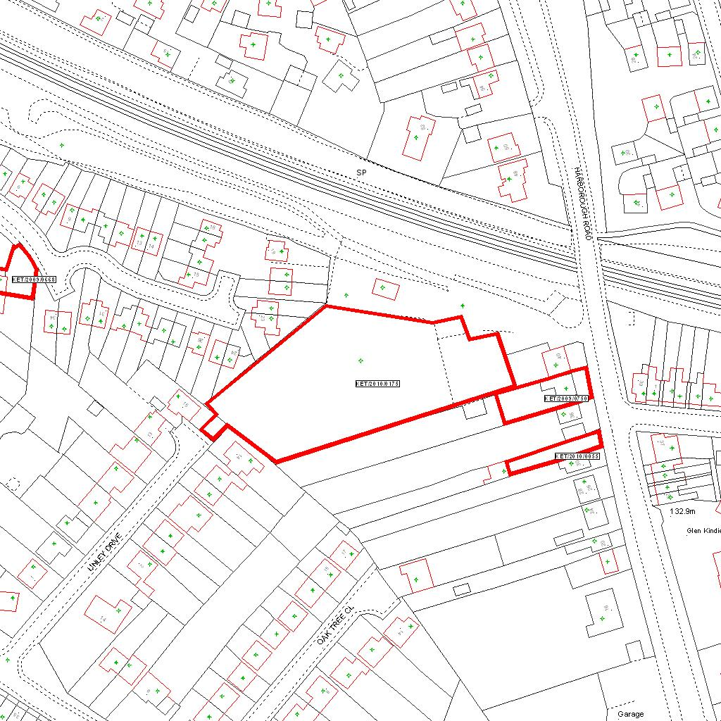

Reproduced from the Ordnance Survey mapping with the permission of the Controller of Her Majesty’s Stationery Office © Crown copyright. Unauthorised reproduction infringes Crown copyright and may lead to prosecution or civil proceedings.  LA078344 |  | N
Date: 12/03/2010 Do not scale from this map. For illustrative purposes only.

