BOROUGH OF KETTERING

Committee | Full Planning Committee - 27/04/2010 | Item No: 5.1
Report Originator | Alison Riches  Development Officer | Application No:  KET/2010/0160
Wards Affected | Welland
Location | 11 Queens Road, Wilbarston
Proposal | Full Application: First floor rear extension
Applicant | Mr S Winn

1. PURPOSE OF REPORT

  - To describe the above proposals
  - To identify and report on the issues arising from it
  - To state a recommendation on the application

2. RECOMMENDATION

THE DEVELOPMENT CONTROL MANAGER RECOMMENDS that this application be APPROVED subject to the following Condition(s):-

1. The development hereby permitted shall be begun before the expiration of 3 years from the date of this planning permission.
REASON: To comply with Section 91 of the Town and Country Planning Act 1990 (as amended) and to prevent an accumulation of unimplemented planning permissions.

2. The materials to be used in the construction of the external surfaces of the development hereby permitted shall match, in type, colour and texture those on the existing building.
REASON: In the interests of visual amenity in accordance with policy 13 of the North Northamptonshire Core Spatial Strategy.

Notes (if any) :-
- The applicant is reminded of the provisions of the Party Wall etc Act 1996 which may require notification of the works hereby permitted to all affected neighbours. More detailed information regarding the provisions of 'The Act' should be obtained from an appropriately qualified professional with knowledge of party wall matters.

This permission does not convey any legal or civil right to undertake works that affect land or premises outside of the applicant's control. Care should be taken upon commencement and during the course of building operations to ensure that no part of the development, including the foundations, eaves and roof overhang will encroach on, under or over adjoining land without the consent of the adjoining land owner.

Justification for Granting Planning Permission

The proposal is in accordance with national and local policies as set out in Planning Policy Statement 1, Policy 48 of The East Midlands Regional Plan and Policy 13 of the North Northamptonshire Core Spatial Strategy. There are no material considerations that indicate against the proposal.

Officers Report

3.0 | Information

Relevant Planning History
KE/2001/0541. Conservatory to rear. Approved 23/08/2001.

KE/1994/0316. Domestic lounge/bedroom. Approved 19/07/1994.

KE/1994/0136. Domestic lounge/bedroom. Refused 22/04/1994.

Site Description
Officer's site inspection was carried out on 25/03/2010.

The application site is located with the front elevation orientated to the southwest, close to the junction of two roads, both designated Queens Road, in Wilbarston village.

The application site is a two-storey semi-detached dwellinghouse covered in cream render with a brown concrete tile roof. All windows and doors are dark brown PVCu. The dwellinghouse is set at the front of a long narrow irregular shaped plot with an outbuilding located halfway up the rear plot.

There are two doors in the front elevation covered by a hipped roof canopy. One door is flat within the front elevation, and the other has been put in the centre of a bay fronted addition to the property. The bay fronted addition is located close to the boundary with the adjoining semi-detached dwellinghouse at No.9 Queens Road.

Three extensions have been added along the length of the rear elevation. A subordinate two-storey hipped roof extension was added in the mid 1990s to the easternmost point of the dwellinghouse. This addition shields the rear garden from views from Queens Road to the east. Adjacent to the two-storey addition, a conservatory has been added, and immediately adjacent to the adjoining semi-, abutting the boundary, a single storey hipped roof extension has been added under permitted development rights.

The rear elevation is orientated northeast and the boundary with the adjoining semi- doglegs in such a way that the occupiers of the application site can directly look into the ground floor windows in the rear elevation of the neighbouring semi- at No.9 Queens Road.

The dwellinghouses immediately surrounding the application site are predominantly two-storey and form part of the same development but there is also some single storey infill development to the northwest. There are some much older more traditional stone barns and cottages to the east and south which are included in Wilbarston village Conservation Area.

Proposed Development
The proposal is for the rear roof slope of the existing dwellinghouse to be extended down from the eaves above an existing single storey rear addition to join the eaves of this addition. A dormer extension with a hipped roof is proposed at first floor level within the amended roof.

The existing single storey rear addition has a hipped roof and abuts the boundary with the adjoining semi-detached property at No.9 Queens Road. The proposed dormer extension is set away from this boundary within the proposed new roof slope.

Any Constraints Affecting the Site
None.

4.0 | Consultation and Customer Impact

Parish/Town Council
- No response received.

Neighbours
- No comments received.

5.0 | Planning Policy

National Policies
PPS1. Delivering Sustainable Development
PPS7. Sustainable Development in Rural Areas

Development Plan Policies

East Midlands Regional Plan
Policy 2. Promoting Better Design

North Northamptonshire Core Spatial Strategy
Policy 13. General Sustainable Development Principles

Local Plan
RA3. Rural Area: Restricted Infill Villages

6.0 | Financial/Resource Implications
 | None
7.0 | Planning Considerations
The key issues for consideration in this application are:-

- The principle of development.
- The effect of the proposal on the character and appearance of the wider street scene, surrounding development and the existing dwellinghouse.
- The effect of the proposal on the living conditions of residents either side/nearby.

1. Principle of Development
The application site is in an established residential area to the eastern side of Wilbarston village and policy 13 of the North Northamptonshire Core Spatial Strategy supports extensions to residential properties, provided there is no adverse impact on character and appearance and residential amenity. The application of policy is discussed in the report below.

2. Character and Appearance
The proposal is located to the rear of the property and will not be visible from the public highways in either of the Queens Roads. It will also not be visible in the Conservation Area which includes the stone cottage and outbuildings immediately opposite the application site.

Although the proposal includes a dormer window and a low sloping roof, characteristics not normally associated with existing residential development in the immediate area, the fact that it will not be visible from the public realm means that there will be no adverse impact on the character and appearance of the wider street scene and surrounding development. Provided the materials used match the existing, as stated in the planning application, the proposal will not adversely impact on the character and appearance of the existing dwellinghouse.

As such, the proposal complies with policy 13 of the North Northamptonshire Core Spatial Strategy which requires new development to respect the character of its surroundings.

3. Residential Amenity
The proposed extension comprises a dormer window at first floor level which extends 2.43 metres from the rear elevation and 0.6 metres from the boundary with the adjoining semi- at No.9 Queens Road. The proposed use of the extension is as an en-suite and dressing room and will form the only fenestration for the bedroom it is extended from.

By virtue of the properties being semi-detached, each neighbour currently experiences some overlooking from the first floor windows into their rear gardens. By adding a projection at first floor level to the rear elevation, there could be an issue of further overlooking of the adjoining property; however, any overlooking experienced will occur further down the neighbour’s garden and will be less intrusive than currently experienced when looking out of the rear elevation windows.

In addition, the neighbour at No.9 already experiences some loss of amenity caused by the dogleg in the boundary with the application site, meaning the occupants can be directly observed at ground floor level from the garden.

There are no issues with loss of amenity to other surrounding neighbours due to the separation distance between the properties being too great for and adverse impacts to occur.

The proposal therefore does not further impact on the amenities of surrounding occupiers and therefore complies with policy 13 of the North Northamptonshire Core Spatial Strategy which requires new development not to result in an unacceptable impact on the amenities of neighbouring properties.

Conclusion

Section 38(6) of the Planning and Compulsory Purchase Act 2004 requires that this planning application must be determined in accordance with the Development Plan unless material considerations indicate otherwise. In this regard the proposed development is strongly supported by the aims and objectives of the Development Plan policies listed in the report, and there are no material considerations which would outweigh the Development Plan subject to the imposition of the recommended planning conditions.

Background Papers |  | Previous Reports/Minutes
Title of Document: |  | Ref:
Date: |  | Date:
Contact Officer: | Alison Riches, Development Officer on 01536 534316

SITE LOCATION PLAN

11 Queens Road, Wilbarston
Application No.: KET/2010/0160

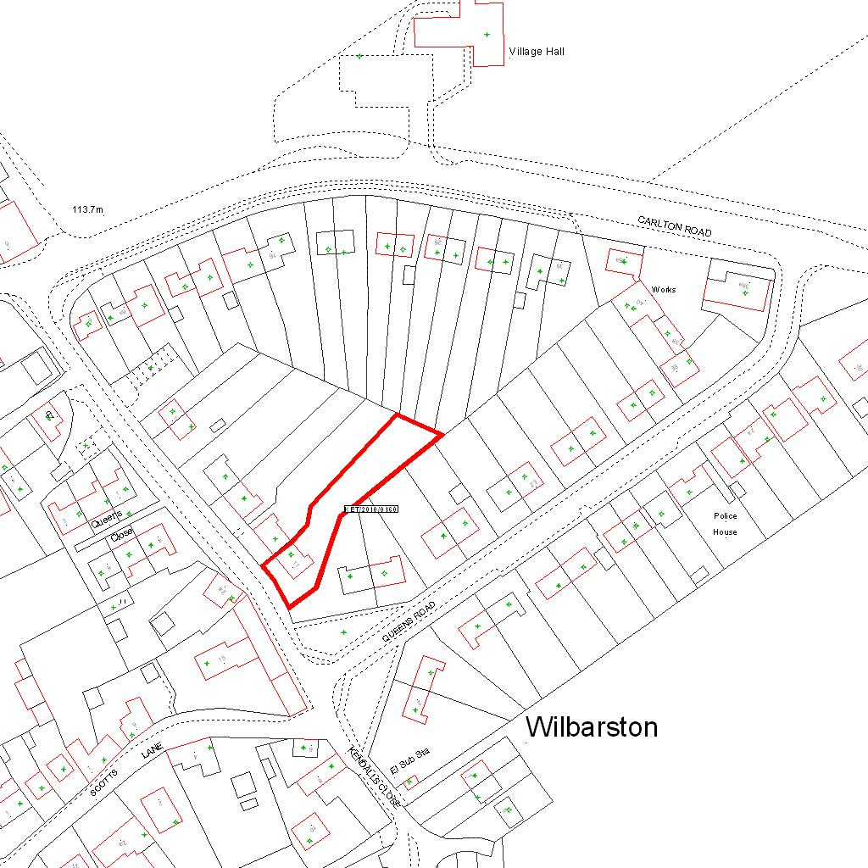

Reproduced from the Ordnance Survey mapping with the permission of the Controller of Her Majesty’s Stationery Office © Crown copyright. Unauthorised reproduction infringes Crown copyright and may lead to prosecution or civil proceedings.  LA078344 |  | N
Date: 10/03/2010 Do not scale from this map. For illustrative purposes only.

