BOROUGH OF KETTERING

Committee | Full Planning Committee - 02/03/2010 | Item No: 5.7
Report Originator | Alison Riches  Development Officer | Application No:  KET/2010/0030
Wards Affected | Desborough St. Giles
Location | 17 Regent Street, Desborough
Proposal | Full Application: Two storey and single storey rear extensions
Applicant | Mrs S Marshall

1. PURPOSE OF REPORT

  - To describe the above proposals
  - To identify and report on the issues arising from it
  - To state a recommendation on the application

2. RECOMMENDATION

THE DEVELOPMENT CONTROL MANAGER RECOMMENDS that this application be APPROVED subject to the following Condition(s):-

1. The development hereby permitted shall be begun before the expiration of 3 years from the date of this planning permission.
REASON: To comply with Section 91 of the Town and Country Planning Act 1990 (as amended) and to prevent an accumulation of unimplemented planning permissions.

2. The development hereby permitted shall not be carried out other than in accordance with the amended plan number 09045/01 revision A received 10th February 2010.
REASON: In the interests of amenities of neighbouring properties in accordance with policy 13 of the North Northamptonshire Core Spatial Strategy.

3. The materials to be used in the construction of the external surfaces of the development hereby permitted shall match, in type, colour and texture those on the existing building.
REASON: In the interests of visual amenity in accordance with policy 13 of the North Northamptonshire Core Spatial Strategy and policy 2 of the East Midlands Regional Plan.

4. Notwithstanding the provisions of Article 3 of the Town and Country Planning (General Permitted Development) Order 1995 (or any Order revoking and re-enacting that Order with or without modification) no additional openings permitted by Schedule 2, Part 1 Class A shall be made in the northwest or southeast elevations of the building.
REASON: To protect the amenity and privacy of the occupiers of adjoining properties in accordance with policy 13(l) of the North Northamptonshire Core Spatial Strategy.

Notes (if any) :-
- The applicant is reminded of the provisions of the Party Wall etc Act 1996 which may require notification of the works hereby permitted to all affected neighbours. More detailed information regarding the provisions of 'The Act' should be obtained from an appropriately qualified professional with knowledge of party wall matters.

This permission does not convey any legal or civil right to undertake works that affect land or premises outside of the applicant's control. Care should be taken upon commencement and during the course of building operations to ensure that no part of the development, including the foundations, eaves and roof overhang will encroach on, under or over adjoining land without the consent of the adjoining land owner.

Justification for Granting Planning Permission

The proposal is in accordance with national and local policies as set out in Planning Policy Statement 1, Policy 2 of The East Midlands Regional Plan and Policy 13 of the North Northamptonshire Core Spatial Strategy. There are no material considerations that indicate against the proposal.

Officers Report

3.0 | Information

Relevant Planning History
None.

Site Description
Officer's site inspection was carried out on 02/02/2010.

The application site is a two-storey red brick Victorian/Edwardian terraced dwellinghouse with a pantile roof located within a well established residential area to the northeast of Desborough Town Centre. There is a single storey addition to the rear of the property which is approximately half the width of the rear elevation and abuts the northwest boundary with the neighbouring property at No.19 Regent Street. All original windows and doors have been replaced with brown PVCu, some with diamond shaped leading in the upper part of the windows, some plain glass.

There is a bay window at ground floor level with a flat lead roof, and limestone effect lintels above the first floor window and front door. The front window sill is blue engineering brick. There is decorative brick detailing at the front eaves. At the rear, there is a square ground floor bay window with a flat lead roof above, and the first floor window has a red brick lintel and sill. The brickwork at the rear has been painted cream at ground floor level as has the single storey rear addition.

There is a long narrow garden at the rear bounded by a 3 metre wall leading to 1.8 metre high panel fencing along the southeast boundary, 1.8 metre high panel fencing at the rear boundary and 1.8 metre high panel fencing stepping down to 1.2 metre high panel fencing along the northwest boundary. There is a gate in the northwest boundary to allow the occupiers of No.17 access across the land of No.15 to an alley way leading out onto Regent Street.

Surrounding property is predominantly Victorian/Edwardian terraced properties interspersed with newer build semi-detached properties.

Proposed Development
The original proposal submitted was for a two-storey rear extension to the property extending 5.295 metres from the rear elevation and 3.5 metres wide, with a 2.1m by 3.5 metre extension to the first floor. The existing single storey rear addition is to be demolished to accommodate the new development.

There were neighbour amenity issues with the original proposal so the applicants were requested to reduce the length of the ground floor extension by 0.8 to 4.495 metres and to amend the first floor window detail to incorporate some obscure glazing.

Amended plans were received as requested and there are no objections from neighbours.

Any Constraints Affecting the Site
None

4.0 | Consultation and Customer Impact

Desborough Town Council
No objection.

Neighbours
No comments received.

5.0 | Planning Policy

National Policies
PPS1. Delivering Sustainable Development

Development Plan Policies

East Midlands Regional Plan
Policy 2. Promoting Better Design

North Northamptonshire Core Spatial Strategy
Policy 13. General Sustainable Development Principles

6.0 | Financial/Resource Implications
 | None
7.0 | Planning Considerations
The key issues for consideration in this application are:-

1. The principle of development.
2. The effect of the proposal on the character and appearance of the wider street 3. Scene, surrounding development and the existing dwellinghouse.
4. The effect of the proposal on the living conditions of residents either side/nearby.

1. The Principle of Development
Section 38(6) of the Planning and Compulsory Purchase Act 2004 requires that this planning application must be determined in accordance with the Development Plan unless material considerations indicate otherwise.

The application site is in an established residential area to the northeast of Desborough Town Centre. Policies in the development plan support extensions to residential properties provided there is no adverse impact on character and appearance and residential amenity. The principle of development for this proposal is therefore established subject to the satisfaction of the development plan criteria.

2. Character and Appearance
The proposed extensions are subordinate to the existing dwellinghouse and located at the rear. As it is a terraced property the proposal will not be visible from the public realm. As such, there will be no impact on the character and appearance of the wider street scene. Any impact on the character and appearance of surrounding development and the existing dwellinghouse is negligible as the extension has been designed to be reflective of the proportions and materials used.

The proposal is therefore considered to comply with the aims and objectives of policy 13(h) of the North Northamptonshire Core Spatial Strategy and policy 2 of the East Midlands Regional Plan which require new development to respect the character of its surroundings.

3. Residential Amenity
The amended scheme submitted raises no issues in relation to loss of amenity and complies with policy 13(l) of the North Northamptonshire Core Spatial Strategy which requires new development not to result in an unacceptable impact on the amenities of neighbouring properties by reason of loss of light or overlooking.

Conclusion

Section 38(6) of the Planning and Compulsory Purchase Act 2004 requires that this planning application must be determined in accordance with the Development Plan unless material considerations indicate otherwise. In this regard the proposed development is strongly supported by the aims and objectives of the Development Plan policies listed in the report, and there are no material considerations which would outweigh the Development Plan subject to the imposition of the recommended planning conditions.

Background Papers |  | Previous Reports/Minutes
Title of Document: |  | Ref:
Date: |  | Date:
Contact Officer: | Alison Riches, Development Officer on 01536 534316

SITE LOCATION PLAN

17 Regent Street, Desborough
Application No.: KET/2010/0030

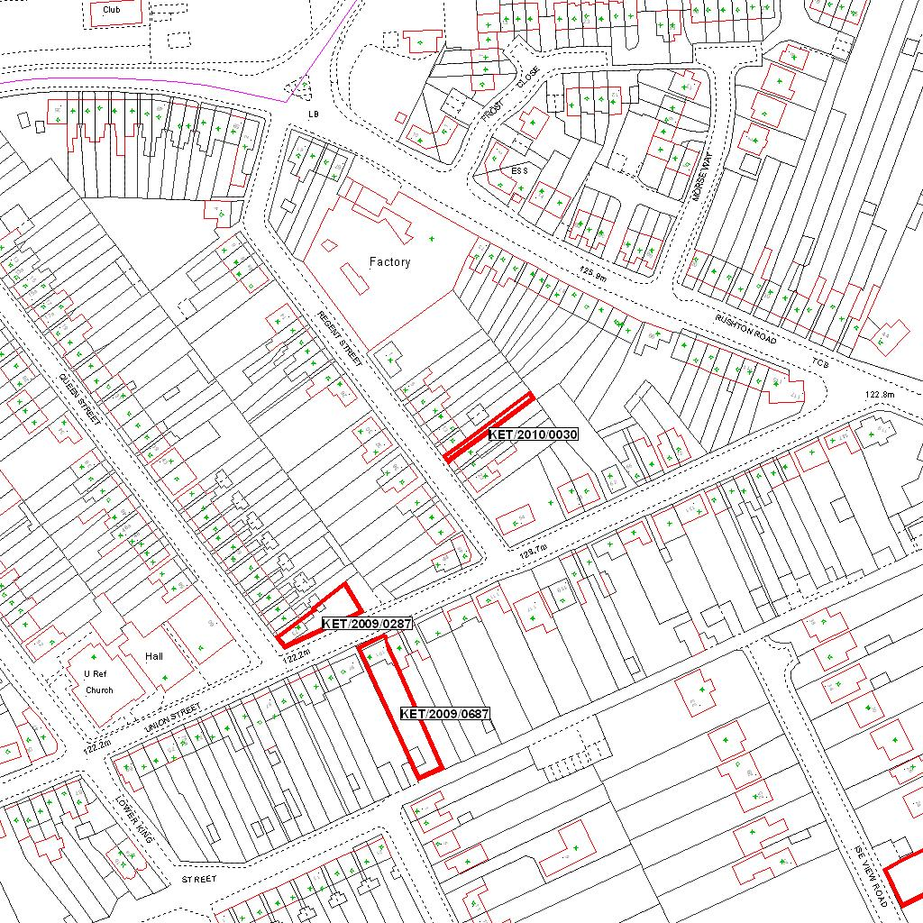

Reproduced from the Ordnance Survey mapping with the permission of the Controller of Her Majesty’s Stationery Office © Crown copyright. Unauthorised reproduction infringes Crown copyright and may lead to prosecution or civil proceedings.  LA078344 |  | N
Date: 21/01/2010 Do not scale from this map. For illustrative purposes only.

