BOROUGH OF KETTERING

Committee | Full Planning Committee - 02/03/2010 | Item No: 5.6
Report Originator | Louise Haggan-Craig  Development Officer | Application No:  KET/2009/0773
Wards Affected | St. Michaels and Wicksteed
Location | Fishton Close Garages, Fishton Close, Kettering
Proposal | Full Application: 5 no. dwellings, including parking spaces and associated landscaping
Applicant | Mrs M Walker Leicester Housing Association

1. PURPOSE OF REPORT

  - To describe the above proposals
  - To identify and report on the issues arising from it
  - To state a recommendation on the application

2. RECOMMENDATION

THE DEVELOPMENT CONTROL MANAGER RECOMMENDS that this application be APPROVED, subject to a S.106 OBLIGATION being entered into, and to the following conditions:-

1. The development hereby permitted shall be begun before the expiration of 3 years from the date of this planning permission.
REASON: To comply with Section 91 of the Town and Country Planning Act 1990 (as amended) and to prevent an accumulation of unimplemented planning permissions.

2. No development shall take place until a plan prepared to a scale of not less than 1:500 showing details of existing and intended final ground and finished floor levels has been submitted to and approved in writing by the Local Planning Authority. The development shall not be carried out other than in accordance with the approved details.
REASON: To preserve the character of the area in accordance with policies 13 of the North Northamptonshire Core Spatial Strategy

3. The development hereby permitted shall not be carried out other than in accordance with the approved materials details and samples submitted with the application [buff brick, beige render, grey concrete tiles and timber framed windows].
REASON: To clarify the terms of the permission and ensure a satisfactory visual appearance.

4. No development shall take place until there has been submitted to and approved in writing by the Local Planning Authority a scheme of landscaping which shall specify all trees to be retained, species of trees and plants, planting sizes, spacing and numbers of trees and shrubs to be planted. The approved scheme shall be carried out in the first planting and seeding seasons following the occupation of the building. Any trees or plants which, within a period of 5 years from the date of planting, die, are removed or become seriously damaged or diseased shall be replaced in the next planting season with others of similar size and species.
REASON: To improve the appearance of the site in the interests of visual amenity in accordance with policy 13 of the North Northamptonshire Core Spatial Strategy.

5. No development shall take place on site until a scheme for boundary treatment has been submitted to and approved in writing by the Local Planning Authority. The development shall not be occupied until the approved scheme has been fully implemented in accordance with the approved details.
REASON: In the interests of the amenities and privacy of the neighbouring property in accordance with policy 13 of the North Northamptonshire Core Spatial Strategy.

6. Unless otherwise agreed in writing by the Local Planning Authority, development other than that required to be carried out as part of an approved scheme of remediation shall not commence until parts A - D have been complied with. If unexpected contamination is found after development has begun, development shall be halted on that part of the site affected by the unexpected contamination to the extent specified by the Local Planning Authority in writing until part D has been complied with in relation to that contamination.

A. Site Characterisation An investigation and risk assessment, in addition to any assessment provided with the planning application, shall be completed in accordance with a scheme to assess the nature and extent of any contamination on the site, whether or not it originates on the site. The contents of the scheme are subject to the approval in writing of the Local Planning Authority. The investigation and risk assessment must be undertaken by competent persons and a written report of the findings must be produced. The written report is subject to the approval in writing of the Local Planning Authority. The report of the findings must include:
(i) a survey of the extent, scale and nature of contamination;
(ii) an assessment of the potential risks to:
- human health,
- property (existing or proposed) including buildings, crops, livestock, pets, woodland and service lines and pipes,
- adjoining land,
- groundwaters and surface waters,
- ecological systems,
- archeological sites and ancient monuments;
(iii) an appraisal of remedial options, and proposal of the preferred option(s). This must be conducted in accordance with DEFRA and the Environment Agency's 'Model Procedures for the Management of Land Contamination, CLR 11'.

B. Submission of Remediation Scheme A detailed remediation scheme to bring the site to a condition suitable for the intended use by removing unacceptable risks to human health, buildings and other property and the natural and historical environment must be prepared, and is subject to the approval in writing of the Local Planning Authority. The scheme must include all works to be undertaken, proposed remediation objectives and remediation criteria, timetable of works and site management procedures. The scheme must ensure that the site will not qualify as contaminated land under Part 2A of the Environmental Protection Act 1990 in relation to the intended use of the land after remediation.

C. Implementation of Approved Remediation Scheme The approved remediation scheme must be carried out in accordance with its terms prior to the commencement of development other than that required to carry out remediation, unless otherwise agreed in writing by the Local Planning Authority. The Local Planning Authority must be given two weeks written notification of commencement of the remediation scheme works. Following completion of measures identified in the approved remediation scheme, a verification report (referred to in PPS23 as a validation report) that demonstrates the effectiveness of the remediation carried out must be produced, and is subject to the approval in writing of the Local Planning Authority.

D. Reporting of Unexpected Contamination In the event that contamination is found at any time when carrying out the approved development that was not previously identified it must be reported in writing immediately to the Local Planning Authority. An investigation and risk assessment must be undertaken in accordance with the requirements of part A, and where remediation is necessary a remediation scheme must be prepared in accordance with the requirements of part B, which is subject to the approval in writing of the Local Planning Authority. Following completion of measures identified in the approved remediation scheme a verification report must be prepared, which is subject to the approval in writing of the Local Planning Authority in accordance with part C.

REASON (common to all): To ensure that risks from land contamination to the future users of the land and neighbouring land are minimised, together with those to controlled waters, property and ecological systems, and to ensure that the development can be carried out safely without unacceptable risks to workers, neighbours and other offsite receptors.

7. Notwithstanding the submitted information, there shall be no external illumination on the site at any time other than in accordance with a detailed scheme which shall first have been submitted to and approved in writing by the Local Planning Authority.
REASON: In the interests of the amenity of occupants of neighbouring properties in accordance with policy 13 of the North Northamptonshire Core Spatial Strategy.

8. Notwithstanding the provisions of Article 3 of the Town and Country Planning (General Permitted Development) Order 1995 (or any Order revoking and re-enacting that Order with or without modification) no building, structure or extension permitted by Class A or E of Part 1 of Schedule 2 of the Order shall be erected on the application site.
REASON: To reduce the risk of flooding to the proposed development and future occupants in accordance with policy 13 of the Core Spatial Strategy for North Northamptonshire.

9. Prior to the commencement of development, a scheme detailing the security measures/standards to be incorporated within all openings associated with the development shall have been submitted to and approved in writing by the Local Planning Authority. The development shall thereafter be carried out in accordance with these approved details.
REASON: To reduce the potential for crime in accordance with policy 13 of the North Northamptonshire Core Spatial Strategy and the adopted SPG 'Planning Out Crime in Northamptonshire'.

10. Prior to the commencement of development a scheme for the protection of the retained trees shall be submitted to and approved in writing by the Local Planning Authority.
REASON: To ensure the continued well being of the trees in the interests of the amenity of the locality in accordance with policy 13 of the adopted CSS.

11. The parking spaces hereby approved shall be provided prior to the first occupation of the development hereby permitted and shall be permanently retained and kept available for the parking of vehicles.
REASON: To ensure adequate on-site parking provision for the approved building and to discourage parking on the adjoining highway in the interests of local amenity and highway safety in accordance with policy 13 of the North Northamptonshire Core Spatial Strategy.

Notes (if any) :-
- NONE

Justification for Granting Planning Permission

The proposal is in accordance with national and local policies as set out in Planning Policy Statements/Guidance Notes 1, 3, 9, 13, 23 and 25, Policies 2 and 48 of The East Midlands Regional Plan, Policies 5, 6, 7, 9, 10, 13 and 14 of the North Northamptonshire Core Spatial Strategy, and Policy 35 of the Local Plan for Kettering Borough. The issues relating to parking and access are material planning considerations and, in reaching the decision to approve the proposal, have been carefully weighed against all relevant policy considerations.

Officers Report

3.0 | Information

Relevant Planning History
Residential garage site.

Site Description
The application site is situated to the south of Kettering Town Centre within an established residential area comprising two storey properties to the east and three storey flatted development to the north and west. The application site is contained within Fishton Close which comprises an existing garage area and access to flatted development to the north west of the site. Fishton Close is situated to the rear of a number of residential properties fronting Whiteford Drive. The topography of the land falls from west to east. The site is currently underused, unkempt and an eyesore on the immediate area.

Proposed Development
This is a full application for the construction of five affordable dwellings. The proposal is to construct three 2 bedroom properties and two 3 bedroom properties. The dwellings are to be constructed to meet Code level 5 for Sustainable Homes.

Any Constraints Affecting The Site
None.

4.0 | Consultation and Customer Impact

Highway Authority
Response received 15th February 2010. Concerns have been raised in respect of highway safety matters relating to the layout of the site. Revised plans have been requested and will be the subject of the Committee update.

Northamptonshire Police
Response received 15th January 2010. No objection, recommend a condition in respect of security measures.

Kettering Borough Council Environmental Health

Response received 18th January 2010. No objection, recommend imposition of condition.

Neighbours
A letter of objection has been received which raise the following concerns:
- Removal of existing parking to make way for development.
- Damage to the existing rented garages.
- The proposal may compromise the security of my garden area.
- Will the proposal provide my property with a dropped kerb?

5.0 | Planning Policy

National Policies
PPS1. Delivering Sustainable Development
PPS3: Housing
PPG13. Transport
PPS23. Planning and Pollution Control

Development Plan Policies

East Midlands Regional Plan
Policy 2. Promoting Better Design
Policy 48. Regional Car Parking Standards

North Northamptonshire Core Spatial Strategy
Policy 6. Infrastructure Delivery and Developer Contributions
Policy 7. Delivering Housing
Policy 9. Distribution & Location of Development
Policy 10. Distribution of Housing
Policy 13. General Sustainable Development Principles
Policy 14: Energy Efficiency and Sustainable Construction

Local Plan

35. Housing: Within Towns

SPGs
Sustainable design SPD.

6.0 | Financial/Resource Implications
 | A Section 106 Obligation is required to secure the affordable housing provision on site and provide £14,517.20 towards pooled highway contributions.
7.0 | Planning Considerations
The key issues for consideration in this application are:-

1. Principle
2. Housing mix and tenure
3. Design, Character and appearance
4. Amenity
5. Highways and Access
6. Environmental Matters
7. Trees
8. Sustainable Design
9. Planning Obligations

1. Principle
PPS3 encourages the use of land within existing settlements. The application site comprises an underused and partly derelict garage area and as such is Brownfield land. Policy 9 of the Core Spatial Strategy states that priority will be given to previously developed land and that this should provide for at least 30% of the overall housing requirement for North Northamptonshire. The CSS defines Kettering as a Growth Town, a primary focus for development, the town is considered an appropriate location for the proposed development and this is further strengthened by saved policy 35 of the Local Plan for Kettering Borough which supports the provision of housing within towns.

2. Housing Mix
The scheme would provide for 100% affordable housing for social rent comprising five family homes. The East Kettering Housing Market Assessment has identified a need for these dwelling type’s specifically affordable family housing and the scheme is therefore fully supported by the Councils Housing Strategy Team. As such the scheme accords with policy 15 of the North Northamptonshire Core Spatial Strategy.

3. Design, Character and Appearance
The site is currently occupied by rows of garages and surrounded on all sides by residential properties comprising buff bricks, dark roof tiles with low roof pitches and white windows. The garages will be demolished as part of the proposed development. The scheme will comprise five two storey dwellings some of which will face directly onto Fishton Close and some side onto it. The proposal will also provide parking, turning areas and soft landscaping features. The density of the development reflects that of the immediate locality and benefits from good sized private rear gardens and well proportioned houses in comparison to existing development. The building form and materials have been specifically selected to remain in keeping with the context of the surrounding area and will include buff brick and render. Given the site constraints, the development makes an effective and efficient use of the land.

It is considered that the site will have a positive impact upon the appearance of the existing area and enhance an underused and deadened area which currently provides little purpose and is in need of rejuvenation. The dwellings will provide a strong frontage, natural surveillance of Fishton Close and a more attractive street scene in comparison to the existing situation. As such, the application complies with design objectives contained within national planning policy and development plan policy specifically Policy 13 of the North Northamptonshire Core Spatial Strategy.

The scheme has been designed to achieve Code Level 5 for Sustainable Homes and as such will incorporate various methods of generating sustainable energy such as solar panels which will be prevalent from the street scene and public realm areas. The use of this equipment is instrumental in reducing carbon emissions and reducing reliance upon fossil fuels in accordance with PPS1, Policy 14 of the CSS and the Sustainable Design SPD. This renewable energy priority and exemplary sustainability level is considered to be of significant material weight. The scheme is therefore in accordance with criteria h of Policy 13 of the CSS.

4. Amenity
The application site is surrounded on all sides by residential development and as such privacy and access to light are important considerations in the determination of this application. Significant pre application discussions have taken place between developers and the local planning authority in relation to this specific issue. The proposed layout is seen as the best possible solution in order to provide suitable development on this site which does not compromise privacy levels to an unacceptable degree. It is accepted that the relationship between the proposed dwellings and existing dwellings is constrained but the distances between properties is such that a reasonable level of privacy will be maintained. The layout is considered to be acceptable particularly as the development will improve the character and appearance of the local area, provide affordable family homes and attain an exemplary level in respect of sustainability and renewable energy. The direct ‘back to back’ distance for two proposed properties facing onto the rear of existing properties along Whiteford Drive measures approximately 19 metres. Again this is a close relationship but deemed to be an acceptable distance for access to light. With well designed and thought out boundary treatment and landscaping measures it is considered the proposed development is acceptable in amenity terms and complies with policy 13 of the North Northamptonshire Core Spatial Strategy.

5. Highways and Access
Awaiting revised plans.

6. Environmental Matters
The underlying geology across Northamptonshire commonly presents unacceptable levels of naturally occurring arsenic and other forms of contamination. A condition must be attached to any planning permission requiring further investigation of contamination and appropriate remediation in accordance with PPS23.

7. Trees
An arboricultural report has been submitted with the application. It is considered that the information provided is satisfactory and conforms with British Standard requirements. There are a number of mature trees situated on the boundary of the site which provide valuable amenity. These are recommended for retention in order to provide the site with screening and immediate maturity. The development will involve the removal of an existing Norway Maple tree, although its loss is regrettable, it is not considered to be of high amenity value. The imposition of a landscaping condition will also ensure that the tree is replaced and soft landscaping features provided to further enhance the immediate area.

8. Sustainable Design
Policy 14 of the North Northamptonshire Core Spatial Strategy requires that development meets the highest viable standards of resource and energy efficiency, provision for waste recycling/reduction and provision for water efficiency and water recycling. In this case the applicant is seeking to obtain Code Level 5 for Sustainable Homes which far surpasses the level required for the majority of affordable housing schemes.

9. Planning Obligations
A Section 106 Obligation is required to secure the following obligations:
- 100% affordable housing
- A financial contribution of £14,517.20 towards transport measures. This figure is based upon £3871.25 per dwelling less 25% for affordable housing.

Conclusion

The development will provide residential accommodation which is both affordable and sustainable. It will enhance and rejuvenate a run down area of Kettering. The proposal complies with development plan policy and national planning objectives. Although there are highway safety concerns, it is envisaged that revisions to the existing layout of the proposed development and the imposition of highway conditions can overcome the main issues. Amendments to the scheme will be presented by means of an update.

Background Papers |  | Previous Reports/Minutes
Title of Document: |  | Ref:
Date: |  | Date:
Contact Officer: | Louise Haggan-Craig, Development Officer on 01536 534316

SITE LOCATION PLAN

Fishton Close Garages, Fishton Close, Kettering
Application No.: KET/2009/0773

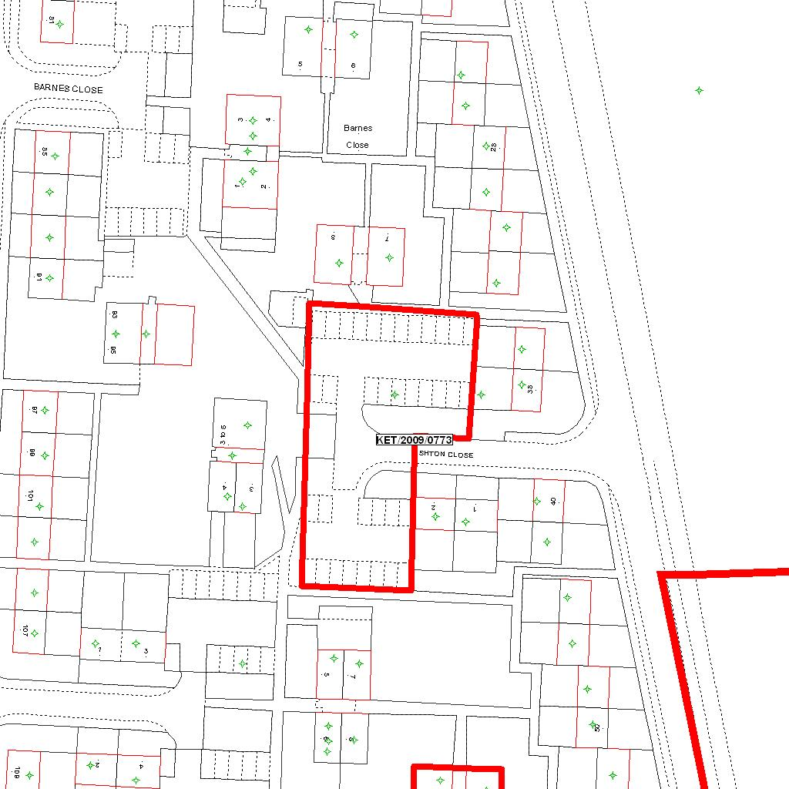

Reproduced from the Ordnance Survey mapping with the permission of the Controller of Her Majesty’s Stationery Office © Crown copyright. Unauthorised reproduction infringes Crown copyright and may lead to prosecution or civil proceedings.  LA078344 |  | N
Date: 04/01/2010 Do not scale from this map. For illustrative purposes only.

