BOROUGH OF KETTERING

Committee | Full Planning Committee - 02/02/2010 | Item No: 5.2
Report Originator | Alex Jelley  Assistant Development Officer | Application No:  KET/2009/0717
Wards Affected | Desborough St. Giles
Location | 20 Ise View Road, Desborough
Proposal | Full Application: Single storey front extension and porch
Applicant | Mr P Johnson

1. PURPOSE OF REPORT

  - To describe the above proposals
  - To identify and report on the issues arising from it
  - To state a recommendation on the application

2. RECOMMENDATION

THE DEVELOPMENT CONTROL MANAGER RECOMMENDS that this application be APPROVED subject to the following Condition(s):-

1. The development hereby permitted shall be begun before the expiration of 3 years from the date of this planning permission.
REASON: To comply with Section 91 of the Town and Country Planning Act 1990 (as amended) and to prevent an accumulation of unimplemented planning permissions.

2. No development shall commence on site until details of the types and colours of all external facing and roofing materials to be used, together with samples, have been submitted to and approved in writing by the Local Planning Authority. The development shall not be carried out other than in accordance with the approved details.
REASON: In the interests of the visual amenities of the area in accordance with policy 13 of the North Northamptonshire Core Spatial Strategy.

3. Notwithstanding the provisions of Article 3 of the Town and Country Planning (General Permitted Development) Order 1995 (or any Order revoking and re-enacting that Order with or without modification) no additional openings permitted by Schedule 2, Part 1 Classes A or C shall be made in the North elevation or roof plane of the extension.
REASON: To protect the amenity and privacy of the occupiers of adjoining property in accordance with policy 13 of the North Northamptonshire Core Spatial Strategy.

Notes (if any) :-
- This planning permission is subject to "pre-commencement" conditions which require details/drawings to be submitted to and approved in writing by the Local Planning Authority before ANY development may lawfully commence. Any development commenced in breach of these "pre-commencement" conditions will be unauthorised, a breach of planning control, and liable to immediate Enforcement and Stop Notice action.

Justification for Granting Planning Permission

The proposal is in accordance with national and local policies as set out in Planning Policy Statement 1 and Policy 13 of the North Northamptonshire Core Spatial Strategy. There are no material considerations that indicate against the proposal.

Officers Report

3.0 | Information

Relevant Planning History
KET/2008/0576 - Erection of new dwelling and garages at 20 Ise View Road, Desborough– REFUSED

Ket/2005/0332 – Erection of a new former bungalow on land between 20 and 24 Ise View Road, Desborough - APPROVED

Site Description
Officer's site inspection was carried out on 19.01.2010

The application consists of a small bungalow located towards the centre of the site. The bungalow is set at a similar depth to the adjacent dwellings of Nos. 16 and 24. Along the Eastern side of Ise View Road the properties, including the application site, have long thin plots. The rear garden area of the site is mainly laid to grass. The properties to the rear of the application site also have long rear gardens.

The site is within an area of mixed residential dwellings of a variety of designs including a mixture of bungalows and 2 storey properties. The site to the North, which is currently between the application site and no. 24, has consent for a dormer bungalow, set at a similar depth to the adjacent properties, including the application site.

Proposed Development
This application seeks permission for a single storey front extension and porch at No. 20 Ise View Road in Desborough. For further detail please refer to Section 7.0 of this report.

Any Constraints Affecting the Site
None

4.0 | Consultation and Customer Impact
 | None
5.0 | Planning Policy

National Policies
PPS1. Delivering Sustainable Development

North Northamptonshire Core Spatial Strategy
Policy 13. General Sustainable Development Principles

6.0 | Financial/Resource Implications
 | None
7.0 | Planning Considerations
The key issues for consideration in this application are:-

1. Principle of Development
2. Design and Character
3. Residential Amenity

1. Principle of Development

Section 38(6) of the Planning and Compulsory Purchase Act requires local planning authorities to determine planning applications in accordance with their Development Plan unless material planning considerations indicate otherwise. Policy 13 of the North Northamptonshire Core Spatial Strategy provides for extensions to residential properties subject to specific criteria being satisfied. In particular; extensions should be suitable in terms of their type, scale, design and positioning; they should respect the character of the existing building and the surrounding properties; and they should not detrimentally impact upon the amenity of existing or future occupiers of adjoining properties. National policy in the shape of PPS1 promotes the sustainable use of existing land and buildings, highlighting the importance matters of design and amenity play in achieving this.

2. Design and Character

The proposal is for a single storey front (West) extension to No. 20 Ise View Road, with a porch to one side (South) of this. The porch would be within the space enclosed by the new ridged roof, but would be open on two sides. The extension element would be on the existing bedroom in the Northwest corner of the dwelling, and would be constructed of facing bricks and roof tiles to match existing. This would need to be secured through condition. The porch would have a timber framed canopy above it, and the materials used in this construction would also need to be conditioned to ensure they are appropriate within the street scene. The windows and doors would be white UPVC to match existing. The proposals are minor in scale, measuring 2.5 metres in depth, 2.5 metres to eaves and 4.5 metres to ridge height, and a combined (including the porch area) 6.5 metres in width. There are various examples of similar development within the surrounding area. It is considered that with a condition in place requiring samples of materials to be approved, the application is meets the requirements of those elements of policy 13 of the North Northamptonshire Core Spatial Strategy that have regard to matters of design and character.

3. Residential Amenity

The extension would lie to the South of No. 24 Ise View Road, and as such it was essential to ensure that no loss of light would occur as a result of the proposed development. As can be ascertained from the measurements take on drawing no. 09043, the extension, due to its minimal scale, positioning and orientation in relation to neighbouring properties, will not result in a loss of light in the habitable rooms of existing adjoining dwellings.
An extant permission (KET/2005/0332) exists for a dormer bungalow on the land immediately to the North of the site, and between Nos. 20 and 24 Ise View Road. Having assessed the approved plans it is considered that the construction of this extension would not be sufficiently detrimental to the amenity of the occupiers of that new dwelling to warrant refusal of this application. Though a small degree of light would be lost in the morning, much of the light to habitable rooms would be during the afternoon and evening, and this application will not affect this.

Given the single storey nature of the extension, as well as the precise design of it, boundary screening and the distances between the application site and neighbouring properties, it is not considered that the extension will impact upon the privacy of neighbours, however a condition removing Permitted Development Rights for openings in the North elevation will ensure that future concern arises. Therefore the application meets the requirements of policy 13 of the North Northamptonshire Core Spatial Strategy in so far as they relate to matters of amenity.

Conclusion

The application is in accordance with the Development Plan and there are no material planning considerations that indicate against approval. The extension and porch are considered to be suitable in terms of design and character, and there would be no detrimental impact on the amenity of existing or future occupiers of adjoining properties.

Background Papers |  | Previous Reports/Minutes
Title of Document: |  | Ref:
Date: |  | Date:
Contact Officer: | Alex Jelley, Assistant Development Officer on 01536 534316

SITE LOCATION PLAN

20 Ise View Road, Desborough
Application No.: KET/2009/0717

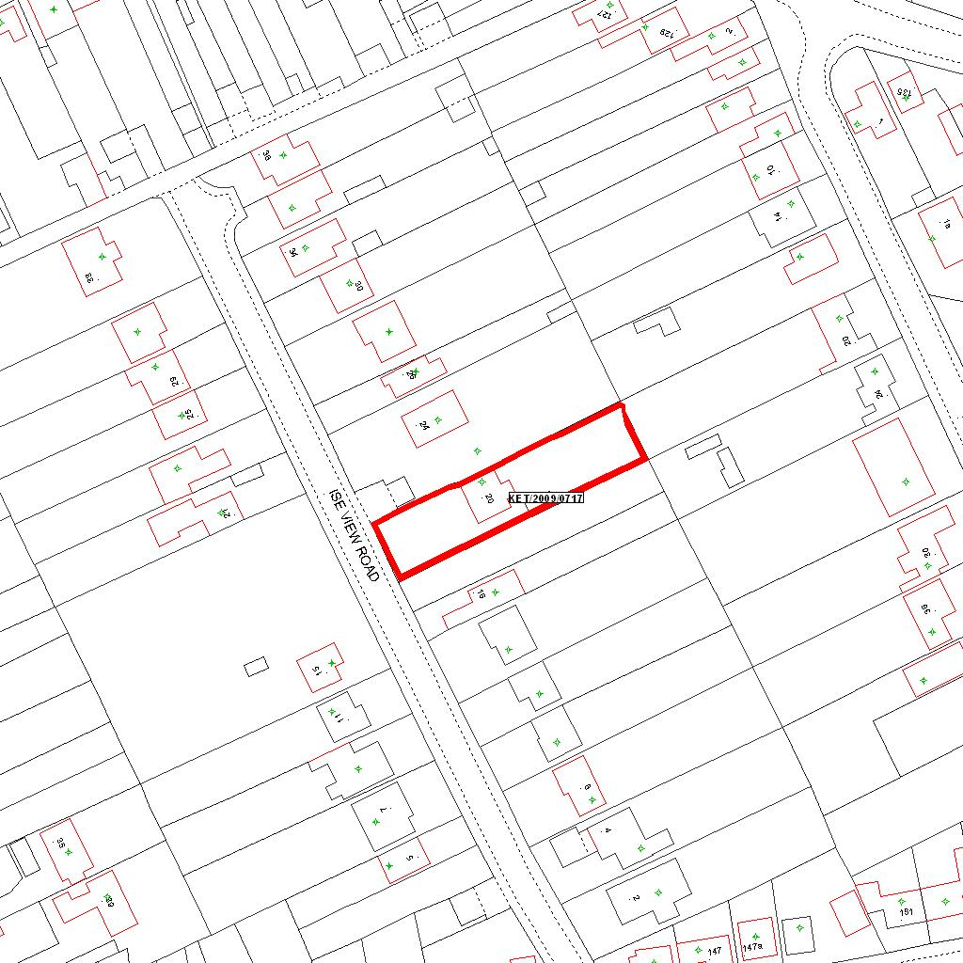

Reproduced from the Ordnance Survey mapping with the permission of the Controller of Her Majesty’s Stationery Office © Crown copyright. Unauthorised reproduction infringes Crown copyright and may lead to prosecution or civil proceedings.  LA078344 |  | N
Date: 30/11/2009 Do not scale from this map. For illustrative purposes only.

