SITE VISIT AND OFFICER’S RECOMMENDATION

Full Planning Committee Item
15/09/2009

Earliest Decision: |  | 07/09/2009  07/09/2009  07/09/2009  14/09/2009 | Case Officer: | Alex Jelley
Expiry Date: |  | 29/09/2009 | ODPM Code: | 13
Description: | Full Application  2 no. detached dwellings with garages, access and all ancillary works
Location: | Barton Road (Land off), Kettering

RECOMMENDATION: | APPROVED subject to the following Condition(s):-
Justification: | The Proposal is in accordance with national and local policies as set out in Planning Policy Statements 1 and 3, Planning Policy Guidance Notes 17 and 15, Policies 13 and 14 of the North Northamptonshire Core Spatial Strategy, and Policy K12 of the Local Plan for Kettering Borough or Supplementary Planning Document Open Space. There are no material considerations that indicate against the proposal.

Subject to the following conditions/for the following reasons:

1. The development hereby permitted shall be begun before the expiration of 3 years from the date of this planning permission.
REASON: To comply with Section 91 of the Town and Country Planning Act 1990 (as amended) and to prevent an accumulation of unimplemented planning permissions.

2. No development shall commence on site until details of the types and colours of all external facing and roofing materials to be used, together with samples, have been submitted to and approved in writing by the Local Planning Authority. The development shall not be carried out other than in accordance with the approved details.
REASON: In the interests of the visual amenities of the area in accordance with policy 13 of the North Northamptonshire Core Spatial Strategy.

3. No development shall take place until there has been submitted to and approved in writing by the Local Planning Authority a scheme of landscaping which shall specify species, planting sizes, spacing and numbers of trees and shrubs to be retained and/or planted. The approved scheme shall be carried out in the first planting and seeding seasons following the occupation of the building. Any trees or plants which, within a period of 5 years from the date of planting, die, are removed or become seriously damaged or diseased shall be replaced in the next planting season with others of similar size and species.
REASON: To improve the appearance of the site in the interests of visual amenity in accordance with policy 13 of the North Northamptonshire Core Spatial Strategy.

4. No development shall commence until there has been submitted to and approved in writing by the Local Planning Authority a detailed scheme indicating the positions, design, materials and type of screen walls and fences to be erected. The building shall not be occupied until the scheme has been fully implemented in accordance with the approved details.
REASON: In the interests of the amenities of the area in the interests of amenity in accordance with policy 13 of the North Northamptonshire Core Spatial Strategy.

5. Prior to first use or occupation of the development hereby permitted, the means of vehicular access shall be or (or widened to) a minimum width of 4.5 metre for the first 10.0 metre from the Highway Boundary. That area shall be paved with a hard bound surface for the first 5 metre from the highway boundary. The maximum gradient over the 5 metre distance shall not exceed 1 in 15.
REASON: In the interests of highway safety in accordance with policy 13 of the North Northamptonshire Core Spatial Strategy.

6. Prior to first use of occupation of the development hereby permitted, vehicular visibility splays of 2.0 metres from the carriageway edge along the centre of the vehicular access by a distance of 43 metres measured from the centre of the vehicular access along the carriageway edge. Any features within or affecting the resultant triangular areas shall not exceed 0.9 metres above the access/carriageway level.
REASON: In the interests of highway safety in accordance with policy 13 of the North Northamptonshire Core Spatial Strategy.

7. Prior to first use of occupation of the development hereby permitted pedestrian visibility splays of at least 2.0 x 2.0 metres shall be provided on each side of the vehicular access. These measurements are taken from and along the highway boundary. Any features within or affecting the resultant triangular areas shall not exceed 0.6 metres above access/footway level.
REASON: In the interests of highway safety in accordance with policy 13 of the North Northamptonshire Core Spatial Strategy.

8. Prior to first use or occupation, the proposed vehicular access, parking and turning facilities shall be provided in accordance with the approved plans and shall thereafter be set aside and retained for those purposes.
REASON: In the interests of highway safety in accordance with policy 13 of the North Northamptonshire Core Spatial Strategy.

9. No development shall commence on site until details of a scheme for the storage of refuse has been submitted to and approved in writing by the Local Planning Authority. The use of the building shall not commence until the approved scheme has been fully implemented and shall be retained as approved thereafter.
REASON: In the interests of general amenity and to ensure that no obstruction is caused on the adjoining highway in accordance with policy 13 of the North Northamptonshire Core Spatial Strategy.

10. Development shall not commence until a drainage strategy including on and off-site works has been submitted to and approved in writing by the Local Planning Authority. The development shall not be carried out other than in accordance with the approved strategy, and the building shall not be occupied until the approved strategy has been fully implemented.
REASON: To ensure a satisfactory development in accordance with policy 13 of the North Northamptonshire Core Spatial Strategy.

11. Unless otherwise agreed in writing by the Local Planning Authority, development other than that required to be carried out as part of an approved scheme of remediation shall not commence until parts A - D have been complied with. If unexpected contamination is found after development has begun, development shall be halted on that part of the site affected by the unexpected contamination to the extent specified by the Local Planning Authority in writing until part D has been complied with in relation to that contamination.

A. Site Characterisation An investigation and risk assessment, in addition to any assessment provided with the planning application, shall be completed in accordance with a scheme to assess the nature and extent of any contamination on the site, whether or not it originates on the site. The contents of the scheme are subject to the approval in writing of the Local Planning Authority. The investigation and risk assessment must be undertaken by competent persons and a written report of the findings must be produced. The written report is subject to the approval in writing of the Local Planning Authority. The report of the findings must include:
(i) a survey of the extent, scale and nature of contamination; (ii) an assessment of the potential risks to:
o human health,
o property (existing or proposed) including buildings, crops, livestock, pets, woodland and service lines and pipes,
o adjoining land,
o groundwaters and surface waters,
o ecological systems,
o archeological sites and ancient monuments;
(iii) an appraisal of remedial options, and proposal of the preferred option(s). This must be conducted in accordance with DEFRA and the Environment Agency's 'Model Procedures for the Management of Land Contamination, CLR 11'.

B. Submission of Remediation Scheme A detailed remediation scheme to bring the site to a condition suitable for the intended use by removing unacceptable risks to human health, buildings and other property and the natural and historical environment must be prepared, and is subject to the approval in writing of the Local Planning Authority. The scheme must include all works to be undertaken, proposed remediation objectives and remediation criteria, timetable of works and site management procedures. The scheme must ensure that the site will not qualify as contaminated land under Part 2A of the Environmental Protection Act 1990 in relation to the intended use of the land after remediation.

C. Implementation of Approved Remediation Scheme The approved remediation scheme must be carried out in accordance with its terms prior to the commencement of development other than that required to carry out remediation, unless otherwise agreed in writing by the Local Planning Authority. The Local Planning Authority must be given two weeks written notification of commencement of the remediation scheme works. Following completion of measures identified in the approved remediation scheme, a verification report (referred to in PPS23 as a validation report) that demonstrates the effectiveness of the remediation carried out must be produced, and is subject to the approval in writing of the Local Planning Authority.

D. Reporting of Unexpected Contamination In the event that contamination is found at any time when carrying out the approved development that was not previously identified it must be reported in writing immediately to the Local Planning Authority. An investigation and risk assessment must be undertaken in accordance with the requirements of part A, and where remediation is necessary a remediation scheme must be prepared in accordance with the requirements of part B, which is subject to the approval in writing of the Local Planning Authority. Following completion of measures identified in the approved remediation scheme a verification report must be prepared, which is subject to the approval in writing of the Local Planning Authority in accordance with part C.
REASON: To ensure that risks from land contamination to the future users of the land and neighbouring land are minimised, together with those to controlled waters, property and ecological systems, and to ensure that the development can be carried out safely without unacceptable risks to workers, neighbours and other offsite receptors.

12. Notwithstanding the provisions of Article 3 of the Town and Country Planning (General Permitted Development) Order 1995 (or any Order revoking and re-enacting that Order with or without modification) no additional openings permitted by Schedule 2, Part 1 Classes A or C shall be made in the East elevation or roof plane of Plot 1.
REASON: To protect the amenity and privacy of the occupiers of adjoining property in accordance with policy 13 of the North Northamptonshire Core Spatial Strategy.

Notes (if any)
- This planning permission is subject to "pre-commencement" conditions which require details/drawings to be submitted to and approved in writing by the Local Planning Authority before ANY development may lawfully commence. Any development commenced in breach of these "pre-commencement" conditions will be unauthorised, a breach of planning control, and liable to immediate Enforcement and Stop Notice action.

With regard to condition 11, the developer is advised that the required submission be carried out in accordance with the following:

The phase 1 (desk top study) shall be carried out to identify and evaluate all potential sources of contamination and the impacts on land and/or controlled waters, relevant to the site. The desk top study shall establish a "conceptual site model" and identify all plausible pollutant linkages. Furthermore, the assessment shall set objectives for intrusive site investigation works/Quantitative Risk Assessment (or state if none required). Two full copies of the desk top study and non-technical summary shall be submitted to the LPA.

A site investigation shall be carried out to fully and effectively characterise the nature and extent of any land contamination and/or pollution of controlled waters. It shall specifically include a risk assessment that adopts the Source-Pathway-Receptor principle, in order that any potential risks are adequately assessed taking into account the sites existing status and proposed new use. Two full copies of the site investigation and findings shall be submitted to the Local Planning Authority.

Where the risk assessment identifies any unacceptable risk or risks, a detailed remediation strategy to deal with land contamination and/or pollution of controlled waters affecting the site shall be submitted to the Local Planning Authority. The closure report required by the condition shall provide validation and certification that the required works regarding contamination have been carried out in accordance with the approved method statement(s). Post remediation sampling and monitoring results shall be included in the closure report.

For further information regarding the development of brown field sites please refer to the Developers Guide produced by the Northamptonshire Contaminated Land Group available on request from either Development Services or the Environmental Health Department at Kettering Borough Council. It can also be downloaded from the Council's website:- www.kettering.gov.uk.

If you wish to discuss the requirements of the above condition please do not hesitate to contact Mr C. Stopford, Environmental Services Manager (01536) 534280.

Officers Report

3.0 | Information

Relevant Planning History
KET/1987/0027 – Residential development of 114 four and five bedroom houses with car parking, amenity and public space off Barton Road and Warkton Lane, Kettering – APPROVED on appeal

KET/1988/0175 – Approval of Reserved Matters (KET/1987/0027) – APPROVED

KET/2009/0035 – 2 no. detached dwellings with garages, access, and all ancillary works on land off Barton Road - REFUSED

Site Description
Officer's site inspection was carried out on 17.08.09

The site is an area of open land occupying a space between Barton Road to the South and Gainsborough Avenue to the North. It is surrounded by residential properties on three sides, and some fairly substantial screening to the South. A path runs through it connecting the two roads, and this path is also part of the adopted highway network.

There is a barrier along the side of Barton Road that runs for almost the entire length of the street frontage of the site, leading to a crossing adjacent to the Eastern edge. There is substantial boundary treatment around the site, though there are a number of windows that look onto it from the surrounding residential in nature, although there is no strong design characteristic.

Proposed Development
2 no. detached dwellings with garages, access and all ancillary works at land off Barton Road in Kettering

Any Constraints Affecting the Site
A Road

4.0 | Consultation and Customer Impact

Barton Seagrave Parish Council
Objection. Loss of open space. Highway safety.

Highway Authority
No objection

Environmental Health
No objection subject to condition

Neighbours
14 letters of objection were received. The main issues were with regards to highway safety, loss of open space and amenity. These issues will be addressed in detail in Section 7.0 of this report.

5.0 | Planning Policy

National Policies
PPG15. Planning and the Historic Environment
PPG17. Sport and Recreation
PPS1. Delivering Sustainable Development
PPS3: Housing

North Northamptonshire Core Spatial Strategy
Policy 5: Green Infrastructure
Policy 13. General Sustainable Development Principles
Policy 14: Energy Efficiency and Sustainable Construction

Local Plan
K12. Kettering: New Housing Sites

SPGs
SPD: Open Space

6.0 | Financial/Resource Implications
 | None
7.0 | Planning Considerations
The key issues for consideration in this application are:-

- Principle of Development
- Design, Character and Appearance
- Residential Amenity
- Open Space
- Highway Safety

1. Principle of Development
The Development Plan provides for development of this kind subject to detailed policy criteria being satisfied. In particular; PPS1 and PPS3, together with policy 13 of the North Northamptonshire Core Spatial Strategy, indicate that new dwellings should be suitable in terms of type, scale, design and positioning; they also ensure that new development respects the character of the surrounding area. PPS1 and policy 13 of the CSS also state that they should not detrimentally impact upon the amenity of existing or future occupiers of adjoining properties and they should have an acceptable form of access from the highway. PPG17, which is expanded upon by policy 13 of the North Northamptonshire Core Spatial Strategy and adopted Open Space SPD, states that “Existing open space…should not be built on unless an assessment has been undertaken which has clearly shown the open space…to be surplus to requirements.” PPS1 and PPS3 promote sustainable development within town boundaries, highlighting the importance matters of public open space, design and amenity play in achieving this.

2. Design, Character and Appearance
The proposals provide for two dwellings to the North of Barton Road. The layout has been altered since the previous application (KET/2009/0035) to allow for a changed access. This has led to some minor alterations to the positioning of the housing. Plot 1 now faces Barton Road, and is positioned to the East of the site, while Plot 2 faces the remaining area of open space to the West. There is a detached shared garage between the two dwellings, and to the rear. This layout would provide a level of street frontage suitable to the locality. At present there is a substantial level of screening along the boundary with Barton Road. While the plans show that some of this is to be retained, it is important that this is dealt with in more detail, and as such it would be necessary to require boundary treatments through condition as part of any approval.

The designs of the two properties are entirely in keeping with those found on existing properties in the surrounding area, and this could be furthered by a condition requiring samples of all materials to be used. The dwellings in the surrounding area are also similar in scale to those proposed, although there is a range of house types on offer. The proposed single storey garages are standard in design and considered appropriate.

As a result of the above it is considered that the proposals meet the requirements of policy 13 of the North Northamptonshire Core Spatial Strategy in so far as they relate to matters of design, character and appearance.

Though the site is adjacent to a row of Listed cottages (West of the site on Barton Road), it is not considered that it would have any affect on their character and setting. The screening between them is substantial, and in any case the proposal would involve the retention of the open space to the West of the footpath, which visually separates the new development from the existing. The application therefore meets the requirements of PPG15 and those elements of policy 13 of the North Northamptonshire Core Spatial Strategy that deal with matters of historical conservation.

3. Residential Amenity
A large number of objections have been received in relation to the proposals’ effect on amenity, both in a specific sense in terms of those properties adjoining the site, and in a more general sense in relation to the loss of open space. I will address these issues distinctly, as they merit close examination.

Firstly, with respect to the adjoining properties, it is considered that the proposals would not result in a loss of amenity by virtue of loss of light or overlooking. Plot 1 is no closer than 6 metres, flank to flank, to No. 61 Barton Road. It follows the building line of that property and no windows are proposed in the East elevation other than at ground floor level. A condition removing Permitted Development Rights for additional openings on that elevation would ensure that no future concerns arise.

Neither plot is closer than 25 metres to the adjoining properties on Gainsborough Avenue, to the North. While windows are proposed on the Northern elevations, the distance involved is considered to be sufficient to remove and concern in terms of loss of privacy. Furthermore, condition requiring screening details would ensure that the site boundary is appropriately dealt with.

In terms of loss of sunlight, due to the positioning of the dwellings within the site, their orientation, scale and design, it is considered that there would be no material loss of sunlight to habitable rooms of neighbouring properties as a result of this development.

It is considered that the amenity space provided for the occupiers of the new dwellings would be adequate given the scale of the properties, and their location within the town. Plot 1 would have a private amenity space of approximately 120 square metres, while Plot 2 would have one of approximately 78 square metres. Both of these are considered acceptable.

The proposals therefore meet the requirements of policy 13 of the North Northamptonshire Core Spatial Strategy in relation to their direct impact on the amenity of existing or future occupiers of adjoining properties.

4. Open Space
With regards to amenity in the wider area, the main issue relates to open space.

The Approval of Reserved Matters Application KET/1988/0175 clearly identifies the application site as ‘Open Space’. Since the development was built out, it is clear that the application site has been used as such, and has been maintained by Kettering Borough Council accordingly. Furthermore, PPG17 requires local authorities to “undertake robust assessments of the existing and future needs of their communities for open space, sports and recreational facilities”. Kettering Borough Council carried out just such an assessment in 2006, in which the application site was marked as Amenity Green Space. Following on from this assessment, Kettering Borough Council has also produced an Open Space SPD, which details the Council’s approach to the protection of these designated Public Open Spaces.

Policy 5 and 13 of the North Northamptonshire Core Spatial Strategy and the Open Space SPD indicate that development that results in a net loss of Public Open Space should be refused where it is not proven that a surplus of needs exists.

Furthermore, these policies should be read in conjunction with national policy, and PPG17 clearly states that the quality of the space, the provision of that type of space, and the provision of other types of open space within the locality should form part of the decision making process. Thus it is not simply a question of stating that Public Open Space will be retained; a more thorough and detailed approach to the protection of specific parcels of open space is required.

The level of open space available for residents within the 480 metre buffer zone around the site, and in the wider area of ‘Zone 4’ (used in the PPG17 Assessment to denote the urban area of Kettering and Barton Seagrave), was assessed against the standards included within the PPG17 Assessment. What follows is the break down of what was found (in hectares per 1000 population):

Parks and Gardens
Standard – 0.3
Zone 4 – 1.13
480m – 0.252

Natural and Semi-Natural Amenity Space
Standard – 0.9
Zone 4 – 0.64
480m – 2.046

Amenity Green Space
Standard – 0.8
Zone 4 – 0.78
480m – 0.828

Outside Sports Facilities
Standard – 1.8
Zone 4 – 3.09
480m – 8.113

Total Provision
Standard – 3.8
Zone 4 – 5.64
480m – 3.9373

By looking at the four different types of amenity space (in terms of the Total Provision figure identified above, a more overarching and detailed view of open space provision can be found than if simply focussing on Amenity green Space. Indeed, the PPG17 Assessment states that Amenity Green Space provision should be considered in relation to the provision of other types of amenity space, and that further research into local demand should be conducted in relation to population density.

It is concluded from this approach that a loss of 0.129ha of Amenity Green Space (as proposed by this application) would not be sufficiently detrimental to warrant refusal, given the large-scale overprovision within Zone 4, and the 480 metre buffer zone specifically (in terms of the Total Provision figure). Even with the loss of the Barton Road Amenity Green Space; classed as “below average for quality and accessibility” by the PPG17 study; there would still be a slight overprovision within the 480 metre buffer zone, and a larger figure within the wider Zone 4 (in terms of the Total Provision figure).

Consideration was given to requiring a contribution from the developer to mitigate against the loss of open space. This could be done in a quantitative manner by the provision of a space of an equal area elsewhere, or in a qualitative manner by improving the quality of an existing area of open space. The quantitative approach was assessed as unsuitable, given the lack of available land within the surrounding area. In terms of a qualitative contribution a financial sum could be required via a S.106 obligation (this will be addressed in the committee update report). Any S.106 obligation will need to be completed on or before 28 September 2009.

5. Highway Safety
The previous application, KET/2009/0035, was refused on highway safety grounds. Specifically, this related to the access point onto Barton Road. Since that refusal it is understood that the applicant has been in discussions with Northamptonshire County Council, the Highway Authority, in order to achieve a scheme that met their requirements. The consultation response from the Highways Authority clearly indicates that they no longer have any objection to this application. Subject to standard conditions related to the access, parking, turning and visibility splays, it is considered that this application meets the requirements of policy 13 of the North Northamptonshire Core Spatial Strategy that relate to highway safety.

Conclusion
The application is in accordance with the aims of planning policy, and there are no material planning considerations that indicate against approval. It is considered that the development would be suitable in terms if design and character, would not detrimentally impact upon amenity and would have a satisfactory relationship with the highway network. The application should therefore be approved.

Background Papers |  | Previous Reports/Minutes
Title of Document: |  | Ref:
Date: |  | Date:
Contact Officer: | Alex Jelley, Assistant Development Officer on 01536 534316

SITE LOCATION PLAN

Barton Road (Land off), Kettering
Application No.: KET/2009/0446

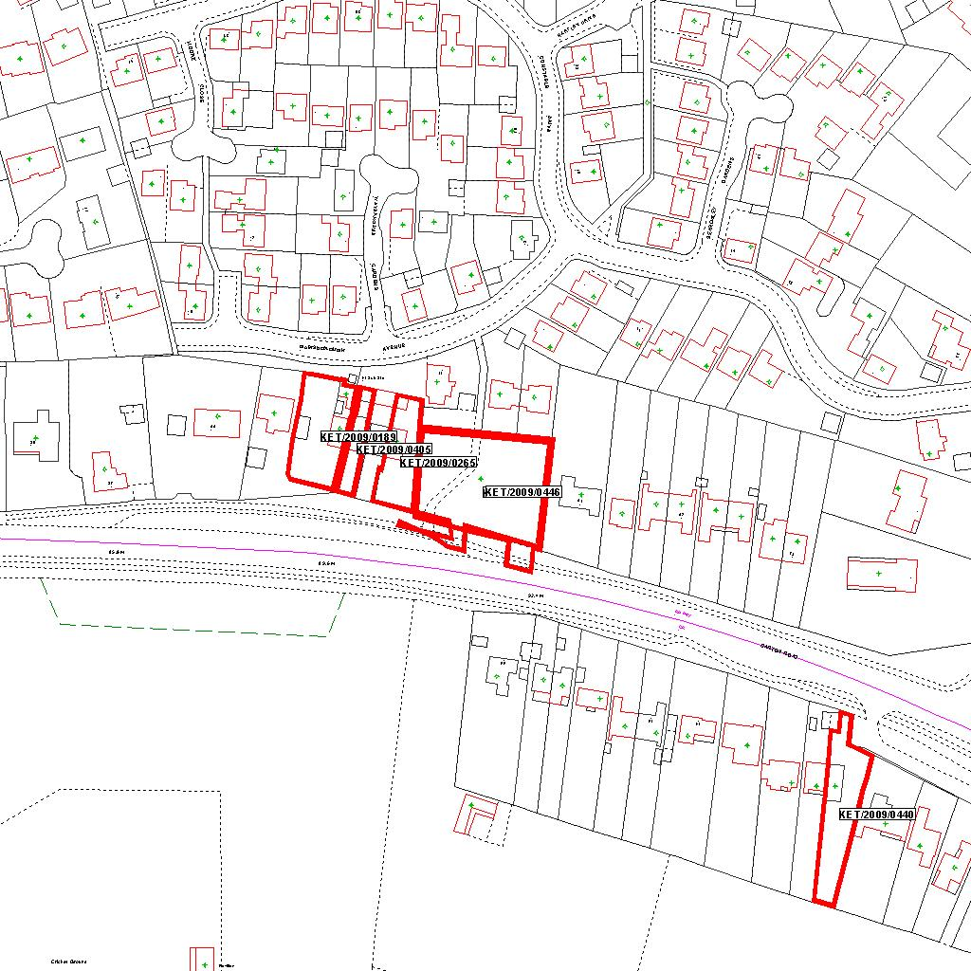

Reproduced from the Ordnance Survey mapping with the permission of the Controller of Her Majesty’s Stationery Office © Crown copyright. Unauthorised reproduction infringes Crown copyright and may lead to prosecution or civil proceedings.  LA078344 |  | N
Date: 07/08/2009 Do not scale from this map. For illustrative purposes only.

Signed Date

Case Officer

CHAIR/VICE CHAIRS PANEL Yes/No

DELEGATED COMMITTEE

Notes

Signed Date

Authorising Officer

REPORT and RECOMMENDATION APPROVED

Signed Date
Authorising Officer

