1. PURPOSE OF REPORT

1.1 To consult with the Town Forum as part of the development of the Kettering Borough Improvement Plan 2010/11.

Background information

1.2 Each year Kettering Borough Council produces an Improvement Plan setting out the Council’s priorities and targets for the future. The Plan also reports on the previous year’s performance and achievements. In effect, it is a bit like a company’s annual report, but without the financial information. This is contained separately in the Council’s Statement of Accounts.

  - The Council’s Constitution sets out the requirement consult with the Fora as part of the process of developing the Improvement Plan, hence the purpose of this report. Feedback from the Fora will be considered by the Council’s Research and Development (R&D) Committee. Recommendations from the R&D Committee can then be considered by the Executive Committee, which ratifies the final report for approval for Full Council prior to the end of June.

  - The Council’s Improvement Plan, is still in development. It is a high level policy document and is shaped by the Council’s corporate priorities. These are its basic building blocks. The Plan, through these priorities, sets out fairly broad priority areas for which the Council needs to remain focused. This is particularly important given the current difficult economic climate and pressures on public funding.

  - The Improvement Plan plays an important role in delivering the Council’s obligations to the Local Strategic Partnership’s Community Strategy and the wider Local Area Agreement. It is supported by more detailed Service Plans that are developed alongside the budget process. This relationship is shown by the diagram opposite.

The Improvement Plan’s role in delivering the wider agenda

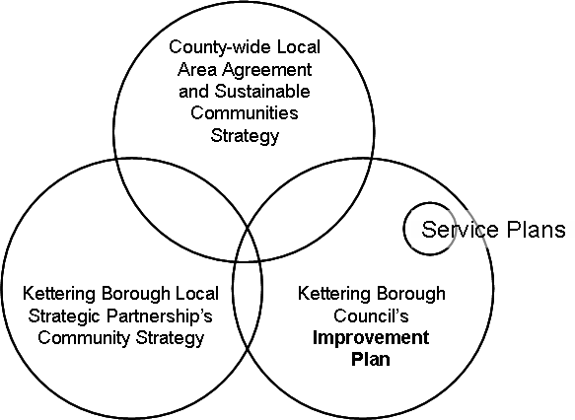

Considerations

  - Kettering Borough Council is seeking feedback on the priority areas that the Kettering Town Forum would like to raise. To help, the Council’s corporate priorities have been included as Appendix A to this report. The Council is particularly interested in feedback on:

- Existing services or initiatives provided by the Council that the Forum would like to see getting a high or higher priority;

- New services or initiatives that the Forum would like to see being developed – please note that these would need to be funded and therefore could be at the expense of other services;

- Services or initiatives that the Forum feels should be given a low or lower priority.

6. RECOMMENDATION

That the Forum:

(i) Notes the current position of the Council’s draft Improvement Plan and priorities, and

(ii) Provides feedback for consideration by the Council’s Research and Development Committee.

