 | Direct Line: (01536) 534398  Email: anneireson@kettering.gov.uk  Our Ref: AI  Your Ref:  Date: 7th December 2009

Dear Councillor

You are summoned to a meeting of Kettering Borough Council to be held in the Council Chamber, Municipal Offices, Bowling Green Road, Kettering on Wednesday, 16th December 2009 at 7.00 pm.

Please note that I am happy to welcome the Bishop Stopford School Choir who will be singing carols prior to the commencement of the formal part of the meeting and, as usual the Mayor has kindly invited all members to a reception in the Parlour after the meeting.

Yours faithfully

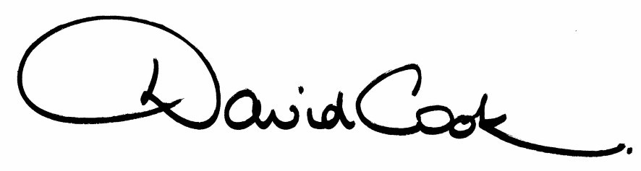
D Cook
Chief Executive

A G E N D A

1. Apologies.

2. Minutes of the meeting of the Council held on 23rd June 2009 to be approved as a correct record and signed by the Mayor.

3. Declarations of Interest:

(a) Personal
(b) Prejudicial

4. To receive any announcements from the Mayor and/or the Leader of the Council.

5. Report of the Chief Executive

6. Annual Report of the Chair of the Standards Committee (Mrs Julie Miller) – verbal report

7. The Mayor to ask members of the public present if they wish to speak on any item on the Agenda.

8. Local Democracy Week – Event Feedback

9. Crime and Disorder Committee

10. Changing the Constitution – Register of Gifts and Hospitality

11. Gambling Act 2005 Statement of Licensing Policy

12. To receive any reports from the Council's Executive Committee in accordance with Council Procedure Rule 3 (ix)

13. To consider motions received in accordance with Council Procedure Rule 14:-

To be proposed by Councillor James Hakewill and seconded by Councillor Russell Roberts

“As we come to the end of 2009, this Council congratulates and celebrates the individuals, teams, clubs , places and businesses in our Borough who bring us praise and recognition, both from around our country and around the world.".

14. To receive any questions from members.

15. Any matters of urgency that the Mayor decides should be considered.

Fire Alarm

All meetings shall be adjourned immediately on the sounding of the fire alarm. The alarm is a continuous two-tone siren. On hearing the alarm please leave the building by the nearest emergency exit. There are emergency exits at both ends of the corridor outside the meeting rooms. On leaving the building please cross the car park and assemble on the grassed area by the church. Do not attempt to drive out of the car park as this may impede the arrival of emergency vehicles. Please do not return to the building until you are told it is safe to do so by a Council employee.

Toilets

There are toilets in the corridor off the main entrance to the building you came through to get to the meeting room.

Breastfeeding and Baby Changing Facilities

The Council actively supports breastfeeding mothers. If you wish to use a private area please ask a member of staff. There are baby changing facilities in the corridor off the main entrance adjacent to the toilets.

.Access for Disabled People

There are allocated parking bays outside the main entrance to the Municipal Offices for disabled people. The meeting rooms are located on the ground floor and access is gained for wheelchair users via the main entrance. If you require assistance, please ask the attendant on duty in the reception area.

No Smoking

Smoking is not permitted in the Municipal Offices.

Private and Confidential Items

The press and members of the public can be excluded from business of the meeting on the grounds that it involves items of business which include the likely disclosure of exempt information as defined by Paragraphs 1-7 of the Local Government (Access to Information) (Variation) Order 2006 in respect of Schedule 12A to the Local Government Act 1972. The reason for discussing the issue in private is indicated on the Order of Business.

