To all Members | Direct Line: (01536) 534398  Email: anneireson@kettering.gov.uk  Our Ref: AI  Your Ref:  Date: 15th June 2009

Dear Councillor

You are summoned to a meeting of Kettering Borough Council to be held in the Council Chamber on Tuesday, 23rd June 2009 at 7.00 pm.

Yours faithfully

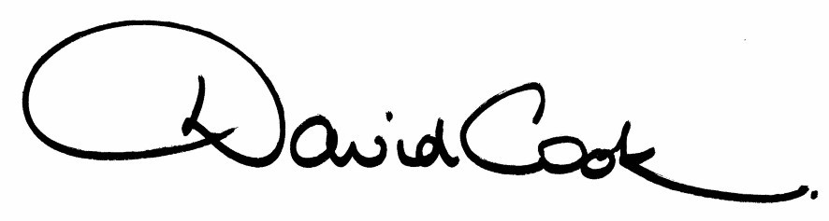

D Cook
Chief Executive

A G E N D A

1. Apologies.

2. Northamptonshire Enterprise Limited - Presentation

3. Minutes of the Annual Meeting of the Council held on 13th May 2009 to be approved as a correct record and signed by the Mayor

4. Declarations of Interest:-

- Personal
- Prejudicial

5. To receive any announcements from the Mayor and/or the Leader of the Council.

6. Report of the Chief Executive.

7. The Mayor to ask members of the public present if they want to speak on any item on the agenda.

8. Statement of Accounts 2009/10 (to follow)

9. Kettering Borough Council Improvement Plan 2009-10 (attached)

10. Appointment of Statutory Officers (to follow)

11. To receive questions from members

12. To consider any motions received in accordance with Council Procedure Rule 16.

Proposed by Councillor Mary Malin and Seconded by Councillor Chris Smith-Haynes that:-

“This Council wishes to congratulate all our staff for their dedication and support during this past year. Many received public applause at this year’s recent staff awards ceremony. This council formally recognises everyone’s contribution and we wish to record our thanks for their response over the year, and for achieving the highest standards of Public Service.”

13. Any matters of urgency that the Mayor decides should be considered.

15.6.09
Fire Alarm

All meetings shall be adjourned immediately on the sounding of the fire alarm. The alarm is a continuous two-tone siren. On hearing the alarm please leave the building by the nearest emergency exit. There are emergency exits at both ends of the corridor outside the meeting rooms. On leaving the building please cross the car park and assemble on the grassed area by the church. Do not attempt to drive out of the car park as this may impede the arrival of emergency vehicles. Please do not return to the building until you are told it is safe to do so by a Council employee.

Toilets

There are toilets in the corridor off the main entrance to the building you came through to get to the meeting room.

Facilities for Babies and Children

If you wish to use a private area to feed your baby please ask a member of staff. There are changing facilities in the corridor off the main entrance adjacent to the toilets.

.Access for Disabled People

There are allocated parking bays outside the main entrance to the Municipal Offices for disabled people. The meeting rooms are located on the ground floor and access is gained for wheelchair users via the main entrance. If you require assistance, please ask the attendant on duty in the reception area.

No Smoking

Smoking is not permitted in the Municipal Offices.

