Direct Line: (01536) 534398
Email: anneireson@kettering.gov.uk
Our Ref: AI
Your Ref:
Date: 20th April 2009

Dear Councillor

You are summoned to a meeting of Kettering Borough Council to be held in the Council Chamber on Wednesday, 29th April 2009 at 7.00 pm.

Yours faithfully

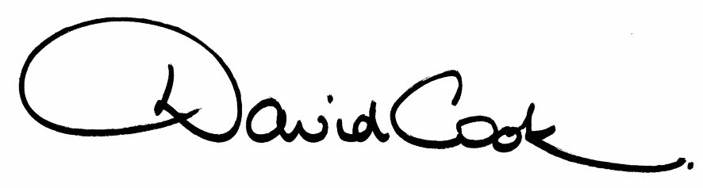

D Cook
Chief Executive

NB: The Mayor would like to invite all Councillors to join her for refreshments in the Mayor’s Parlour following the conclusion
of the meeting

A G E N D A

1. Apologies.

2. Northants Fire and Rescue Service - Presentation

3. Minutes of the meeting of the Council held on 26th February 2009 to be approved as a correct record and signed by the Mayor

4. Declarations of Interest:-

- Personal
- Prejudicial

5. To receive any announcements from the Mayor or the Leader of the Council.

6. Report of the Chief Executive.

7. The Mayor to ask members of the public present if they want to speak on any item on the agenda.

8. East Kettering Strategic Design Supplementary Planning Document

9. To receive questions from members

10. To consider any motions received in accordance with Council Procedure Rule 16.

Proposed by Councillor Jim Hakewill and Seconded by Councillor Russell Roberts

“This council congratulates the Northamptonshire based BrawnGP Team on its superb performances in the opening Formula One Grand Prix of 2009. Along with the Milton Keynes based Red Bull success in China this demonstrates that Northamptonshire and the wider Milton Keynes and South Midlands Growth area is a centre of excellence for the Motor racing industry. This success must be used to attract new businesses and jobs to help fulfil this council’s objective of securing infrastructure, jobs and only then new homes in the Borough..”

11. Any matters of urgency that the Mayor decides should be considered.

20.4.09
Fire Alarm

All meetings shall be adjourned immediately on the sounding of the fire alarm. The alarm is a continuous two-tone siren. On hearing the alarm please leave the building by the nearest emergency exit. There are emergency exits at both ends of the corridor outside the meeting rooms. On leaving the building please cross the car park and assemble on the grassed area by the church. Do not attempt to drive out of the car park as this may impede the arrival of emergency vehicles. Please do not return to the building until you are told it is safe to do so by a Council employee.

Toilets

There are toilets in the corridor off the main entrance to the building you came through to get to the meeting room.

Facilities for Babies and Children

If you wish to use a private area to feed your baby please ask a member of staff. There are changing facilities in the corridor off the main entrance adjacent to the toilets.

.Access for Disabled People

There are allocated parking bays outside the main entrance to the Municipal Offices for disabled people. The meeting rooms are located on the ground floor and access is gained for wheelchair users via the main entrance. If you require assistance, please ask the attendant on duty in the reception area.

No Smoking

Smoking is not permitted in the Municipal Offices.

