BOROUGH OF KETTERING

Committee | Full Planning Committee - 31/03/2009 | Item No: 5.3
Report Originator | Alex Jelley  Assistant Development Officer | Application No:  KET/2009/0074
Wards Affected | William Knibb
Location | 2 School Lane, Kettering
Proposal | Full Application: Single storey rear extension
Applicant | Ms B Bhavsan Elan Chemists,

1. PURPOSE OF REPORT

- To describe the above proposals
- To identify and report on the issues arising from it
- To state a recommendation on the application

2. RECOMMENDATION

THE DEVELOPMENT CONTROL MANAGER RECOMMENDS that this application be APPROVED subject to the following Condition(s):-

1. The development hereby permitted shall be begun before the expiration of 3 years from the date of this planning permission.
REASON: To comply with Section 91 of the Town and Country Planning Act 1990 (as amended) and to prevent an accumulation of unimplemented planning permissions.

2. The materials to be used in the construction of the external surfaces of the development hereby permitted shall match, in type, colour and texture those on the existing building.
REASON: In the interests of visual amenity in accordance with policy 13 of the North Northamptonshire Core Spatial Strategy.

Notes (if any) :-
1 Northamptonshire Police have the following informatives for this application:

a) The premises would benefit from a NACOS fitted alarm preferably with police response. This is due to the building containing drugs.
b) All Entry/Exit doors of the building should meet LPS1175 sr1 as a minimum standard which is the minimum requirement for door security (as per current Secured by Design guides). Ground floor windows and doors should be laminated to 6.4mm.

To discuss these issues further, please contact Kelly McDermott, Crime Prevention Design Advisor, Department for Service Improvement, Northamptonshire Police via email on Kelly.mcdermott@northants.pnn.police.uk or phone 08453 700700 Ext: 4302.

Justification for Granting Planning Permission

The Proposal is in accordance with national and local policies as set out in Planning Policy Statement 1, policy 13 of the North Northamptonshire Core Spatial Strategy, Policy GS5 of the Northamptonshire County Structure Plan and adopted supplementary planning guidance note 'Plannning Out Crime in Northamptonshire'. There are no material considerations that indicate against the proposal.

Officers Report

3.0 | Information

Relevant Planning History
KET/2005/0904 - Proposed extension to chemist with residential flats above – APPROVED.

This application was for an extension to the rear of the site to provide for residential flats and an increased unit at ground floor level. It is not considered to be a relevant consideration.

Site Description
Officer's site inspection was carried out on 18.03.2009.

The application site is located on School Lane within the Kettering town centre Conservation Area. It is a standard two storey town centre property with ground floor units used as a chemist.

To the rear of the property is a small courtyard area, which is not visible from the highway.

See photos attached to file for further information.

Proposed Development
This application is for a single storey extension to the rear of the existing building at 2 School Lane in Kettering.

Any Constraints Affecting the Site
Kettering town centre Conservation Area.

4.0 | Consultation and Customer Impact

Environment and Enforcement Team
No objection

Environmental Health Department
No objection

5.0 | Planning Policy

Legislation
The Planning (Listed Buildings and Conservation Areas) Act 1990

National Policies
PPS1. Delivering Sustainable Development
PPG15. Planning and the Historic Environment

North Northamptonshire Core Spatial Strategy
P13. General Sustainable Development Principles

Structure Plan
GS5. Design

SPGs
SPG: Planning Out Crime in Northamptonshire

6.0 | Financial/Resource Implications
 | None
7.0 | Planning Considerations
The key issues for consideration in this application are:-

1 Principle of Development
2 Design, Character and Appearance
3 Amenity

1. Principle of Development
The Development Plan contains relevant policies that provide for development of this kind subject to detailed policy criteria being satisfied. In particular; extensions should be suitable in terms of design, scale, type and position; they should respect the character of the surrounding Conservation Area; and they should not detrimentally impact upon the amenity of surrounding properties. National policy in the form of PPS1 promotes the sustainable use of existing land and buildings, focussing on the importance matters of design and character play in achieving this. PPG15 expands upon the legislative basis of S.72 of the Planning Act 1990 which states that: “special attention shall be paid to the desirability of preserving or enhancing the character or appearance of that [Conservation] area.”

2. Design, Character and Appearance
The proposals are entirely subordinate to the existing building, being set down from the existing roof height and set back from the main line of the building. The extension would not be visible from the highway, or public open space, and as such cannot be considered to impact upon the character of the area. As a result it is considered that the proposed extension would respect the character of its surroundings, preserving the appearance of the Conservation Area, and be appropriate in relation to the design of the existing building itself. The proposed development is therefore in keeping with the design-led requirements of policy GS5 of the Northamptonshire County Structure Plan and policy 13 of the North Northamptonshire Core Spatial Strategy, both of which seek to ensure that development is suitable in terms of design, character and appearance.

3. Amenity
Due to its orientation, design, scale and positioning, the proposed extension would not detrimentally impact upon the amenity of existing or future occupiers of adjoining properties or the wider area. As a result, it is considered that the development meets the criteria set out by policy 13 of the North Northamptonshire Core Spatial Strategy

that ensure development is acceptable in terms of its impact on amenity in the surrounding area, and also the aims of sustainable development as specified within PPS1.

Conclusion

The proposal is considered to be in accordance with national, regional and local planning policy and there are no other material planning considerations that would constitute refusal of this application. It is considered that the proposed extension would not have an adverse impact on the amenity of the area, and will not adversely affect the character or appearance of the site or the surrounding Conservation Area.

Background Papers |  | Previous Reports/Minutes
Title of Document: |  | Ref:
Date: |  | Date:
Contact Officer: | Alex Jelley, Assistant Development Officer on 01536 534316

SITE LOCATION PLAN

2 School Lane, Kettering
Application No.: KET/2009/0074

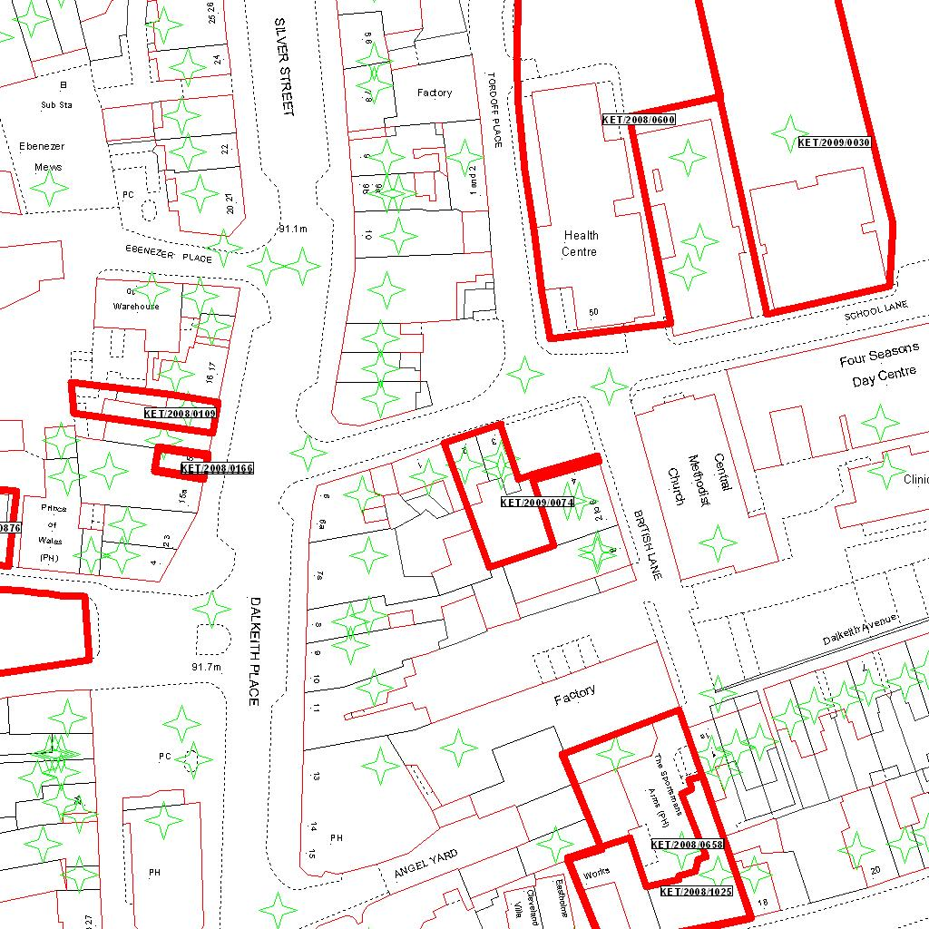

Reproduced from the Ordnance Survey mapping with the permission of the Controller of Her Majesty’s Stationery Office © Crown copyright. Unauthorised reproduction infringes Crown copyright and may lead to prosecution or civil proceedings.  LA078344 |  | N
Date: 11/02/2009 Do not scale from this map. For illustrative purposes only.

