BOROUGH OF KETTERING

Committee | Full Planning Committee - 31/03/2009 | Item No: 5.1
Report Originator | Michael Boniface  Development Officer | Application No:  KET/2008/1012
Wards Affected | Welland
Location | Homefield Grange Retreat, Manor Road, Rushton
Proposal | Full Application: 2 no. single storey extensions to link existing buildings and below ground swimming pool
Applicant | Miss S Peck

1. PURPOSE OF REPORT

- To describe the above proposals
- To identify and report on the issues arising from it
- To state a recommendation on the application

2. RECOMMENDATION

THE DEVELOPMENT CONTROL MANAGER RECOMMENDS that this application be APPROVED subject to the following Condition(s):-

1. The development hereby permitted shall be begun before the expiration of 3 years from the date of this planning permission.
REASON: To comply with Section 91 of the Town and Country Planning Act 1990 (as amended) and to prevent an accumulation of unimplemented planning permissions.

2. All external walls shall be constructed in natural stone and shall not be laid, coursed or pointed other than in accordance with a sample panel which shall have been constructed on site and approved in writing by the Local Planning Authority prior to the commencement of construction of any such external walls. As approved, the sample panel shall be retained on site and kept available for re-inspection throughout the construction period.
REASON: In the interests of the character and appearance of the Conservation Area in accordance with policy 13 of the Core Spatial Strategy for North Northamptonshire.

3. No development shall commence on site until details of the types and colours of all external roofing materials to be used, together with samples, have been submitted to and approved in writing by the Local Planning Authority. The development shall not be carried out other than in accordance with the approved details.
REASON: In the interests of the visual amenities of the area and to protect the charcter of the conservation area in accordance with policy 13 of the Core Spatial Strategy for North Northamptonshire.

4. No development shall take place on site until full details of all windows, doors, timber finishes and rainwater goods have been submitted to and approved in writing by the Local Planning Authority. The development shall not be carried out other than in accordance with the approved details.
REASON: In the interests of the character and appearance of the Conservation Area in accordance with policy 13 of the Core Spatial Strategy for North Northamptonshire.

5. Prior to the commencement of development a scheme for the provision of waste water drainage shall be submitted to and approved in writing by the Local Planning Authority. The development shall not be carried out other than in accordance with the approved scheme.
REASON: To prevent pollution of the water environment in accordance with policy 13 of the Core Spatial Strategy for North Northamptonshire.

Notes (if any) :-
1. This planning permission is subject to "pre-commencement" conditions which require details/drawings to be submitted to and approved in writing by the Local Planning Authority before ANY development may lawfully commence. Any development commenced in breach of these "pre-commencement" conditions will be unauthorised, a breach of planning control, and liable to immediate Enforcement and Stop Notice action.

Justification for Granting Planning Permission

The Proposal is in accordance with national and local policies as set out in Planning Policy Statements/Guidance Notes 1, 4, 7, 13 and 15, Policies 9, 11 and 13 of the North Northamptonshire Core Spatial Strategy, Policies T3, T9 and GS5 of the Northamptonshire County Structure Plan and Policies 7 and RA14 of the Local Plan for Kettering Borough. There are no material considerations that indicate against the proposal.

Officers Report

3.0 | Information

Relevant Planning History
KET/2008/0410 – Extension works to link existing buildings, plus first floor extension over garage – REFUSED 20/06/08. Appeal outstanding.

KET/2006/0272 - First floor extension above stores/stable building. First floor extension above garage to form a gym. Alteration to bedroom window to gable wall of house – WITHDRAWN 24/05/06

KET/2006/0185 - Turn room into therapy room and use some of the bedrooms for business purposes – APPROVED 18/04/06

Site Description
Officer's site inspection was carried out on 12/01/2009.

The application site is situated outside the village of Rushton, on the east side, and is therefore in open countryside as defined by the Local Plan. The site is within Rushton Conservation Area. Access to the site is off Manor Road and is shared with a public right of way (Bridleway).

The property is a conversion of former farm buildings, constructed of local limestone and sandstone. Within the last 10 years the buildings have been converted from farm buildings, first into a residential property and then into the current use as a mixed residential and commercial use as a residential holistic therapy business.

The buildings are mainly facing around a courtyard. Within the courtyard the group of building are made up of a two storey element which is roofed with natural slate and single storey buildings which are roofed with pantiles. Projecting from the two storey building is another two storey element which is subordinate in height and does not face into the courtyard.

Proposed Development
Single storey extensions, conversion of existing garage building for further business use and construction of an underground swimming pool.

Any Constraints Affecting The Site
- Open Countryside.
- Conservation Area.
- Public Right of Way.

4.0 | Consultation and Customer Impact

Parish/Town Council
No objection. The proposal is more sympathetic than the previous scheme. It should be noted that the buildings never incorporated a farmhouse.

Highway Authority
No objection as the proposals will not increase the number of clients accommodated by the business, as such use of the existing vehicular access will not be significantly intensified.

Environmental Health
No comment although it is noted that details have not been provided as to how the applicant intends to dispose of pool water or store and dispose of chemicals.

Neighbours
11 letters of objection for the following reasons:
- Inadequate vehicular access, parking and congestion.
- Odour from foul sewage – septic tank inadequate.
- Similar facilities exist in the village and those proposed are not necessary.
- Highway safety and conflict with the adjacent bridleway.
- Parking creates an urban feel.
- Decision has not been made on current appeal.
- Inappropriate commercial activity.
- Entire building is now used for business purposes.
- Development in the open countryside.
- Out of character.
- Adverse visual impact.
- Detriment to the conservation area.
- Impact on Rushton Manor.
- Neighbouring amenity.
- Development extends outside of the curtilage.
- Increased vehicular movements and disturbance.

5.0 | Planning Policy

National Policies
PPS1 – Delivering Sustainable Development
PPG4 – Industrial, Commercial Development and Small Firms
PPS7 – Sustainable Development in Rural Areas
PPG13 – Transport
PPG15 – Planning and the Historic Environment

Development Plan Policies

Regional Policy
RSS8 – Regional Spatial Strategy for the East Midlands

North Northamptonshire Core Spatial Strategy
9 – Distribution and Location of Development
11 – Distribution of Jobs
13 – General Sustainable Development Principles
14 – Energy Efficiency and Sustainable Construction

Structure Plan
GS5 – Design
T3 – Transport Requirements
T9 – Parking

Local Plan
7 – Environment: Protection of the Open Countryside
RA14 – Rural Area: Reuse and Conversion of Rural Buildings

SPGs
Parking (2003)

6.0 | Financial/Resource Implications
 | None
7.0 | Planning Considerations
The key issues for consideration in this application are:-

1 Principle of Development;
2 Design, Character and Appearance;
3 Impact on the Conservation Area;
4 Highway and Parking Issues;
5 Neighbouring Amenity;
6 Others Matters.

1. Principle of Development
PPS7 supports the reuse of rural buildings but suggests that development should be located within the most sustainable locations such as existing towns or designated service centres in the first instance. It is recognised however that a limited amount of development should be allowed in rural areas to support the local economy and bring appropriate buildings back into viable use. Policy 11 of the Core Spatial Strategy expands upon these principles and suggests that employment related development can be encouraged in locations within and adjoining settlements.

While the site is located outside of the settlement boundary for Rushton, it is noted that the site currently operates a mixed use permission as a residential dwelling and holistic therapy business. The proposed development would provide additional facilities within the site, though the number of bedrooms would not be increased and it is not expected therefore that a significant number of additional customers would be attracted. It is noted that two additional part-time members of staff are anticipated but again this would not intensify the business use to such an extent as would warrant refusal of the application on sustainability grounds.

2. Design, Character and Appearance
As suggested above, these former agricultural buildings have been converted to a mixed residential and commercial property. Although it is recognised that the buildings now incorporate design elements akin to a domestic property, the range of

buildings have largely retained their agricultural character, particularly in terms of their simple form and layout. It is considered important that any proposals to extend the development respect this character.

Policy RA14 of the local plan offers specific guidance on the reuse and conversion of existing rural buildings suggesting that proposals will only be acceptable where the structure is physically suitable without the need for significant alterations or extensions and where proposals are small in scale and subordinate in size and form to the original building amongst other criteria.

Contrary to previous applications, the proposed additions are considered to respect the hierarchy of buildings evident within the site, maintaining the prominence of the two storey, former threshing barn. The proposed additions are relatively small scale and would have the effect of completing the existing courtyard created by the buildings. The detailed design of the proposals is simple and subordinate in form and scale reflecting the appearance of the existing buildings on the site. The proposed swimming pool addition would be concealed entirely below ground level. A condition would require the submission of materials for approval so as to ensure an appropriate elevational appearance.

3. Impact on the Conservation Area
The buildings are located within the conservation area and as such, the proposals have the potential to impact upon its character and appearance. As discussed above, the detailed design and form of the proposals are considered acceptable in the context of the existing complex. Although the buildings are clearly visible on views across the open countryside from the village and particularly to users of the adjacent bridleway, the additions would largely be concealed behind existing structures and would not detract from the character of the buildings themselves, nor the wider area.

4. Highway and Parking Issues
The development would be served by the existing vehicular access via a bridleway from Manor Road. The small intensification in use of the site discussed above will not lead to a significant additional strain on the highway network and it would not therefore be reasonable to require improvements. Similarly, the parking provision currently existing is considered acceptable. While neighbours concerns are noted, there will not be a significant increase in the number of customers to the site and the scheme will not therefore exacerbate any existing issues. The Local Highway Authority has not raised an objection to the proposals.

5. Neighbouring Amenity
The business use is located some distance from the nearest residential properties although it is acknowledged that the traffic movements associated with the site have the potential to impact upon neighbouring amenity. Given that the number of bedrooms for business purposes will remain the same, the improved facilities offered will not generate a significant number of additional movements and on this basis, no additional adverse impact will result to neighbouring amenity.

6. Other Matters
Concerns have been raised that the existing means of disposing of waste is inadequate and that the proposed development could exacerbate odour issues. The applicant suggests that the additional facilities will be connected to the existing drainage system. It is considered prudent however to attach a condition requiring details of the proposed system for approval so as to ensure suitability.

The fact that similar facilities are available within the village and that an outstanding appeal exists are not material considerations and no weight should be attached to these matters.

The principle of development in the open countryside for commercial purposes has been established through previous planning permissions and accords with policy as set out above.

The proposed development is a sufficient distance from the Manor House (a listed building) as to avoid any adverse impact upon its setting.

Conclusion

The proposed development complies with both national and local planning policy and there are no material planning matters which indicate against the proposal; as such, planning permission should be granted.

Background Papers |  |  | Previous Reports/Minutes
Title of Document: |  |  | Ref:
Date: |  |  | Date:
Contact Officer: |  | Michael Boniface, Development Officer on 01536 534316

SITE LOCATION PLAN

Homefield Grange Retreat, Manor Road, Rushton
Application No.: KET/2008/1012

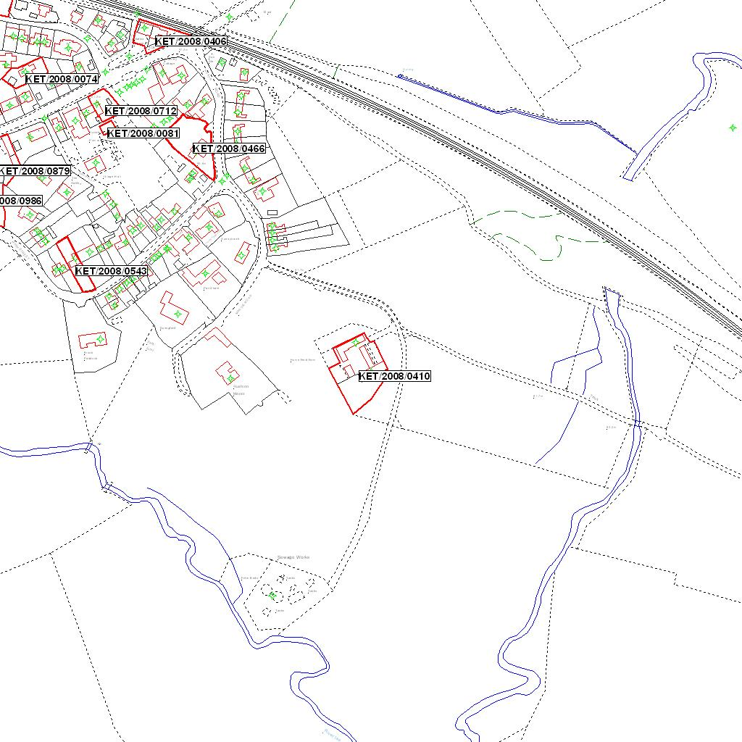

Reproduced from the Ordnance Survey mapping with the permission of the Controller of Her Majesty’s Stationery Office © Crown copyright. Unauthorised reproduction infringes Crown copyright and may lead to prosecution or civil proceedings.  LA078344 |  | N
Date: 15/12/2008 Do not scale from this map. For illustrative purposes only.

