To all Members | Direct Line: (01536) 534398  Email: anneireson@kettering.gov.uk  Our Ref: AI  Your Ref:  Date: 18th February 2009

Dear Councillor

You are summoned to a meeting of Kettering Borough Council to be held in the Council Chamber on Thursday, 26th February 2009 at 7.00 pm.

Yours faithfully

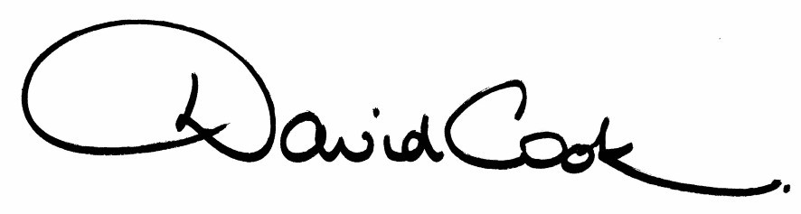

D Cook
Chief Executive

A G E N D A

1. Apologies.

2. ‘Health of Northamptonshire’ - Presentation by Dr Stephen Horsley (Primary Care Trust)

3. Minutes of the meeting of the Council held on 17th December 2008 to be approved as a correct record and signed by the Mayor

4. Minutes of the Budget Consultation Meeting held on 22nd January 2009 to be approved as a correct record.

5. Declarations of Interest:-

- Personal
- Prejudicial

6. To receive any announcements from the Mayor or the Leader of the Council.

7. Report of the Chief Executive.

8. The Mayor to ask members of the public present if they want to speak on any item on the agenda.

9. Nomination of Deputy Mayor 2009/10

Reports:

10. Budget Proposals 2009/10 - General Fund, Capital Programme and Housing Revenue Account (report to follow)

11. North Northamptonshire Sustainable Design Supplementary Planning Document (report attached)

12. Changing the Constitution – Local Strategic Partnership Executive Board and Student Council (report to follow)

13. To receive questions from members

14. To consider any motions received in accordance with Council Procedure Rule 16.

Proposed by Councillor Philip Hollobone and Seconded by Councillor J Hakewill:

"That this Council congratulates Kettering Town Football Club, the Poppies, on their fantastic success in getting to the fourth round of the FA Cup and so valiantly twice coming back to even the score against Fulham. Their success has taken Kettering’s name to the forefront of the football world and we wish them well in their future matches."

15. Any matters of urgency that the Mayor decides should be considered.

18.2.09
Fire Alarm

All meetings shall be adjourned immediately on the sounding of the fire alarm. The alarm is a continuous two-tone siren. On hearing the alarm please leave the building by the nearest emergency exit. There are emergency exits at both ends of the corridor outside the meeting rooms. On leaving the building please cross the car park and assemble on the grassed area by the church. Do not attempt to drive out of the car park as this may impede the arrival of emergency vehicles. Please do not return to the building until you are told it is safe to do so by a Council employee.

Toilets

There are toilets in the corridor off the main entrance to the building you came through to get to the meeting room.

Facilities for Babies and Children

If you wish to use a private area to feed your baby please ask a member of staff. There are changing facilities in the corridor off the main entrance adjacent to the toilets.

.Access for Disabled People

There are allocated parking bays outside the main entrance to the Municipal Offices for disabled people. The meeting rooms are located on the ground floor and access is gained for wheelchair users via the main entrance. If you require assistance, please ask the attendant on duty in the reception area.

No Smoking

Smoking is not permitted in the Municipal Offices.

