Direct Line: (01536) 534398
Email: anneireson@kettering.gov.uk
Our Ref: AI
Your Ref:
Date: 21st June 2004

Dear Councillor

You are summoned to a meeting of Kettering Borough Council to be held in the Council Chamber, Municipal Offices, Bowling Green Road, Kettering on Wednesday, 30th June 2004 at 7.00 pm.

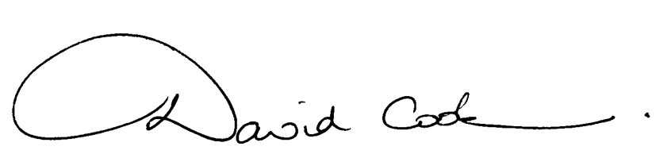Yours faithfully

D Cook
Chief Executive

A G E N D A

1. Apologies.

2. Minutes of the meeting of the Council held on 12th May 2004 to be approved as a correct record and signed by the Mayor.

3. Declarations of Interest.

4. To receive any announcements from the Mayor and/or the Leader of the Council.

5. Reports of the Chief Executive.

6. The Mayor to ask members of the public present if they want to speak on any item on the agenda.

7. Periodic Electoral Review - Kettering Borough (report attached)

8. To receive reports from the Council's Executive and Committees, and receive questions and answers on any of those reports:-

(i) Ise Skatepark - Request for Increase in the Capital Programme
(report attached).

(ii) Corporate Improvement Plan - 2004-2008 (report attached).

9. To consider any motions received in accordance with Council Procedure Rule 16:-

Motion proposed by Councillor Steve King and seconded by Councillor Linda Adams:

“This Council supports efforts in line with Key Action 2A1 of the Corporate Improvement Plan towards making Kettering Borough Council an Eco-friendly Council: by asking appropriate committees (Policy and Improvement and/or Monitoring and Audit) to order a review into how environmentally friendly practice at Kettering Borough Council is, and to research ways of how Kettering Borough Council can achieve the "Eco-Council" status urged on us by the pupils of Geddington Primary School.”

Motion proposed by Councillor John Padwick and seconded by Councillor Maggie Don:

"This Council acknowledges the support for free car parking in town centre car parks on weekdays from 9.00 to 11.00 am and the difficulties that abolition would be likely to cause for trade, the less well off and those from rural areas. In line with the recommendation of the Overview Committee, the Council will therefore retain free car parking on weekdays from 9.00 am to 11.00 am."

10. Any matters of urgency that the Mayor decides should be considered.

21.6.04
Fire Alarm

All meetings shall be adjourned immediately on the sounding of the fire alarm. The alarm is a continuous two-tone siren. On hearing the alarm please leave the building by the nearest emergency exit. There are emergency exits at both ends of the corridor outside the meeting rooms. On leaving the building please cross the car park and assemble on the grassed area by the church. Do not attempt to drive out of the car park as this may impede the arrival of emergency vehicles. Please do not return to the building until you are told it is safe to do so by a Council employee.

Toilets and Baby Changing Facilities

There are toilets and baby changing facilities in the corridor off the main entrance to the building you came through to get to the meeting room. The Council actively supports breastfeeding mothers. If you wish to use a private area please ask a member of staff.

Access for Disabled People

There are allocated parking bays outside the main entrance to the Municipal Offices for disabled people. The meeting rooms are located on the ground floor and access is gained for wheelchair users via the main entrance. If you require assistance, please ask the attendant on duty in the reception area.

No Smoking

Smoking is not permitted in the Municipal Offices.

