

To all Members | Direct Line: (01536) 534398  Email: anneireson@kettering.gov.uk  Our Ref: AI  Your Ref:  Date: 16th September 2008

Dear Councillor

You are summoned to a meeting of Kettering Borough Council to be held in the Municipal Offices, Bowling Green Road, Kettering on Wednesday, 24th September 2008 at 7.00 pm.

Yours faithfully

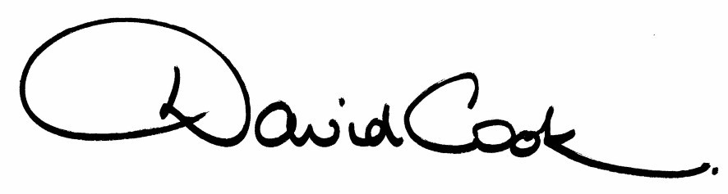

D Cook
Chief Executive

A G E N D A

1. Apologies.

2. Minutes of the meeting of the Council held on 25th June 2008 to be approved as a correct record and signed by the Mayor

3. Declarations of Interest:
- Personal
- Prejudicial

4. To receive any announcements from the Mayor and/or the Leader of the Council.

5. Report of the Chief Executive.

6. The Mayor to ask members of the public present if they want to speak on
any item on the agenda.

7. Presentation by Northamptonshire Police – Ch Supt Paul Fell
‘Partnership working with the Council to date and opportunities for greater collaboration in the future’

To consider the following motion received in accordance with Council Procedure Rule 14:-

Proposed by Councillor Alan Pote and Seconded by Councillor Victoria Perry:-

“This Council welcomes the positive and proactive partnership working with local police colleagues, which makes life safer and more enjoyable for residents, businesses and visitors to our Borough.”

8. To receive questions from members

9. Capital Programme Amendments 2008/09 (report attached)

10. Extended Powers for the North Northamptonshire Joint Planning Committee (report attached)

11. To consider the following motion received in accordance with Council Procedure Rule 14:-

Proposed by Councillor Alison Wiley and Seconded by Councillor Mike Tebbutt:-

“This Council supports South Northamptonshire District Council in their determination to retain the Formula 1 Grand Prix at Silverstone. We recognise that the county as a whole derives great benefit from the motor sport industries that have been drawn to the area by the presence of the Silverstone circuit, as well as the ancillary businesses which have grown up to support these high-tech enterprises. “

12. Any matters of urgency that the Mayor decides should be considered.

NB: The Mayor has agreed to accept the following item as a matter of urgency ;

‘Open Space Supplementary Planning Document’

16.9.08
Fire Alarm

All meetings shall be adjourned immediately on the sounding of the fire alarm. The alarm is a continuous two-tone siren. On hearing the alarm please leave the building by the nearest emergency exit. There are emergency exits at both ends of the corridor outside the meeting rooms. On leaving the building please cross the car park and assemble on the grassed area by the church. Do not attempt to drive out of the car park as this may impede the arrival of emergency vehicles. Please do not return to the building until you are told it is safe to do so by a Council employee.

Toilets

There are toilets in the corridor off the main entrance to the building you came through to get to the meeting room.

Breastfeeding and Baby Changing Facilities

The Council actively supports breastfeeding mothers. If you wish to use a private area please ask a member of staff. There are baby changing facilities in the corridor off the main entrance adjacent to the toilets.

.Access for Disabled People

There are allocated parking bays outside the main entrance to the Municipal Offices for disabled people. The meeting rooms are located on the ground floor and access is gained for wheelchair users via the main entrance. If you require assistance, please ask the attendant on duty in the reception area.

No Smoking

Smoking is not permitted in the Municipal Offices.

Private and Confidential Items

The press and members of the public can be excluded from business of the meeting on the grounds that it involves items of business which include the likely disclosure of exempt information as defined by Paragraphs 1-7 of the Local Government (Access to Information) (Variation) Order 2006 in respect of Schedule 12A to the Local Government Act 1972. The reason for discussing the issue in private is indicated on the Order of Business.

