 | Direct Line: (01536) 534200  Email: ianwhite@kettering.gov.uk  Our Ref: IW  Your Ref:  Date: 9th December 2008

Dear Councillor

You are summoned to a meeting of Kettering Borough Council to be held in the Council Chamber, Municipal Offices, Bowling Green Road, Kettering on Wednesday, 17th December 2008 at 7.00 pm.

Please note that I am happy to welcome the Hall Meadow Primary School Choir who will be singing carols prior to the commencement of the formal part of the meeting and, as usual the Mayor has kindly invited all members to a reception in the Parlour after the meeting.

Yours faithfully

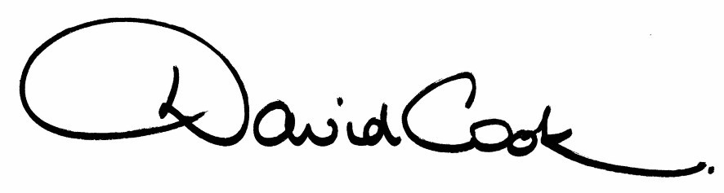
D Cook
Chief Executive

A G E N D A

1. Apologies.

2. Minutes of the meeting of the Council held on 24th September 2008 to be approved as a correct record and signed by the Mayor.

3. Declarations of Interest:

(a) Personal
(b) Prejudicial

4. To receive any announcements from the Mayor and/or the Leader of the Council.

5. Report of the Chief Executive

6. The Mayor to ask members of the public present if they wish to speak on any item on the Agenda.

7. ‘I’m a Councillor – Get me out of here!’ – Event Feedback

8. Sustainable Community Strategy 2008-2011 (NB: Appendices are provided separately – Executive Committee members have already been issued with the documents and are requested to bring them to the meeting.)

9. Appointment of Temporary Monitoring Officer

10. Urgent items approved by the Executive – September to December 2008.

11. To consider the following motions received in accordance with Council Procedure Rule 14:-

i) Proposed by Councillor Jonathan West and seconded by Councillor Paul Corazzo:-

“This Council applauds Kettering Town Football Club’s recent success in the Blue Square Premier League and FA Cup competitions and this Council also supports the Football Club’s social responsibilities, including distancing itself from racism in football.

This Council calls upon the Leader and Executive to work with Kettering Town Football club to ensure a viable future for this important sporting and cultural attribute to our town.”

ii) Proposed by Councillor Jonathan Bullock and seconded by Councillor Paul Marks

“This Council recognises the opportunity that the Sustainable Communities Act 2007 gives to local communities to improve their area by identifying actions that can be facilitated by central government and which will provide clear community benefit.

The Council notes that the deadline for submission of suggestions to the Local Government Association, as “selector”, in accordance with the Act, is the 31st July 2009. Accordingly it is proposed that this opportunity is referred to the Research & Development Committee for inclusion into its work programme so that it can consider, consult and report back to the Executive any recommended actions that could and should be submitted to the Local Government Association before the deadline.”

12. To receive any questions from members.

13. Any matters of urgency that the Mayor decides should be considered.

Fire Alarm

All meetings shall be adjourned immediately on the sounding of the fire alarm. The alarm is a continuous two-tone siren. On hearing the alarm please leave the building by the nearest emergency exit. There are emergency exits at both ends of the corridor outside the meeting rooms. On leaving the building please cross the car park and assemble on the grassed area by the church. Do not attempt to drive out of the car park as this may impede the arrival of emergency vehicles. Please do not return to the building until you are told it is safe to do so by a Council employee.

Toilets

There are toilets in the corridor off the main entrance to the building you came through to get to the meeting room.

Breastfeeding and Baby Changing Facilities

The Council actively supports breastfeeding mothers. If you wish to use a private area please ask a member of staff. There are baby changing facilities in the corridor off the main entrance adjacent to the toilets.

.Access for Disabled People

There are allocated parking bays outside the main entrance to the Municipal Offices for disabled people. The meeting rooms are located on the ground floor and access is gained for wheelchair users via the main entrance. If you require assistance, please ask the attendant on duty in the reception area.

No Smoking

Smoking is not permitted in the Municipal Offices.

Private and Confidential Items

The press and members of the public can be excluded from business of the meeting on the grounds that it involves items of business which include the likely disclosure of exempt information as defined by Paragraphs 1-7 of the Local Government (Access to Information) (Variation) Order 2006 in respect of Schedule 12A to the Local Government Act 1972. The reason for discussing the issue in private is indicated on the Order of Business.

