Direct Line: (01536) 534398
Email: anneireson@kettering.gov.uk
Our Ref: AI
Your Ref:
Date: 6th September 2004

Dear Councillor

You are summoned to a meeting to discuss the State of the Borough to be held in the Monet Suite, Kettering Leisure Village, Thurston Drive, Kettering at 6.00 pm on Wednesday, 15th September 2004.

Please note that a buffet tea will be available at 5.00 pm.

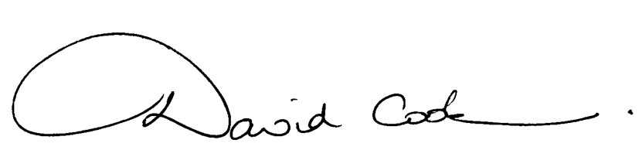Yours faithfully

D Cook
Chief Executive

A G E N D A

1. Apologies  2. Declarations of Interest  3. Welcome from the Mayor  4. Introduction by Councillor Freer  5. Presentations by Panels (approximately 10 minutes each panel)  - Community Safety Partnership  - Cultural Panel  - Enterprise Kettering  - Environment Panel  - Health, Housing and Social Care Panel  - Lifelong Learning Panel  6. Break for refreshments  7. Debate on the following themes (approximately 10 minutes for each theme)  - Community Safety  - Culture  - The Economy  - The Environment  - Health, Housing and Social Care  - Learning for Life  8. Summing up and next steps  9. Any matters of urgency the Mayor decides should be considered. | 6.00 pm  6.10 pm  7.15 pm  7.30 pm
10. Closure of meeting | 9.00 pm

6.9.04

