To all Members | Direct Line: (01536) 534398  Email: anneireson@kettering.gov.uk  Our Ref: AI  Your Ref:  Date: 17th June 2008

Dear Councillor

You are summoned to a meeting of Kettering Borough Council to be held in the Municipal Offices, Bowling Green Road, Kettering on Wednesday, 25th June 2008 at 7.00 pm.

Yours faithfully

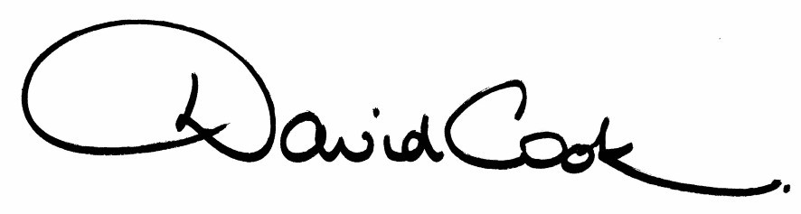

D Cook
Chief Executive

Prior to the commencement of the meeting there will be
a presentation on Kettering Schools Federation

A G E N D A

1. Apologies.

2. Minutes of the Annual Meeting of the Council held on 14th May 2008 to be approved as a correct record and signed by the Mayor

3. Declarations of Interest:
- Personal
- Prejudicial

4. To receive any announcements from the Mayor and/or the Leader of the Council.

5. Report of the Chief Executive.

6. The Mayor to ask members of the public present if they want to speak on any item on the agenda.

7. To receive questions from members.

8. Kettering Borough Council Improvement Plan

9. Corporate Equality and Diversity Scheme

10. Crime and Disorder Strategy

11. Asset Management Plan and Capital Strategy

12. Statement of Accounts 2007/08

13. Improving Primary Care Access (referred from Kettering Town Forum)

14. To consider any motions received in accordance with Council Procedure Rule 16.

Proposed by Councillor Michael Tebbutt and Seconded by Councillor Christopher Lamb:-
“This Council recognises the importance of a successful farming industry and rural economy in our Borough. We call on the Minister of Agriculture to listen to the genuine concerns of local farmers and to find ways to assist this vital industry in the face of spiralling costs and increasing bureaucracy.”

15. Any matters of urgency that the Mayor decides should be considered.

17.6.08
Fire Alarm

All meetings shall be adjourned immediately on the sounding of the fire alarm. The alarm is a continuous two-tone siren. On hearing the alarm please leave the building by the nearest emergency exit. There are emergency exits at both ends of the corridor outside the meeting rooms. On leaving the building please cross the car park and assemble on the grassed area by the church. Do not attempt to drive out of the car park as this may impede the arrival of emergency vehicles. Please do not return to the building until you are told it is safe to do so by a Council employee.

Toilets

There are toilets in the corridor off the main entrance to the building you came through to get to the meeting room.

Breastfeeding and Baby Changing Facilities

The Council actively supports breastfeeding mothers. If you wish to use a private area please ask a member of staff. There are baby changing facilities in the corridor off the main entrance adjacent to the toilets.

.Access for Disabled People

There are allocated parking bays outside the main entrance to the Municipal Offices for disabled people. The meeting rooms are located on the ground floor and access is gained for wheelchair users via the main entrance. If you require assistance, please ask the attendant on duty in the reception area.

No Smoking

Smoking is not permitted in the Municipal Offices.

Private and Confidential Items

The press and members of the public can be excluded from business of the meeting on the grounds that it involves items of business which include the likely disclosure of exempt information as defined by Section 101 1 and Paragraphs 1-7 of Schedule12A to the Local Government Act 1972 (as amended). The reason for discussing the issue in private is indicated on the Order of Business.

