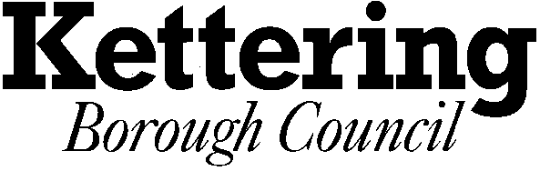

East Kettering
Liaison Forum

Date: | Thursday 22nd May 2008
Time | 7.00 pm
Venue: | Council Chamber, Municipal Offices, Kettering
Committee Administrator: | Ian White   (01536) 534200   ianwhite@kettering.gov.uk
Terms of Reference
- To act as a link between the Local Authorities, Developers and Local Interest Groups
- To monitor the implementation and impact of the development on the economic, environmental and social well being of the area
- To assist in ensuring that local people are kept informed of the development and its programming
- To allow Developers to show draft proposals for aspects of the development and seek comments on them prior to the submission/consideration of planning applications
- To seek to resolve any concerns between the stakeholders that may arise

MEETINGS AT THE MUNICIPAL OFFICES

Fire Alarm

All meetings shall be adjourned immediately on the sounding of the fire alarm. The alarm is a continuous two-tone siren. On hearing the alarm please leave the building by the nearest emergency exit. There are emergency exits at both ends of the corridor outside the meeting rooms. On leaving the building please cross the car park and assemble on the grassed area by the church. Do not attempt to drive out of the car park as this may impede the arrival of emergency vehicles. Please do not return to the building until you are told it is safe to do so by a Council employee.
Toilets

There are toilets in the corridor off the main entrance to the building you came through to get to the meeting room.

Breastfeeding and Baby Changing Facilities

The Council actively supports breastfeeding mothers. If you wish to use a private area please ask a member of staff. There are baby changing facilities in the corridor off the main entrance adjacent to the toilets.

Access for Disabled People

There are allocated parking bays outside the main entrance to the Municipal Offices for disabled people. The meeting rooms are located on the ground floor and access is gained for wheelchair users via the main entrance. If you require assistance, please ask the attendant on duty in the reception area.

No Smoking

Smoking is not permitted in the Municipal Offices.

