Direct Line: (01536) 534398
Email: anneireson@kettering.gov.uk
Our Ref: AI
Your Ref:
Date: 6th May 2008

Dear Councillor

You are summoned to attend the ANNUAL MEETING of the BOROUGH COUNCIL, to be held in the Council Chamber, Municipal Offices, Kettering on Wednesday 14th May 2008 at 6.30 pm.

Yours faithfully

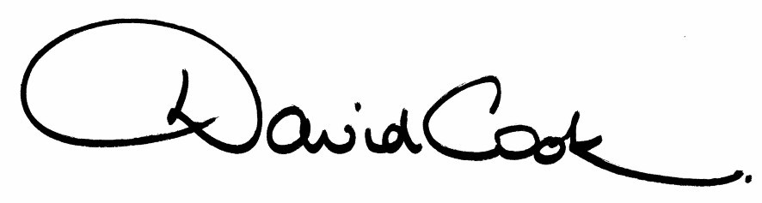

Chief Executive

A G E N D A

- Apologies

2. Election of Mayor

3. Appointment of Deputy Mayor

4. Appointment of Mayor’s Chaplain

5. Presentation of Commemorative Mayoral Badges to the retiring Mayor and Mayoress

6. The minutes of the meeting of the Council held on 30th April 2008 to be approved as a correct record and signed by the Mayor

7. Declarations of Interest
(a) Personal
(b) Prejudicial

8. To receive announcements from the Mayor.

9. To receive announcements from the Chief Executive

10. To elect the Leader and Deputy Leader

11. To receive notification of the appointment of members of the Executive.

12. To receive notification of the appointment of Leader of the Opposition

13. To approve a programme of ordinary meetings of the Council for the year (attached).

14. To decide the allocation of seats (and substitutes) to Committees.

15. To appoint members (including Chairs and Deputy Chairs) to committees, sub-committees and forums identified in the Programme of Meetings.

16. To appoint councillors to serve on outside bodies.

17. Any other items of business the Mayor considers to be urgent.

6.5.08
Fire Alarm

All meetings shall be adjourned immediately on the sounding of the fire alarm. The alarm is a continuous two-tone siren. On hearing the alarm please leave the building by the nearest emergency exit. There are emergency exits at both ends of the corridor outside the meeting rooms. On leaving the building please cross the car park and assemble on the grassed area by the church. Do not attempt to drive out of the car park as this may impede the arrival of emergency vehicles. Please do not return to the building until you are told it is safe to do so by a Council employee.

Toilets

There are toilets in the corridor off the main entrance to the building you came through to get to the meeting room.

Baby Changing Facilities

The Council actively supports breastfeeding mothers. If you wish to use a private area please ask a member of staff. There are baby changing facilities in the corridor off the main entrance adjacent to the toilets.

Access for Disabled People

There are allocated parking bays outside the main entrance to the Municipal Offices for disabled people. The meeting rooms are located on the ground floor and access is gained for wheelchair users via the main entrance. If you require assistance, please ask the attendant on duty in the reception area.

No Smoking

Smoking is not permitted in the Municipal Offices.

